- Open Power Query Editor (PQE) in Power BI and load a sample dataset of IPL cricket matches (download from Kaggle or use any CSV with match details).
ANSWERS:
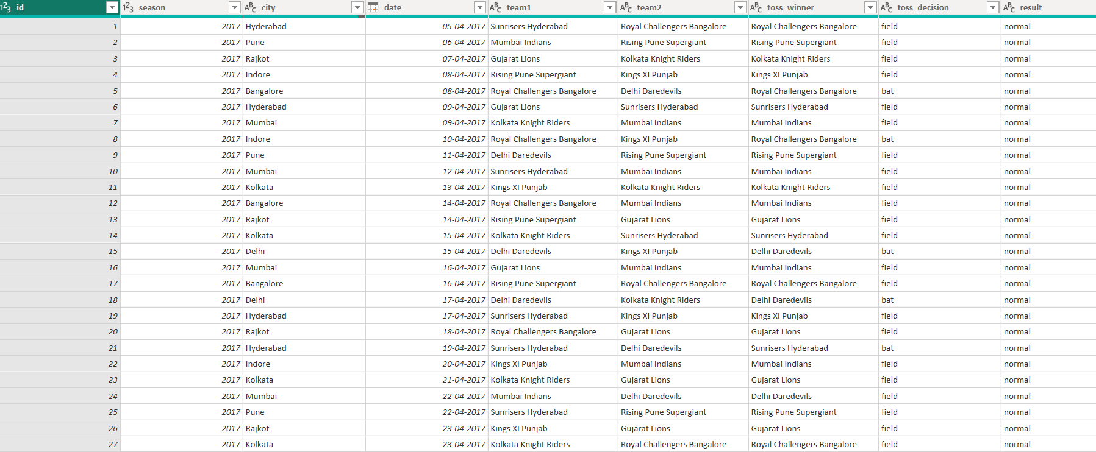

- In PQE, remove all columns except for 'Team 1', 'Team 2', 'Winner', and 'Venue' to focus only on the most relevant details for a quick match summary.
ANSWERS:
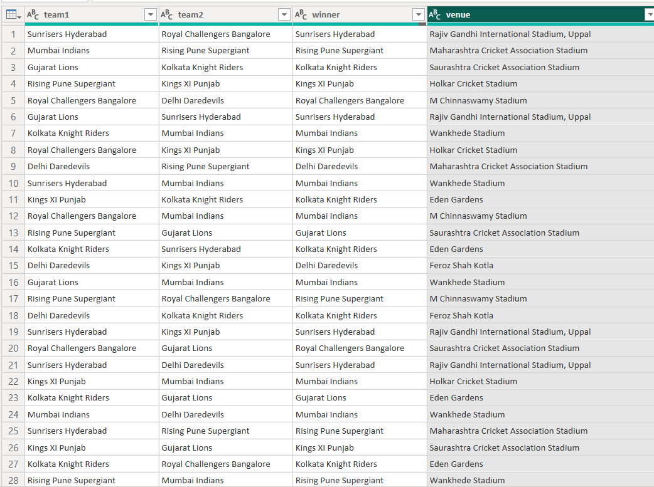
3.) Use the Remove Rows feature in PQE to delete the first 2 rows and any rows where the 'Winner' column is null or empty.
ANSWERS:

- Find and remove duplicate rows in your IPL dataset based on 'Team 1', 'Team 2', and 'Venue' columns Hint Use the 'Remove Duplicates' option after selecting these columns.
ANSWERS:
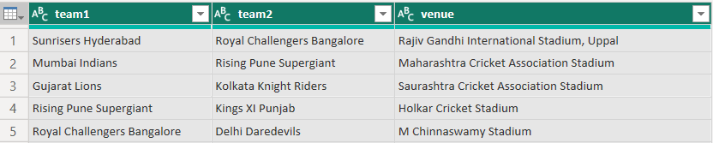

5.) Handle any error rows in your dataset by replacing errors in the 'Winner' column with the value 'Unknown', then load the cleaned data to Power BI
Hint: Right-click the column and use 'Replace Errors'.
ANSWERS:
