1.) Open Microsoft Excel and explore the ribbon: identify and list the purpose of at least three different tabs (such as Home, Insert, Data) and two tools from the Quick Access Toolbar.
ANSWERS:

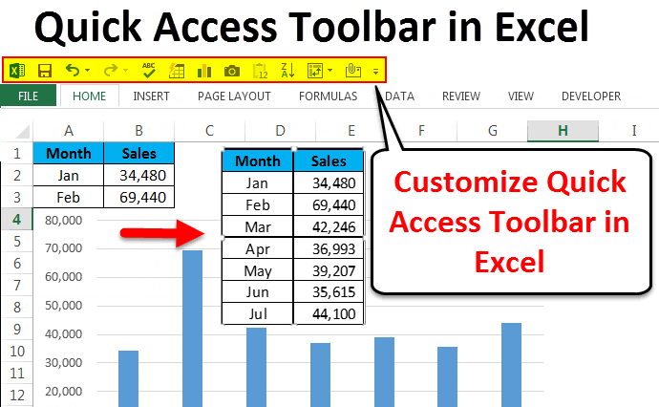

2.Create a new Excel workbook named 'MyPlaylist.xlsx' and add two worksheets: 'Songs' and 'Artists'. Enter sample data in each sheet (at least 5 rows per sheet) using a mix of text, numbers, and dates.
ANSWERS:
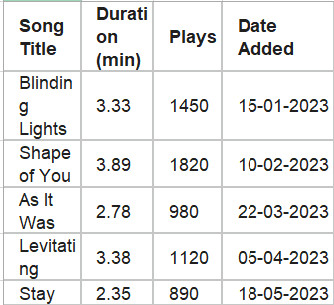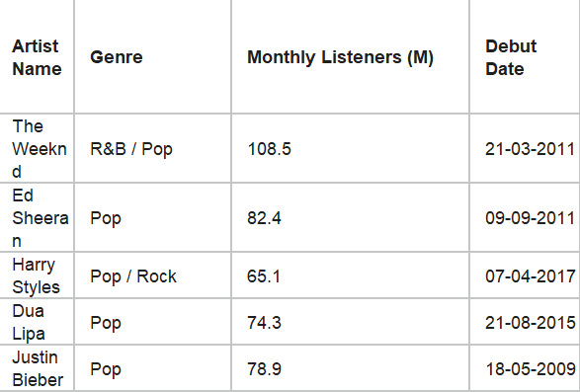

3.) In your 'Songs' worksheet, use both A1 and R1C1 referencing styles to write formulas that sum the duration of songs in column B. Switch between referencing modes and observe how the formula changes.
Hint: You can enable R1C1 mode from Excel Options → Formulas.
ANSWERS:
Song Title | Duration (min) | Plays | Date Added
Blinding Lights | 3.33 | 1450 | 15-01-2023
Shape of You | 3.89 | 1820 | 10-02-2023
As It Was | 2.78 | 980 | 22-03-2023
Levitating | 3.38 | 1120 | 05-04-2023
Stay | 2.35 | 890 | 18-05-2023

Sum: 15.73

4.) Demonstrate the difference between absolute and relative cell references by creating a simple GST calculator in Excel: enter an item price in cell A2, enter GST rate in cell B1, and use both $B$1 and B1 in formulas to calculate GST for multiple items.

ANSWERS:

A | B | C | D
Item | GST Rate: |  | output
Laptop | 1000 | 0.18 | 180
Phone | 500 |  | 90
Headphones | 100 |  | 18
Keyboard | 50 |  | 9

5.) Download a raw dataset from Kaggle or use any exported order history from Flipkart/Amazon. Open it in Excel and identify at least three columns where the data type is incorrect (e.g., a date stored as text, a price as text, or a number as a date). Correct the data types and explain the steps you took.

Hint: Use 'Text to Columns' or 'Format Cells' to fix data types.

ANSWERS:

Order_ID | Order_Date | Price | Quantity
1001 | 2024.05.15 | $450 | 2.00
1002 | 2024.05.16 | $1,200.00 | 1.00
1003 | 2024.05.17 | $85.50 | 5.00
1004 | 2024.05.18 | $299.99 | 3.00
1005 | 2024.05.19 | $15.00 | 10.00

