- Import two CSV files into Power BI: one with a list of restaurants (restaurant_id, name, city) and another with customer reviews (review_id, restaurant_id, rating). Use Merge Queries to join these tables on restaurant_id using an Inner Join, and create a table visual showing each restaurant's name and its average rating.
ANSWERS:
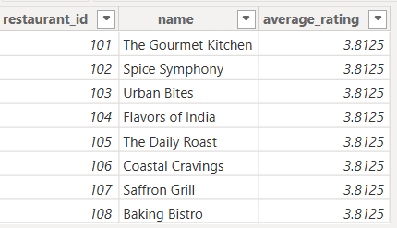

- Use Append Queries in Power BI to combine two tables: one with this month's Zomato orders and another with last month's orders (both with columns: order_id, user_id, amount). After appending, create a summary table showing total orders and total amount spent per user.
ANSWERS:
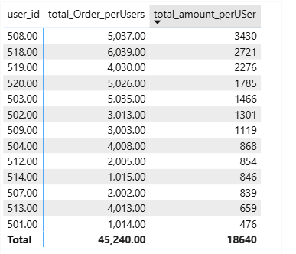

3.) Given a folder containing multiple CSV files of IPL match scores (same columns: match_id, team, runs), use Power BI's 'Combine Files from Folder' feature to load all data into a single table and create a bar chart showing total runs per team.
ANSWERS:
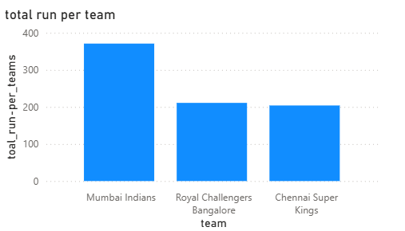
- Open the Query Dependencies View in Power BI for your current report and take a screenshot showing how your queries (from the previous tasks) are connected. Write 2-3 sentences explaining what the arrows and boxes represent in your setup.
Hint: Focus on how Merge, Append, and Folder Combine steps create dependencies between queries.
ANSWERS:
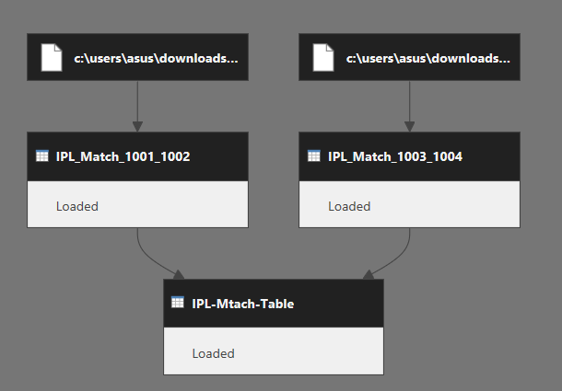

Summary of Your Query Dependencies View
- The Boxes (Data): The top icons represent your raw source CSV files on your computer. The lower blocks represent the individual tables inside Power BI (IPL_Match_1001_1002, IPL_Match_1003_1004, and IPL-Mtach-Table).

- The Arrows (Flow): The lines show the direction of the data. They illustrate how your separate match files flow downwards and merge/append into the single final table at the bottom.

- Dependency: This setup proves that IPL-Mtach-Table relies entirely on the files above it; if you update or refresh the source files, the changes will automatically flow down into your final table.

