- Open Power BI Desktop and import a dataset of your choice (for example, a CSV of IPL cricket matches or Zomato restaurant data). Add two visuals (such as a bar chart and a table) and use the Edit Interactions feature to make sure clicking on one visual only highlights data in the other, instead of filtering it.
ANSWERS:
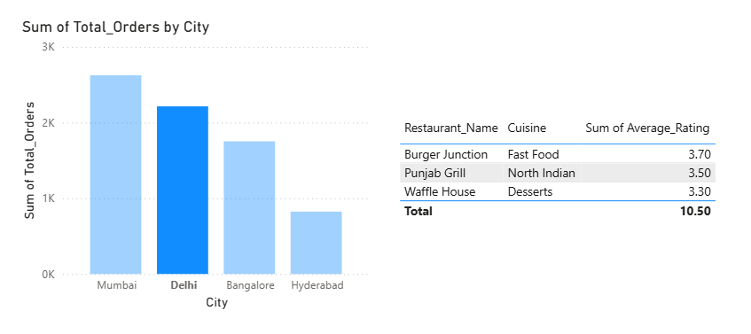
- Create a drill-through page in Power BI that lets users right-click on a Flipkart-style product category in a main report and see detailed information (like average price, top products) for that category on the drill-through page.

Hint: Use the 'Drill-through' filter well to set up the connection between the main page and the drill-through page.
ANSWERS:
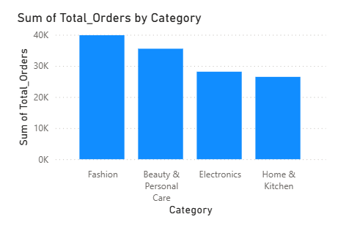

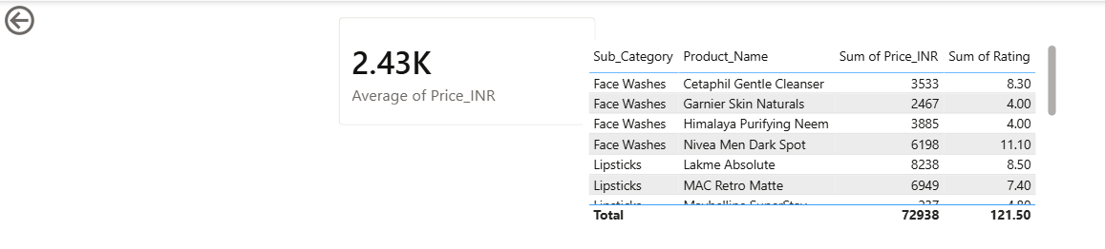

3.) Design a Power BI report showing a hierarchy similar to Zomato's city > restaurant > cuisine. Enable hierarchical navigation so that users can click to drill down from city to restaurant and then to cuisine in a single visual.
Constraint: Use at least three levels in your hierarchy.
ANSWERS:
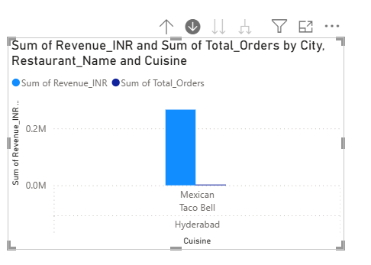
- Take an existing Power BI report you built earlier (any topic) and modify the interactions so that at least one visual does not respond to selections in another visual. Explain in a comment or text box when you would want to use this type of interaction in a real app like BookMyShow or Myntra.
ANSWERS:
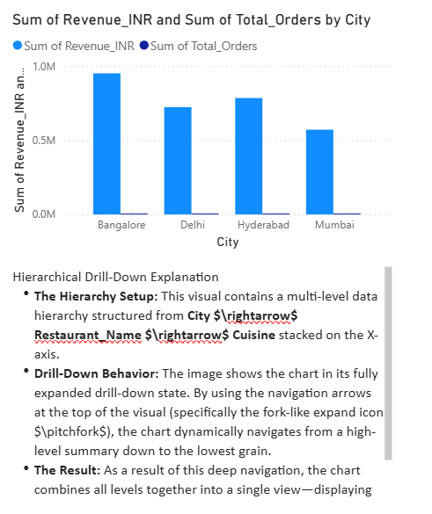

5.) Use ChatGPT or Copilot to generate step-by-step instructions for creating a drill-through page in Power BI, then follow those steps using your own dataset (not the one shown in class). After completing, compare the AI's instructions to your actual process and note any differences.
Hint Paste the AI's instructions in a text box on your report for reference.
ANSWERS:
Comparison: AI Instructions vs. My Actual Process
- What the AI Instructions Said: Look for the "Drill-through" section at the bottom of the Visualizations pane and drag your category field there.
- What I Actually Did (The Difference): In the latest version of Power BI Desktop, the Drill-through bucket has moved from the old Visualizations pane. I found it located at the bottom of the Filters pane under "Page-level filters" / "Drag drill-through fields here".
- Hierarchical Difference: The AI instructions assumed a simple, single-level click. Because my Zomato visual uses an advanced multi-level hierarchy (City > Restaurant > Cuisine), right-clicking on "Hyderabad" passed the entire drill-down path context over to the details page dynamically, which worked much better than the basic AI example.

