- In Power BI Desktop, import a CSV file containing a list of food delivery orders (with columns like OrderID, Restaurant, FoodItem, Month1, Month2, Month3) and use the Unpivot Columns feature in Power Query Editor to convert the Month columns into two columns: 'Month' and 'OrderCount'.

ANSWERS:
orderCount:
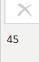
Months:
: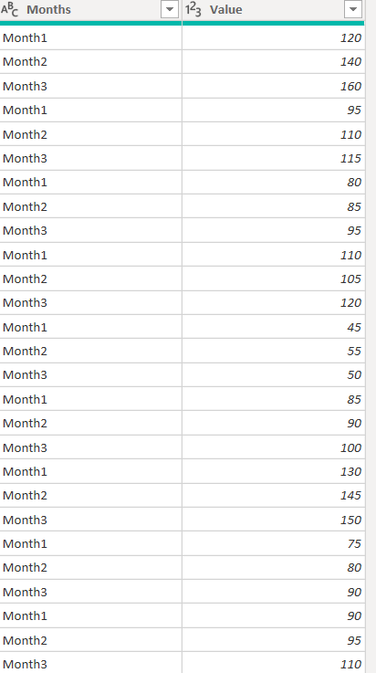

- Using Power Query Editor, apply the Group By transformation on a dataset of Flipkart product sales to calculate the total sales amount for each product category and display the result in a new table.

ANSWERS:
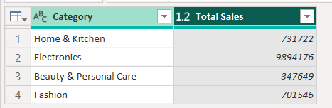

- Add a Custom Column in Power Query Editor to a Spotify-style playlist dataset that combines the 'Artist' and 'SongTitle' columns into a single 'DisplayName' column formatted as 'Artist - SongTitle'.

ANSWERS:
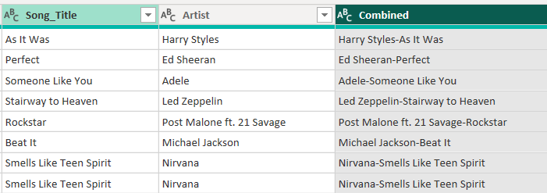

4.) Create a Conditional Column in Power Query Editor for a Zomato restaurant ratings dataset that assigns a 'Status' of 'Top Rated' if the rating is above 4.5, 'Average' if between 3 and 4.5, and 'Needs Improvement' if below 3. Hint Use the 'Conditional Column' feature and set up appropriate IF logic for each range.

ANSWERS:
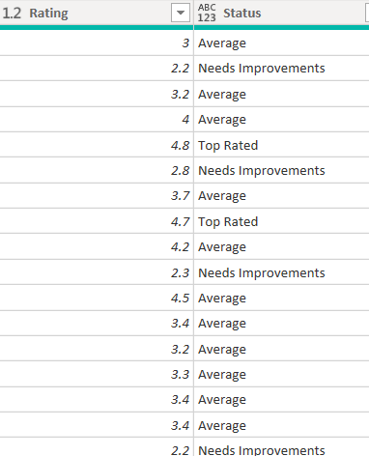

5.) Use Power Query Editor's AI-powered 'Add Column from Examples' feature to generate a new column in a BookMyShow movie bookings dataset that extracts the first word from each movie title as the 'MovieKeyword'.
Hint: Start typing the desired output for a few rows and let Power BI suggest the transformation.

ANSWERS:
