- Import a CSV file containing monthly sales data for three food delivery apps (Zomato, Swiggy, Uber Eats) into Power BI and create a Waterfall chart to visualize the change in total orders from January to June.
ANSWERS:
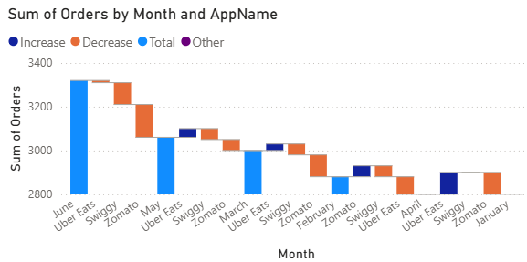
- Using a dataset of user sign-ups for an IPL fantasy league app, build a Funnel chart in Power BI that shows the number of users at each stage: Visited App, Registered, Created Team, Joined League, Made Payment.
ANSWERS:
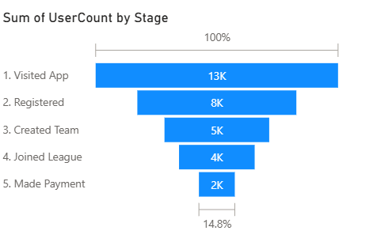

- Download a sample dataset with city-wise Flipkart order volumes across India and create a Map visual in Power BI to display which cities have the highest and lowest order counts.

Hint: Use the city names as the location field and order volume as the size/colour field in the Map visual.

ANSWERS:
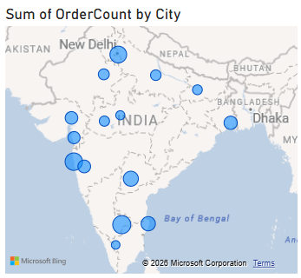
- Given a dataset of movies released in 2023 with their genres and box office collections, create a Tree Map in Power BI to show collections by genre, and within each genre, by individual movie.
ANSWERS:
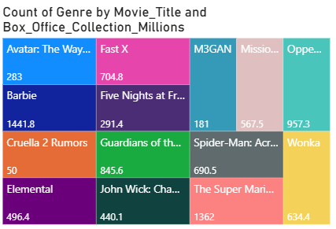
- Use Power BI's Scatter Chart visual to plot the relationship between average daily active users and average session duration for 10 popular Indian apps (e.g., Instagram, WhatsApp, Zomato, Flipkart). Identify any outliers and explain what they might mean.

Hint: Add data labels for at least two points you consider outliers.
ANSWERS:
