1.) Import a CSV file of Zomato restaurant listings into Power BI and use the 'Split Column by Delimiter' feature to separate the 'Restaurant Name - Area' column into two columns: 'Restaurant Name' and 'Area'.
ANSWERS:
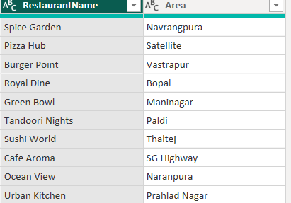

2.) Use the 'Merge Columns' feature in Power BI to combine 'First Name' and 'Last Name' columns from a Flipkart user data table into a single 'Full Name' column, separated by a space.
ANSWERS:
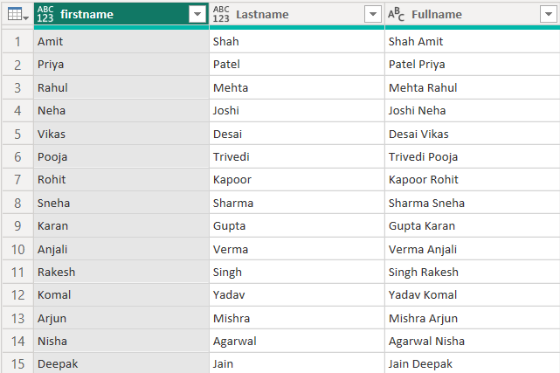

3.) Replace all instances of the value 'Cancelled' with 'Order Failed' in the 'Order Status' column of a Swiggy orders dataset using Power BI's 'Replace Values' function.
ANSWERS:
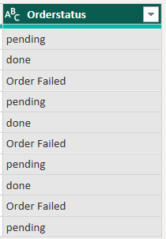

4.) Change the data type of the 'Order Amount' column from Text to Decimal Number in a Paytm transaction table in Power BI, and verify that the column now supports numerical calculations
ANSWERS:
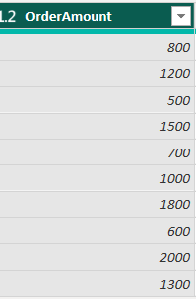

5.) In a Movie Ticket Booking dataset (like BookMyShow), use the 'Fill Down' operation in Power BI to fill missing 'Movie Name' values based on the previous row's value.
Hint Blank rows for 'Movie Name' should inherit the name from the last non-blank entry above.
ANSWERS:

BEFORE:
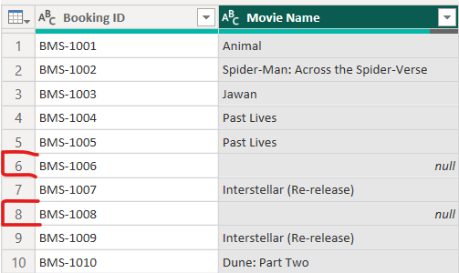

AFTER:
