- Open Power BI Desktop and import a CSV file containing monthly step count data (columns: Month, Steps) for a year, then create a Line Chart visual to show the trend of steps over the months.
ANSWERS:
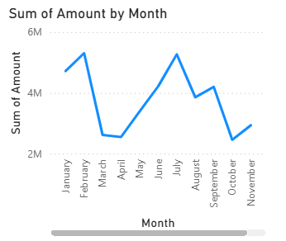

- Using a sample dataset of your favorite food delivery app orders (columns: Restaurant, OrderCount), create a Pie Chart in Power BI to display the share of orders for each restaurant, and customize the legend to show percentage values.
ANSWERS:
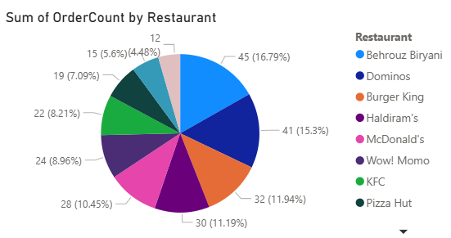

- Import a dataset with daily active user counts for three different social media apps (columns: Date, Instagram, WhatsApp, YouTube), and create an Area Chart in Power BI to visualize the usage patterns of all three apps over a two-week period.
ANSWERS:
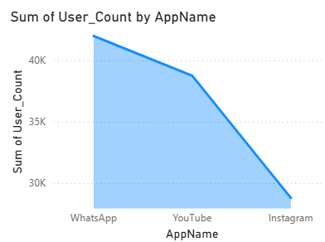

- Build a Combo Chart in Power BI using a dataset of monthly Zomato orders (columns: Month, TotalOrders, AverageOrderValue), where TotalOrders is shown as columns and AverageOrderValue as a line on the same chart.

Hint: Use the Combo Chart visual and assign the appropriate fields to column and line values.

ANSWERS:
