- Download a sample dataset of 30 online orders (including customer names, addresses, and order IDs) and use the Remove Duplicates tool in Excel to eliminate any duplicate order records.
ANSWERS:
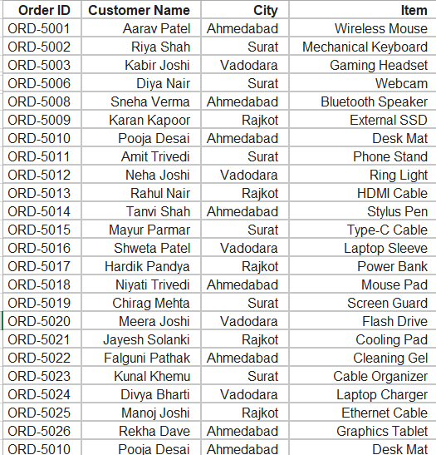

- Use the Text to Columns feature in Excel to split a Zomato-style delivery address column (e.g., 'Flat 12B, Sunrise Apartments, SG Highway, Ahmedabad') into separate columns for Flat/House No., Building Name, Street, and City.
Hint: Choose the correct delimiter (comma or space) based on the sample data format.
ANSWERS:
Order ID | Customer Name | Flat/House No. | Building Name | Street | city
ORD-6001 | Aarav Patel | Flat 12B | Sunrise Apartments | SG Highway | Ahmedabad
ORD-6002 | Riya Shah | Villa 4 | Palm Meadows | Sindhu Bhavan Road | Ahmedabad
ORD-6003 | Kabir Joshi | Plot 8 | Shivalik Plaza | Ambawadi | Ahmedabad
ORD-6004 | Ananya Gupta | B-202 | Orchid Heights | CG Road | Ahmedabad
ORD-6005 | Rohan Mehta | House 15 | Silver Oak | Thaltej | Ahmedabad

- Apply Flash Fill in Excel to extract the username from a list of email addresses (e.g., from 'rahul.patel99@gmail.com' extract 'rahul.patel99') and display it in a new column.
ANSWERS:
Email Address | Username
rahul.patel99@gmail.com | rahul.patel99
ananya.gupta@yahoo.com | ananya.gupta
vikram_singh88@outlook.com | vikram_singh88
diya.shah@hotmail.com | diya.shah
kabir.joshi21@gmail.com | kabir.joshi21
sneha.verma@company.org | sneha.verma
rohan_mehta@rediffmail.com | rohan_mehta
pooja.desai5@gmail.com | pooja.desai5
amit.trivedi@yahoo.in | amit.trivedi
neha.joshi99@outlook.com | neha.joshi99

- Replace all phone numbers in a contact list that start with '98' using the Find & Replace tool with wildcards in Excel, changing the starting digits to '99' (e.g., '9876543210' becomes '9976543210').
Hint: Use wildcards like '?' or '*' in the Find field to match the pattern.
ANSWERS:
Contact Name | Phone Number
Aarav Patel | 9976543210
Riya Shah | 9123456789
Kabir Joshi | 9925012345
Ananya Gupta | 9900112233
Rohan Mehta | 9999999999
Diya Nair | 9712345678
Vikram Singh | 9944556677
Sneha Verma | 9622334455
Karan Kapoor | 9911223344
Pooja Desai | 9555667788

- Use the Error Checking ribbon tools in Excel to identify and fix any #DIV/0! or #VALUE! errors in a dataset of IPL player statistics, ensuring all formulas display valid results.
ANSWERS:
Player Name | Runs Scored | Balls Faced | Matches Played | Strike Rate | Batting Average
Virat Kohli | 650 | 450 | 15 | 144.4444444 | 43.33333333
MS Dhoni | 320 | 0 | 14 | 0 | 22.85714286
Rohit Sharma | 510 | 380 | 16 | 134.2105263 | 31.875
Hardik Pandya | N/A | 210 | 12 | 0 | 0
Rishabh Pant | 410 | 310 | 13 | 132.2580645 | 31.53846154

