# Krushil Naik

Somerset, NJ

DevOps Engineer

Email: [krushilnaik96@gmail.com](mailto:krushilnaik96@gmail.com) | LinkedIn: <https://www.linkedin.com/in/krushilnaik>

GitHub: <https://github.com/krushilnaik>

Experienced Software Engineer proficient in CI/CD, cloud implementations, and automation tools, with a focus on producing secure and practical results while emphasizing quality assurance.

**Badges**

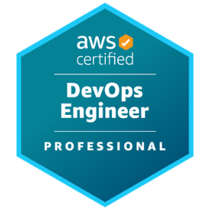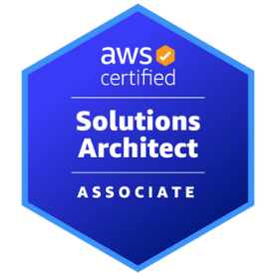****

**Skills**

**Programming Languages:** JavaScript/TypeScript, Python, Java, Go/Golang, PHP

**Web Development Technologies:** NextJS, TailwindCSS, MongoDB, NodeJS, React, Redux, ExpressJS, Django, Flask, Laravel, PostgreSQL, MySQL, SQLite, Vercel, Netlify, Heroku, GraphQL, SCSS, RESTful APIs, Content Management Systems (CMS), Cassandra, Power Automate, Power Pages, Dataverse

**AWS Services:** IAM, CloudWatch, CloudFront, S3, CloudFormation, Lambda, EC2, RDS, VPC, ECR, WAF, EKS, DynamoDB, API Gateway, Route 53

**DevOps Technologies:** CI/CD, Kubernetes, Helm, Docker, Terraform, Prometheus, Grafana, Elastic Stack, Jenkins, ArgoCD, OpenShift, Ansible, Packer, Git, GitHub, GitLab, SonarQube, Azure DevOps

**Work Experience**

**SkillStorm** (11/2023 –Present) – DevOps Engineer **[Contracted to PwC]**

* Designed and implemented a CI/CD pipeline from scratch for a **Microsoft Power Pages** site using **Azure DevOps**, leading to a 40% reduction in deployment time and increased QA deployment frequency by 90%.
* Automated transferal of essential data across environments, achieving an 80% decrease in manual effort. Integrated process with Microsoft Teams, allowing for fast access to infrastructure during application maintenance windows.
* Resolved critical bugs in applications managed within the Azure DevOps environment.

**Self-Employed** (04/2023 – 02/2024) – Fullstack Engineer (Freelance)

* Built website for local construction business from the ground up with **NextJS** and **TypeScript**
* Designed **REST API** to facilitate uploading project documents to **Headless CMS** with security and scalability in mind

**Smoothstack** (11/2022 – 04/2023) – DevOps Engineer (Contract)

* Automated shutdown of idle resources using **CloudWatch** alarms and **Lambda** functions, reducing monthly AWS costs by 56%.
* Created **Jenkins** pipelines to run tests, build Java **Spring Boot** microservices, and push size-optimized, production-ready **Docker** images to **ECR** for deployment to **EKS** cluster.
* Optimized **Kubernetes** nodes to run 30-40% more efficiently, resulting in more schedulable pods per node and 33% Kubernetes-related cost savings.
* Created custom machine images to decrease time to provisioning new VMs in dynamic clusters by 40%.
* Reconfigured **React** and **Angular** application architectures to reduce cost to host the frontends by 93%.
* Developed **Terraform** script to deploy the entire infrastructure of a full-stack application to AWS with a single CLI command, streamlining the setup process and reducing deployment time by 60%.

**Clutch** (05/2022 – 08/2022) **–** Software Engineer (Internship)

* Pulled data from **PostgreSQL and Cassandra** databases, rendering them on **React** frontends using **JDBC** and Java on the backend.
* Developed and implemented cron jobs that email a CSV with customer usage statistics across the various Clutch services to the product management team every Monday morning.

**Tris Pharma** (05/2017 – 08/2017) – Quality Assurance Associate

* Reconciled data and ensured reports followed SOPs.
* Oversaw and maintained company databases to ensure successful FDA audits.

**Relevant Certifications**

AWS Certified DevOps Engineer – Professional (05/2023)

AWS Solutions Architect – Associate (04/2023)

AWS Certified Cloud Practitioner (02/2023)

HashiCorp Certified: Terraform - Associate (002) (02/2023)

**Other Certifications**

Microsoft Certified: Power BI Data Analyst Associate (10/2023)

Microsoft Certified: Azure AI Fundamentals (10/2023)

Microsoft Certified: Azure Data Fundamentals (10/2023)

SAP Certified Technology Consultant - SAP S/4HANA System Administration (09/2023)

SAP Certified Application Associate - Business Foundation & Integration with SAP ERP 6.07 (09/2023)

**Education**

**Fort Hays State University** (Graduated 12/2022) –Bachelor of Science, Computer Science