Acknowledge
We, the students of Shrinathji College of Computer Application, studying in the final year of BCA, are pleased and satisfied to present this project report on
“Homy Bazaar”
We are thankful to all who have helped us in the successful completion of this project and for providing valuable guidance throughout our work.
We are deeply grateful to the many people who have guided, inspired, and motivated us. We take this opportunity to thank all of them. This endeavour has given us insight into various aspects of software implementation in practical applications.
It has provided us with hands-on experience that we could not have gained from books alone. We are especially grateful to our guide, Prof. Milind Pawar, who supported us throughout the learning process and enriched our knowledge during the project work.
We are also very thankful to Dr. Shivangi Patel and all the staff members of the Computer Department, who were a constant source of motivation, knowledge, and moral support.
We would like to extend our sincere thanks to our friends, family members, and everyone who directly or indirectly helped us during this project. Without their support and encouragement, this project would not have become a reality.
Finally, we express our heartfelt gratitude to the Almighty for everything.
Thanking you.
Riddhi Pawar
Krushi Patel

INDEX
Sr No. | Table of contents
1. | Introduction
2. | Scope of Project
3. | Project Profile
4. | Software Used

INTRODUCTION
"Homy Bazaar" is a modern and convenient online grocery shopping platform designed to make your everyday shopping easy, affordable, and enjoyable. Whether you’re a busy professional, a homemaker, or a student, Homy Bazaar ensures a smooth shopping experience with a wide range of fresh groceries, daily essentials, and household items all available at your fingertips. The platform offers intuitive navigation, secure login, and detailed product listings to help users shop effortlessly and confidently. With its clean layout, real-time cart updates, and seamless checkout process, Homy Bazaar turns grocery shopping into a smart, time-saving experience for everyone.
Main Advantages of Homy Bazaar
- User-Friendly Interface: Simple and intuitive design that allows quick navigation and easy access to products and categories.
- Secure Access: Authentication-based login ensures a safe, personalized experience for every customer.
- Wide Range of Products: From fresh fruits and vegetables to packaged foods and cleaning supplies, Homy Bazaar offers everything under one roof.
- Instant Updates & Offers: Get notified about new arrivals, seasonal discounts, and trending deals instantly.
- Interactive Design: Clean and attractive layout with dynamic visuals, hover effects, and smooth animations for an engaging shopping experience.
- Personalized Shopping: Smart recommendations and user profiles tailor product suggestions based on your past purchases and preferences.
- Responsive & Modern Layout: Optimized for all devices — mobile, tablet, or desktop — to ensure a consistent and high-quality experience anywhere, anytime.
Scope of project
The Homy Bazaar Project aims to develop a complete online grocery shopping platform that enables users to browse, purchase, and manage daily essentials with ease. The system allows users to search for items, compare prices, and securely complete orders through a smooth checkout process. Its core focus is on providing a convenient and time-saving solution for grocery shopping, combining a simple interface with real-time cart and order tracking features.
Registered users can log in to manage their profiles, view order history, create Wishlist, and receive updates on offers or restocks. The platform is designed to build user trust with safe transactions, fast performance, and accurate product information ensuring customer satisfaction and repeat purchases.
Future Enhancements
Future versions of Homy Bazaar may include advanced features like:
AI-based Smart Recommendations: Suggesting items based on previous shopping behaviour and preferences. Subscription & Auto-Reorder Options: Allowing users to automatically reorder frequently bought items.Live Customer Chat Support: Real-time help and assistance for a better shopping experience. Reward Points & Loyalty System: Offering exclusive benefits and discounts for regular shoppers. Voice Search & Multilingual Support: Making the platform accessible and easy to use for everyone. Social Sharing: Allowing users to share grocery lists or favourite products with family and friends.

PROJECT PROFILE
Project Title | Homy Bazaar
Developer | Riddhi Pawar  Krushi Patel
Development Tool | Front-end: JS, HTML and CSS
Database | MongoDB compass
Purpose | Homy Bazaar aims to simplify and enhance the online home shopping experience by combining convenience, sustainability, and trust. It empowers users to shop smarter while contributing to a greener lifestyle.
Language | JavaScript and jQuery
Documentation Tool | MS Office 2021
Internal Guide | Dr. Chandni Raval

Project Environment
Software Used:
Language | HTML, JavaScript, CSS
Operating System | Windows 11
Server | MongoDB
Web Browser | Chrome, Microsoft Edge
Designing Tool | Visual Studio Code
Server-Side Scripting | MongoDB compass

Technology Used:

Front end and back end are generalized terms that refer to the initial and the end stages to handles a system. The front end is responsible for collecting input in various forms the user and processing it to confirm to a specification the back end can use. The front end is an interface between the users and the back end.
The main reason of forming a combination of these two ends is, to provide different functionality of both getting and providing data or information to the user with the help of this medium.
The main reason of talking front end is subjecting all processing part to be performed by this front end that interact with user enabling to use different facilities of the system. And thus, taking back end is to keep all the data at the base back for retrieval, processing and resulting.



What’s New In Window 11 fir Computers?
For developers, Windows 11 offers new tools and resources
We tried to make Windows a more open platform with Windows 11.
We gave the development process some care, as well as the equipment and skills required to produce truly remarkable apps. With developers in mind, we created Windows 11. The tools, frameworks, and languages that you are familiar with and enjoy using can be used to develop apps. Additionally, we accept all of your apps and will do our best to make them feel at home on Windows.
Enabling the hybrid workforces and classrooms of tomorrow
Windows 11 is the operating system for hybrid work and learning.
Through the rapid acceleration of digital transformation that we've seen over the last 19 months, it is critical for today's organization to be resilient and flexible.



What Is MongoDB?
MongoDB is a popular, open-source NoSQL database management system that stores data in flexible, JSON-like documents rather than the rigid tables and rows of traditional relational databases.
Key features and concepts of MongoDB:
Document-Oriented Model: Data is stored in documents, which are BSON (Binary JSON) objects. This model naturally maps to objects in most modern programming languages, making it easy for developers to use.
Dynamic Schemas: Documents within the same collection (similar to a table in SQL) do not need to have the exact same fields or structure. This flexibility supports rapid, iterative application development and evolving data requirements.
Scalability and High Availability: MongoDB is designed for horizontal scaling (sharding), which distributes data across multiple servers to handle large data volumes and high traffic loads. It also uses replica sets to maintain multiple copies of data for redundancy and automatic failover, ensuring high availability.
Powerful Querying: It provides a rich MongoDB Query Language (MQL) that supports ad hoc queries, indexing (including geospatial and text search), and real-time aggregation for powerful data analysis.
Deployment Options: MongoDB is available in various forms, including the free-to-use Community Edition, the commercial Enterprise Advanced version, and MongoDB Atlas, a fully managed cloud database service across major cloud providers like AWS, Azure, and Google Cloud.
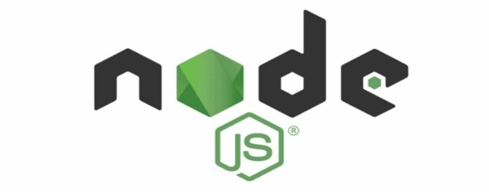

What Is Node.js?
Node.js is a free, open-source, cross-platform JavaScript runtime environment that allows developers to run JavaScript code outside of a web browser. It is built on the Google Chrome V8 JavaScript engine and is widely used for building fast, scalable network applications, APIs, and microservices.
Key Features
Asynchronous and Event-Driven: Node.js uses a non-blocking I/O model and a single-threaded event loop, which means it can handle multiple requests concurrently without waiting for previous operations to complete. This makes it highly efficient for I/O-intensive applications.
"JavaScript Everywhere" Paradigm: It enables developers to use the same language (JavaScript) for both client-side (frontend) and server-side (backend) development, which streamlines the development process.
High Performance: By leveraging the V8 engine, which compiles JavaScript into native machine code, Node.js delivers exceptional speed and performance.
Rich Ecosystem (npm): Node.js comes with a vast ecosystem of open-source libraries and modules available through the Node Package Manager (npm), the largest single-language code repository in the world.
Cross-Platform: It runs on various operating systems, including Windows, macOS, and Linux, providing flexibility in development and deployment.



What is Visual Studio Code?
Visual Studio Code (famously known as VS Code) is a free open-source text editor by Microsoft. VS Code is available for Windows, Linux, and macOS. Although the editor is relatively lightweight, it includes some powerful features that have made VS Code one of the most popular development environment tools in recent times.
Visual Studio Code was first announced on April 29, 2015, by Microsoft at the 2015 Build conference. A preview build was released shortly thereafter.
FEATURES
VS Code supports a wide array of programming languages from Java, C++, and Python to CSS, Go, and Docker file. Moreover, VS Code allows you to add on and even creating new extensions including code linters, debuggers, and cloud and web development support.
The VS Code user interface allows for a lot of interaction compared to other text editors.
> The activity bar
> The side bar
> Editor groups
> The panel

Data Flow Diagram
Following is the Data Flow Diagram, which represent overall flow of the in the system from department. This will help in understanding the flow of the system to other users.
Process
External Entity
Data Store
Data Flow

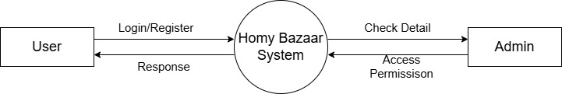
Zero Level DFD

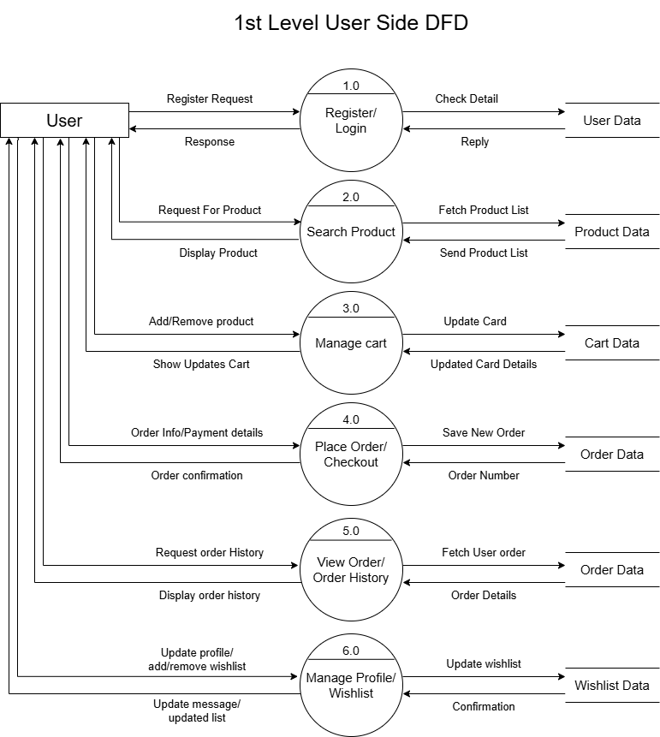
1st Level User Side DFD

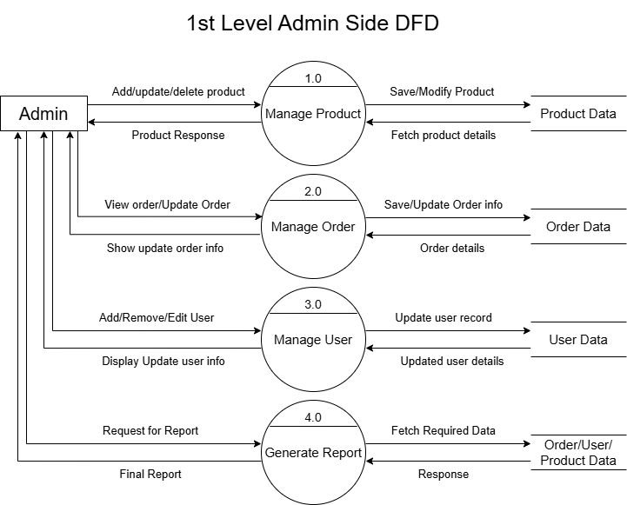
1st Level Admin Side DFD

Entity Relationship Diagram
(ER-Diagram)
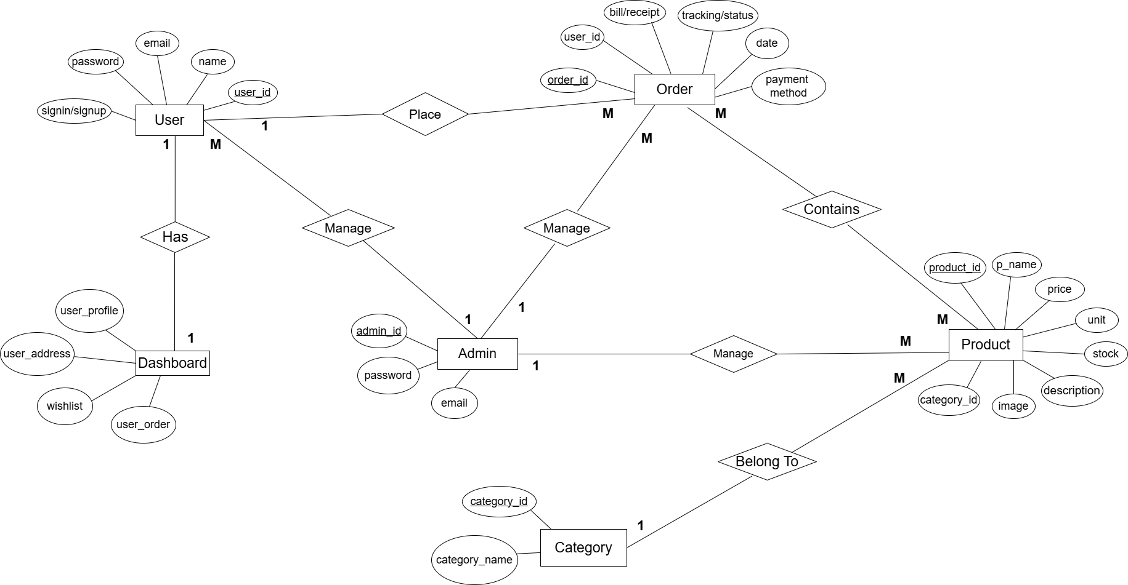
ER Diagram is known as Entity-Relationship Diagram, it is used to analyze to the structure of the Database. It shows relationship between entities and their attributes. An ER model provides a means of communication.

Data Dictionary
Data dictionary is a store of information about the data in database. The dictionary defines the name, description, source of data, users of data, and keywords in data, formula to derive the data, specification and such other details. Data dictionary brings common understanding of the data in the organization. RDBMS provides software to created he use of data dictionary enforces the standards of processing, usage's application and documentation in the organization.
Data Dictionary are an integral component of structured analysis, since data flow diagram by them do not fully describe the information about the system. The data dictionary provides additional information about the system.
A Data Dictionary is a catalogue-a repository of the elements in a system. These elements center on data the way they are structured to meet user requirements and organization needs. In a Data Dictionary, a list of all the elements composing the data flowing through a system is included.
If a project team member wants to know the definition of a data item name or the contents of a particular data flow, the information will be available in the data dictionary.
Descriptions of all data used in the system are given in a Data Dictionary.
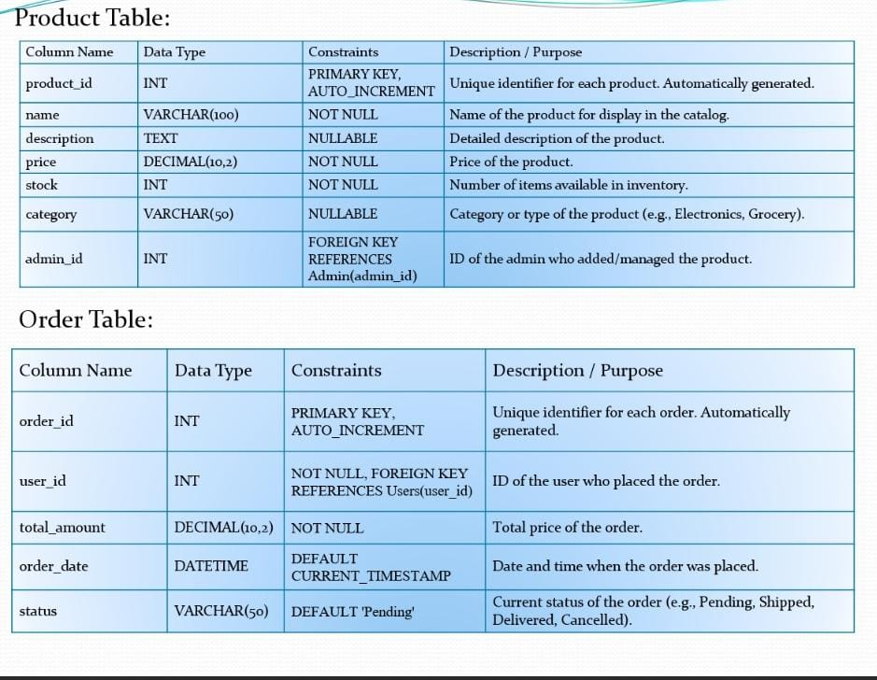
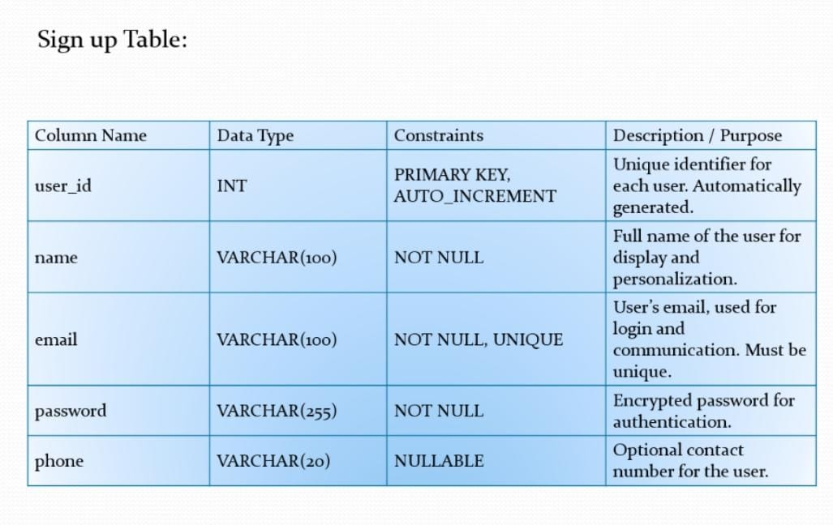

Screenshots
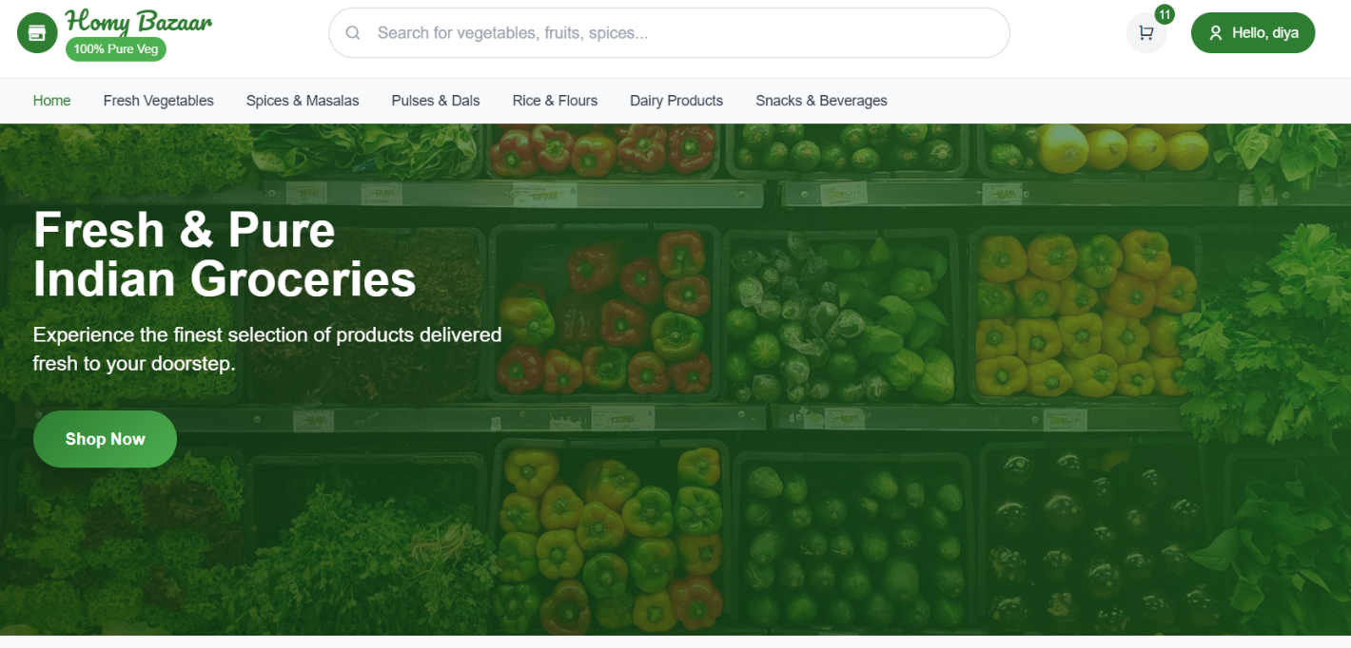
Home Page:
User Sign-Up and Login Page:
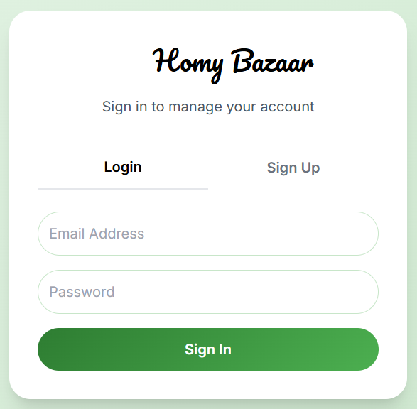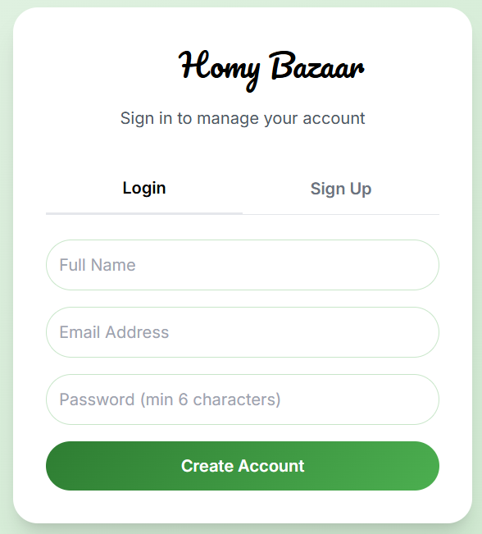

User Dashboard:
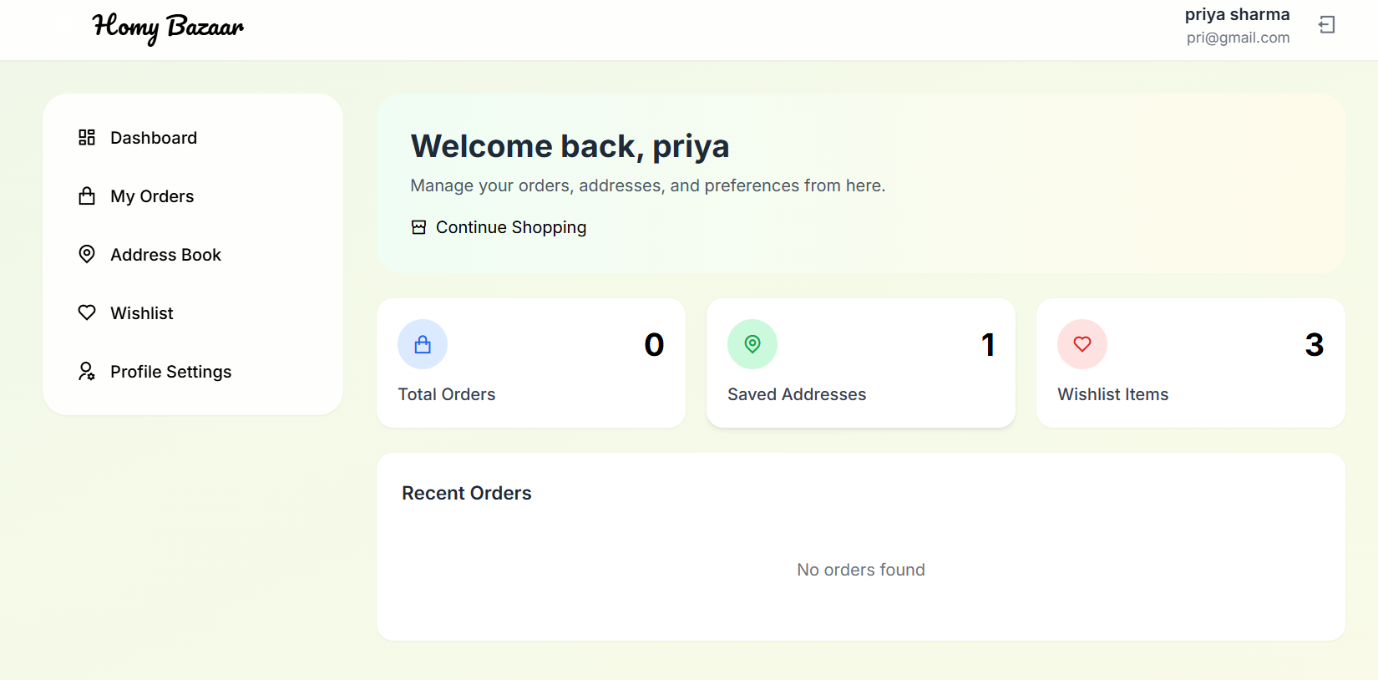
User Order History and Tracking:

Admin Login Page:
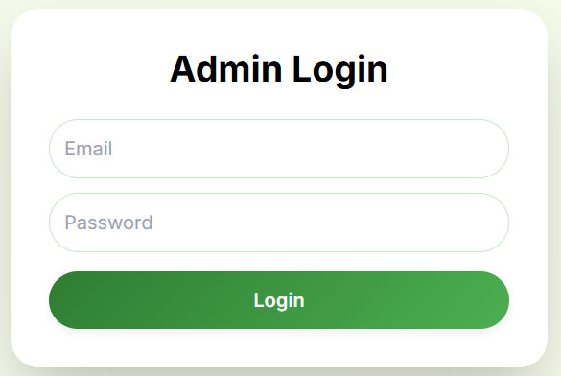

Admin Dashboard:
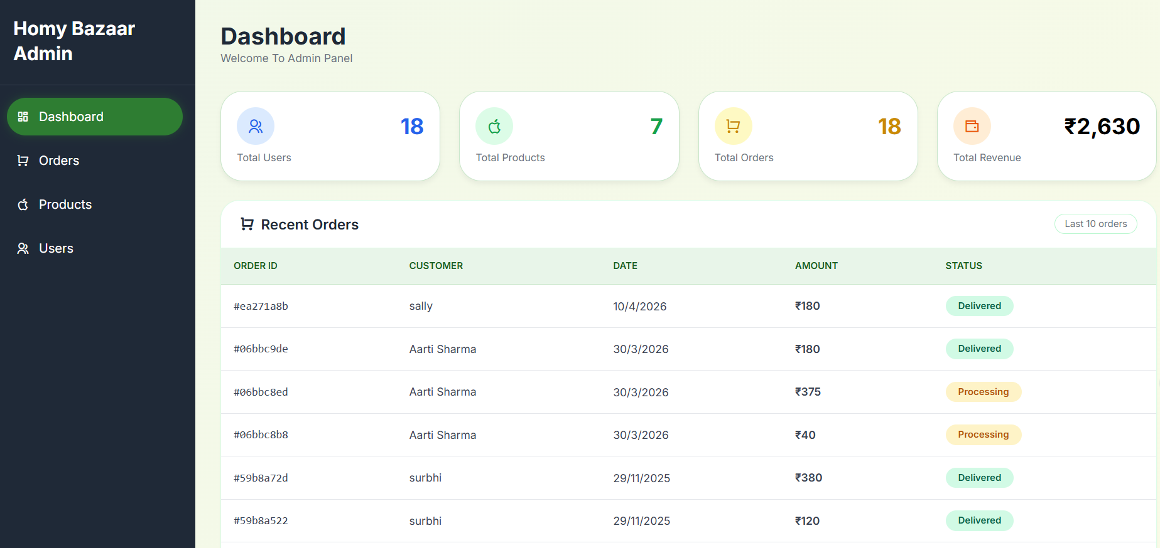

Product Management:
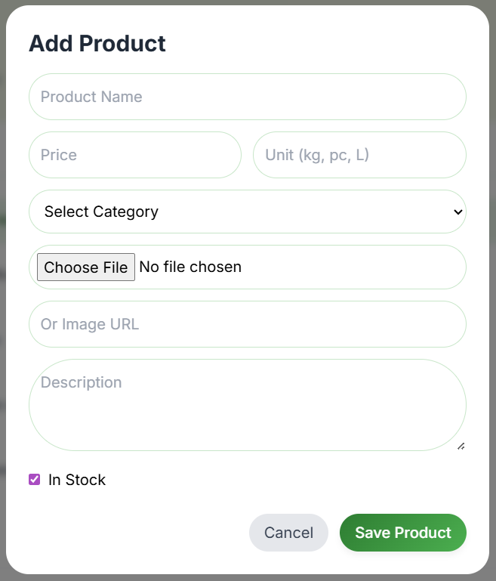
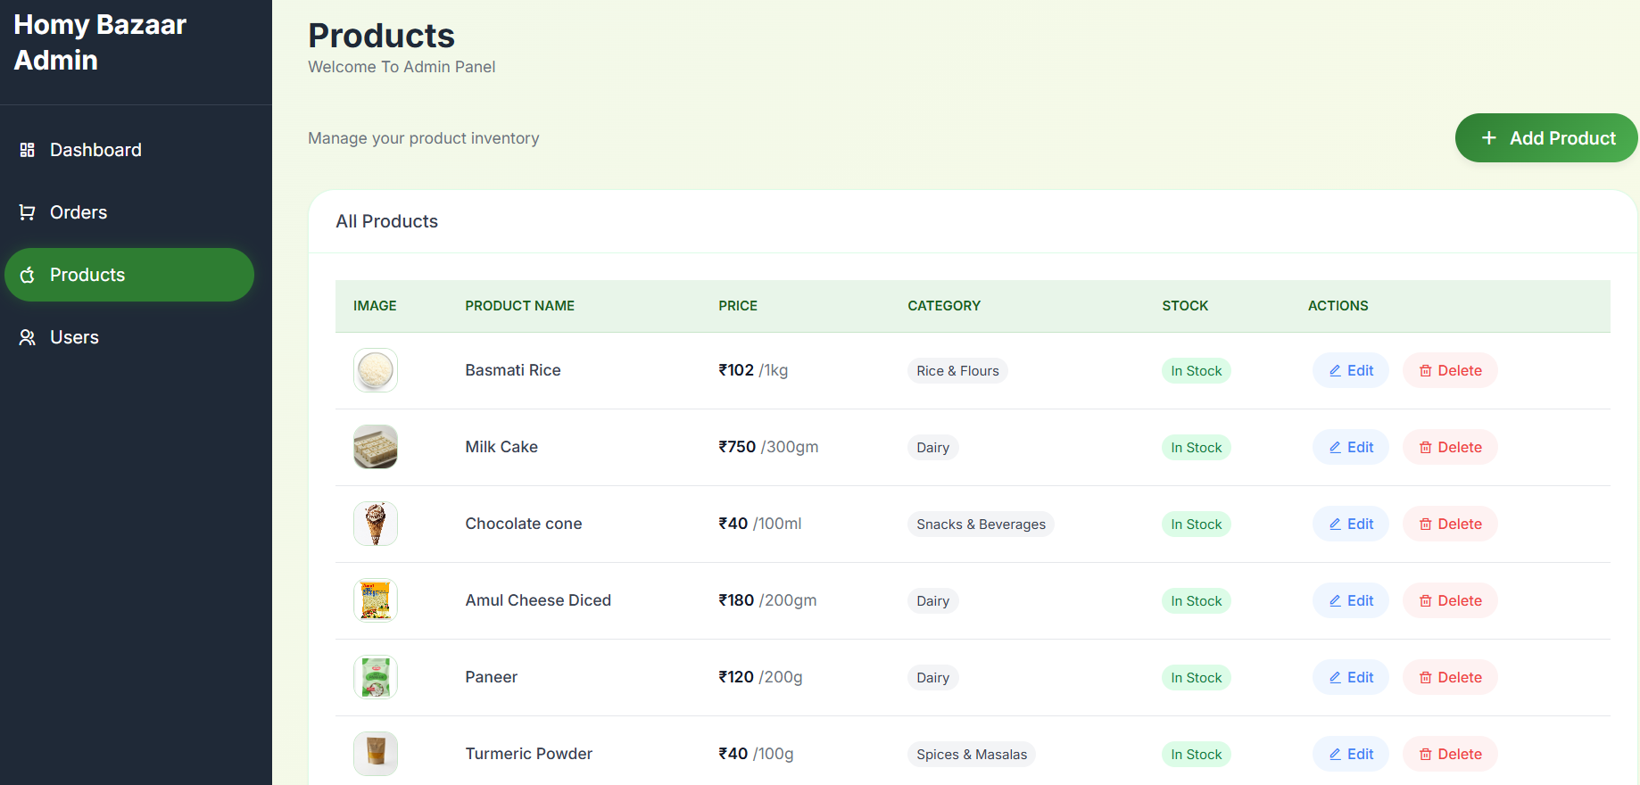

Order Management:
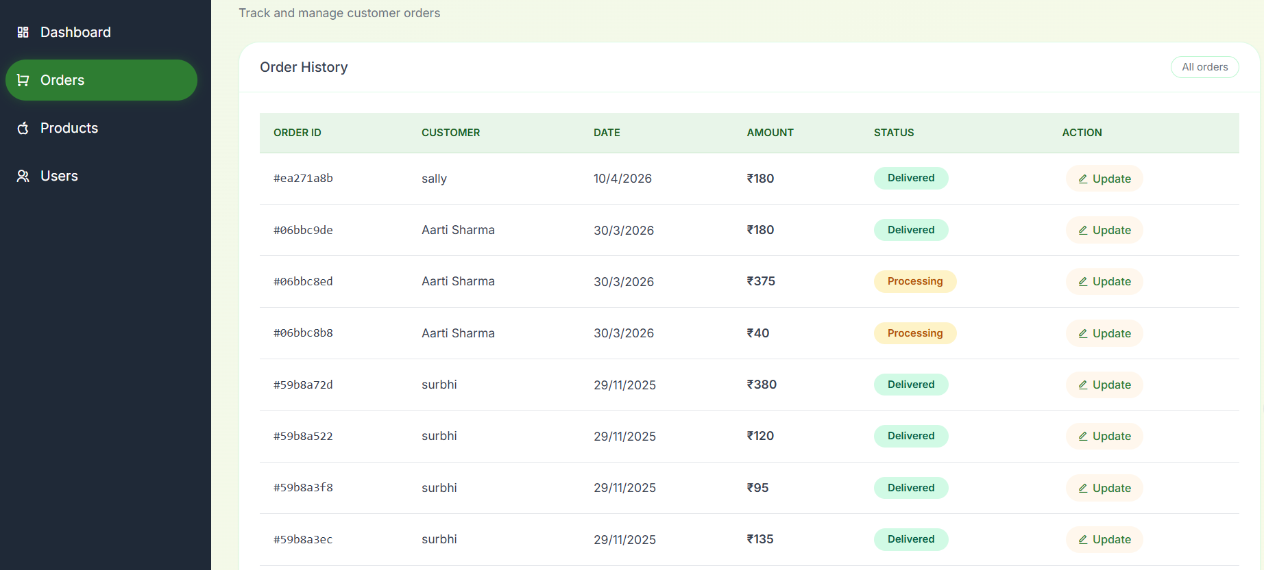
User Management:
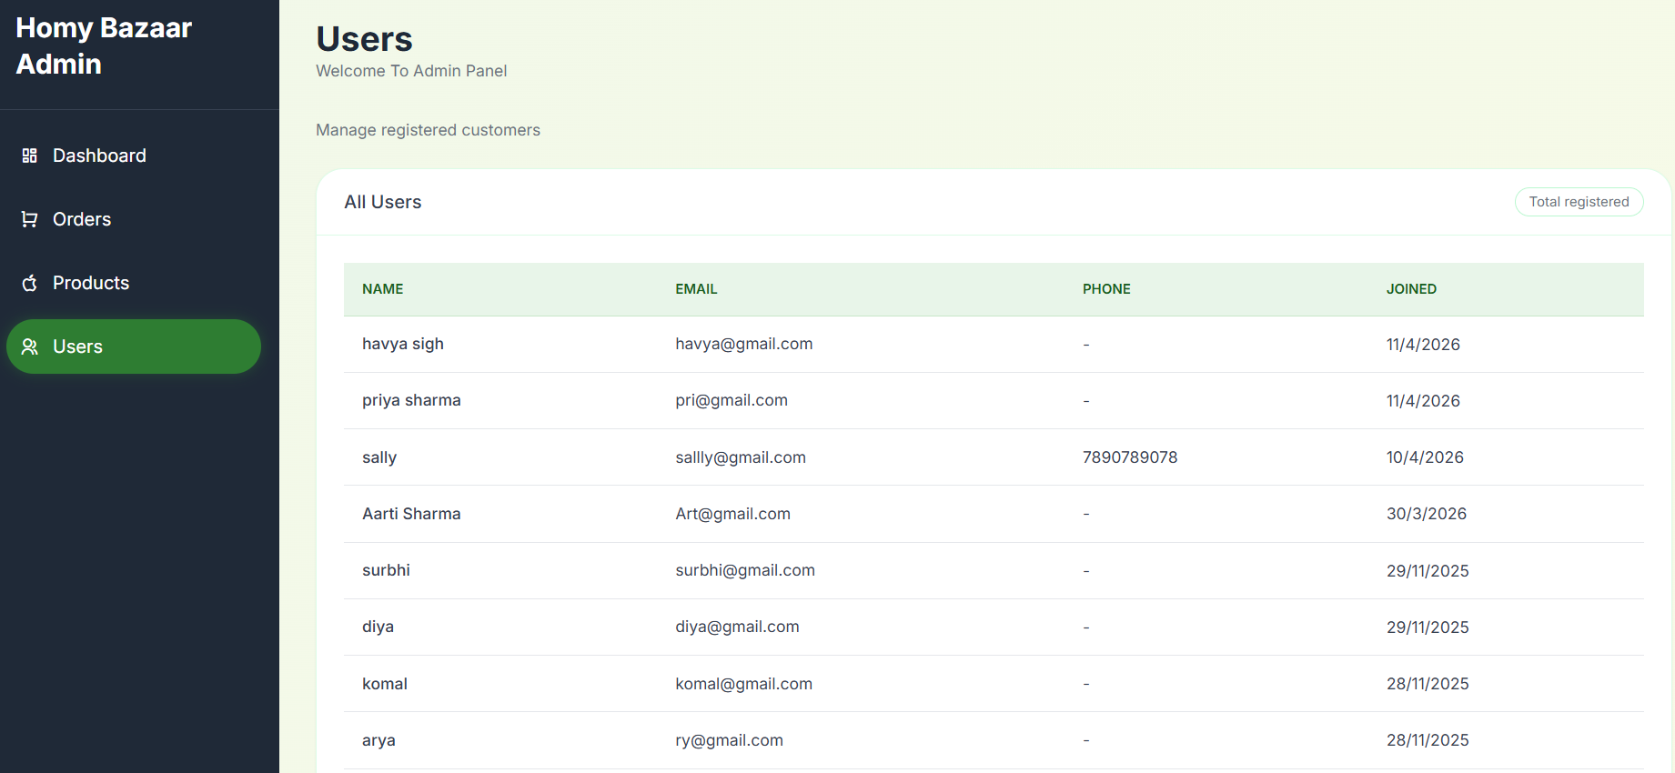

Reference:
https://www.jiomart.com/ - online grocery shopping store
https://chatgpt.com/- AI for coding and designing
https://www.mongodb.com/- database connections
https://www.drawio.com/- for DFD & ER Diagrams
https://gemini.google.com/- AI for coding and designing

