A
Project Report
On
“ServeKind”
Submitted in
Partial Fulfillment of the requirement
For the Award of the degree of
Bachelor of Computer Applications
Affiliated to
Veer Narmad South Gujarat University, Surat
A.Y. 2025-26

Submitted By: Under the Guidance of:
Riddhi Pawar (7341) Prof. Milind Pawar
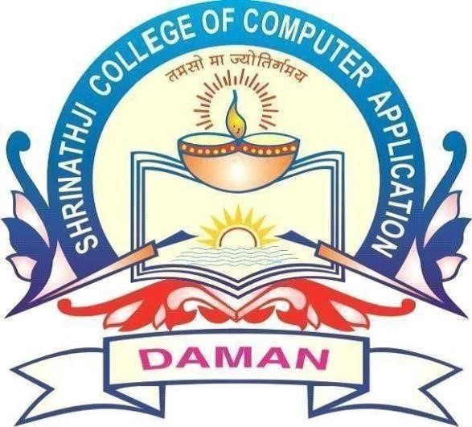
Krushi Patel (7340)

Shree Amar Jyot Education society’s
Shrinathji College of Computer Applications [BCA]
Varkund - Daman

