Acknowledge
We, the students of Shrinathji College of Computer Application, studying in the final year of BCA, are pleased and satisfied to present this project report on
“ServeKind”
We are thankful to all who have helped us in the successful completion of this project and for providing valuable guidance throughout our work.
We are deeply grateful to the many people who have guided, inspired, and motivated us. We take this opportunity to thank all of them. This endeavour has given us insight into various aspects of software implementation in practical applications.
It has provided us with hands-on experience that we could not have gained from books alone. We are especially grateful to our guide, Prof. Milind Pawar, who supported us throughout the learning process and enriched our knowledge during the project work.
We are also very thankful to Dr. Shivangi Patel and all the staff members of the Computer Department, who were a constant source of motivation, knowledge, and moral support.
We would like to extend our sincere thanks to our friends, family members, and everyone who directly or indirectly helped us during this project. Without their support and encouragement, this project would not have become a reality.
Finally, we express our heartfelt gratitude to the Almighty for everything.
Thanking you.
Riddhi Pawar
Krushi Patel

INDEX
Sr No. | Table of contents
1. | Introduction
2. | Scope of Project
3. | Project Profile
4. | Software Used

INTRODUCTION
“ServeKind” is a compassionate and technology-driven food donation platform dedicated to connecting those who have with those in need. Designed to make the act of giving simple, transparent, and impactful, ServeKind enables individuals, organizations, and communities to contribute food easily through an organized and secure system. Whether it’s surplus food from events, restaurants, or homes, ServeKind ensures that every contribution reaches the right hands at the right time. With a clean interface, smart donation tracking, and seamless communication between donors and volunteers, the platform empowers people to fight hunger one meal at a time.
Main Advantages of ServeKind
- User-Friendly Interface: Clean and intuitive design allowing donors, recipients, and volunteers to navigate and participate effortlessly.
- Secure Access: Authentication-based login ensures verified donations and safe participation for all users.
- Multiple Donation Options: Support through monetary donations, food contributions, or volunteer services, making it easy for anyone to help in their own way.
- Real-Time Updates: Track donations, view status updates, and receive notifications about ongoing drives or new campaigns.
- Interactive & Inspiring Design: Engaging visuals and dynamic layout that reflect kindness, community, and hope.
- Volunteer Engagement: Dedicated volunteer registration and task allocation system to ensure organized food distribution.
- Responsive & Accessible Platform: Works smoothly across devices, enabling people to donate or volunteer anytime, anywhere.

Scope of project
The ServeKind Project aims to create a digital platform that bridges the gap between donors, NGOs, and individuals in need. It provides an efficient and transparent way to manage food donations and reduce wastage. Through ServeKind, users can donate surplus food, register as volunteers, or contribute funds to support hunger-relief efforts.
The system simplifies coordination between donors and recipients while ensuring safety, authenticity, and accountability. It also helps NGOs manage donations, track inventory, and communicate with volunteers. The overall goal is to build a sustainable ecosystem where technology enhances compassion — making giving back simple, quick, and meaningful.
Future Enhancements
Future versions of ServeKind may introduce advanced features such as:
AI-Powered Matching System: Automatically connecting nearby donors with NGOs or recipients in real time.Translation & Multilingual Support: Making the platform accessible to users across different languages and regions.Geo-Location Tracking: Mapping donations and volunteer activities for faster delivery and better coordination.Automated Food Quality Verification: Using image recognition or data input to ensure safe food distribution.Reward & Recognition System: Appreciating top donors and volunteers with digital certificates or points.Community Stories & Impact Section: Showcasing real-life stories of change to inspire more participation.Integration with Government & Local NGOs: Strengthening partnerships to maximize food reach and minimize wastage..

PROJECT PROFILE
Project Title | ServeKind
Developer | Riddhi Pawar  Krushi Patel
Development Tool | JavaScript, HTML and CSS
Database | PHP
Purpose | The purpose of this project is to serve those in need
Language | JavaScript, PHP, HTML, CSS
Documentation Tool | MS Office 2021
Internal Guide | Prof. Milind Pawar

Project Environment
Software Used:
Language | HTML, JavaScript, CSS, PHP
Operating System | Windows 11
Server | Xampp
Web Browser | Chrome, Microsoft Edge
Designing Tool | Visual Studio Code
Server-Side Scripting | PHP and MySql

Technology Used:

Front end and back end are generalized terms that refer to the initial and the end stages to handles a system. The front end is responsible for collecting input in various forms the user and processing it to confirm to a specification the back end can use. The front end is an interface between the users and the back end.
The main reason of forming a combination of these two ends is, to provide different functionality of both getting and providing data or information to the user with the help of this medium.
The main reason of talking front end is subjecting all processing part to be performed by this front end that interact with user enabling to use different facilities of the system. And thus, taking back end is to keep all the data at the base back for retrieval, processing and resulting.

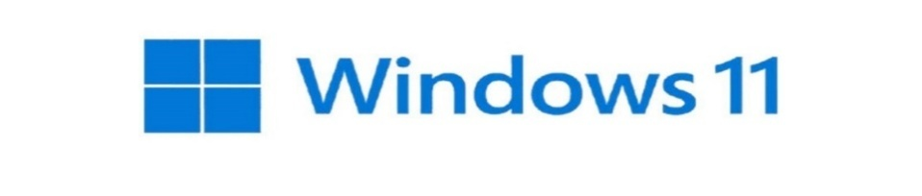

What’s New In Window 11 fir Computers?
For developers, Windows 11 offers new tools and resources
We tried to make Windows a more open platform with Windows 11.
We gave the development process some care, as well as the equipment and skills required to produce truly remarkable apps. With developers in mind, we created Windows 11. The tools, frameworks, and languages that you are familiar with and enjoy using can be used to develop apps. Additionally, we accept all of your apps and will do our best to make them feel at home on Windows.
Enabling the hybrid workforces and classrooms of tomorrow
Windows 11 is the operating system for hybrid work and learning.
Through the rapid acceleration of digital transformation that we've seen over the last 19 months, it is critical for today's organization to be resilient and flexible.


What Is PHP?
PHP is an open-source, interpreted, and object-oriented scripting language that can be executed at the server-side. PHP is well suited for web development. Therefore, it is used to develop web applications.
> PHP stands for Hypertext Preprocessor.
> PHP is an interpreted language, i.e., there is no need for compilation.
> PHP is faster than other scripting languages, for example, ASP.
> PHP is a server-side scripting language, which is used to manage the dynamic content of the website.
> PHP can be embedded into HTML.
Easy to Learn & Use: PHP has a simple syntax, making it beginner-friendly for web developers.
Open Source & Free: PHP is open-source, meaning it is free to use and has strong community support.
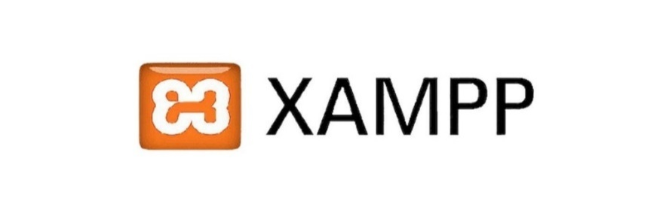
What is XAMPP?
XAMPP is an abbreviation where X stands for Cross-Platform, A stands for Apache, M stands for MYSQL, and the Ps stand for PHP and Perl, respectively. It is an open-source package of web solutions that includes Apache distribution for many servers and command-line executables along with modules such as Apache server, Maria DB, PHP, and Perl.
XAMPP helps a local host or server to test its website and clients via computers and laptops before releasing it to the main server. It is a platform that furnishes a suitable environment to test and verify the working of projects based on Apache, Perl, MySQL database, and PHP through the system of the host itself. Among these technologies, Perl is a programming language used for web development, PHP is a backend scripting language, and Maria DB is the most vividly used database developed by MySQL.


What is PhpMyAdmin?
PhpMyAdmin is a free software tool written in PHP, intended to handle the administration of MySQL over the Web. PhpMyAdmin supports a wide range of operations on MySQL and Maria DB. Frequently used operations (managing databases, tables, columns, relations, indexes, users, permissions, etc.) can be performed via the user interface, while you still have the ability to directly execute any SQL statement.
PhpMyAdmin comes with a wide range of documentation and users are welcome to update our wiki pages to share ideas and how-to for various operations. The PhpMyAdmin team will try to help you if you face any problem; you can use a variety of support channels to get help.
PhpMyAdmin is also very deeply documented in a book written by one of the developers - Mastering PhpMyAdmin for Effective MySQL Management, which is available in English and Spanish.

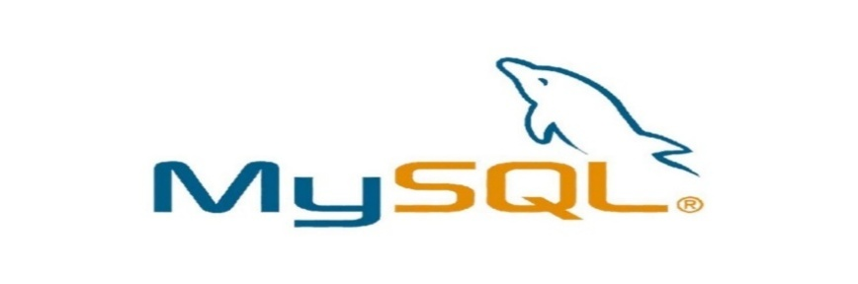
What is MySQL?
> MySQL is a database system used on the web
> MySQL is a database system that runs on a server
> MySQL is ideal for both small and large applications
> MySQL is very fast, reliable, and easy to use
> MySQL compiles on a number of platforms
> MySQL is free to download and use
PHP + MySQL
PHP combined with MySQL are cross-platform (you can develop in
Windows and serve on a Unix platform)
PHP is easy to learn and runs efficiently on server side.
ADVANTAGE:
Easy To Use: MySQL is easy to use. We have to get only the basic knowledge of SQL. We can build and interact with MySQL by using only a few simple SQL statements.
It Is Secure: MySQL consists of a solid data security layer that protects sensitive data from intruders. Also, passwords are encrypted in MySQL.

What is Visual Studio Code?
Visual Studio Code (famously known as VS Code) is a free open-source text editor by Microsoft. VS Code is available for Windows, Linux, and macOS. Although the editor is relatively lightweight, it includes some powerful features that have made VS Code one of the most popular development environment tools in recent times.
Visual Studio Code was first announced on April 29, 2015, by Microsoft at the 2015 Build conference. A preview build was released shortly thereafter.
FEATURES
VS Code supports a wide array of programming languages from Java, C++, and Python to CSS, Go, and Docker file. Moreover, VS Code allows you to add on and even creating new extensions including code linters, debuggers, and cloud and web development support.
The VS Code user interface allows for a lot of interaction compared to other text editors.
> The activity bar
> The side bar
> Editor groups
> The panel

Data Flow Diagram
Following is the Data Flow Diagram, which represent overall flow of the in the system from department. This will help in understanding the flow of the system to other users.
Process
External Entity
Data Store
Data Flow

Zero Level DFD
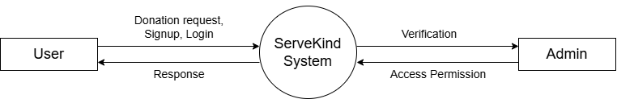

1st Level User Side DFD
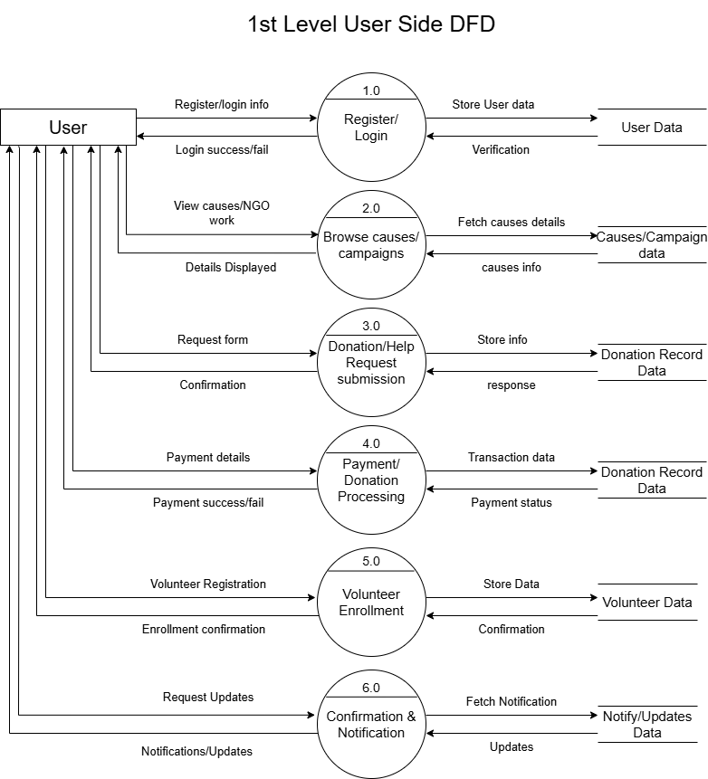
1st Level Admin Side DFD
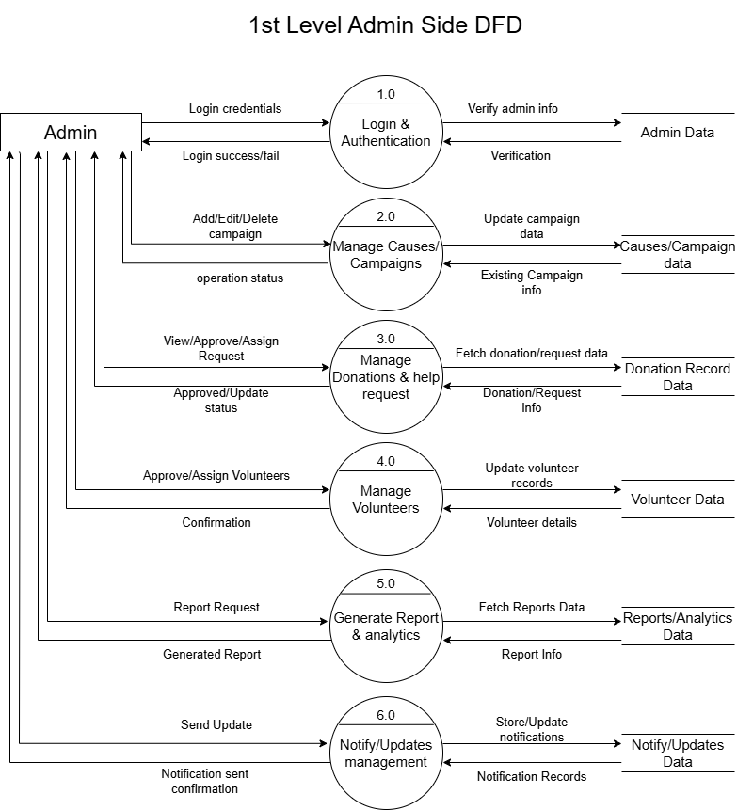

Entity Relationship Diagram
(ER-Diagram)
ER Diagram is known as Entity-Relationship Diagram, it is used to analyze to the structure of the Database. It shows relationship between entities and their attributes. An ER model provides a means of communication.
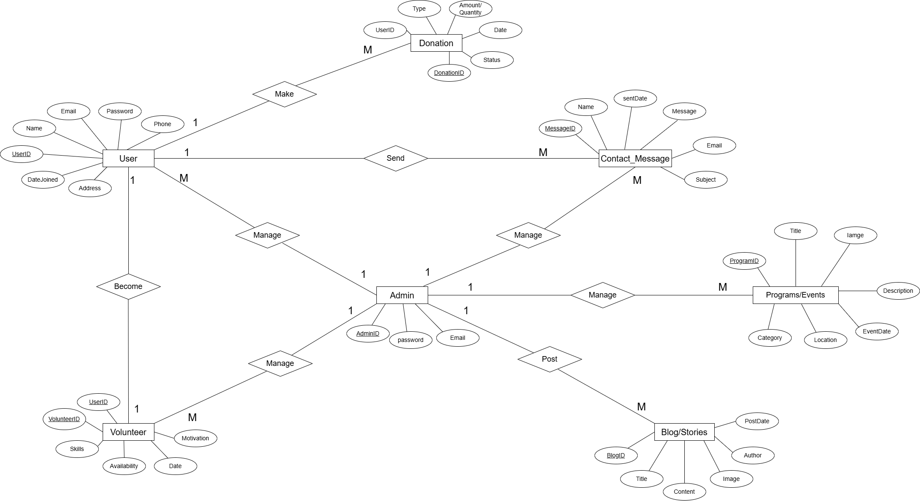

Data Dictionary
Data dictionary is a store of information about the data in database. The dictionary defines the name, description, source of data, users of data, and keywords in data, formula to derive the data, specification and such other details. Data dictionary brings common understanding of the data in the organization. RDBMS provides software to created he use of data dictionary enforces the standards of processing, usage's application and documentation in the organization.
Data Dictionary are an integral component of structured analysis, since data flow diagram by them do not fully describe the information about the system. The data dictionary provides additional information about the system.
A Data Dictionary is a catalogue-a repository of the elements in a system. These elements center on data the way they are structured to meet user requirements and organization needs. In a Data Dictionary, a list of all the elements composing the data flowing through a system is included.
If a project team member wants to know the definition of a data item name or the contents of a particular data flow, the information will be available in the data dictionary.
Descriptions of all data used in the system are given in a Data Dictionary.

User Table:
Column Name | Data Type | Constraint | Description
user_id | INT | PRIMARY KEY,  AUTO_INCREMENT | Unique identifier for the user.
full_name | VARCHAR(100) | NOT NULL | User's full name (from signup).
email | VARCHAR(150) | UNIQUE, NOT NULL | User's email address for login.
password | VARCHAR(255) | NOT NULL | Hashed password.
created_at | TIMESTAMP | DEFAULT CURRENT_TIMESTAMP | Account creation timestamp.

Monatary_donation Table:
Column Name | Data Type | Constraint | Description
donation_id | INT | PRIMARY KEY, AUTO_INCREMENT | Unique identifier for the donation.
user_id | INT | FOREIGN KEY (Nullable) | Links to users table. Null if guest.
first_name | VARCHAR(50) | NULLABLE | Guest donor's first name.
last_name | VARCHAR(50) | NULLABLE | Guest donor's last name.
email | VARCHAR(150) | NOT NULL | Donor's email address.
phone | VARCHAR(15) | NOT NULL | Donor's phone number.
amount | DECIMAL(10,2) | NOT NULL | Donation amount (e.g., 500.00).
payment_method | VARCHAR(20) | NOT NULL | Method used (e.g., 'card', 'upi').
transaction_id | VARCHAR(50) | NOT NULL | Unique payment gateway transaction ID.
tax_receipt | TINYINT(1) | DEFAULT 0 | 1 if 80G receipt requested, else 0.
created_at | TIMESTAMP | DEFAULT CURRENT_TIMESTAMP | Date and time of donation.

Food donation Table:
Column Name | Data Type | Constraint | Description
food_id | INT | PRIMARY KEY, AUTO_INCREMENT | Unique identifier for food request.
user_id | INT | FOREIGN KEY (Nullable) | Links to users table.
donation_type | VARCHAR(50) | NOT NULL | Type (Cooked Food, Raw Materials, etc.).
donation_details | TEXT | NOT NULL | Quantity and description of items.
address_line1 | VARCHAR(255) | NOT NULL | Pickup address line 1.
address_line2 | VARCHAR(255) | NULLABLE | Pickup address line 2.
city | VARCHAR(50) | NOT NULL | City for pickup.
pincode | VARCHAR(10) | NOT NULL | Area pincode.
pickup_date | DATE | NOT NULL | Preferred date for pickup.
pickup_time | TIME | NOT NULL | Preferred time for pickup.
contact_name | VARCHAR(100) | NOT NULL | Name of person at pickup location.
contact_phone | VARCHAR(15) | NOT NULL | Phone number for coordination.
food_safety | TINYINT(1) | NOT NULL | Confirmation of safety standards (1=Yes).
status | VARCHAR(20) | DEFAULT 'Pending' | Status (Pending, Picked Up, Completed).
created_at | TIMESTAMP | DEFAULT CURRENT_TIMESTAMP | Time request was submitted.

Contact_us Table:
Column Name | Data Type | Constraint | Description
message_id | INT | PRIMARY KEY, AUTO_INCREMENT | Unique ID for the message.
first_name | VARCHAR(50) | NOT NULL | Sender's first name.
last_name | VARCHAR(50) | NULLABLE | Sender's last name.
email | VARCHAR(150) | NOT NULL | Sender's email.
phone | VARCHAR(15) | NULLABLE | Sender's phone number.
subject | VARCHAR(100) | NOT NULL | Inquiry subject (Donation, Volunteer, etc.).
message | TEXT | NOT NULL | The message content.
created_at | TIMESTAMP | DEFAULT CURRENT_TIMESTAMP | Time message was sent.

Volunteer Table:
Column Name | Data Type | Constraint | Description
volunteer_id | INT | PRIMARY KEY, AUTO_INCREMENT | Unique ID for application.
user_id | INT | FOREIGN KEY (Nullable) | Links to users table.
first_name | VARCHAR(50) | NOT NULL | Volunteer's first name.
last_name | VARCHAR(50) | NOT NULL | Volunteer's last name.
email | VARCHAR(150) | NOT NULL | Contact email.
phone | VARCHAR(15) | NOT NULL | Contact phone.
location | VARCHAR(50) | NOT NULL | Selected city (Delhi, Mumbai, etc.).
areas_of_interest | TEXT | NOT NULL | Comma-separated list (e.g., 'Delivery, Admin').
availability | TEXT | NOT NULL | Comma-separated (e.g., 'Weekends').
message | TEXT | NOT NULL | "Why do you want to volunteer?" answer.
agreed_terms | TINYINT(1) | NOT NULL | 1 indicates agreement to terms.
created_at | TIMESTAMP | DEFAULT CURRENT_TIMESTAMP | Application submission time.

Screenshots
Home page
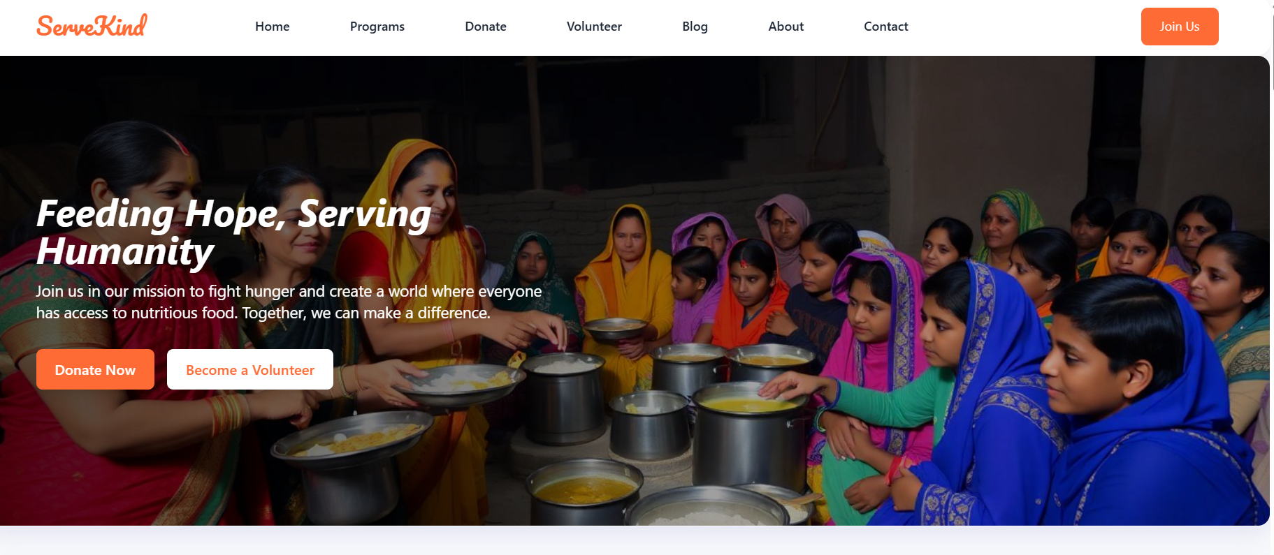
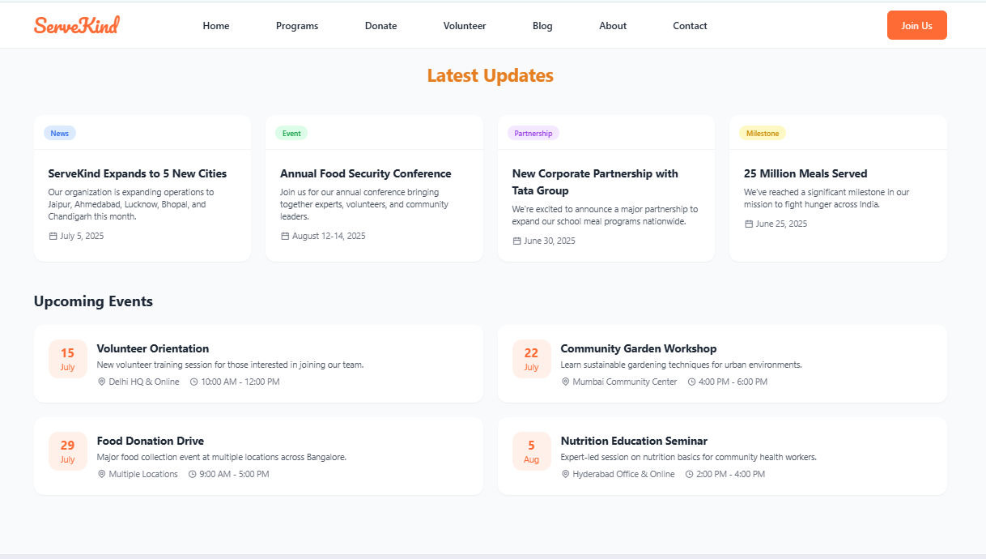

User login & signup
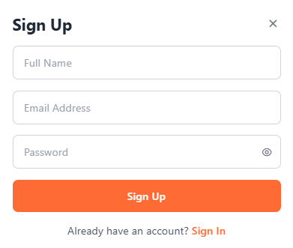
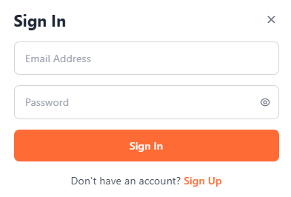
Programs
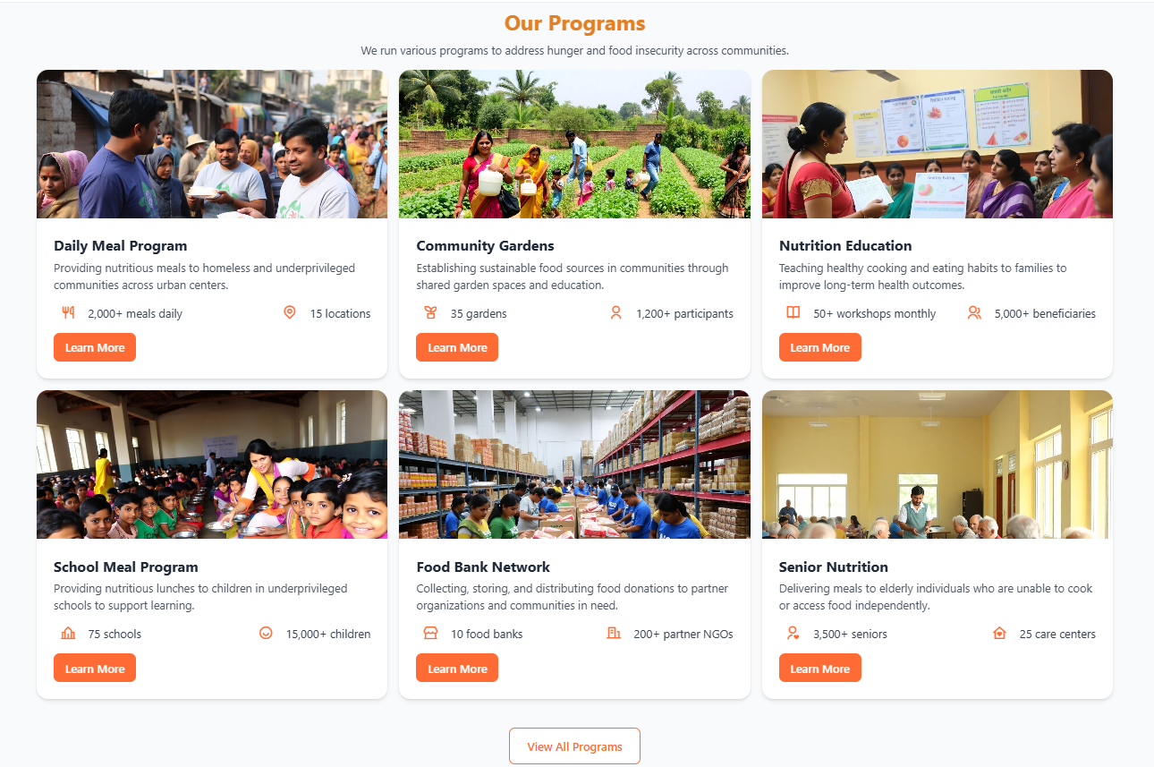

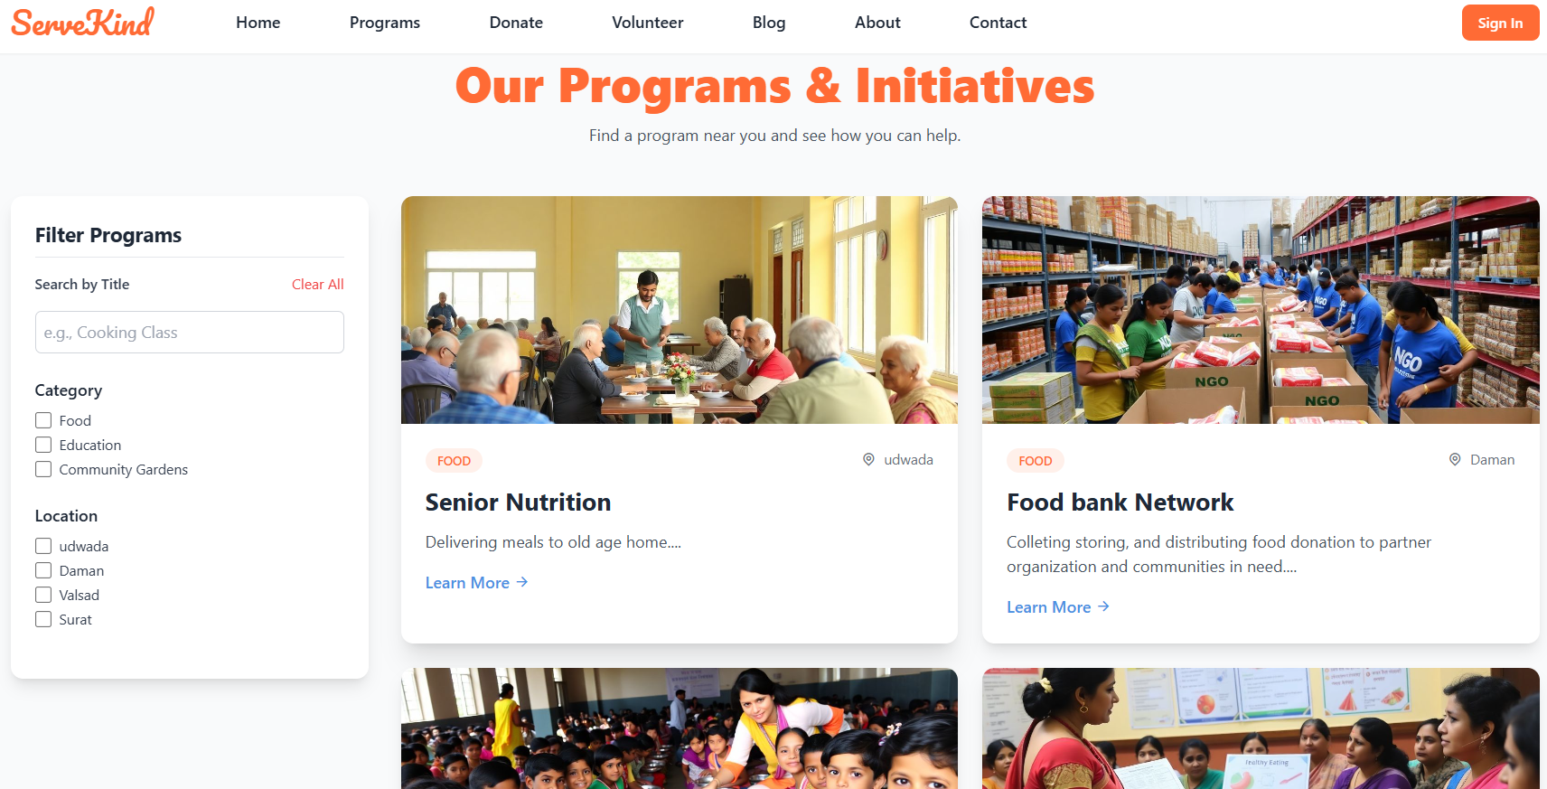
Donations
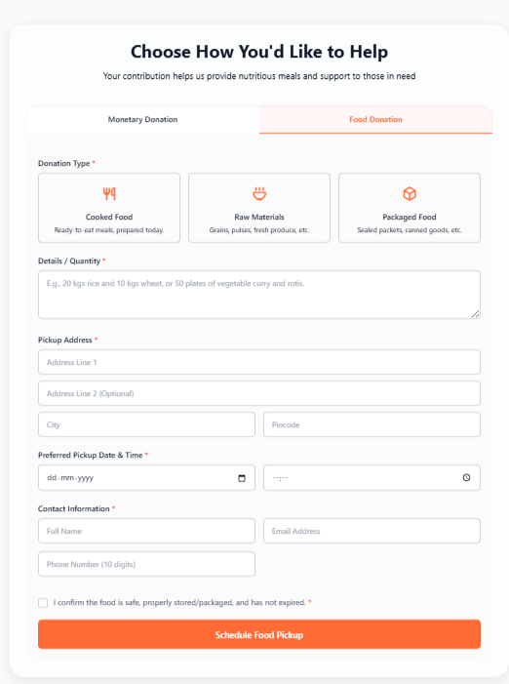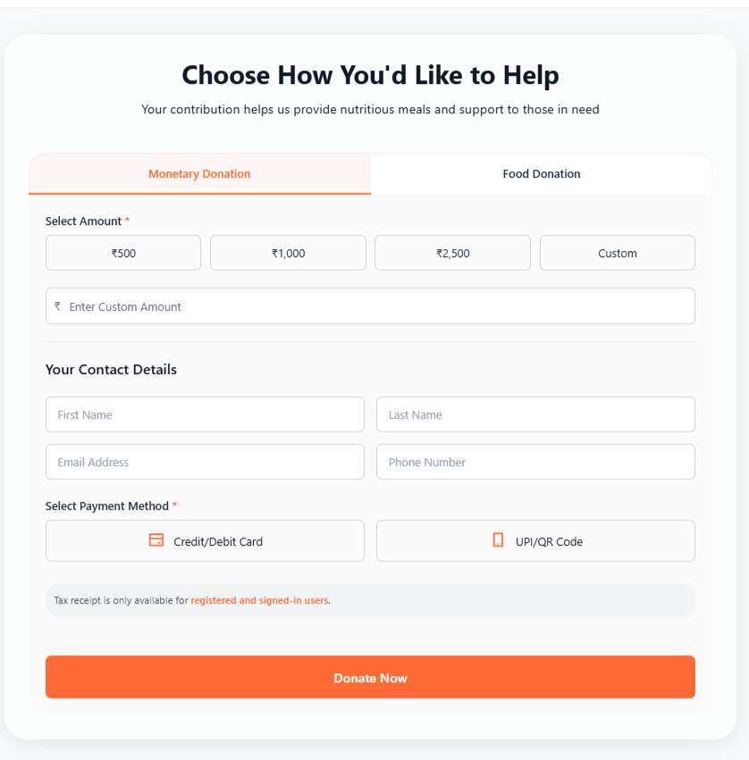

Volunteers & Contact us
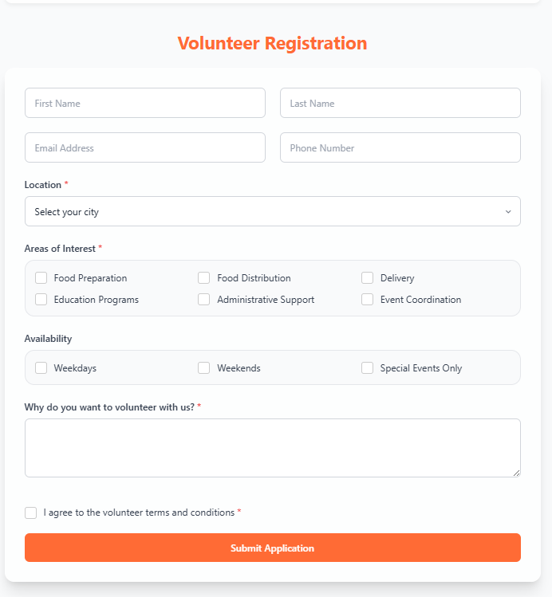
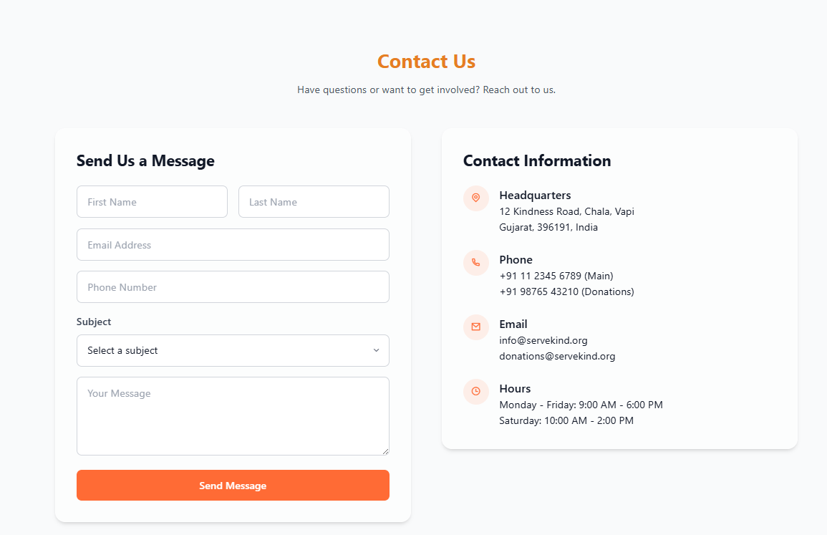

Blogs, Stories & About Us
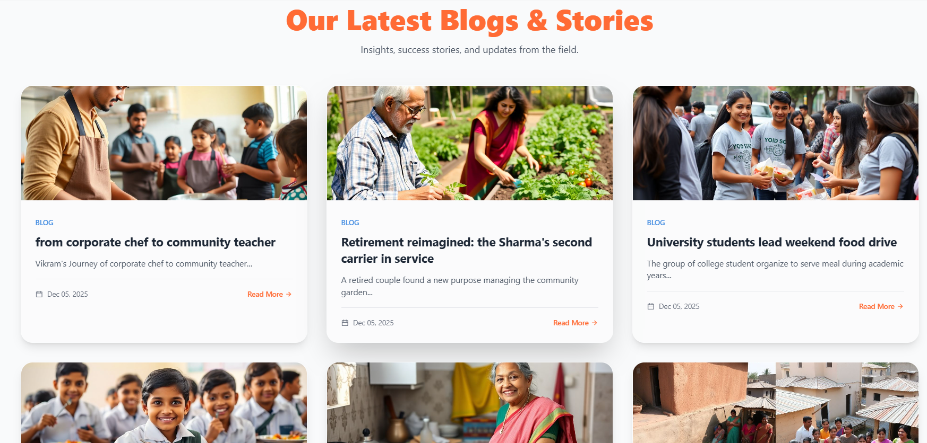
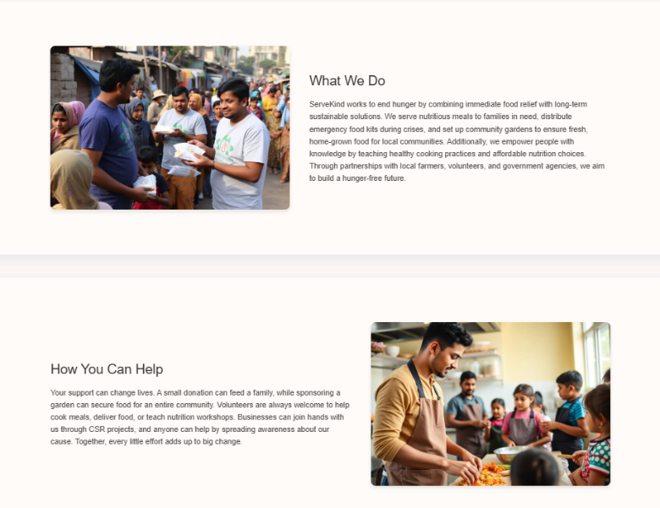
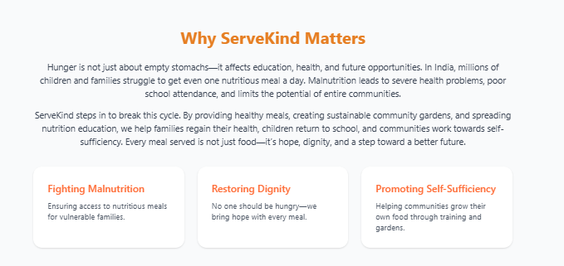
User’s Dashboard
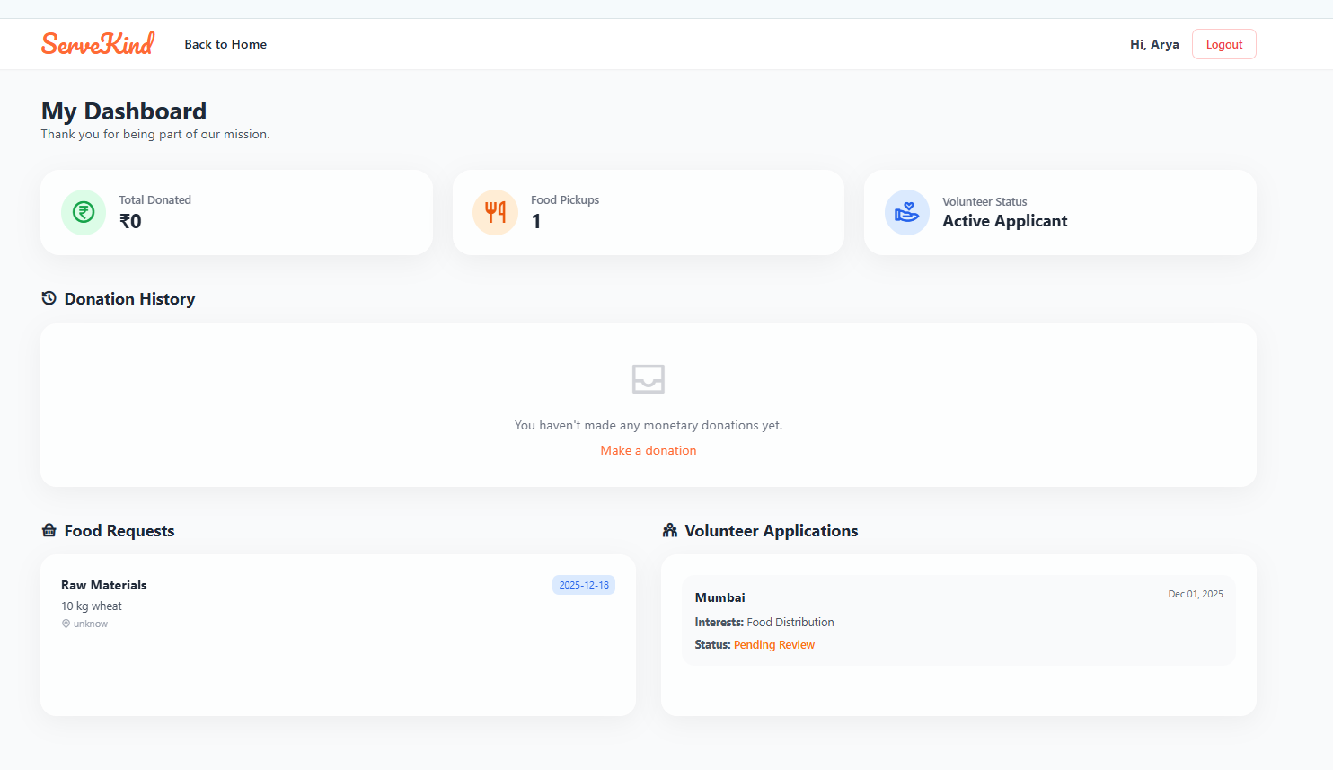
Admin Login/Dashboard
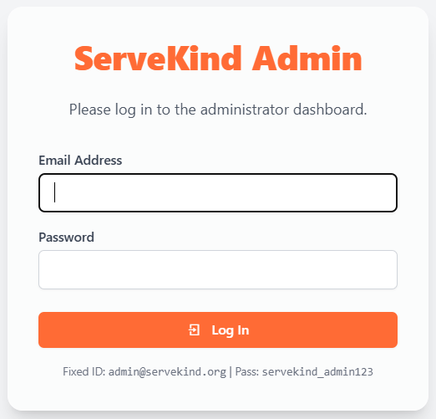

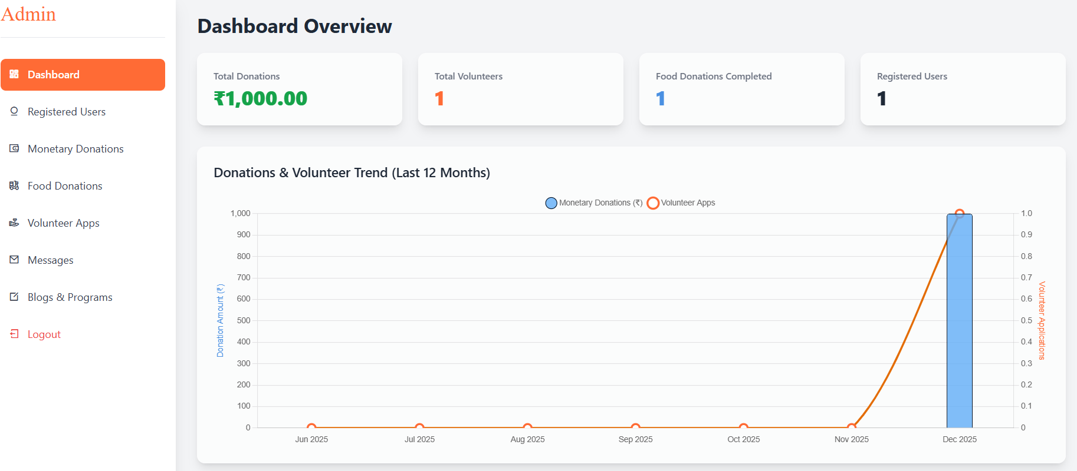

Volunteer Application & ContactMessage
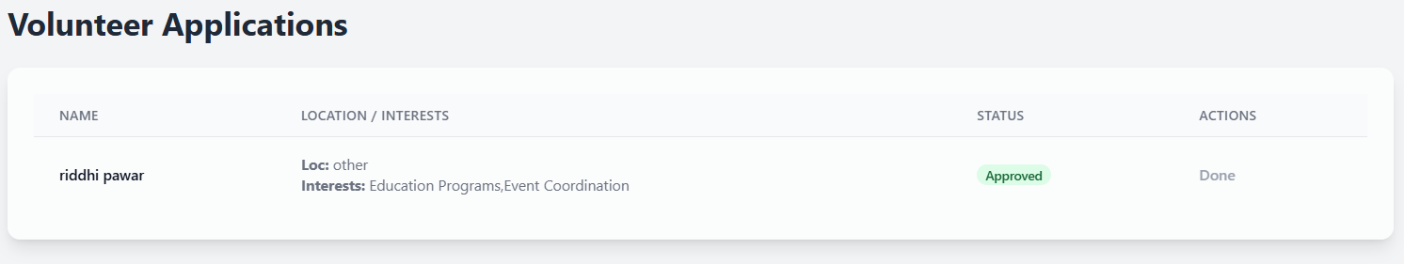
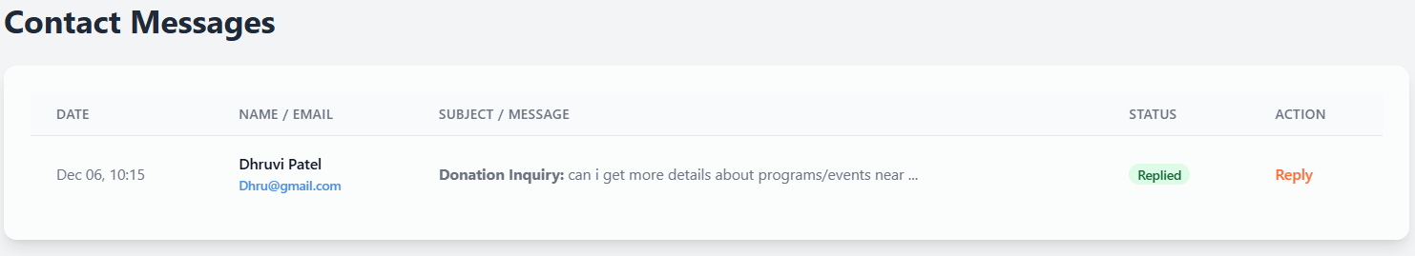

Program And Blog Management
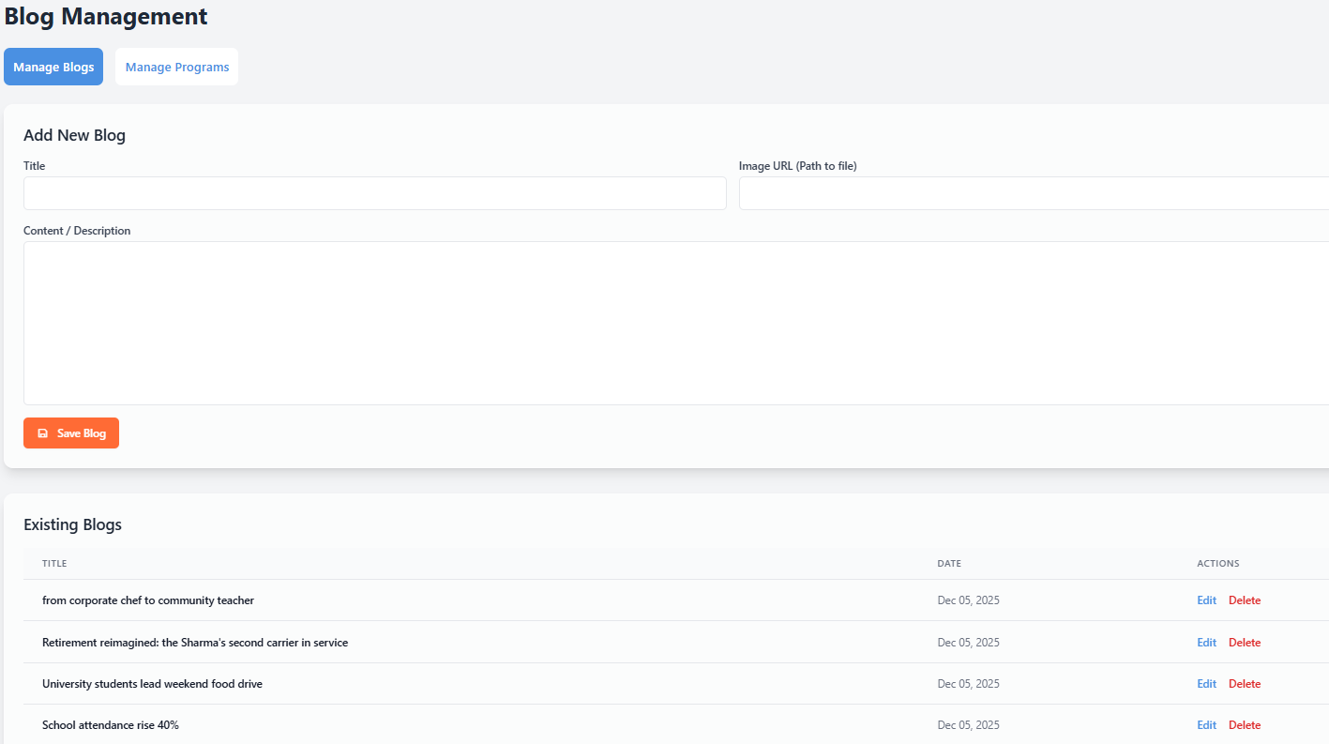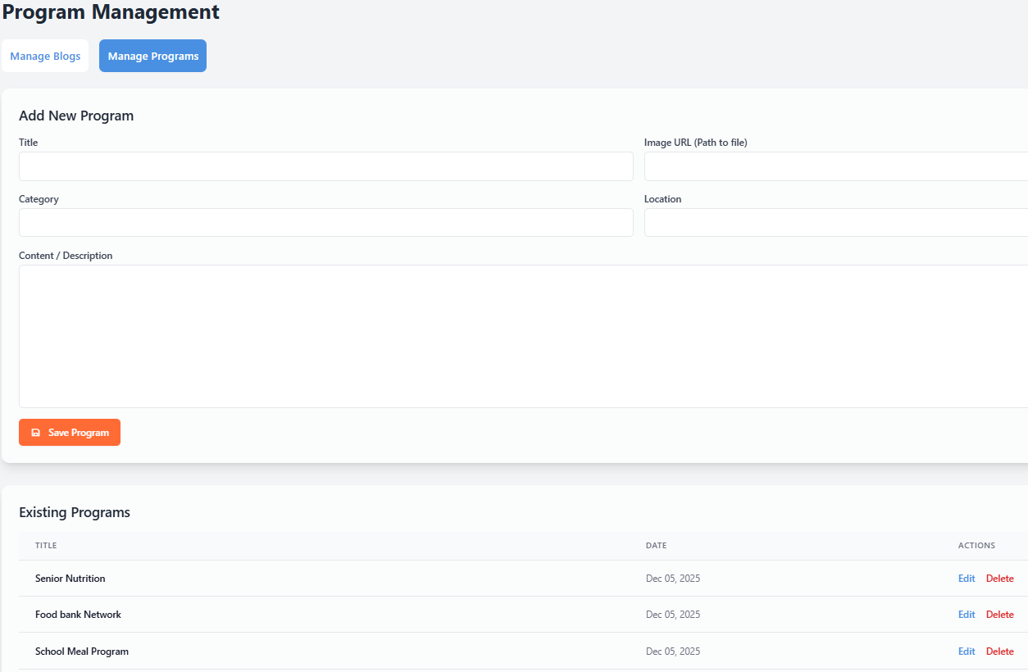

Conclusion

ServerKind successfully establishes a digital platform that simplifies and organizes community support activities such as donations, volunteering, and program management.
By providing an easy-to-use interface for users and a powerful admin panel for the organization, ServerKind ensures transparency, efficiency, and real-time communication.
The system enables the NGO to reach more people, manage resources better, and handle form submissions in a structured manner. Features like volunteer approvals, donation tracking, blog updates, and program management help build trust and engagement within the community.
Overall, ServerKind contributes to a more connected, informed, and socially responsible society by bridging the gap between people willing to help and those who need support.

Reference

https://www.apachefriends.org/ - for php And Mysql database

https://www.mca.gov.in/content/mca/global/ - Ministry of corporate Affairs

https://www.akshayapatra.org/ - NGO for references

https://gemini.google.com/ - For website designing

https://chatgpt.com/ - for coding

https://www.youtube.com/ - For NGO working & functions guidelines

