Output:-

1.Password validation:-

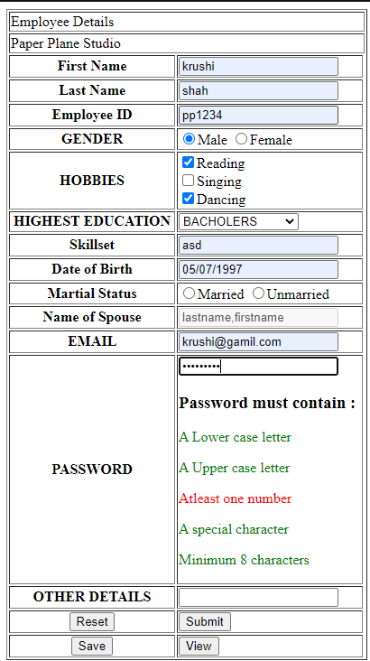

As all criteria matches the criteria disappears.

2. Before dragging the element

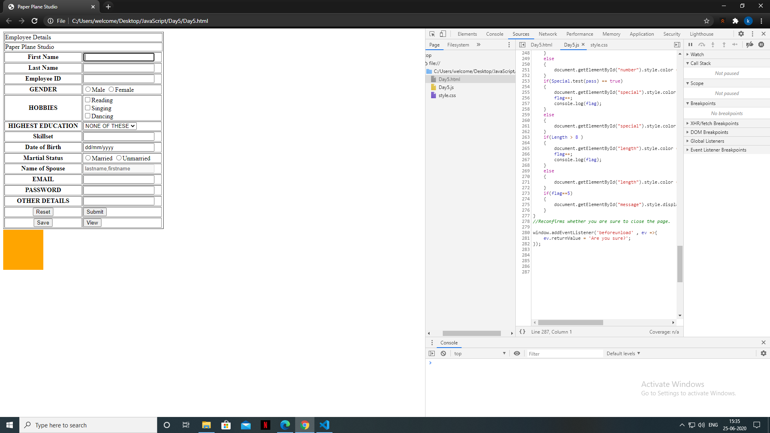

3. After dragging the element

