BVRIT HYDERABAD
COLLEGE OF ENGINEERING FOR WOMEN
PROJECT REPORT
ON
GLOBAL RETAIL SALES ANALYTICS
Submitted by
STUDENT NAME | ROLL NUMBER
Ch. Krushitha | 24WH1A05CB
G. Sreeja | 24WH1A05BX
Thanmai Sahasra | 24WH1A05BN

ABSTRACT
Global Retail Sales Analytics is a business intelligence project that uses Microsoft Power BI to explore and present retail sales information through an interactive dashboard. The project focuses on organizing sales data and presenting key business measures such as revenue, profit, units sold, and sales performance across regions and sales channels, where those measures are available in the source data. Interactive filters, including Region and Sales Channel slicers, allow users to focus on selected parts of the business and observe how the dashboard visuals respond to those selections. The aim is to make large volumes of sales information easier to understand and to support data-driven observations. The dashboard is intended as an analytical and educational tool; conclusions should be based on the actual figures and visuals in the final Power BI file.
Dataset used: 1000000 Sales Records.csv (reported dataset size: 1,000,000 records). The final report includes spaces for verified KPI values, dashboard screenshots, and faculty details to be completed before submission.

TABLE OF CONTENTS
- Introduction
- Problem Statement
- Objectives
- Scope of the Project
- Dataset Description
- Tools and Technologies
- Methodology
- Dashboard Design and Features
- Key Performance Indicators
- Dashboard Screenshots
- Observations and Business Insights
- Results and Discussion
- Limitations
- Conclusion and Future Scope
- References

1. INTRODUCTION
Retail businesses generate substantial amounts of data through sales transactions, regional operations, and different sales channels. Reviewing raw records manually can be time-consuming and may make it difficult to identify patterns. Data analytics and business intelligence tools help convert this information into visual summaries that are easier to interpret.
This project, Global Retail Sales Analytics, uses Microsoft Power BI to present sales-related information in an interactive dashboard. The dashboard is designed to help users examine overall performance and compare results by region and sales channel. Users can interact with slicers and charts to explore the information from different perspectives.

2. PROBLEM STATEMENT
A large retail sales dataset can be difficult to interpret when it is viewed only as rows and columns. Decision-makers may need to compare revenue, profit, units sold, and performance across regions or sales channels. The project addresses this problem by presenting relevant sales information through a consolidated, interactive Power BI dashboard.

3. OBJECTIVES
- To load and explore the provided retail sales dataset.
- To organize the available sales information for analysis and visualization.
- To present important sales and profitability measures using KPI cards, where supported by the data.
- To compare sales performance across regions and sales channels.
- To provide interactive filtering through Region and Sales Channel slicers.
- To communicate findings through clear charts and a dashboard overview.

4. SCOPE OF THE PROJECT
The project is limited to the information available in the supplied sales dataset and the visuals implemented in the final Power BI file. It covers descriptive analysis of retail sales data. It does not claim to forecast future sales or establish causal relationships unless such features are separately implemented and documented.
- Analysis dimensions: Region and Sales Channel.
- Measures considered: Revenue, Profit, Units Sold, and record/order counts where present.
- Output: An interactive Power BI dashboard and this project report.

5. DATASET DESCRIPTION
The project uses a CSV file named “1000000 Sales Records.csv”. The dataset was described during project development as containing 1,000,000 records. The following fields were identified in the available data summary:
Field | Description
Region | Geographical region associated with the sales record or summary.
Sales_Channel | Sales channel classification, such as Online or Offline.
Total_Records | Record count represented in the supplied summary.
Units_Sold | Number of units sold.
Revenue | Sales revenue amount.
Profit | Profit amount.
Note: Confirm the exact field list and data types against the CSV file and Power BI Fields pane before final submission. The field descriptions above reflect the fields identified during project discussion; they should not be treated as a complete data dictionary if the source file contains additional columns.

6. TOOLS AND TECHNOLOGIES
- Microsoft Power BI Desktop – used to load data, create visualizations, configure slicers, and build the dashboard.
- CSV dataset – used as the source of retail sales information.
- Power Query Editor – used for data inspection and any cleaning or transformation steps actually performed.
- DAX – may be used for calculated measures if present in the final PBIX; list only the measures actually created.
Before submission, remove any tool or operation from this section that was not actually used.

7. METHODOLOGY
- Data loading: Import the CSV dataset into Power BI Desktop and verify that the data is loaded correctly.
- Data inspection: Review the available columns, data types, missing values, and duplicate records.
- Data preparation: Apply only the cleaning and transformation steps required by the source data. Record the actual steps performed.
- Measure preparation: Use existing numeric fields or create appropriate measures for the KPI cards. Verify each measure against the underlying data.
- Dashboard development: Create KPI cards, charts, and slicers to summarize and explore the sales information.
- Interaction testing: Select different regions and sales channels to confirm that the relevant visuals respond correctly.
- Validation: Compare displayed values with Power BI totals or source-data summaries and check for blank or erroneous visuals.

8. DASHBOARD DESIGN AND FEATURES
The dashboard is titled “GLOBAL RETAIL SALES ANALYTICS” and uses the subtitle “Global Sales / Revenue Trends / Business Insights”. It is intended to provide a concise overview of the available sales information.
- KPI cards: display high-level numeric measures selected for the dashboard.
- Region slicer: allows the user to filter the dashboard by geographical region.
- Sales Channel slicer: allows comparison or filtering by channel.
- Charts: present comparisons and trends using the fields available in the dataset.
- Interactive filtering: selecting a slicer value updates connected visuals, allowing focused analysis.
Describe the exact chart titles and KPI labels visible in the final PBIX here. Do not include a visual or feature that is not present in the submitted dashboard.

9. KEY PERFORMANCE INDICATORS
KPIs provide a compact summary of business performance. Complete the table below using the exact labels and values displayed in the final dashboard. Do not estimate or manually invent values.
KPI | Meaning | Final dashboard value
Total Revenue | Total sales revenue for the selected data scope. | [Enter verified value]
Total Profit | Total profit for the selected data scope. | [Enter verified value]
Units Sold | Total number of units sold. | [Enter verified value]
Total Records / Orders | Count shown by the dashboard; use the correct label from the PBIX. | [Enter verified value]
Other KPI | Add only if it is present in the dashboard. | [Enter verified value]
If Profit Margin is displayed, document its formula exactly as implemented. A common definition is Profit Margin = (Total Profit / Total Revenue) × 100, provided both measures use compatible definitions and the denominator is non-zero.

10. DASHBOARD SCREENSHOTS
Insert clear screenshots captured directly from the final Power BI Desktop dashboard. Ensure that titles, KPI labels, chart axes, and slicers are readable. If the dashboard has multiple pages, include a screenshot of each important page.
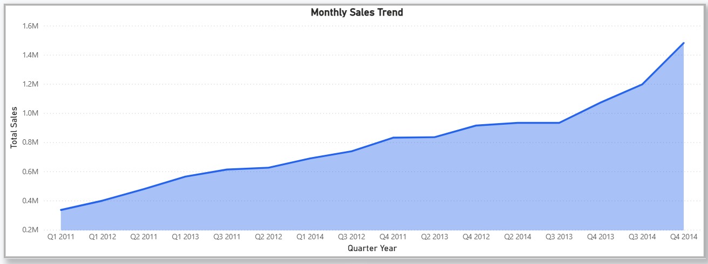

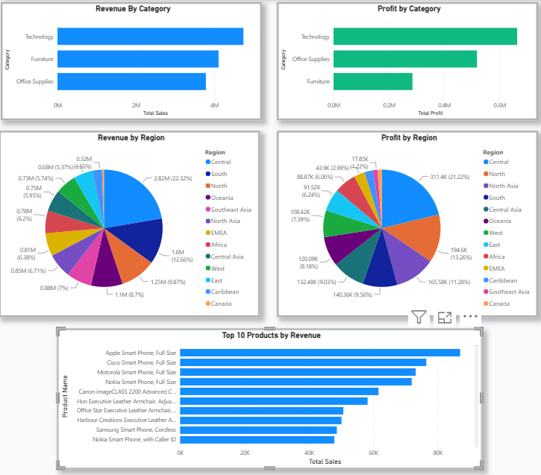
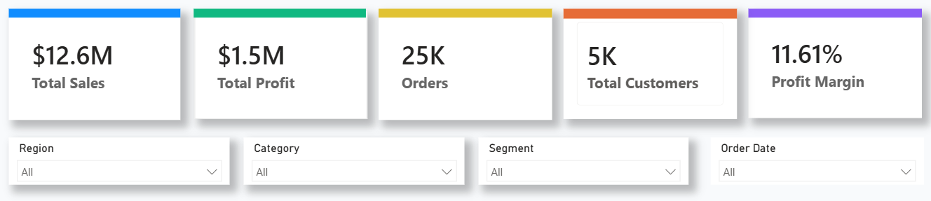
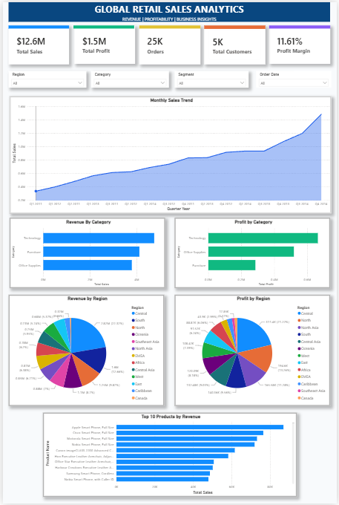

11. OBSERVATIONS AND BUSINESS INSIGHTS
Use this section to explain what the actual dashboard reveals. The statements below are prompts, not pre-filled findings. Complete them only after checking the final dashboard.
- Region comparison: The region with the highest revenue is [enter region], with [enter value].
- Profit comparison: The region with the highest profit is [enter region], with [enter value].
- Channel comparison: [Online / Offline / other] has the higher revenue in the selected scope, based on [enter value].
- Units sold: The highest units-sold result is observed in [enter region or channel], based on [enter value].
- Filter interaction: When [enter slicer selection] is selected, the dashboard visuals [describe the verified change].
Avoid writing that one region or channel performs best unless the comparison is supported by the values and filters shown in the submitted PBIX.

12. RESULTS AND DISCUSSION
The project produces an interactive Power BI dashboard that consolidates selected retail sales measures and allows users to explore them by region and sales channel. The dashboard reduces the effort required to inspect the dataset manually and provides a visual basis for comparing sales performance. The final discussion should refer to the verified KPI values, charts, and observations recorded in Sections 9 and 11.
Dashboard validation performed: [Describe the slicer tests, value checks, and any corrections made before final submission.]

13. LIMITATIONS
- The analysis depends on the accuracy, completeness, and definitions used in the supplied dataset.
- The dashboard presents descriptive summaries and does not automatically explain the causes of performance differences.
- The insights are limited to the fields and time period available in the dataset.
- Any missing, inconsistent, or duplicated data may affect the results if it is not handled appropriately.

14. CONCLUSION AND FUTURE SCOPE
Global Retail Sales Analytics demonstrates how Microsoft Power BI can be used to transform retail sales data into an interactive visual dashboard. By presenting KPI cards, charts, and Region and Sales Channel slicers, the project makes it easier to review sales information and compare performance across selected categories. The completed PBIX file and screenshots serve as the main project output.
Possible future enhancements include:
- Adding time-based analysis if date fields are available in the source dataset.
- Adding product-level analysis if product information is available.
- Creating drill-through pages and richer tooltips for detailed exploration.
- Adding forecasting only after selecting and validating an appropriate time-series method and date field.
- Publishing the dashboard securely through Power BI Service, subject to account and licence availability.

15. REFERENCES
- Microsoft Learn – Power BI documentation: https://learn.microsoft.com/power-bi/
- Dataset: 1000000 Sales Records.csv (record the original download/source URL and access date here).
- Add any other tutorials, articles, or sources actually consulted.
Attribution note: If any part of the dashboard layout, report design, or PBIX file was adapted from the GitHub repository listed above, clearly identify the reused/adapted parts, retain required notices, and follow the repository's licence. Do not present another creator's original dashboard design or work as entirely your own. Describe your own dataset work, changes, validation, and analysis accurately.

