AWS Assignment Set 5 — Question 2
Linux Web Server on Amazon EC2 with Security Group

1. Objective
Deploy a Linux web server on Amazon EC2, secure it with an AWS Security Group, install Apache HTTP Server, host a custom webpage, and verify the deployment.

2. Environment
- EC2 instance: Assignment5-Q2-WebServer
- Instance type: t3.micro
- Operating system: Ubuntu Server
- Availability Zone: ap-south-1b
- Web server: Apache2
- Public IPv4 used for testing: 13.233.41.97

3. Security Group
Protocol | Port | Source | Purpose
TCP | 22 | 0.0.0.0/0 | SSH remote administration
TCP | 80 | 0.0.0.0/0 | HTTP web traffic
TCP | 443 | 0.0.0.0/0 | HTTPS web traffic
Security note: the captured configuration allows SSH from 0.0.0.0/0. For stronger security, SSH should be restricted to the administrator's trusted IP address or another controlled access mechanism.

4. Apache Deployment
Commands used:
sudo apt update
sudo apt upgrade -y
sudo apt install apache2 -y
sudo systemctl status apache2
Verification results:
- sudo systemctl is-active apache2 → active
- sudo systemctl is-enabled apache2 → enabled
- curl -I http://localhost → HTTP/1.1 200 OK
- sudo ss -tulnp | grep ':80' → Apache listening on TCP port 80

5. Custom Web Page
The custom webpage was deployed as /var/www/html/index.html and was successfully accessed through the EC2 public IPv4 address.
Displayed content:
Linux Web Server Successfully Deployed
AWS EC2 + Apache
Assignment Set 5 - Question 2

6. Architecture
Internet → Security Group (22/80/443) → EC2 Ubuntu → Apache2 → /var/www/html/index.html → Custom Web Page

7. Evidence

OP-1.PNG
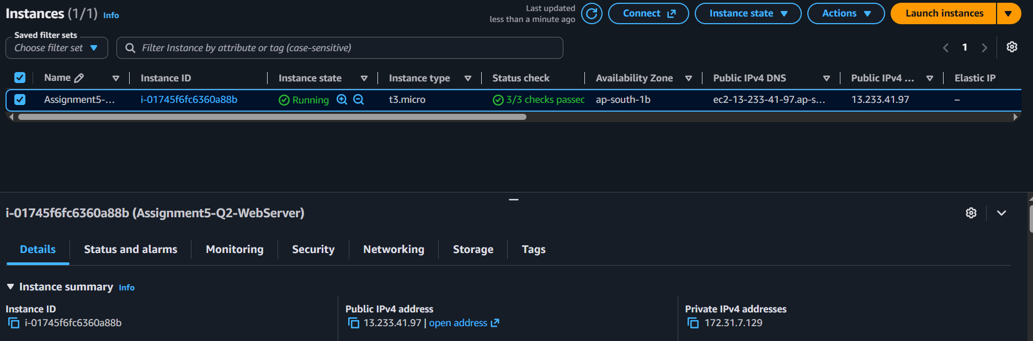

OP-2.PNG
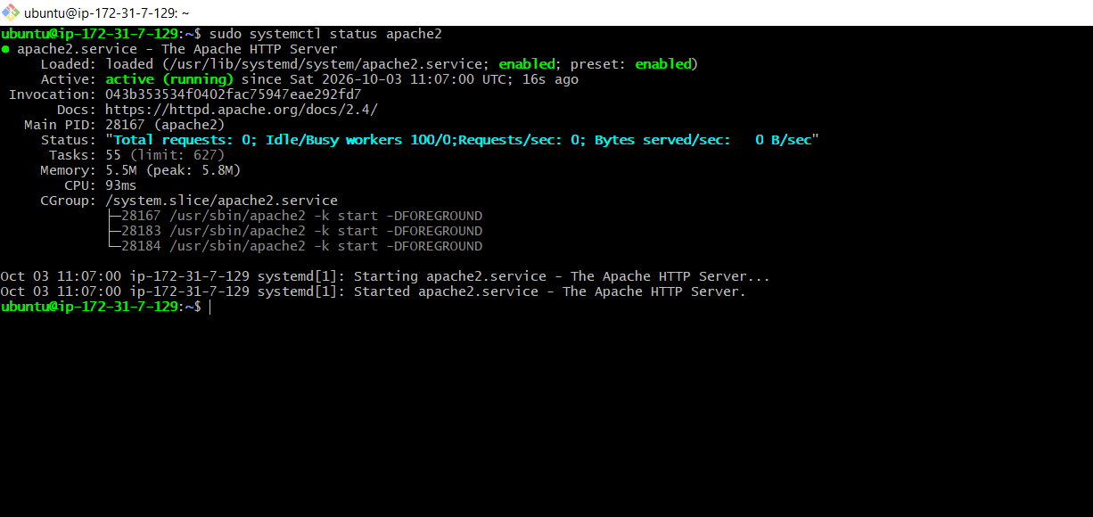

OP-3.PNG
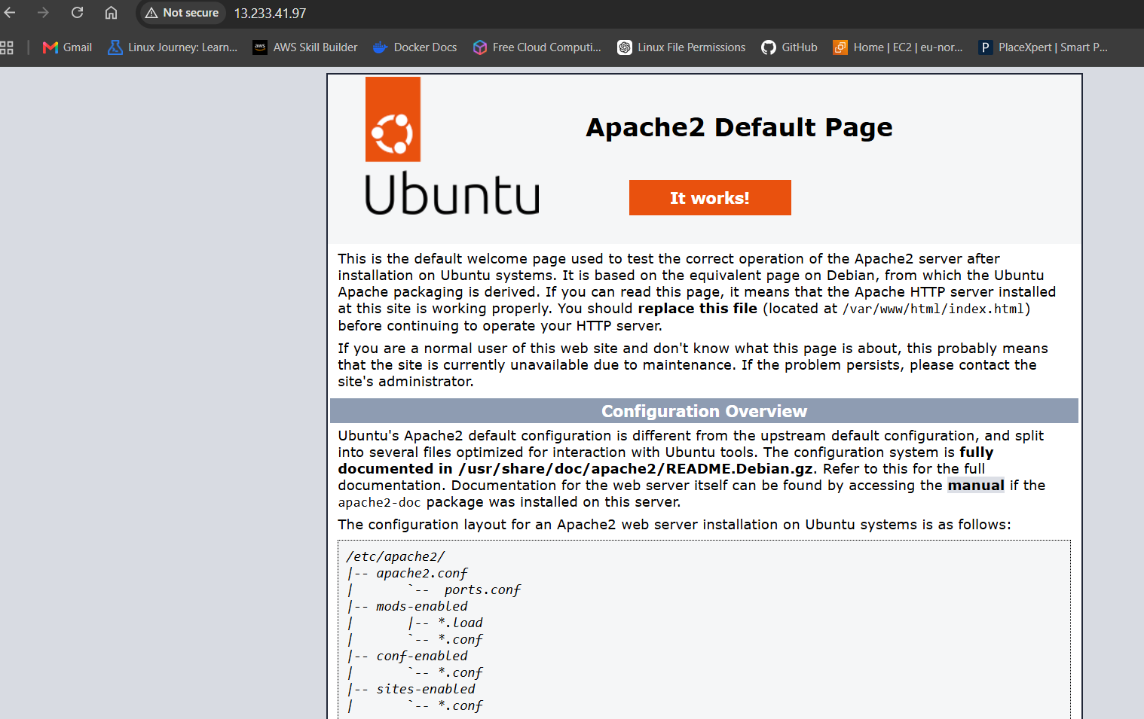

OP-4.PNG
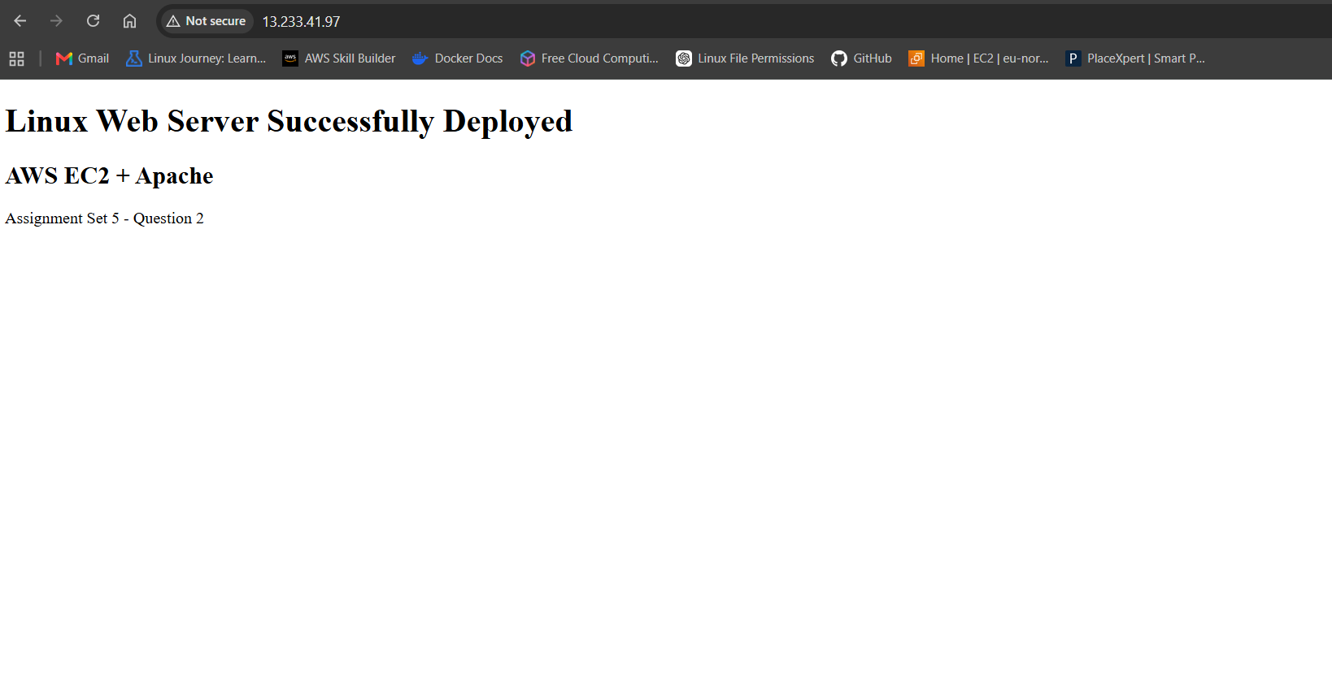

OP-5.PNG
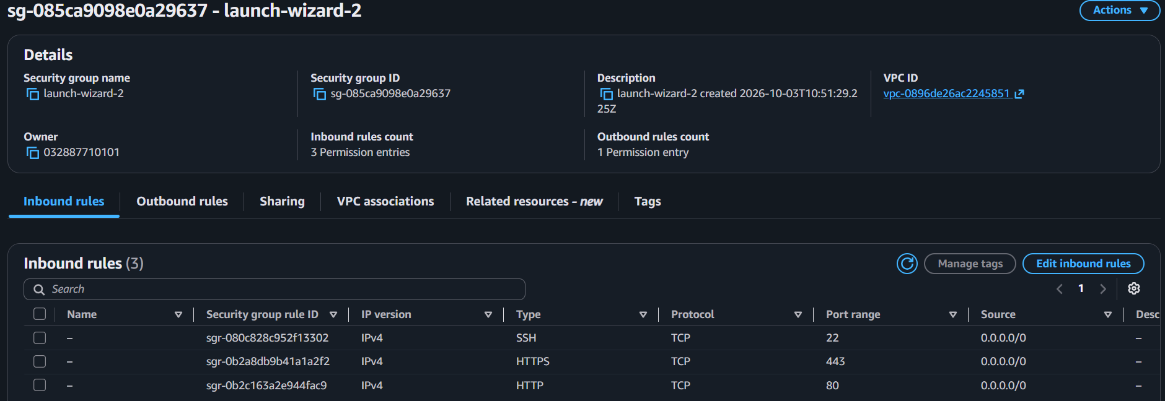

OP-6.PNG
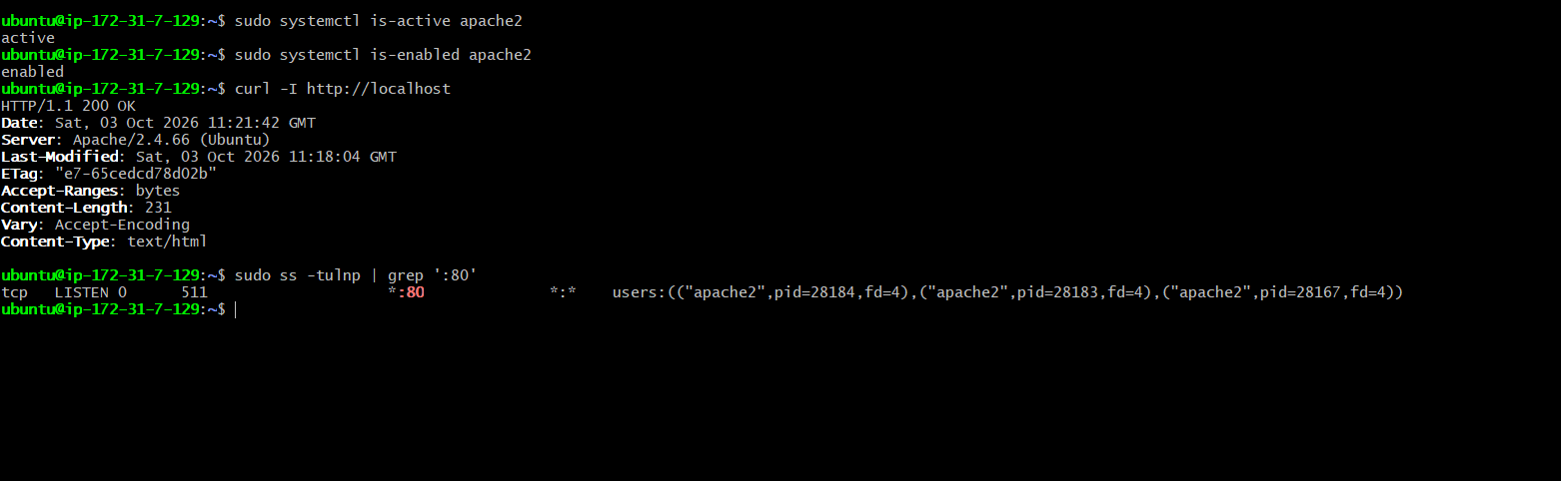

8. Conclusion
The Linux web server was successfully deployed on Amazon EC2 using Ubuntu and Apache. The Security Group was configured with SSH, HTTP, and HTTPS inbound rules. Apache was verified as active and enabled, HTTP port 80 was verified as listening, and the custom webpage was successfully served through the EC2 public IPv4 address.

