AWS Assignment Set 5 — Question 3
DynamoDB Student Management System

1. Objective
Create a DynamoDB table for a student management system and demonstrate insert, retrieve, update, and delete operations.

2. Table Configuration
Configuration | Value
Table name | StudentManagement
Partition key | StudentID
Type | String (S)
Sort key | None
Read capacity | On-demand
Write capacity | On-demand
Region | Asia Pacific (Mumbai) / ap-south-1

3. Partition Key
StudentID was selected as the partition key because each student has a unique identifier such as STU001, STU002, or STU003. This provides a natural key for identifying and retrieving an individual student record.

4. Initial Student Records
StudentID | Name | Course | Age | Email
STU001 | Rahul Sharma | MCA | 24 | rahul@example.com
STU002 | Priya Patil | MCA | 23 | priya@example.com
STU003 | Amit Kulkarni | BCS | 22 | amit@example.com

5. Operations Performed
Create: Created StudentManagement with StudentID as the String partition key.
Insert: Inserted STU001, STU002, and STU003.
Retrieve: Queried StudentID = STU002 and retrieved Priya Patil's record.
Update: Changed STU002 Course from MCA to MBA.
Delete: Deleted STU003 and verified that STU001 and STU002 remained.

6. Evidence Screenshots

DynamoDB Table Created
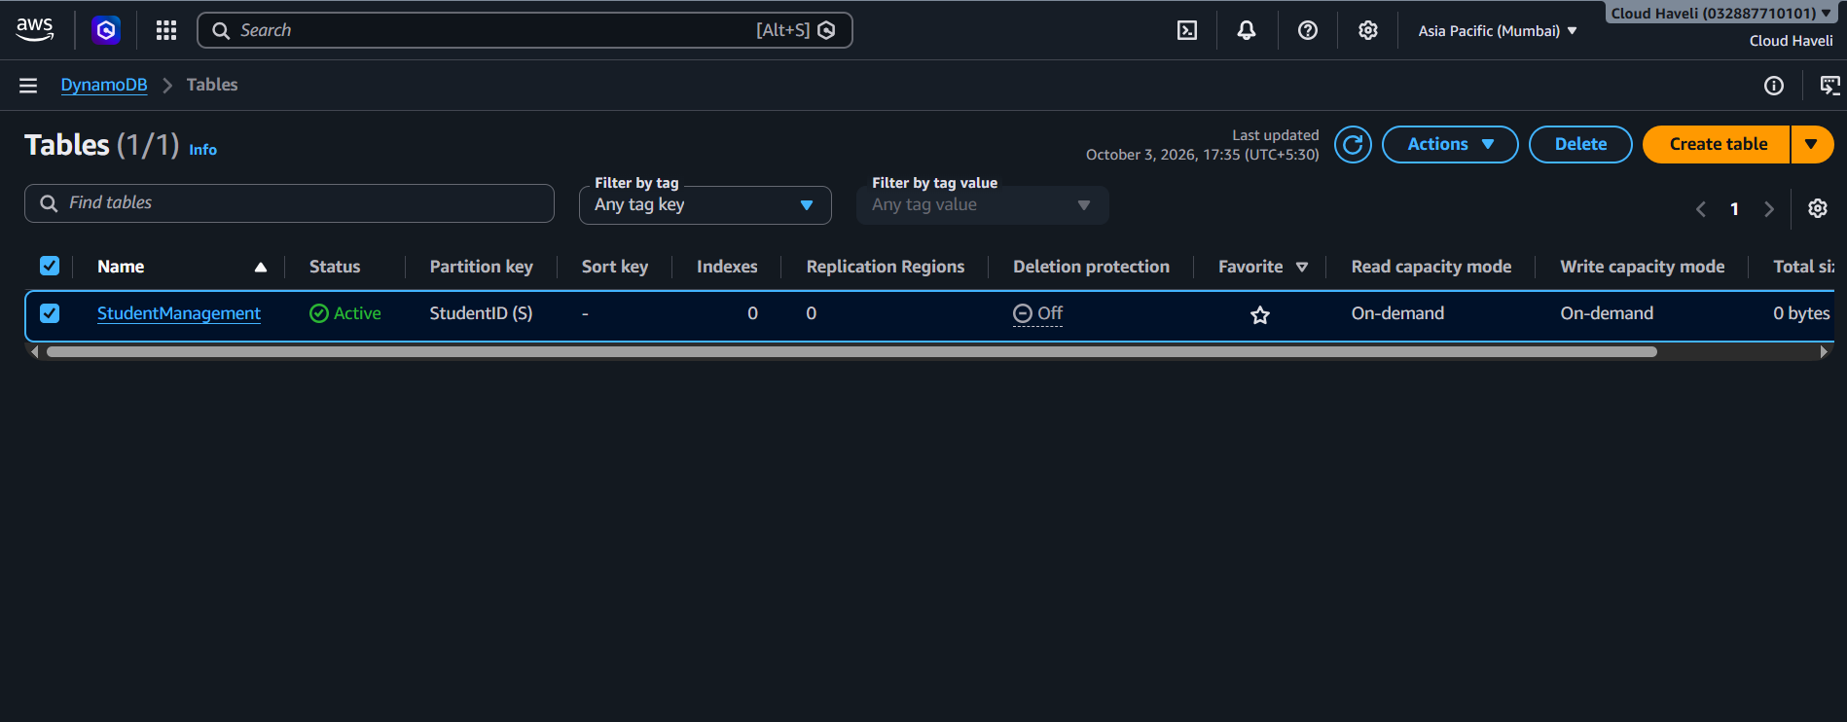

Student Records Inserted
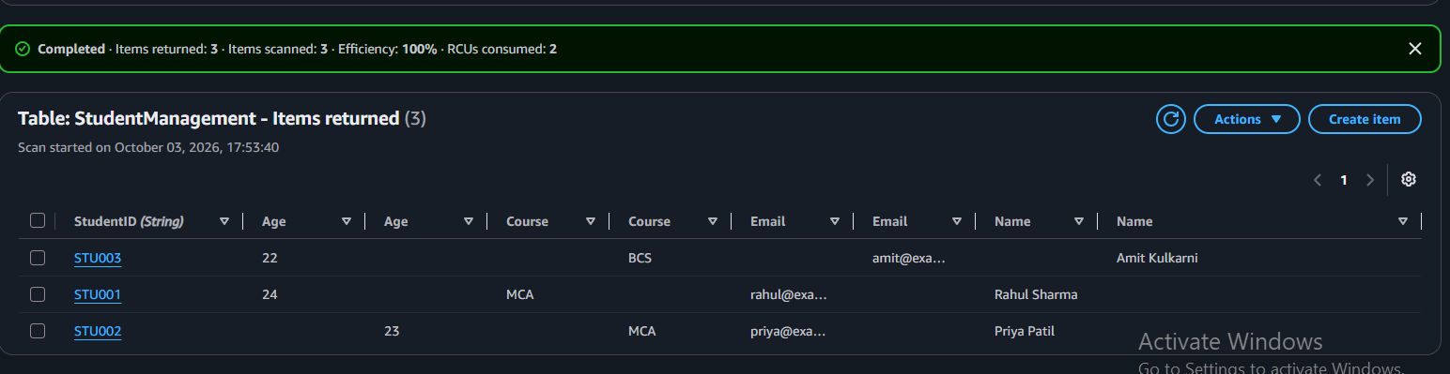

Retrieve STU002 Using Query
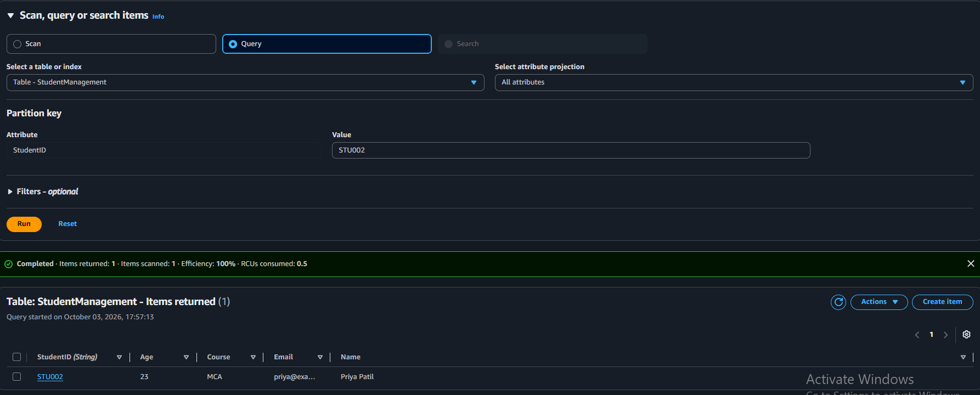

Update STU002
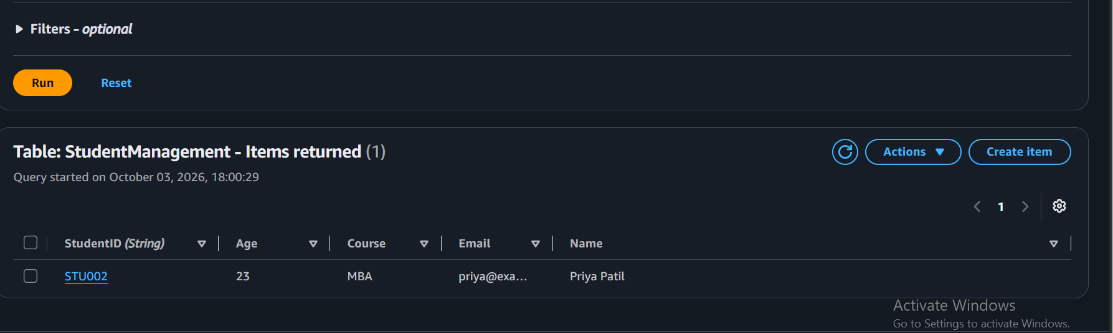

Delete STU003
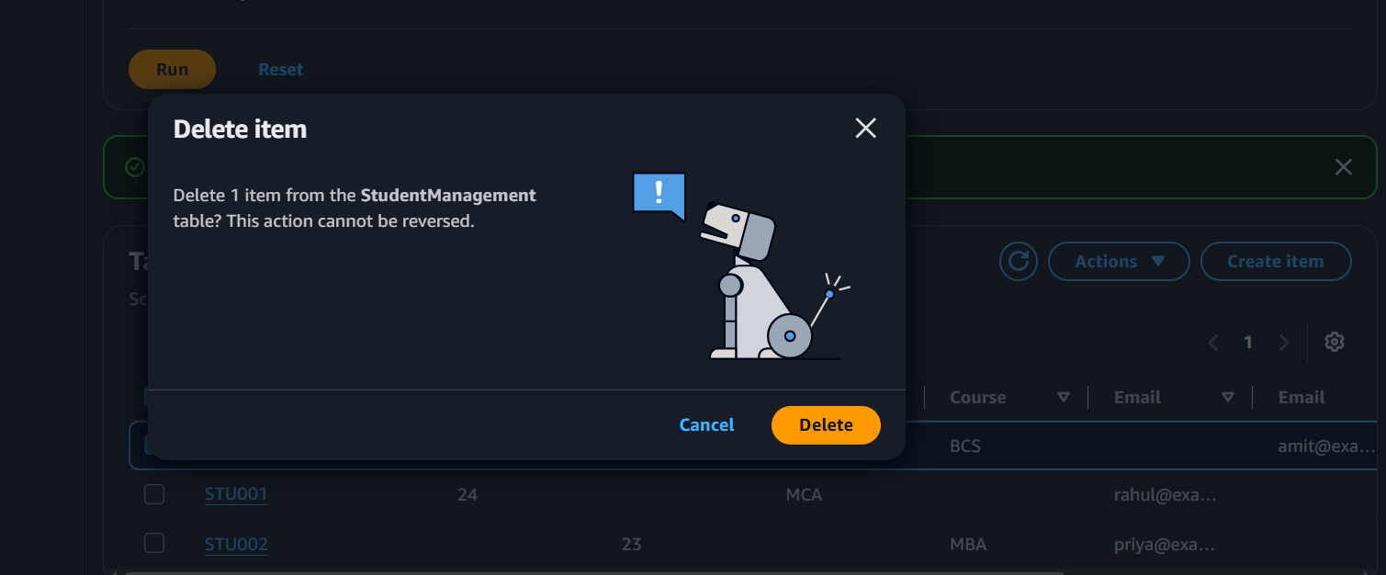

7. Final State
STU001 remains unchanged. STU002 remains with Course = MBA after the update. STU003 was deleted.

8. Conclusion
The DynamoDB Student Management System was successfully implemented and all required CRUD-style operations were demonstrated through the AWS Management Console.

