Significance of work

ABSTRACT

In the vehicle security system, we recognize the driver’s face and give alerts whenever the driver is drowsy and he blinks his eyes and an alarm is ringed to maintain their safety. Drowsiness is one the main reasons/ major causes these days for road accidents. Here, to avoid such kind of accidents we are developing a system which is a drowsiness alert system and vehicle’s safety system. By using Artificial Intelligence (AI) technology, we are building this system. Firstly, the image of the driver is captured and it is identified by using face recognition techniques and once the driver is in the vehicle and he starts driving the vehicle, for instance if he feels drowsy there will be an alert/ alarm so that he can get himself awake, take a break, and then drive the vehicle. Computer vision and machine learning algorithms are used to design this system. In this system, we are using eye landmarks which determine the EAR (Eye Aspect Ratio ratio) to check whether the driver is drowsy.

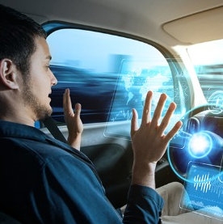

Driver drowsiness is a critical factor contributing to road accidents, posing a significant threat to public safety. The Driver Drowsiness Alert Detection Project addresses this issue by developing an intelligent system that can detect signs of drowsiness in drivers in real-time and issue timely warnings to prevent accidents. Leveraging computer vision and machine learning techniques, the system analyzes facial expressions and eye movements to assess the driver's level of alertness. This report provides a comprehensive overview of the project, including the motivation, problem statement, literature review, methodology, experimental setup, and results. The findings demonstrate the effectiveness of the developed system in accurately detecting drowsiness, paving the way for enhanced road safety measures. The report also discusses the limitations of the project and suggests potential areas for future research and improvement. Overall, the Driver Drowsiness Alert Detection Project represents a significant advancement in leveraging technology to mitigate the risks associated with driver drowsiness and promote safer driving practices.

INTRODUCTION

Every human being needs sleep, lack of sleep causes human inactiveness, improper reflex, losing of focus, gets deviated which decreases the capability to make proper decisions which is necessary for driving a vehicle. As per WHO records about 1.25 million of people were injured or dead due to accidents in a year. Some of them neglect the traffic rules, like over speeding, crossing the signals, crossing the lane, also having technical issues with the break’s failure, tires.

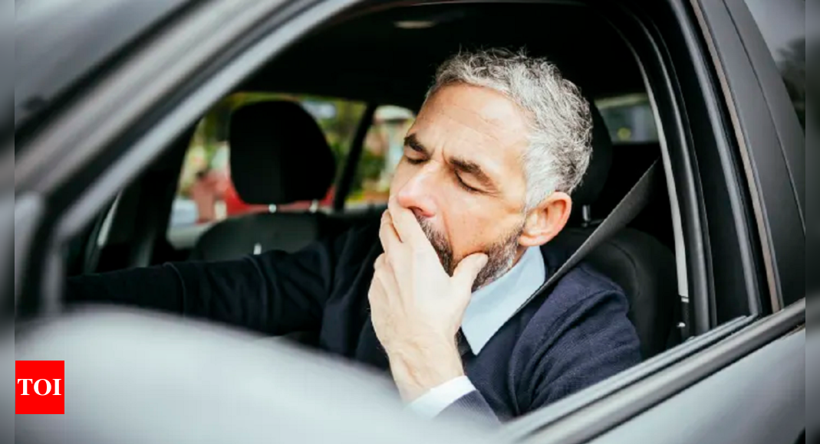

To mitigate these issues this paper focuses on the solution to reduce the fatal cases by providing a smart drowsiness detection system. This model has an accuracy of 93%. Machine learning, Computer vision are being used in this model which are the subset of AI and it allows the user to train the system and predict the output in a certain range. This technology helps to reduce the gap between human and machines. Computer vision is the library which captures, understands the images to perform image processing. It helps in processing and extraction of the data to generate the information and it uses other libraries which play an important role in the system.

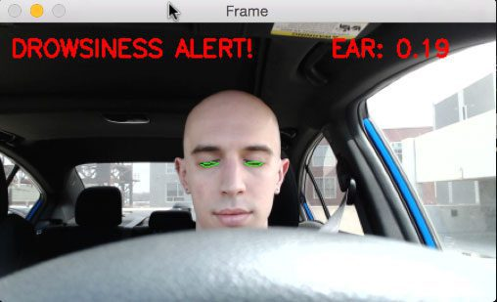

It has a graphical user interface (GUI) which makes the operating systems easy for users to use. Where you can simply create your own windows for generating output of a certain model. Here, we are using model for drowsiness detection. The outcome of this model is to alert and predict whenever the driver is drowsy, changing his track and when the vehicle is not maintained well. The aim of this paper is to implement this system in the vehicle, and ensure driver’s safety. Algorithms are used to process the signals and to give relevant output.

People have continually developed machines and formulated techniques to ease and protect their lives, for dull sports like journeying to work, or for greater absorbing purposes like plane journey. With the development in generation, modes of transportation stored on gain ground dominion and our dependency on it commenced largely. It has substantially changed our lives as we are aware of it. Now, we can journey to venues at a tempo that even our grandparents would not have idea viable. In present times, almost all people on this world makes use of some type of transportation each day. few people are wealthy sufficient to possess cars while others use shuttle. However, there are a few policies and codes of behavior for people who pressure regardless of social repute. One among them is staying conscious/ alert and energetic even when we are driving. Neglecting our duties closer to more secure travel has sanction masses of heaps of devastation to get couple with this high-quality origination annually. It can appear to be an insignificant component to most oldsters but following policies and act on the street is of maximum consequence. Even as on pavement, a motorcar wields most electricity and in incautious arms, it may be ruinous and from time to time, that negligence put people’s lives in insecurity. One sort of carelessness is not always admitting while we also worn-out to drive. If you want to detect and avert an unfavorable result from such trivial, many analysts have written studies papers on the driver drowsiness detection systems. However, at instances, some factors and scrutiny made via the gadget are not correct sufficient. Consequently, to provide statistics and any other perspective at the hassle to hand, to be able to enhance their Implementations and to similarly optimize the solution, this venture has been finished.



Our current facts screen that in 2015, just in India, 148,708 people have expired due to automobile associated misadventures. Of these accidents, at least 22 percentage have been brought on because of exhaustion causing drivers to make errors. This may be almost few ranges still, as most of them have a couple of causes which can lead to an accident, the collaboration of drowsiness as a reason is typically. Be little drowsiness mixed with horrific Architecture in developing international locations like India is a recipe for Tragedy. Drowsiness, in popular, is very hard to measure or look at unlike alcohol and pills, which have cleaned key signs and exams which can be available easily. Likely, the exceptional answers to this hassle are attention about Drowsiness-associated misadventure and selling drivers to admit drowsiness while wanted. previous was difficult and hard to reap, and the closing is not feasible without the sometime as using for lengthy hours is much profitable. While there may be an enlarge need for an activity, the income related to it will increase Main to an increasing number of human beings acquiring itis the case for using shipping automobiles at dark time. Coins motivates drivers to make foolish choices like riding whole night despite drowsiness.

**Proposed Techniques:**

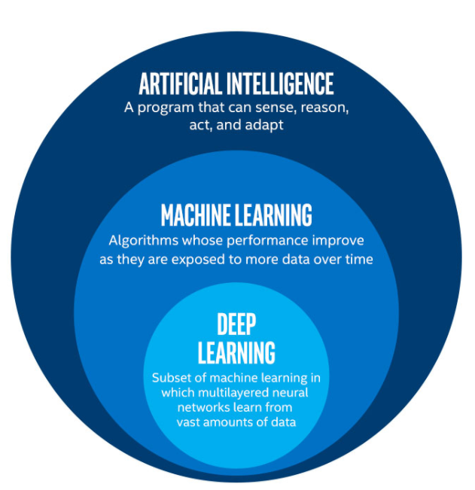

1. **Artificial Intelligence** (AI):

Artificial Intelligence (AI) is the study and creation of computer systems that can perceive, reason and act. The primary aim of Al is to produce intelligent machines. The intelligence should be exhibited by thinking, making decisions, solving problems, more importantly by learning. Al is an interdisciplinary field that requires knowledge in computer science, linguistics, psychology, biology, philosophy and so on for serious research.

According to the father of Artificial Intelligence, John McCarthy, it is the science and engineering of making intelligent machines, especially intelligent computer programs. It is a way of Making a Computer, a Computer-Controlled Robot, or a Software Think Intelligently in the similar manner the intelligent humans think.

Artificial intelligences (AI), the ability of a digital computer or computer-controlled robot to perform tasks commonly associated with intelligent beings. The term is frequently applied to the project of developing systems endowed the intellectual processes characteristic of humans, such as the ability to reason, discover meaning, generalize, or learn from experience. Since the development of the digital computer in the 1940s, it has been demonstrated that computers can be programmed to carry out very complex tasks—as, for example, discovering proofs for mathematical theorems or playing chess— with great proficiency. Still, despite continuing advances in computer processing speed and memory capacity, there are yet no programs that can match human flexibility over wider domains or in tasks requiring much everyday knowledge. On the other hand, some programs have attained the performance levels of human experts and professionals in performing certain specific tasks, so that artificial intelligence in this limited sense is found in applications as diverse as medical diagnosis, computer search engines, and voice or handwriting recognition.

2.Machine Learning

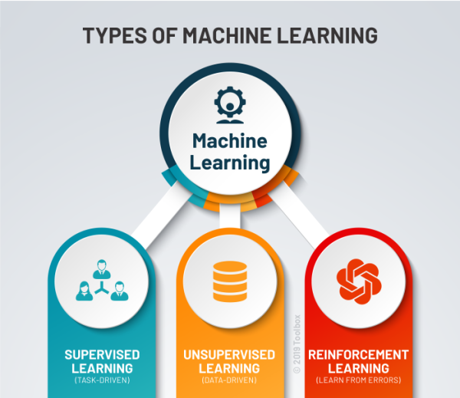

Machine learning is an application of artificial intelligence (AI) that provides systems the ability to automatically learn and improve from experience without being explicitly programmed.

Machine Learning is defined as the study of computer programs that leverage algorithms and statistical models to learn through inference and patterns without being explicitly programed. Machine Learning field has undergone significant developments in the last decade. Machine learning focuses on the development of computer programs that can access data and use it to learn for themselves. There are also some types of machine learning algorithms that are used in very specific use-cases, but three main methods used today are: Supervised Machine Learning Algorithm Unsupervised Machine Learning Algorithm Reinforcement Machine Learning Algorithm Among these, the type of machine learning algorithm we used in our system is supervised machine learning algorithm.

**Supervised machine learning** :

This can apply what has been learned in the past to new data using labelled examples to predict future events. Starting from the analysis of a known training dataset, the learning algorithm produces an inferred function to make predictions about the output values. The system can provide targets for any new input after sufficient training. The learning algorithm can also compare its output with the correct, intended output and find errors in order to modify the model accordingly.

**Unsupervised machine learning**:

It holds the advantage of being able to work with unlabeled data. This means that human labor is not required to make the dataset machine-readable, allowing much larger datasets to be worked on by the program. In supervised learning, the labels allow the algorithm to find the exact nature of the relationship between any two data points. However, unsupervised learning does not have labels to work off of, resulting in the creation of hidden structures. Relationships between data points are perceived by the algorithm in an abstract manner, with no input required from human beings. The creation of these hidden structures is what makes unsupervised learning algorithms versatile. Instead of a defined and set problem statement, unsupervised learning algorithms can adapt to the data by dynamically changing hidden structures. This offers more post deployment development than supervised learning algorithms

**Reinforcement Machine Learning**:

It directly takes inspiration from how human beings learn from data in their lives. It features an algorithm that improves upon itself and learns from new situations using a trial-and-error method. Favorable outputs are encouraged or ‘reinforced’, and unfavorable outputs are discouraged or ‘punished’. Based on the psychological concept of conditioning, reinforcement learning works by putting the algorithm in a work environment with an interpreter and a reward system. In every iteration of the algorithm, the output result is given to the interpreter, which decides whether the outcome is favorable or not. In case of the program finding the correct solution, the interpreter reinforces the solution by providing a reward to the algorithm. If the outcome is not favorable, the algorithm is forced to reiterate until it finds a better result. In most cases, the reward system is directly tied to the effectiveness of the result. In typical reinforcement learning use-cases, such as finding the shortest route between two points on a map, the solution is not an absolute value. Instead, it takes on a score of effectiveness, expressed in a percentage value. The higher this percentage value is, the more reward is given to the algorithm. Thus, the program is trained to give the best possible solution for the best possible reward.

**3.Deep Learning**:

Deep learning is an artificial intelligence (AI) function that imitates the workings of the human brain in processing data and creating patterns for use in decision making. Deep learning is a subset of machine learning in artificial intelligence that has networks capable of learning unsupervised from data that is unstructured or unlabeled. Also known as deep neural learning or deep neural network. It is a form of machine learning, with functions that operate in a nonlinear decision-making process. Deep learning occurs when decisions are made on unstructured data without supervision. Object recognition, speech recognition, and language translation are some of the tasks performed through deep learning. Deep learning is an AI function that mimics the workings of the human brain in processing data for use in detecting objects, recognizing speech, translating languages, and making decisions. Deep learning AI is able to learn without human supervision, drawing from data that is both unstructured and unlabelled. It is a form of machine learning, can be used to help detect fraud or money laundering, among other functions.

**4.Neural Networks**

Neural networks are artificial systems that were inspired by biological neural networks. These systems learn to perform tasks by being exposed to various datasets and examples without any task-specific rules. The idea is that the system generates identifying characteristics from the data they have been passed without being programmed with a preprogrammed understanding of these datasets. Components of a typical neural network involve neurons, connections, weights, biases, propagation function, and a learning rule. Neurons will receive an input from predecessor neurons that have an activation, threshold, an activation function f, and an output function. Connections consist of connections, weights and biases which rules how neuron i transfers output to neuron j. Propagation computes the input and outputs the output and sums the predecessor neurons function with the weight. The learning rule modifies the weights and thresholds of the variables in the network. Artificial Neural Networks contain artificial neurons which are called units. These units are arranged in a series of layers that together constitute the whole Artificial Neural Networks in a system. A layer can have only a dozen units or millions of units as this depends on the complexity of the system. Commonly, Artificial Neural Network has an input layer, output layer as well as hidden layers. The input layer receives data from the outside world which the neural network needs to analyze or learn about. Then this data passes through one or multiple hidden layers that transform the input into data that is valuable for the output layer. Finally, the output layer provides an output in the form of a response of the Artificial Neural Networks to input data provided. In the majority of neural networks, units are interconnected from one layer to another. Each of these connections has weights that determine the influence of one unit on another unit. As the data transfers from one unit to another, the neural network learns more and more about the data which eventually results in an output from the output layer.

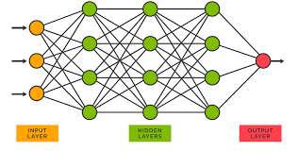

**Types:**

1. **Feedforward Neural Network**:

The feedforward neural network is one of the most basic artificial neural networks. In this ANN, the data or the input provided ravels in a single direction. It enters into the ANN through the input layer and exits through the output layer while hidden layers may or may not exist. So the feedforward neural network has a front propagated wave only and usually does not have backpropagation.

1. **Recurrent Neural Network:**

The Recurrent Neural Network saves the output of a layer and feeds this output back to the input to better predict the outcome of the layer. The first layer in the RNN is quite similar to the feed-forward neural network and the recurrent neural network starts once the output of the first layer is computed. After this layer, each unit will remember some information from the previous step so that it can act as a memory cell in performing computations.

1. **Convolutional Neural Network**:

A Convolutional neural network has some similarities to the feed-forward neural network, where the connections between units have weights that determine the influence of one unit on another unit. But a CNN has one or more than one convolutional layer that use a convolution operation on the input and then pass the result obtained in the form of output to the next layer. CNN has applications in speech and image processing which is particularly useful in computer vision.

1. **Modular Neural Network**:

A Modular Neural Network contains a collection of different neural networks that work independently towards obtaining the output with no interaction between them. Each of the different neural networks performs a different sub-task by obtaining unique inputs compared to other networks. The advantage of this modular neural network is that it breaks down a large and complex computational process into smaller components, thus decreasing its complexity while still obtaining the required output.

1. **Radial basis function**:

Neural Network Radial basis functions are those functions that consider the distance of a point concerning the center. RBF functions have two layers. In the first layer, the input is mapped into all the Radial basis functions in the hidden layer and then the output layer computes the output in the next step. Radial basis function nets are normally used to model the data that represents any underlying trend or function.

**4.Python**



Python is an interpreted, object-oriented, high-level programming language with dynamic semantics. It is high-level built in data structures, combined with dynamic typing and dynamic binding, make it very attractive for Rapid Application Development, as well as for use as a scripting or glue language to connect existing components together. Python's 18 simple, easy to learn syntax emphasizes readability and therefore reduces the cost of program maintenance. Python supports modules and packages, which encourages program modularity and code reuse. The Python interpreter and the extensive standard library are available in source or binary form without charge for all major platforms, and can be freely distributed. Since there is no compilation step, the edit-test-debug cycle is incredibly fast. Debugging Python programs is easy: a bug or bad input will never cause a segmentation fault. Instead, when the interpreter discovers an error, it raises an exception. When the program doesn't catch the exception, the interpreter prints a stack trace. A source level debugger allows inspection of local and global variables, evaluation of arbitrary expressions, setting breakpoints, stepping through the code a line at a time, and so on. The debugger is written in Python itself, testifying to Python's introspective power. On the other hand, often the quickest way to debug a program is to add a few print statements to the source: the fast edit-test-debug cycle makes this simple approach very effective. It is easy to learn syntax and portability capability makes it popular these days.

The followings facts give us the introduction to Python:

1. Python was developed by Guido van Rossum at Sichting Mathematics Centrum in the Netherlands.

2.It was written as the successor of programming language named ‘ABC’.

3.It is first version was released in 1991.

4.The name Python was picked by Guido van Rossum from a TV show named Monty Python’s Flying Circus.

5.It is an open-source programming language which means that we can freely download it and use it to develop programs. It can be downloaded from [www.python.org](http://www.python.org).

6.Python programming language is having the features of Java and C both. It is having the elegant ‘C’ code and on the other hand, it is having classes and objects like Java for object-oriented programming. 7.It is an interpreted language, which means the source code of Python program would be first converted into bytecode and then executed by Python virtual machine. Python for Data Science Whether you’re doing straightforward data analysis or full-on data science, you’d be hard pressed to find a better suite of tools than those in Python. The Pandas library is a quantum-leap improvement over the dusty Excel spreadsheets in which financial analysis was done for so long. If Pandas is not fast enough for you, most of the basic vector operations can be one with NumPy. NumPy also offers the ability to do linear algebra, scientific computing, and a host of other highly technical things. It is, therefore, a great tool to learn how to use well. Python is the fifth most important language as well as most popular language for Machine learning and data science.

The following are the features of Python that makes it the preferred choice of language for data science: 1. Extensive set of packages

2. Easy prototyping

3.Collaboration feature

4.One language for many domains 19 Artificial Intelligence and Machine Learning Python community has developed many modules to help programmers implement machine learning. Artificial intelligence and machine learning have become buzzwords these days, but the truth is that it all comes down to algorithms, code, and logic. Given the scope and power of Python, it’s no surprise that some truly world-class tools exist for generating intelligent behavior in Python. Arguably the most popular is the ubiquitous machine learning library, Scikit-Learn. Speaking from experience, Sk-learn makes the process of building everything from classifiers to regression models orders of magnitude simpler than it otherwise would be. If neural networks are more your jam, there’s always TensorFlow. Adding in the new Kera’s API, building a state-of-the-art neural network is easier than it has ever been.

**6.Jupiter:**

Notebook the Jupiter Notebook is an open-source web application that allows you to create and share documents that contain live code, equations, visualizations, and narrative text. Uses include: data cleaning and transformation, numerical simulation, statistical modeling, data visualization, machine learning, and much more. The Jupiter notebook has two components. Users input programming code or text in rectangular cells in a front-end web page. The browser then passes that code to a back-end ‘kernel’, which runs the code and returns the results (see our example at go.nature.com/2yqq7ak). By Pérez’s count, more than 100 Jupiter kernels have been created, supporting dozens of programming languages. Normally, each notebook can run only one kernel and one language, but workarounds exist. Importantly, the kernels need not reside on the user’s computer. When future users of the LSST use Jupiter notebooks to analyze their data, the code will be running on a supercomputer in Illinois, providing computational muscle no desktop PC could match. Notebooks can also run in the cloud. Google’s Collaboratory project, for instance, provides a Google-themed front-end to the Jupiter notebook. It enables users to collaborate and run code that exploits Google’s cloud resources — such as graphical processing units — and to save their documents on Google Drive. Two additional tools have enhanced Jupiter’s usability. One is Jupiter, a service that allows institutions to provide Jupiter notebooks to large pools of users. The IT team at the University of California, Berkeley, where Pérez is a faculty member, has deployed one such hub, which Pérez uses to ensure that all students on his data-science course have identical computing environments. “We cannot possibly manage IT support for 800 students, helping them debug why the installation on their laptop is not working; that’s simply infeasible,” he says. 20 The other development is Binder, an open-source service that allows users to use Jupiter notebooks on GitHub in a web browser without having to install the software or any programming libraries. Users can also execute Jupiter notebooks on the Google cloud by inserting https://colab.research.google.com/github before the URL of a notebook on GitHub, or using the commercial service Code Ocean. In September, Code Ocean rolled out a new user interface for its cloud-based code-sharing and code-execution service, also based on Jupiter.

Significance of Work

The significance of developing a driver drowsiness alert system is multi-fold and can have a significant impact on road safety. Here are some key reasons why this work is significant:

**1. Preventing Accidents:** Drowsy driving is a major cause of accidents worldwide. According to studies, fatigue-related crashes can be just as dangerous as drunk driving. By developing an effective drowsiness alert system, the aim is to detect signs of driver fatigue in real-time and alert the driver, thereby preventing potential accidents and saving lives.

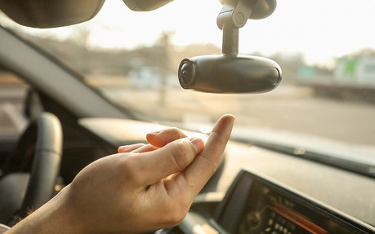

**2. Promoting Road Safety:** Road safety is a critical concern globally. By implementing drowsiness detection technology in vehicles, it contributes to enhancing overall road safety by addressing one of the primary causes of accidents. It helps reduce the risk of drowsy driving-related incidents, protecting not only the driver but also passengers, pedestrians, and other road users.

**3. Mitigating Human Error**: Humans are prone to errors, especially when fatigued or drowsy. By incorporating technology that can monitor and detect signs of drowsiness, the system acts as an additional safety net to mitigate human errors. It helps in maintaining driver alertness and attentiveness, reducing the likelihood of accidents caused by driver fatigue.

**4. Improved Driver Well-being:** Driver fatigue not only poses risks on the road but can also lead to health issues and reduced overall well-being. By alerting drivers when they are becoming drowsy, the system promotes awareness and encourages them to take appropriate breaks, rest, or engage in activities that help them stay alert and focused. It contributes to enhancing the physical and mental well-being of drivers.

**5. Efficient Resource Utilization:** Accidents resulting from drowsy driving lead to significant economic costs in terms of medical expenses, vehicle damage, and loss of productivity. By preventing accidents, a driver drowsiness alert system helps in efficient resource utilization by reducing the burden on healthcare systems, insurance companies, and businesses affected by accidents.

**6. Technological Advancement:** Developing and implementing driver drowsiness detection technologies involves the integration of various sensors, algorithms, and data analysis techniques. This work drives technological advancements and innovation in the automotive industry, contributing to the development of smarter and safer vehicles.

Overall, the significance of developing a driver drowsiness alert system lies in its potential to save lives, prevent accidents, promote road safety, mitigate human errors, improve driver well-being, and foster technological progress. By addressing the issue of driver fatigue, this work contributes to creating safer and more efficient transportation systems.