 Tel: (020)27421293, Fax: (020) 27421293, Mob: 9764067287(TPO)
Dr. D.Y.Patil Unitech Society’s
Dr .D.Y.Patil Institute of Management and Research Pimpri, Pune-18
(Affiliated to University of PUNE and approved by AICTE.)
Mail- placement.imr@dypvp.edu.in/sushilkulkarni11@gmail.com

Student Name: Krushna Dnyandeo Belokar E-Mail Id: krushnab5283@gmail.com Phone No: 7057251753
Objective:
As a fresher, my skills are C, CPP, HTML, CSS, JAVA, MYSQL, VISUAL BASIC, JAVASCRIPT, PHP, Reactjs basics. Looking forward to pursue skills and knowledge for building my career in cooperate environment which would help to grow my potential. | 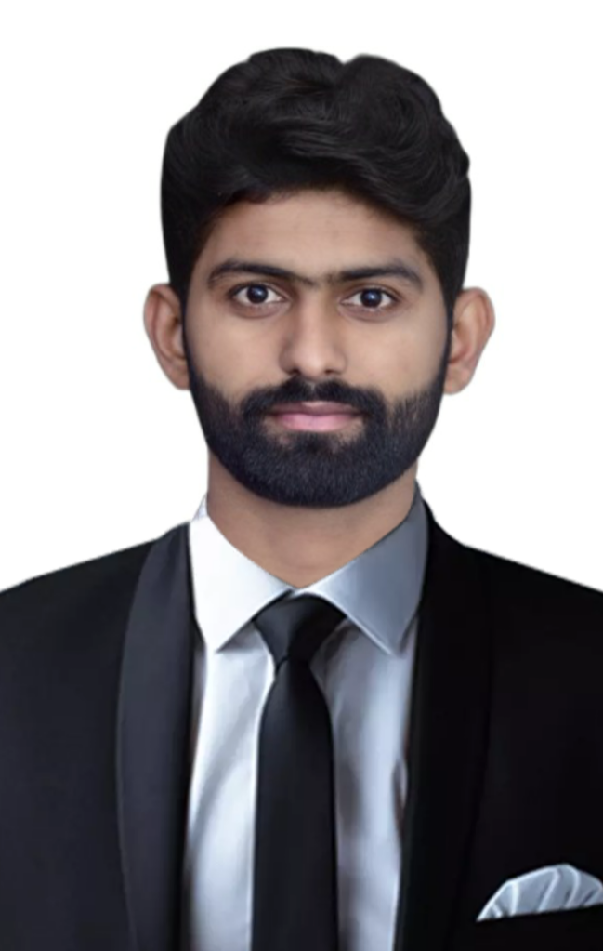

Education | University/ Board | Percentage | Year of Passing
M. C. A(Pursuing) | SAVITRIBAI PHULE PUNE UNIVERSITY | 93.04 | First-Sem
B. C. A | SAVITRIBAI PHULE PUNE UNIVERSITY | 65.91 | 2020
H. S. C | MAHARASHTRA BOARD | 63.38 | 2015
S. S. C | MAHARASHTRA BOARD | 61.60 | 2012

Technical Skills:
- Programming Skills: C/C++, Java, HTML, CSS, PHP, VB.NE, Reacts basic.
- Microsoft Office: MS-Word, MS-PowerPoint, MS-Excel, MS-Access etc.
- Scripting Languages: JavaScript and PHP.
- Database: MySQL, MS-Access, Oracle.
- Tools And IDE: Visual Basic 6.0, Eclipse, NetBeans, Sublime Text, Visual Studio.
- Framework Known: .Net Framework, Bootstrap, Tachyons CSS framework.

Projects Undertaken:
- Book Shop Management System:
- Front End: Java.
- Back End: MySQL.
- The project was built in my academic year. The main objective of this project was to keep shop’s valuable data secure and manage it in a simple and easy manner like managing customers data, products data, expenses data etc. And to reduce the paper work of shop keeper.
- Online Counselling System
- Front End: HTML, CSS, JavaScript.
- Back End: Java, Jsp MySQL.
This project was built in my academic year. The main objective of this project was to help others like any individuals, who feels alone, who feels depress, who want any kind of suggestions regarding to carrier, health, business and many more.
- Simple Calculator Using ReactJs
- Front End: HTML, CSS, Reactjs.
- Editor: VS Code.
This was my practice project in ReactJs, where I build one simple digital Calculator.
- Component Reusability Project Using PHP: Tried to create reusable component using php, and simply reuse the file of code where we need the same code in my project.

Personal Details:
Name: | Krushna Dnyandeo Belokar
DOB: | 15/08/1995
Languages: | English, Marathi, Hindi
Address: | Chakrapani Road, Ganesh Nagar, Ekta Co.No.1 Bhosari Pune-411039
Hobbies: | Gym, Swimming, Coding.
Blood Group: | B+
Extra-Curricular Activity / Awards: | - Participated in various competition conducted by college.  - Certification Course on MSCIT, TYPING: 30-40 English and 30 Marathi.  - Trying to learn Python, Reacts, Angular And some Framework.
Research Contribution: | Consequences Due to Rapid Changes in Technology & Tt’s Impact over Middle Class.

Social Media URL’s:
- GitHub URL: https://github.com/krushnabelokar?tab=repositories
- LinkedIn URL: https://www.linkedin.com/in/krushna-belokar-281010181/
- Portfolio: https://krushnabelokar.github.io/myPortfolio/

Acknowledgment:
I hereby declare that the above-mentioned information is true and trustworthy to the best of my knowledge.

