UNIT–1 MINI PROJECT
Enterprise Student Record and Academic Management Platform
Design Thinking and Product Planning
Detailed Project Report
Student Name: Krushna Dattatray Dhokane
PRN: 2125UDSM1116
Roll No.: 116
B.Tech – Artificial Intelligence and Data Science

Table of Contents
1. Introduction and Project Overview
2. Business Requirements Document (BRD)
3. Business Process Understanding
4. Problem Analysis and Business Justification
5. Design Thinking Report
6. IBM Design Thinking Report
7. IBM Loop Documentation
8. Stakeholder Analysis
9. User Persona Report
10. Requirements Engineering
11. Product Vision
12. Minimum Viable Product (MVP)
13. Product Roadmap
14. User Flow and Use Cases
15. Initial System Architecture
16. Project Charter
17. Git Repository Initialization
18. Project Folder Structure
19. Product Discovery Documentation
20. Testing and Validation Plan
21. Risks and Mitigation
22. Conclusion

1. Introduction and Project Overview
The Unit–1 mini project asks students to apply Design Thinking and Product Planning to a software solution for managing student records and academic information in a higher education institution. The work starts with business understanding and user needs rather than coding.

1.1 Project Objectives
- Understand admissions, course registration, attendance, examination and result management.
- Identify problems in manual or fragmented academic record management.
- Apply the five Design Thinking stages.
- Analyze stakeholders and create user personas.
- Prepare functional and non-functional requirements.
- Define product vision, MVP, roadmap and initial architecture.
- Prepare the project charter and repository structure.

1.2 Product Scope
The Unit–1 scope is planning and product discovery. The output is a development-ready product plan for later Agile implementation.

1.3 Lifecycle Flow
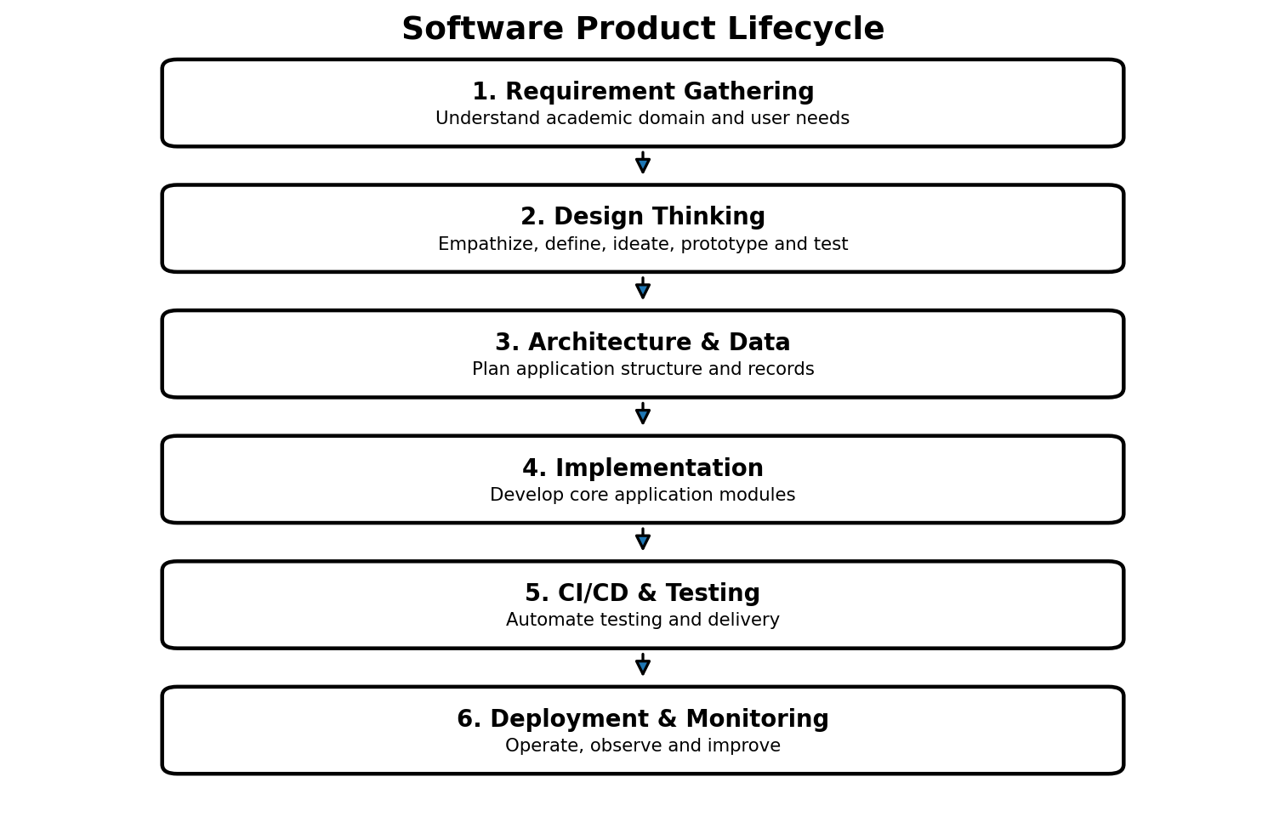

2. Business Requirements Document (BRD)

2.1 Business Problem
Academic institutions handle large volumes of student and academic information. When processes are manual or distributed across separate records, students and staff may face delays, duplicate entry, difficulty finding information, reporting effort and inconsistent records.

2.2 Business Objectives
- Centralize student academic information.
- Reduce repetitive manual record handling.
- Make attendance and result information easier to access.
- Support academic report generation.
- Provide secure and role-appropriate access.
- Create a scalable foundation for future development.

2.3 Major Business Processes
Process | Main Activities | Users
Admission & Registration | Create student record, capture academic details | Students, Admin
Course Registration | Assign/select courses | Students, Faculty, Admin
Attendance | Record and view attendance | Faculty, Students
Examination | Manage examination information | Exam Cell, Admin
Results | Maintain and publish academic results | Exam Cell, Students, Admin
Reporting | Generate academic reports | Admin, Faculty, Exam Cell

2.4 Business-to-System Mapping
Current Need | Proposed Platform Response | Expected Benefit
Scattered records | Central student record | Better consistency
Manual attendance records | Digital attendance module | Faster updates
Difficult result access | Result dashboard | Improved accessibility
Repeated report preparation | Report generation | Reduced administrative effort
Different user needs | Role-based access | Better control

3. Business Process Understanding
Before software design, the project considers how academic information moves through the institution.

3.1 Academic Record Flow
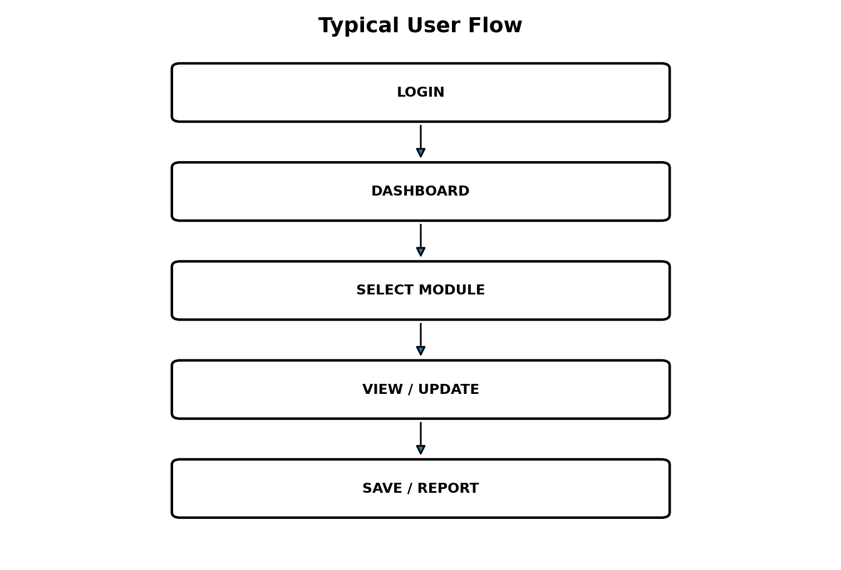

3.2 Process Explanation
- Student registration creates the basic identity and academic record.
- Course registration associates the student with relevant academic courses.
- Faculty members maintain attendance and academic information.
- Examination staff manage examination and result information.
- Students and authorized staff access relevant information through dashboards.
- Administrators use centralized records to prepare academic reports.

4. Problem Analysis and Business Justification

4.1 Major Problems
Problem | Impact | Platform Opportunity
Manual/fragmented records | Time-consuming retrieval and updates | Centralized record management
Repeated data entry | Higher possibility of errors | Structured digital workflows
Delayed academic information | Poor user experience | Dashboard-based access
Report preparation effort | Administrative workload | Automated report generation
Different access requirements | Risk of inappropriate access | Role-based access control

4.2 Core Problem Statement
Students, faculty, academic administrators, and examination staff need a centralized and organized way to manage and access student academic information because fragmented or manual record processes can create delays, repeated work, reporting difficulties, and inconsistent access to information.

5. Design Thinking Report
Design Thinking is used as a human-centered approach. The five stages are Empathize, Define, Ideate, Prototype and Test.
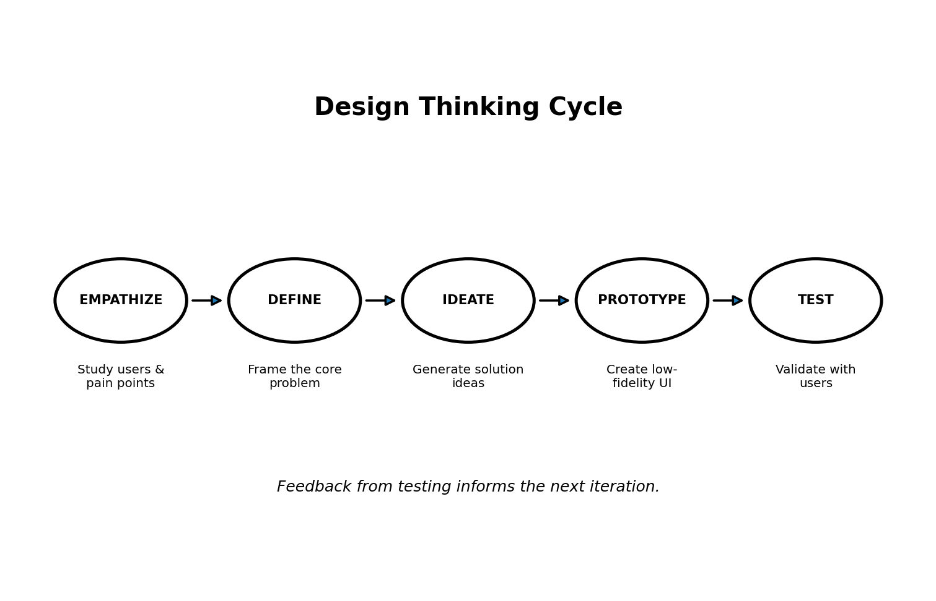

5.1 Empathize
The project considers students, faculty members, academic administrators, examination cell staff and IT support personnel. The purpose is to understand their tasks, expectations, frustrations and information needs.
User | Needs to Understand
Student | How academic information is found and used.
Faculty | How attendance and academic records are maintained.
Academic Administrator | How records and reports are reviewed.
Examination Staff | How examination and result information is processed.
IT Support | How reliability, security and support are maintained.

5.2 Define
The observations are converted into a clear problem statement. The central problem is fragmented academic information management that makes routine academic tasks slower and less convenient.

5.3 Ideate
- Central student dashboard
- Course registration module
- Attendance dashboard
- Examination and result module
- Academic report generation
- Role-based dashboards
- Secure authentication and authorization

5.4 Prototype
Low-fidelity prototypes should cover login, student dashboard, faculty attendance screen, administrator records screen, examination/result screen and report screen.

5.5 Test
Representative users should review the prototype. Testing should examine navigation, clarity, completeness, ease of task completion and whether the proposed workflow solves the identified problem. Feedback should be recorded and used for the next iteration.

6. IBM Design Thinking Report

6.1 Focus on User Outcomes
The product should measure outcomes rather than simply counting technical features. Example: the goal is to make students able to locate their academic information easily, not merely to create a database table.

6.2 Restless Reinvention
The platform should continuously improve through user feedback, observation and later usage information. A feature can be refined when users show confusion or when an academic workflow changes.

6.3 Diverse Empowered Teams
A cross-functional project team can include business/academic stakeholders, UX/design contributors, developers, QA, database specialists and IT/operations personnel.

6.4 Outcome Examples
Feature Goal | User Outcome
Attendance module | Faculty can maintain attendance more easily and students can view it clearly.
Result module | Students can access results without searching through separate records.
Reports | Administrators can obtain required academic information in a structured form.

7. IBM Loop Documentation
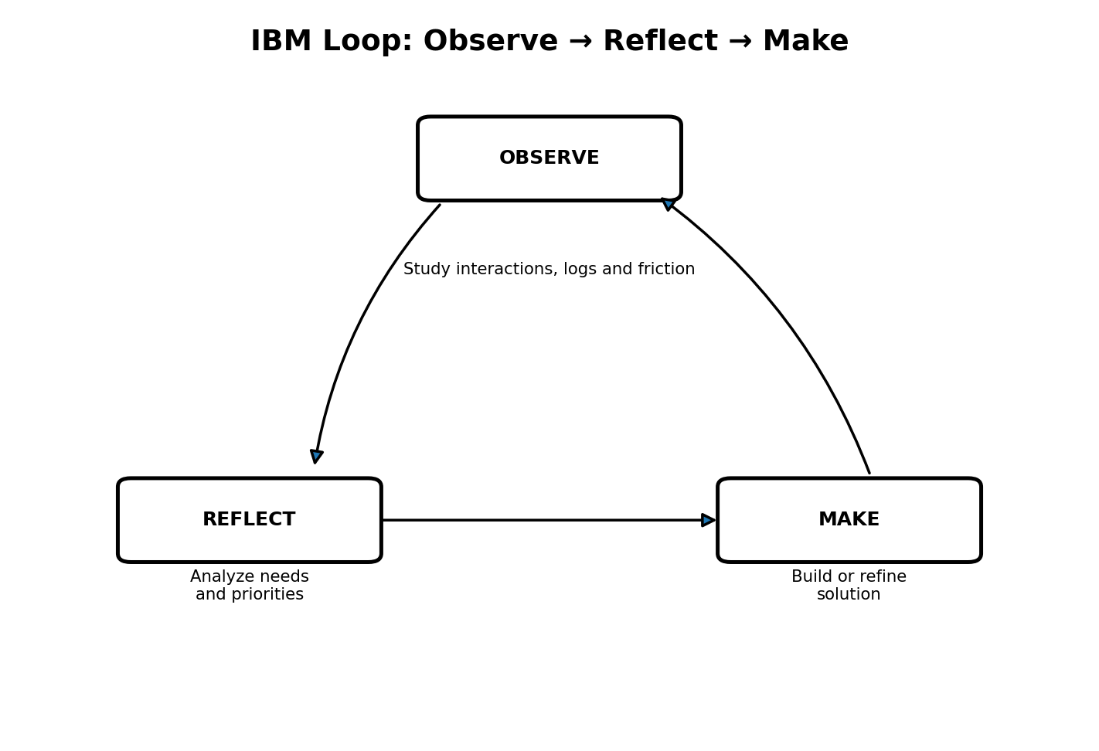
Stage | Project Activity | Output
OBSERVE | Study user interactions, academic workflows and pain points. | Observed needs and friction points
REFLECT | Analyze findings and prioritize important problems. | Prioritized requirements
MAKE | Create/refine prototype, workflow or product feature. | Improved solution
Repeat | Collect new feedback and continue the cycle. | Continuous improvement

8. Stakeholder Analysis
Stakeholder | Power/Interest | Responsibilities | Expectations
Students | High interest | Use academic services | Simple access and accurate records
Faculty | High interest | Maintain academic records | Efficient workflows
Academic Administrators | High power/high interest | Manage academic operations | Reliable records and reports
Examination Cell | High interest | Manage exams/results | Accurate result information
IT Support | High technical interest | Maintain platform | Security, reliability, maintainability

8.1 Stakeholder Communication
- Students: surveys, prototype testing, feedback forms.
- Faculty: workflow discussions and prototype reviews.
- Administrators: requirement validation and report review.
- Examination Cell: result workflow validation.
- IT Support: architecture, security and operations review.

9. User Persona Report
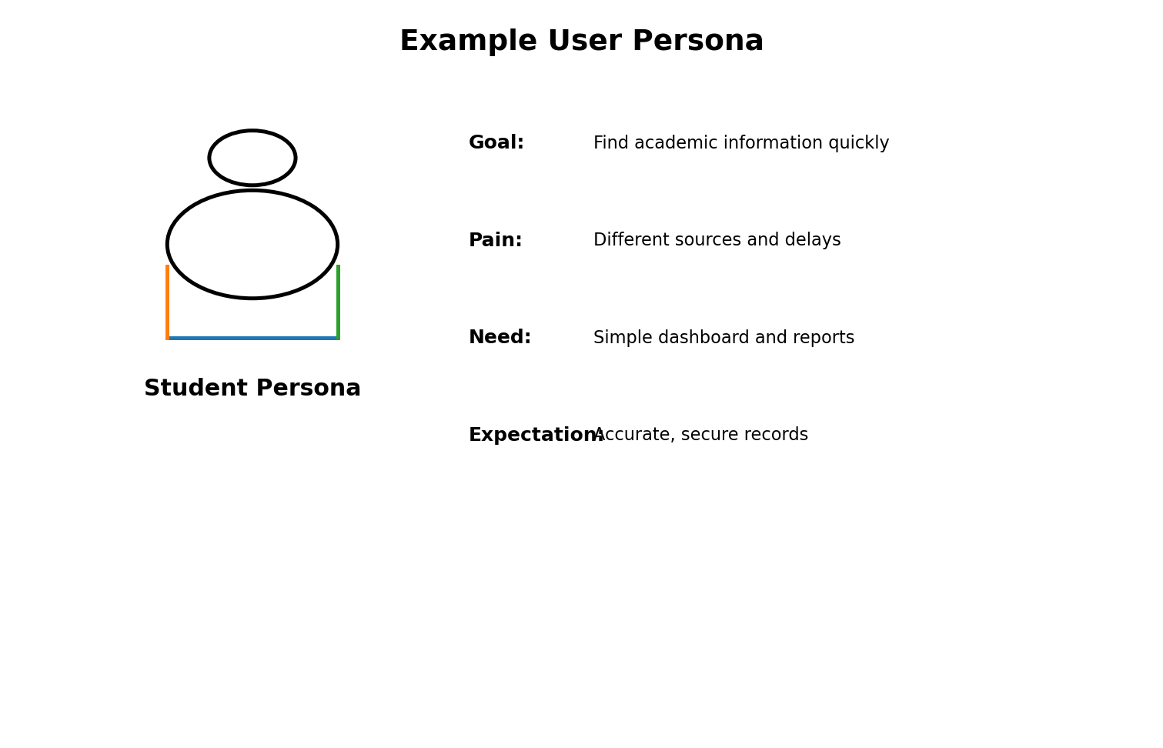
Persona | Goal | Pain Points | Platform Need
Aarav – Student | Access academic information quickly | Different sources, waiting for information | Student dashboard
Ms. Priya – Faculty | Maintain academic records | Repeated manual work | Attendance and academic module
Mr. Rahul – Administrator | Monitor academic operations | Report preparation effort | Central dashboard and reports
Ms. Neha – Exam Staff | Manage results accurately | Large data volume | Exam/result module
IT Support | Keep system reliable | Security and maintenance concerns | Secure, maintainable architecture

10. Requirements Engineering

10.1 Functional Requirements
ID | Requirement | Description
FR-01 | Student Registration | Create and maintain student registration records.
FR-02 | Student Records | Maintain student academic information.
FR-03 | Course Registration | Record courses associated with a student.
FR-04 | Attendance | Record and view attendance information.
FR-05 | Examination | Manage examination information.
FR-06 | Results | Record and provide student results.
FR-07 | Reports | Generate academic reports.
FR-08 | Role-Based Access | Provide appropriate access for different stakeholder roles.

10.2 Non-Functional Requirements
ID | Category | Requirement
NFR-01 | Security | Protect academic data using authentication and authorization.
NFR-02 | Usability | Provide clear and simple workflows.
NFR-03 | Reliability | Maintain consistent records and retrieval.
NFR-04 | Scalability | Support growth in users and academic records.
NFR-05 | Maintainability | Use modular and understandable architecture.
NFR-06 | Availability | Support dependable access during academic operations.

10.3 Requirement Priority
Priority | Meaning | Examples
High | Required for first release | Registration, records, attendance, reports
Medium | Important but can follow core release | Basic examination/result enhancements
Future | Consider after validation | Advanced integrations and additional intelligence

11. Product Vision

11.1 Vision Statement
To provide a centralized, user-focused, secure and scalable Student Record and Academic Management Platform that simplifies academic record management and helps students and academic staff access reliable information.

11.2 Mission
Transform fragmented academic record processes into organized digital workflows through user-centered design, clear requirements and continuous improvement.

11.3 Success Criteria
- Students can access their academic information easily.
- Faculty can maintain attendance and academic records systematically.
- Administrators can access centralized information and reports.
- Examination staff can manage result information accurately.
- The product can evolve as future units add implementation and DevOps capabilities.

12. Minimum Viable Product (MVP)
The MVP is the smallest useful first release that validates the core problem before adding non-essential features.
MVP Module | First Release Capability | Priority
Student Registration | Create and manage student records | High
Record Management | View and update academic information | High
Attendance | Record and view attendance | High
Academic Reports | Generate basic academic reports | High
Course Registration | Basic course association | Medium
Examination/Results | Basic examination and result records | Medium

12.1 MVP User Journey


13. Product Roadmap
Phase | Focus | Activities | Deliverable
1 | Domain Analysis | Understand academic processes and problems | Problem definition
2 | Design Thinking | Empathize, define, ideate, prototype, test | Validated concept
3 | Agile Planning | Backlog, requirements and sprint planning | Development plan
4 | Core Development | Frontend, backend and academic modules | Working increment
5 | DevOps Automation | Testing, CI/CD and containers | Automated delivery
6 | Infrastructure | Infrastructure/configuration automation | Repeatable environment
7 | Deployment & Monitoring | Deploy, monitor and improve | Operational product

14. User Flow and Use Cases

14.1 Common User Flow


14.2 Student Use Cases
- Login
- View profile
- View registered courses
- View attendance
- View examination/result information
- Generate/view academic report

14.3 Faculty Use Cases
- Login
- View assigned courses
- Record attendance
- Review academic records
- Update permitted information

14.4 Administrator Use Cases
- Manage student records
- Review academic information
- Generate reports
- Manage authorized access

14.5 Examination Cell Use Cases
- Manage examination records
- Record results
- Generate result-related reports

15. Initial System Architecture
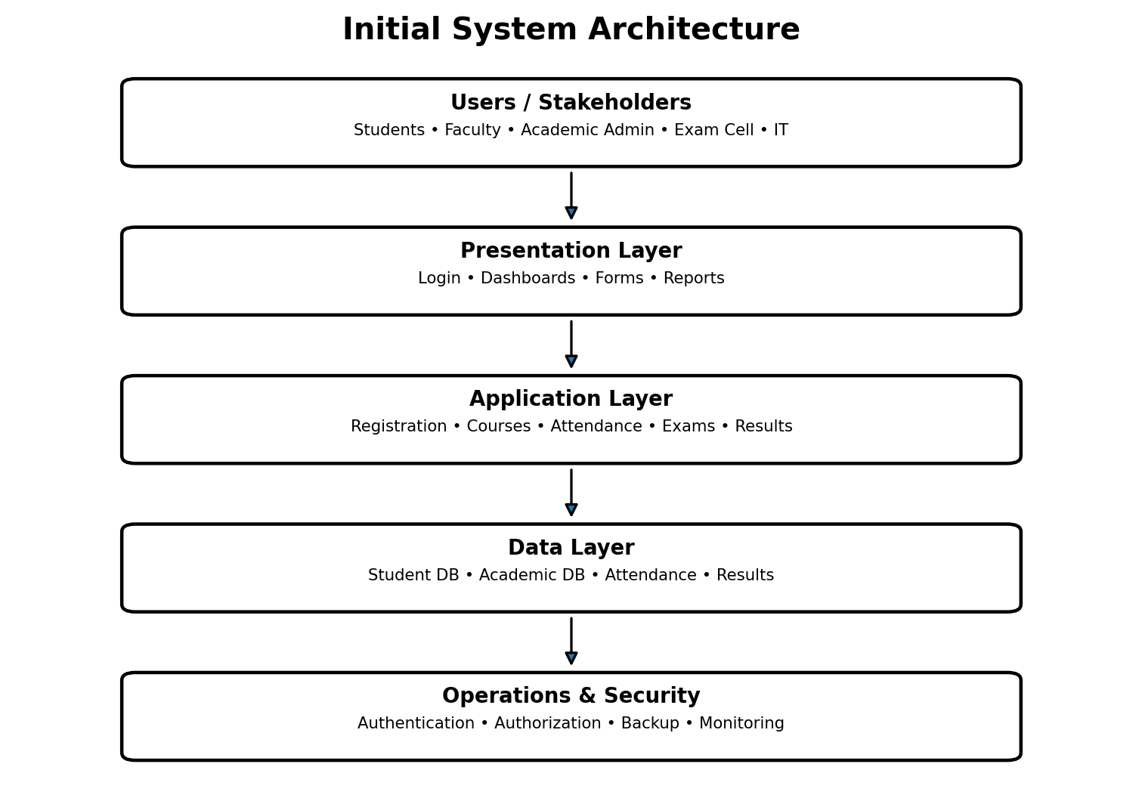

15.1 Architecture Explanation
Layer | Purpose | Example Components
Users | Access the platform | Student, Faculty, Admin, Exam Cell, IT
Presentation | User interaction | Login, dashboards, forms, reports
Application | Business rules | Registration, attendance, exams, results
Data | Persistent information | Student and academic records
Operations/Security | Protection and support | Authentication, authorization, backup, monitoring

16. Project Charter
Item | Description
Project Name | Enterprise Student Record and Academic Management Platform
Project Objective | Plan a user-centered academic record management product.
Primary Users | Students, Faculty, Academic Administrators, Examination Cell, IT Support
Scope | Unit–1 product discovery and planning
Key Deliverables | BRD, vision, stakeholder analysis, personas, FRS, NFRS, Design Thinking, IBM reports, MVP, roadmap, architecture, charter and repository
Success Condition | Clear and validated plan ready for subsequent Agile development
Major Constraint | Implementation is planned for subsequent units rather than being the primary Unit–1 activity

17. Git Repository Initialization

17.1 Suggested Repository Name
enterprise-student-academic-management-platform

17.2 Initialization Steps
- Create the Git repository.
- Add README.md.
- Create the standard folders.
- Add initial documentation.
- Commit the initial structure.
- Use clear commit messages for future work.

17.3 Example Git Workflow

The diagram above is a product lifecycle view; Git work should support the same iterative progression from planning to implementation and continuous improvement.

18. Project Folder Structure
enterprise-student-academic-management-platform/
├── app/
│ ├── modules/
│ │ ├── students/
│ │ ├── courses/
│ │ ├── attendance/
│ │ ├── examinations/
│ │ └── results/
│ ├── database/
│ └── tests/
├── docs/
│ ├── BRD/
│ ├── requirements/
│ ├── design-thinking/
│ ├── personas/
│ ├── architecture/
│ └── roadmap/
├── docker/
├── kubernetes/
├── terraform/
├── ansible/
├── monitoring/
├── .github/
│ └── workflows/
└── README.md

19. Product Discovery Documentation

19.1 Discovery Questions
- How are student records currently created and maintained?
- How do students access attendance and results?
- How do faculty members record attendance?
- How are examination results prepared?
- Which reports are required by administrators?
- Where do delays or duplicate data entry occur?
- What access restrictions are required for different users?

19.2 Discovery Outputs
Discovery Area | Expected Finding
Users | Different stakeholders have different workflows and expectations.
Pain Points | Manual/fragmented records can create delay and repeated effort.
Needs | Centralized records, attendance, results and reporting.
Constraints | Security, usability, reliability and scalability.
Validation | Prototype feedback should guide future iterations.

20. Testing and Validation Plan

20.1 Prototype Testing
Test Area | Example Test | Expected Result
Login | Can a user understand how to sign in? | Clear entry point
Dashboard | Can the user find the required module? | Easy navigation
Attendance | Can faculty locate and update attendance? | Task is understandable
Results | Can a student find result information? | Information is easy to locate
Reports | Can admin identify report generation? | Clear report workflow

20.2 Acceptance Criteria
- Core user flows are understandable.
- Stakeholders can identify their required information.
- Requirements are traceable to user needs.
- Prototype feedback is documented.
- MVP scope is realistic and focused on core value.

21. Risks and Mitigation
Risk | Impact | Mitigation
Unclear requirements | Rework | Use stakeholder interviews and prototype validation
Scope expansion | Delayed project | Keep MVP focused
Poor user adoption | Low value | Test with representative users
Data security issue | High impact | Plan authentication and authorization
Inconsistent records | Incorrect reports | Use structured data and validation
Maintenance difficulty | Future development delays | Use modular repository structure

22. Conclusion
The Enterprise Student Record and Academic Management Platform provides a structured Unit–1 product plan for higher education academic information management. The project begins with business understanding and Design Thinking, identifies stakeholders and user personas, defines functional and non-functional requirements, establishes a product vision and MVP, and then prepares the roadmap, architecture, project charter and repository structure. The diagrams and flows in this report make the proposed product and its development process easier to understand. The resulting plan is suitable as a foundation for Agile planning and implementation in subsequent units.

Appendix A – Quick Submission Checklist
- BRD completed
- Product Vision completed
- Stakeholder Analysis completed
- User Personas completed
- FRS completed
- NFRS completed
- Design Thinking completed
- IBM Design Thinking completed
- IBM Loop completed
- MVP defined
- Product Roadmap completed
- Architecture diagram included
- Project Charter completed
- Git repository plan included
- Folder structure included
- Product Discovery documentation included
- Flowcharts/diagrams included

