# **Year & Branch: TY ETC Subject: Web Technology Subject Code:ET3273**

# **Experiment no: 1**

**Grp-1**

|  |  |  |  |
| --- | --- | --- | --- |
| **Name** | **Roll No.** | **Division** | **GR. No.** |
| Krushna Durole | 62 | A | 12010277 |

# 

**Title:** Design static web page to demonstrate the use of different HTML tags.

**Aim:** Understand use of various HTML tags in web pages.

**Theory**:

An HTML element is defined by a starting tag.

* **<!DOCTYPE>** :- Defines the document type
* **<a>** : Defines a hyperlink
* **<address>** :- Defines contact information for the author/owner of a document
* **<area>** :- Defines an area inside an image map
* **<b>** :- Defines bold text
* **<br>** :- Defines a single line break
* **<body>** :- Defines the document’s body
* **<div> :-** Defines a section in a document
* **<footer>** :- Defines a footer for a document or section
* **<h1> to <h6>** :- Defines HTML headings
* **<img>** :- Defines an image
* **<nav>** :- Defines navigation links
* **<ol>** :- Defines an ordered list
* **<span>** :- Defines a section in a document
* **<td>** :- Defines a cell in a table
* **paragraph** tag offers a way to structure your text into different paragraphs each paragraph of text should go in between an opening

and a closing

* **title** - the title tag is an html code tag that allows you to give a web page a title
* **head** - <head> element is a container for metadata (data about data) and is placed between the <html> tag and the <body> tag.
* **img**-the <img> tag is used to embed an image in an html page.
* **h** - the <h1> to <h6> tags are used to define html headings.<h1> defines the most important heading. <h6> defines the least important heading.
* **em**- the <em> tag is used to define emphasized text. the content inside is typically displayed in italic.
* **strong** - the <strong> tag is used to define text with strong importance
* **a** - he <a> tag defines a hyperlink, which is used to link from one page to another.
* **ul** and li - the <ul> tag defines an unordered (bulleted) list. use the <ul> tag together with the <li> tag to create unordered lists. tip: use css to style lists. tip: for ordered lists, use the <ol> tag.
* **ol**- the <ol> tag defines an ordered list. an ordered list can be numerical or alphabetical. the <li> tag is used to define each list item.
* **table** - the <table> tag defines an html table.
* **tbody**- the <tbody> tag is used to group the body content in an html table
* **thead** - the <thead> tag is used to group header content in an html table.
* **tr** - the <tr> tag defines a row in an html table.
* **Form** The <form> tag is used to create an HTML form for user input.
* **Input -** The <input> tag specifies an input field where the user can enter data.
* **Textarea -** The <textarea> tag defines a multi-line text input control.
* **Button -** The <button> tag defines a clickable button.
* **Select -** The <select> element is used to create a drop-down list.
* **Option -**The <option> tag defines an option in a select list.
* **Label -** The <label> tag defines a label for several elements:

**CODE**:

Home

<!DOCTYPE html>

<html lang="en">

<head>

    <meta charset="UTF-8">

    <meta http-equiv="X-UA-Compatible" content="IE=edge">

    <meta name="viewport" content="width=device-width, initial-scale=1.0">

    <title>Bookify-Home</title>

</head>

<body style="background-color: rgb(222, 205, 205);">

    <nav>

        <button> <label for=""> <a href="Login.html">Login</a></label></button>

        &nbsp;&nbsp;

        <button><label for=""> <a href="Signup.html">Signup</a></label></button>

        &nbsp;&nbsp;

        <button><label for=""><a href="form.html">Submit-Book</a></label></button>

        &nbsp;&nbsp;

        <button><label for=""><a href="Book info.html">Book Info</a></label></button>

        &nbsp;&nbsp;

        <button><label for=""> <a href="contact.html">Contact</a></label></button>

        &nbsp;&nbsp;

    </nav>

    <hr>

    <h1><b>Bookify</b></h1>

    <p>

        Hello !!! <br>

        welcome to <em>Bookify</em>  platform where you can sell, Buy and donate your books.

        platform is developed for helping  community which loves books.

        if you need any help feel free to use this platform.

        <br>

        To access the servies of the platform

        you need to first <B>Register/SignUp </B> and <B>Log In</B>

    </p><br><br><br><p>

        Books available : <a href="Book info.html">Click Here</a>

     </p><hr>

     <h2>Other books available</h2>

     <ol>

        <li>Sherlock Holmes</li>

        <li>The girl next door</li>

        <li>Kite runner</li>

        <li>To kill a mockinjay</li>

     </ol>     <hr>

     <h2>Other authors available</h2>

     <ul>

        <li>Charles Dickens</li>

        <li>Chetan Bhagat</li>

        <li>Ruskin Bond</li>

        <li>Sudha Murthy</li>

     </ul>

     <hr>

     <h2>Audio Books</h2>

     <p>

        <a href="audio.html">Audio Books</a>

     </p>

</body>

</html>

Signup

<!DOCTYPE html>

<html lang="en">

<head>

    <meta charset="UTF-8">

    <meta http-equiv="X-UA-Compatible" content="IE=edge">

    <meta name="viewport" content="width=device-width, initial-scale=1.0">

    <title>Bookify-Signup</title>

    <script>

        function SignUP(){

            alert("You have registered Successfully") }

    </script>

</head>

<body>

    <label><a href="Home.html">DashBoard</a></label>

    <label><a href="Login.html">Login</a></label>

    <HR></HR>

    <h1>Sign Up</h1>

    <p>Sign Up and register to this platform for amazing servies. </p>

    <form>

        <label > Name     :</label><br>

        <input type="text" required> <br>

        <label>College Name   : </label><br>

        <input type="text" required><br>

        <label> PRN           : </label><br>

        <input type="text" required><br>

        <label> Branch        : </label><br>

        <input type="text" required><br>

        <label> Roll No: </label><br>

        <input type="text" required><br>

        <label for="">Email</label><br>

        <input type="text" required><br> <br>

        <button onclick="SignUp()">Submit Book</button>

    </form>

</body>

</html>

Login

<!DOCTYPE html>

<html lang="en">

<head>

    <meta charset="UTF-8">

    <meta http-equiv="X-UA-Compatible" content="IE=edge">

    <meta name="viewport" content="width=device-width, initial-scale=1.0">

    <title>Bookify-Login</title>

    <script>

        function Login(){alert("You have successfully Logged In") }

    </script>

</head>

<body>

    <label><a href="Home.html">DashBoard</a></label>

    <HR></HR>

    <h2>Login</h2>

    <p>Please Login First to access the platform's services</p>

    <form >

        <label for="fname">First name:</label><br>

        <input type="text" id="fname" name="fname"><br>

        <label for="lname">Last name:</label><br>

        <input type="text" id="lname" name="lname"> <br>

        <label for="lprn">PRN : </label><br>

        <input type="text" id="lprn" name="lprn"> <br> <br>

        <button onclick="Login()">Submit</button>

      </form>

</body>

</html>

Authors

<!DOCTYPE html>

<html lang="en">

<head>

    <meta charset="UTF-8">

    <meta http-equiv="X-UA-Compatible" content="IE=edge">

    <meta name="viewport" content="width=device-width, initial-scale=1.0">

    <title>Author's Info</title>

</head>

<body>

    <label><a href="Home.html">DashBoard</a></label>

    <hr>

    <h1>Authors</h3>

        <hr >

        <table cellspacing="30" >

            <thead position="sticky">

                <th bgcolor="gray">Author Name</th>

                <th bgcolor="gray">Image</th>

                <th bgcolor="gray">Bio</th>

            </thead>

            <tbody>

                <tr>

                    <td>Agatha Cristie</td>

                    <td><img src="/images/Agatha_Christie.png" alt="Agatha's Profile Picture"></td>

                    <td>Dame Agatha Mary Clarissa Christie, Lady Mallowan, DBE (née Miller; 15 September 1890

                        12 January 1976) was an English writer known for her 66 detective novels and 14 short story

                        collections, particularly those revolving around fictional detectives Hercule Poirot and Miss Marple.

                        She also wrote the world's longest-running play, the murder mystery The Mousetrap, which has been

                         performed in the West End since 1952. A writer during the "Golden Age of Detective Fiction",

                         Christie has been called the "Queen of Crime". She also wrote six novels under the pseudonym

                         Mary Westmacott. In 1971, she was made a Dame (DBE) by Queen Elizabeth II for her

                         contributions to literature. Guinness World Records lists Christie as the best-selling

                         fiction writer of all time, her novels having sold more than two billion copies.</td>

                </tr>

                <tr>

                    <td>Salman Rushdie</a></td>

                    <td><img src="/images/Hayfestival-2016-Salman-Rushdie-1-cu.jpg" alt="Salman's Profile Picture"></td>

                    <td>Sir Ahmed Salman Rushdie CH FRSL ( born 19 June 1947) is an Indian-born

                        British-American novelist.[3] His work often combines magic realism with historical fiction and

                        primarily deals with connections, disruptions, and migrations between Eastern and Western civilizations,

                        typically set on the Indian subcontinent.Rushdie was born in India, but was sent to England to go to private school.

                        He has lived in the United States since 2000. Rushdie is well known for writing stories which use "magic realism",

                        which is similar to surrealism. This means that things in his stories happen which may be magic or impossible,

                        such as falling from an aeroplane and floating down as gently as paper.[2] He often writes about India, and his

                        stories often are set in different parts of the world.</td>

                </tr>

                <tr>

                    <td>Jules Verne</td>

                    <td><img src="/images/Jules_Verne_by_Étienne_Carjat.jpg" alt="Jules's Profile Picture"></td>

                    <td>Jules Gabriel Verne (8 February 1828-24 March 1905) was a French novelist, poet, and playwright.

                        His collaboration with the publisher Pierre-Jules Hetzel led to the creation of the Voyages

                        extraordinaires,[3] a series of bestselling adventure novels including Journey to the Center

                        of the Earth (1864), Twenty Thousand Leagues Under the Seas (1870), and Around the World in

                        Eighty Days (1872). His novels, always well documented, are generally set in the second half of

                        the 19th century, taking into account the technological advances of the time.</td>

                </tr>

            </tbody>

        </table>

</body>

</html>

Form

<!DOCTYPE html>

<html lang="en">

<head>

    <meta charset="UTF-8">

    <meta http-equiv="X-UA-Compatible" content="IE=edge">

    <meta name="viewport" content="width=device-width, initial-scale=1.0">

    <title>Bookify-Submit</title>

    <script>

        function execute() {

            alert("Book is submitted")

        }

    </script>

</head>

<body>

    <label> <a href="Login.html">Login</a> </label>

    <label ><a href="Signup.html">SignUp</a></label>

    <label><a href="Home.html">DashBoard</a></label>

    <hr>

    <h1>Submit a Book</h1>

    <p>

        You can submite your precious books here.

    </p>

    <form>

        <label >Book Name     :</label> <br>

        <input type="text" required> <br>

        <label>College Name   : </label><br>

        <input type="text" required><br>

        <label> PRN           : </label><br>

        <input type="text" required><br>

        <label> Branch        : </label><br>

        <input type="text" required><br>

        <label> Author Name   : </label><br>

        <input type="text" required><br><br>

        <button onclick="execute()">Submit Book</button>

    </form>

</body>

</html>

Book info

<!DOCTYPE html>

<html><head>

<title style = "color: blueviolet;">Book information</title>

</head>

<body>

   <label><a href="Home.html">DashBoard</a></label>

    <HR></HR>

   <table style ="padding: 100px;border-spacing: 40px">

   <tr>

    <th >S no.</th>

    <th >Book name</th>

    <th >Author</th>

    <th >Link</th>

   </tr>

   <tr>

      <h1>Books Information</h1>

   <td>1.</td>

   <td>Murder on the Orient Express</td>

   <td>Agatha Christie</td>

   <td><a href="https://www.amazon.in/Murder-Orient-Express-Poirot-Christie/dp/0007527500">Murder-Orient-Express-Poirot-Christie</a></td>

   </tr>

    <tr>

        <td>2.</td>

        <td>Midnight's Children</td>

        <td>Salman Rushdie</td>

        <td><a href="https://www.amazon.in/Midnights-Children-Salman-Rushdie/dp/0099582074/ref=sr_1_3?crid=FRTP5T67DYWO&keywords=midnights+children&qid=1672723287&s=books&sprefix=midnught%2Cstripbooks%2C421&sr=1-3">Midnights-Children-Salman-Rushdie</a></td>

   </tr>

   <tr>

    <td>3.</td>

    <td>Journey to the centre of the Earth</td>

    <td>Jules Verne</td>

    <td><a href="https://www.amazon.in/Journey-Centre-Earth-Jules-Verne/dp/8175994053/ref=sr_1_10?crid=1QSAZQDGMGQ9C&keywords=books+to+read&qid=1672723373&s=books&sprefix=books+to+read%2Cstripbooks%2C316&sr=1-10">Journey-Centre-Earth-Jules-Verne</a></td>

   </tr>

   <tr>

    <td>4.</td>

    <td>Little Women</td>

    <td>Jane Austen</td>

    <td><a href="https://www.amazon.in/Worlds-Greatest-Classics-Box-Books/dp/9354401570/ref=sr_1_16?crid=1QSAZQDGMGQ9C&keywords=books+to+read&qid=1672723373&s=books&sprefix=books+to+read%2Cstripbooks%2C316&sr=1-16">Worlds-Greatest-Classics-Box-Books</a></td>

   </tr>

   </table>

   <h3>Access Authors Info</h3>

   <label><a href="authors.html">Click here!!!</a></label>

</body>

</html>

Audio

<!DOCTYPE html>

<html lang="en">

<head>

    <meta charset="UTF-8">

    <meta http-equiv="X-UA-Compatible" content="IE=edge">

    <meta name="viewport" content="width=device-width, initial-scale=1.0">

    <title>audio</title>

</head>

<body style="background-color: beige;">

    <nav>

        <button><label for=""> <a href="Home.html">DashBoard</a></label></button>

        &nbsp;&nbsp;

        <button> <label for=""> <a href="Login.html">Login</a></label></button>

        &nbsp;&nbsp;

        <button><label for=""> <a href="Signup.html">Signup</a></label></button>

        &nbsp;&nbsp;

        <button><label for=""><a href="form.html">Submit-Book</a></label></button>

        &nbsp;&nbsp;

        <button><label for=""><a href="Book info.html">Book Info</a></label></button>

        &nbsp;&nbsp;

        <button><label for=""> <a href="contact.html">Contact</a></label></button>

        &nbsp;&nbsp;

    </nav>

    <hr>

    <h1>Audio Books</h1>

    <table cellspacing="40px">

        <th>Name of the Book</th>

        <th>Audio</th>

        <th>Video</th>

        <tr>

            <td><b><mark style="background-color: rgb(158, 172, 212);">Sherlock Holmes</mark></b> </td>

            <td>

                <audio controls>

                    <source src="/images/title.mp3" type="audio/mp3">

                </audio>

            </td>

            <td>

                <iframe width="560" height="315" src="https://www.youtube.com/embed/IS5iOCTREXA" title="YouTube video player" frameborder="0" allow="accelerometer; autoplay; clipboard-write; encrypted-media; gyroscope; picture-in-picture; web-share" allowfullscreen></iframe>

            </td>

        </tr>

        <tr>

            <td> <mark style="background-color: rgb(135, 178, 155);">The girl next door</mark></td>

            <td>

                <audio controls>

                    <source src="/images/title.mp3" type="audio/mp3">

                </audio>

            </td>

            <td>

                <iframe width="560" height="315" src="https://www.youtube.com/embed/QPI7dOGI8RM" title="YouTube video player" frameborder="0" allow="accelerometer; autoplay; clipboard-write; encrypted-media; gyroscope; picture-in-picture; web-share" allowfullscreen></iframe>

            </td>

        </tr>

        <tr>

            <td><mark style="background-color: rgb(202, 150, 190);">Kite Runner</mark></td>

            <td>

                <audio controls>

                    <source src="/images/title.mp3" type="audio/mp3">

                </audio>

            </td>

            <td>

                <iframe width="560" height="315" src="https://www.youtube.com/embed/uSDHIWHjxws" title="YouTube video player" frameborder="0" allow="accelerometer; autoplay; clipboard-write; encrypted-media; gyroscope; picture-in-picture; web-share" allowfullscreen></iframe>

            </td>

        </tr>

    </table>

</body>

</html>

Contact

<!DOCTYPE html>

<html lang="en">

<head>

    <meta charset="UTF-8">

    <meta http-equiv="X-UA-Compatible" content="IE=edge">

    <meta name="viewport" content="width=device-width, initial-scale=1.0">

    <title>Contact Us</title>

</head>

<body>

    <label><a href="Home.html">DashBoard</a></label>

    <HR></HR>

    <h1>You can reach us at</h3>

        <hr >

        <table>

            <tr>

                <td>Phone No.</td>

                <td><address>

                    <a href="+919370394253">9370394253</a>

                </address></td>

            </tr>

            <tr>

                <td>Email ID</td>

                <td><address>

                    <a href="tyedi1234@gmail.com">tyedi1234@gmail.com</a>

                </address></td>

            </tr>

        </table>

        <hr >

        <form class="" action="mailto:tyedi1234@gmail.com" method="post" enctype="text/plain">

            <label for="name">Enter your Name: </label>

            <input type="text" name="yourName" id=""><br>

            <label for="email">Enter your Email: </label>

            <input type="email" name="yourEmail"><br>

            <label for="message">Enter your message:</label><br>

            <textarea name="yourMessage" id="" cols="30" rows="10">Type here..</textarea><br>

            <input type="submit" name="yourSubmit" id="">

           </form>

</body>

</html>

# **RESULT:**

**Home Page:**

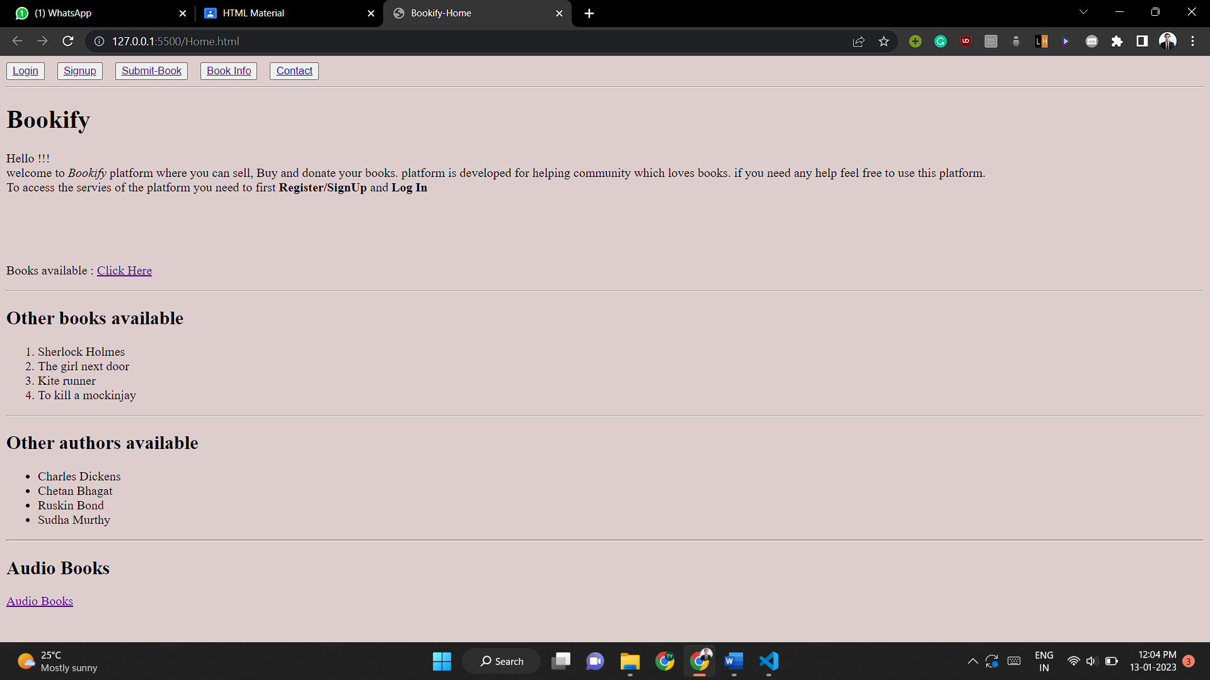

**Login Page:**

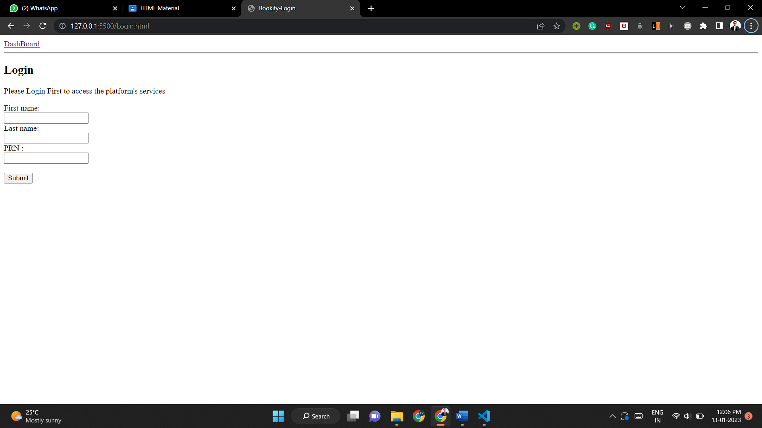

**Signup Page:**

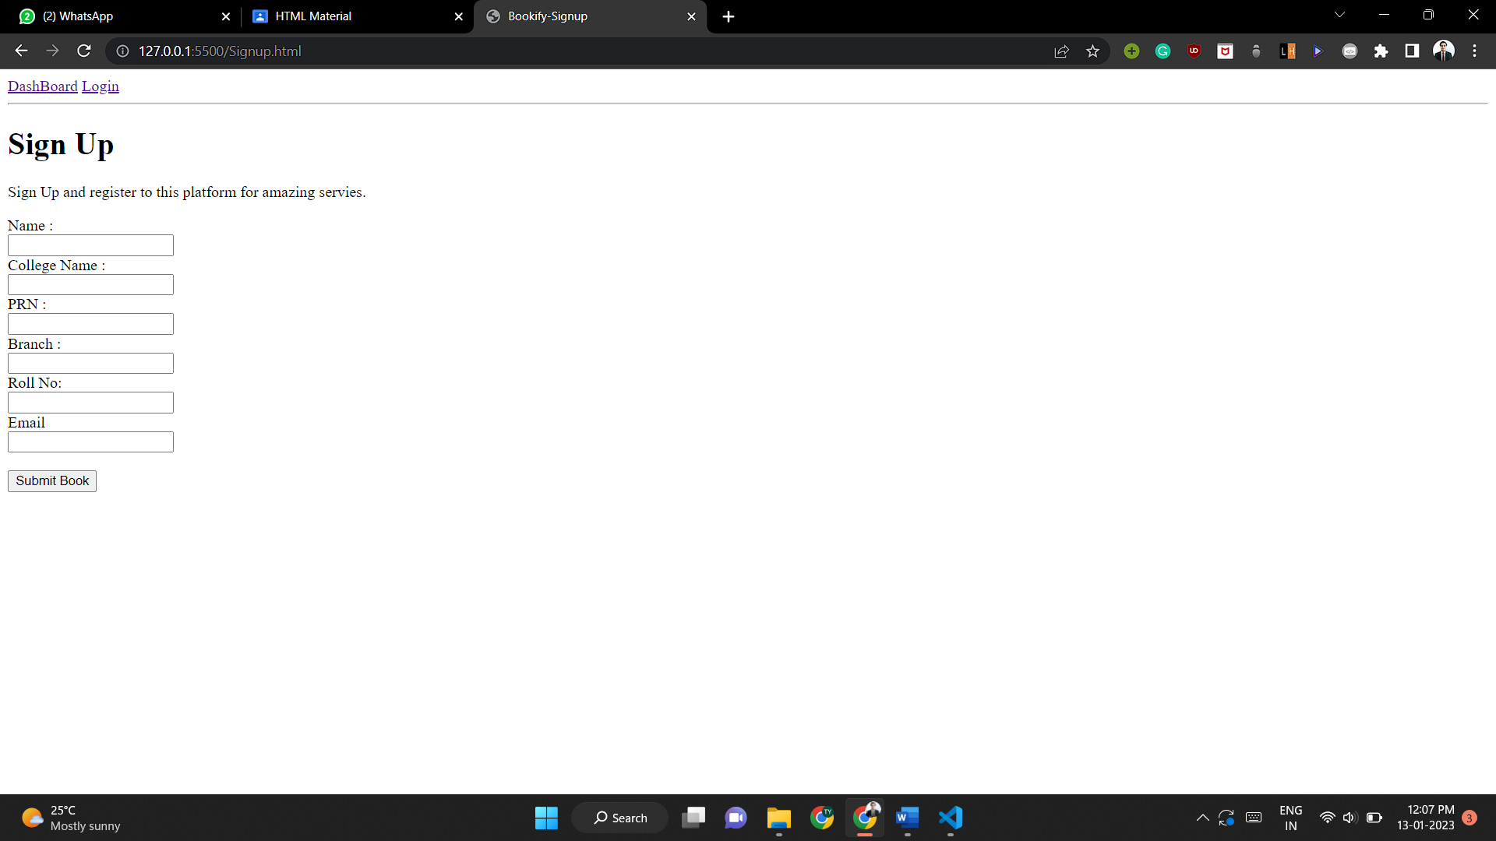

**Book Info:**

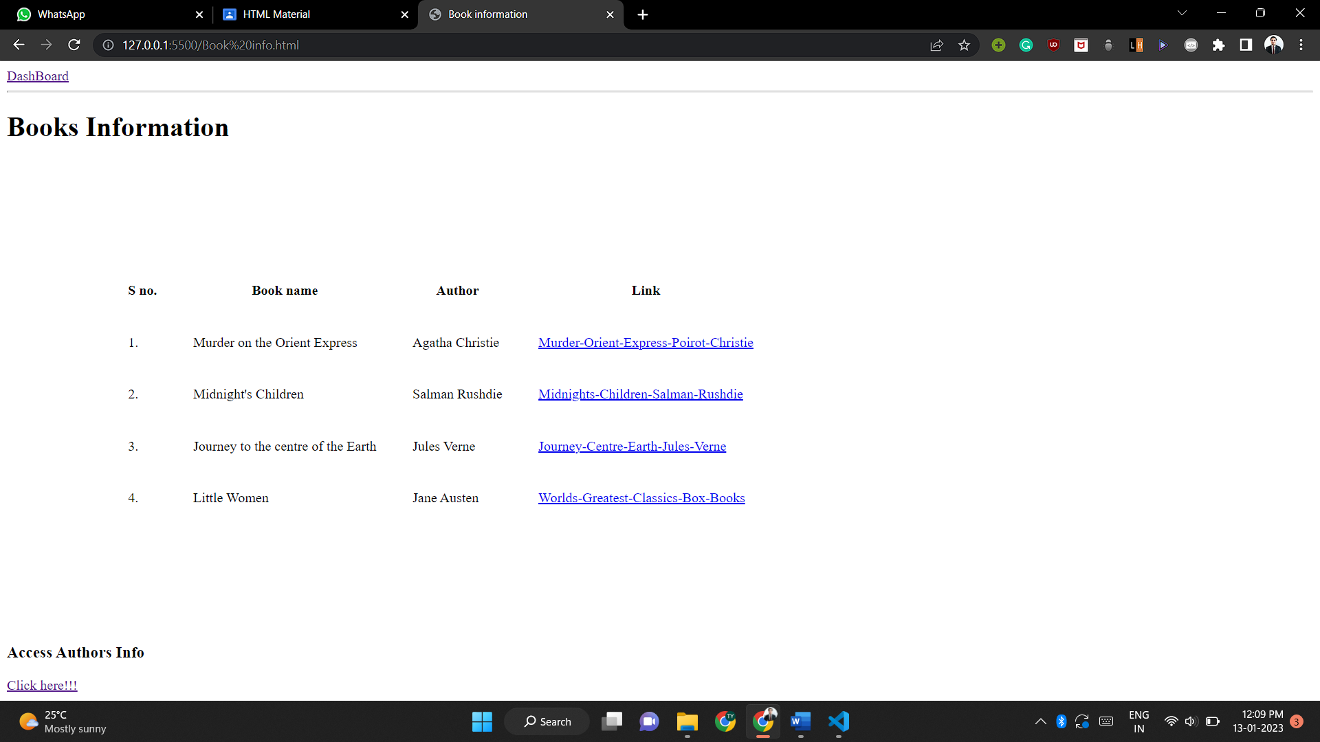

**Submit Book:**

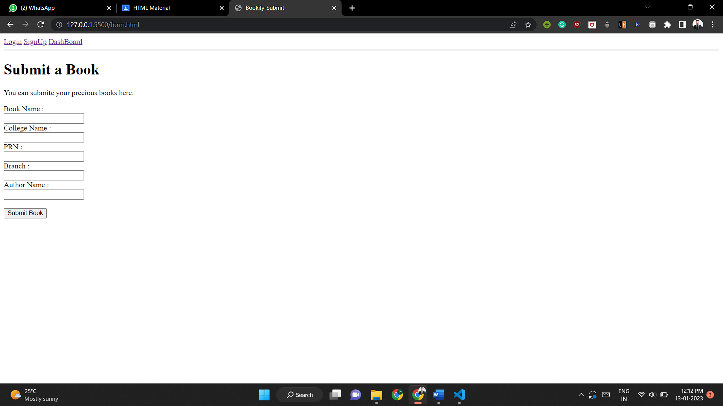

**Contact Info:**

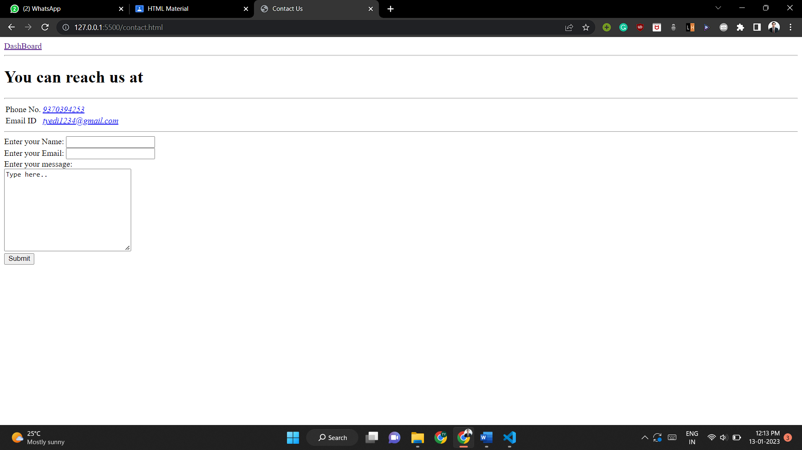

**Authors’ Info:**

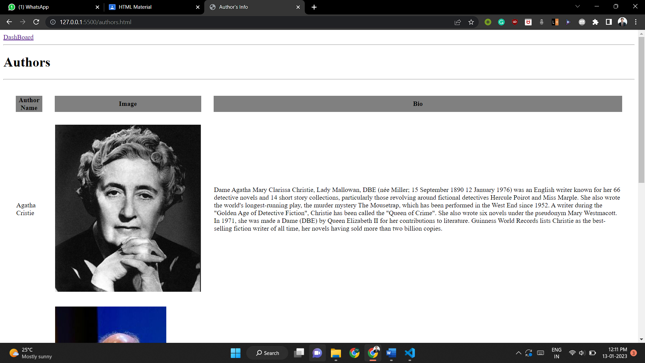

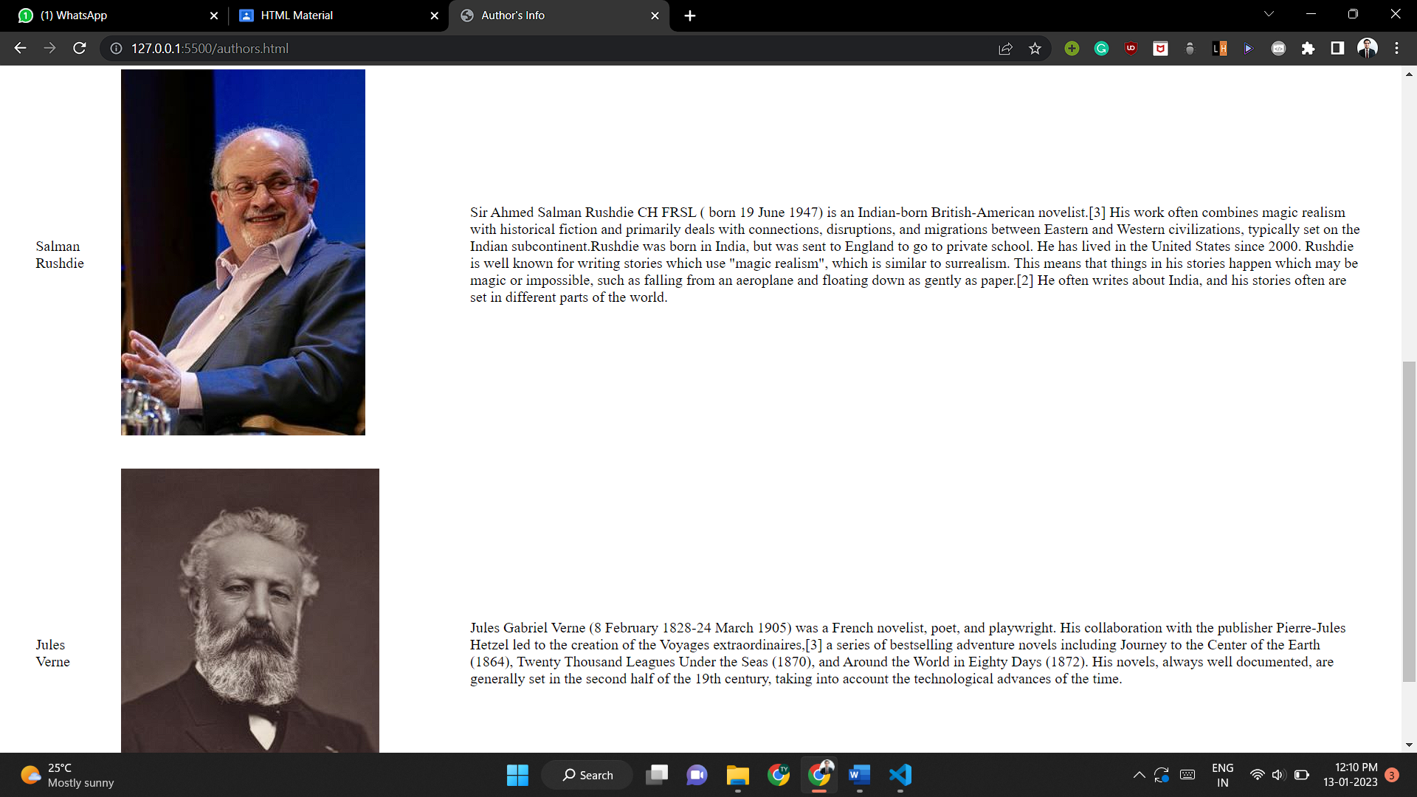

**Audio Books:**

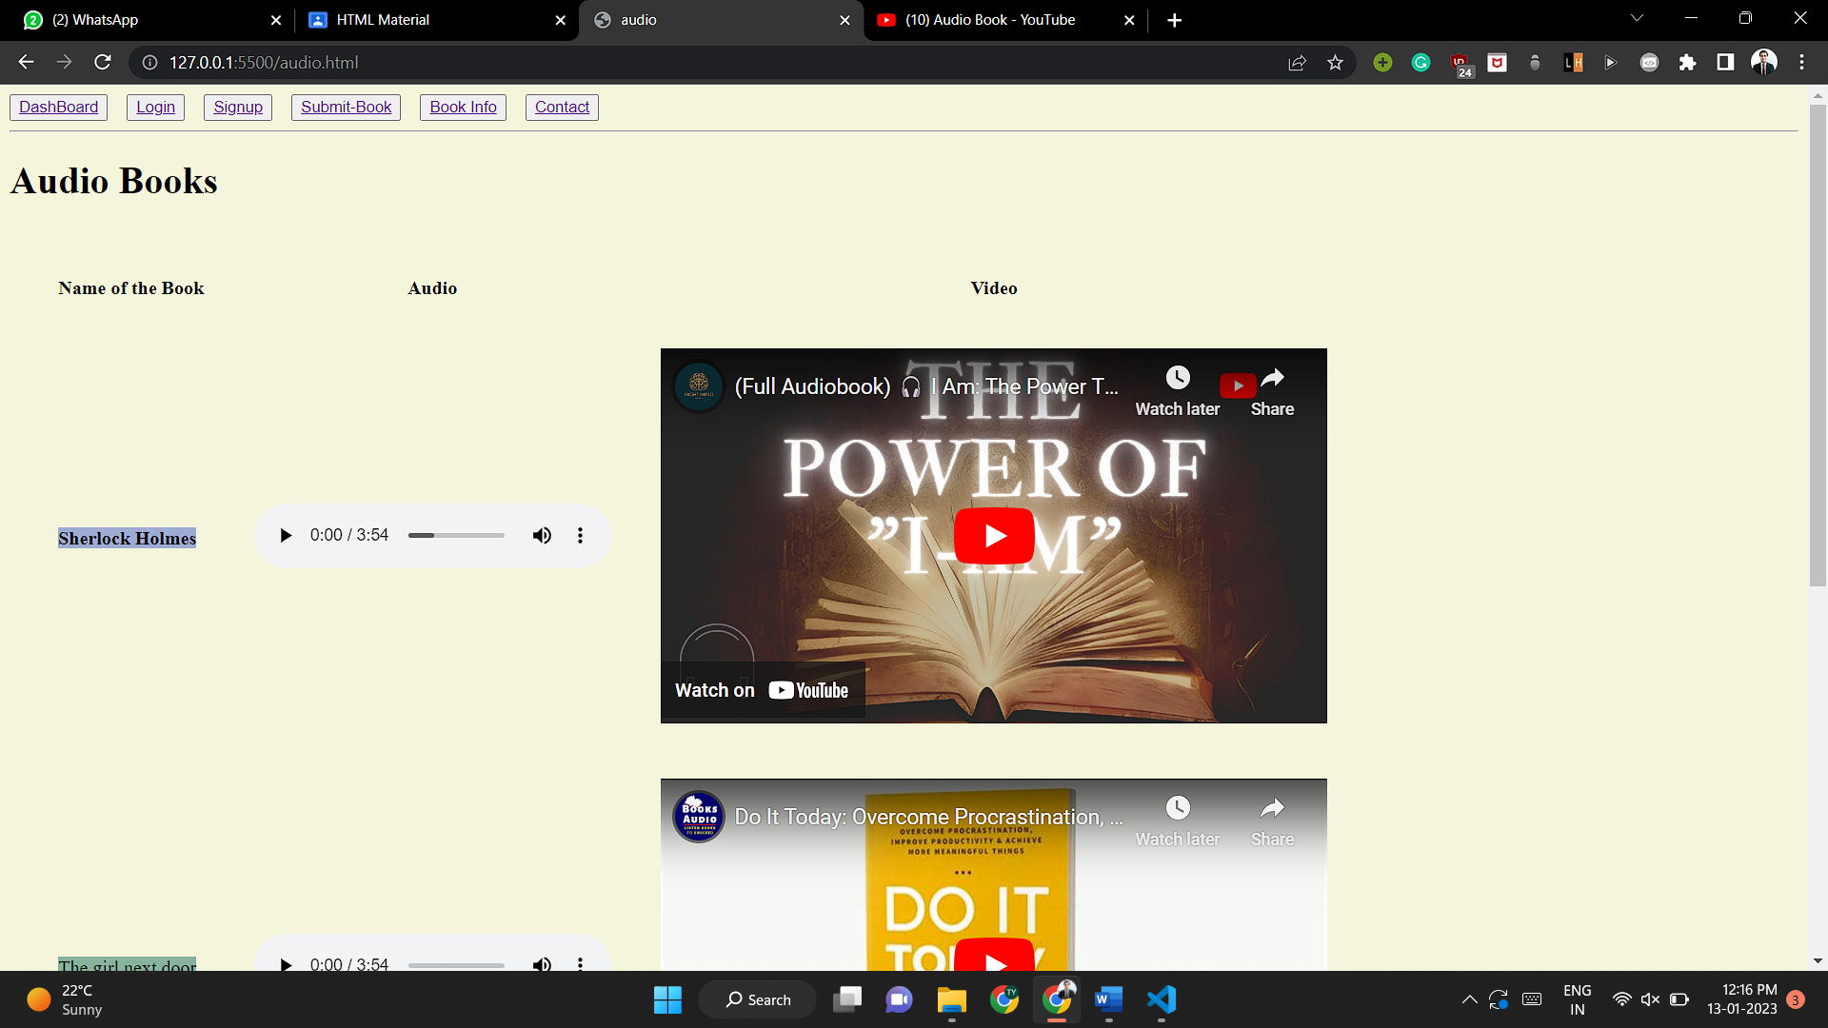

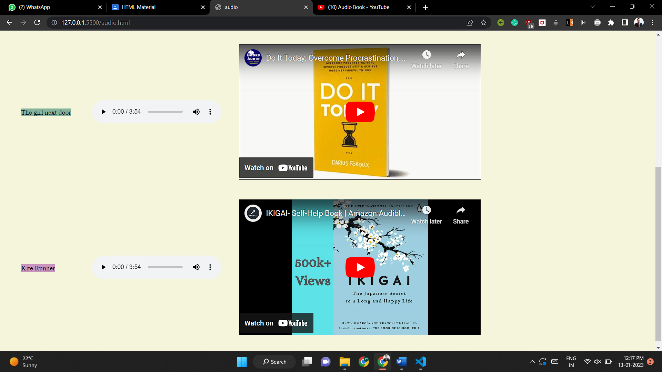

**CONCLUSION:**

HTML, or HyperText Markup Language, is the standard markup language for documents intended to be displayed in a web browser. With the help of this exercise, we became acquainted with HTML through hands-on building of a E-book commerce website, utilising only HTML tags. Currently, 100+ HTML tags are available to describe the entire structure and different functionalities of the website.