**Practical 1: Demonstration of creating database.**

**Name : Aditya Pradip Patil**

**Batch : B3 Roll.no : 94 Div : A**

**\*\*\*\*\*\*\*\*\*\*\*\*\*\*\*\*\*\*\*\*\*\*\*\*\*\*\*\*\*\*\*\*\*\*\*\*\*\*\*\*\*\*\*\*\*\*\*\*\*\*\*\*\*\*\*\*\*\*\*\*\*\*\*\*\*\***

create database studentdb;

use studentdb;

**OUTPUT:**

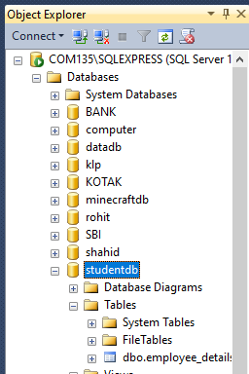

**Practical 2: Create table insert 10 records in it.**

**Name : Aditya Pradip Patil**

**Batch : B3 Roll.no : 94 Div : A**

**\*\*\*\*\*\*\*\*\*\*\*\*\*\*\*\*\*\*\*\*\*\*\*\*\*\*\*\*\*\*\*\*\*\*\*\*\*\*\*\*\*\*\*\*\*\*\*\*\*\*\*\*\*\*\*\*\*\*\*\*\*\*\*\*\*\***

CREATE TABLE employee_details1(

id int,

emp_name VARCHAR(89),

emp_add VARCHAR(89)

);

INSERT INTO employee_details1(id ,emp_name ,emp_add)

values(1,'yash baviskar','gangaram plot');

INSERT INTO employee_details1(id ,emp_name ,emp_add)

values(2,'rohit patil','jamner road');

INSERT INTO employee_details1(id ,emp_name ,emp_add)

values(3,'nilesh patil','lalbag');

INSERT INTO employee_details1(id ,emp_name ,emp_add)

values(4,'lalu patil','nehru road');

INSERT INTO employee_details1(id ,emp_name ,emp_add)

values(5,'sukhdev rane','ty collage');

INSERT INTO employee_details1(id ,emp_name ,emp_add)

values(6,'mahesh nale','nv park');

INSERT INTO employee_details1(id ,emp_name ,emp_add)

values(7,'nilesh tivari','bg finess');

INSERT INTO employee_details1(id ,emp_name ,emp_add)

values(8,'rohit bodade','ram mandit');

INSERT INTO employee_details1(id ,emp_name ,emp_add)

values(9,'ashish patil','imr collage');

INSERT INTO employee_details1(id ,emp_name ,emp_add)

values(10,'mohit patil','dy school');

select * from employee_details1;

OUTPUT:

