AGRIHUB
- Home
- About
- Services
- Team
English हिंदी (Hindi) मराठी (Marathi) LOGIN REGISTER

Empowering Farmers with
Digital Innovation
A one-stop solution for crops, fertilizers, and government schemes.
Explore Platform

Why AgriHub?

The Problem
Farmers struggle with lack of centralized info on schemes and nutrients.

Our Objective
To bridge the gap between farmers and technology.

The Impact
Increased income, better soil quality, and digital literacy.

Our Services

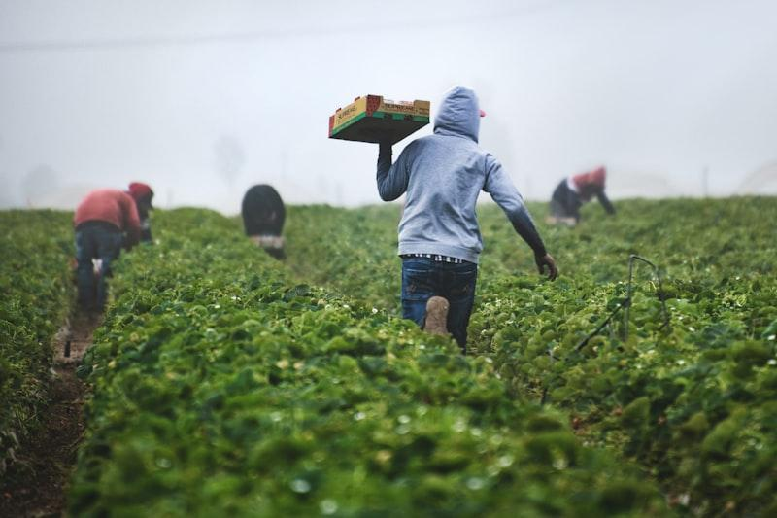

Fertilizer Info
Get correct dosage, application methods, and real-time prices.
Crop Guide



Govt Schemes
Latest updates on subsidies and welfare programs.
Central Schemes



Weather Forecast
Real-time weather updates to plan your sowing and harvesting activities.
Live Alerts

Crop Advisor
AI-driven recommendations based on season, soil, and budget.
Profit Maximizer

Project Team

Aditya Hawaldar

Krushna Patil

Sumit Chandanshive

Manthan Autade

AGRIHUB
Digitalizing Agriculture for a better tomorrow. Connecting farmers, markets, and technology for sustainable growth.

Quick Links
- Home
- About Us
- Services
- Our Team

© 2024 AgriHub Project. All Rights Reserved.
Back to Home

Advanced Fertilizer Calculator
Precise Nutrient Management for Higher Yields

Land Size (in Acres)
Select Crop Category Wheat (गेहूँ) Rice/Paddy (चावल/धान) Maize (मक्का) Pearl Millet (बाजरा) Sorghum (ज्वार) Cotton (कपास) Sugarcane (गन्ना) Soybean (सोयाबीन) Chickpea (चना) Pigeon Pea (तूर/अरहर) Green Gram (मूँग) Black Gram (उड़द) Groundnut (मूंगफली) Mustard (सरसों) Sunflower (सूरजमुखी) Potato (आलू) Onion (प्याज) Tomato (टमाटर) Chili (मिर्च) Brinjal (बैंगन) Okra (भिन्डी) Cabbage/Cauliflower (गोभी) Ginger (अदरक) Turmeric (हल्दी) Banana (केला) Pomegranate (अनार)

Recommendation (per acre)

Primary Nutrients (NPK)
Urea (N): 0 kg
DAP (P): 0 kg
MOP (K): 0 kg
*Alternative to DAP: SSP (Single Super Phosphate): 0 kg

Micronutrients & Soil Health
Zinc Sulphate: 0 kg
Sulphur (Bentonite): 0 kg
Magnesium Sulphate: 0 kg
Organic Manure (FYM): 0 tons
*Note: These are general recommendations. For precise dosage, please get your Soil Health Card tested.
Back to Home

Central Government Schemes
Major flagship initiatives by the Government of India.

PM-Kisan Samman Nidhi
₹6,000 per year income support for all landholding farmers.
Check Eligibility

PM Fasal Bima Yojana
Comprehensive crop insurance against non-preventable natural risks.
Apply Now

PM Krishi Sinchayee Yojana
"Har Khet Ko Pani" - Subsidies for drip/sprinkler irrigation systems.
Apply Subsidy

e-NAM (National Agri Market)
Pan-India electronic trading portal for better price discovery.
Register to Sell

Paramparagat Krishi Vikas
Financial assistance of ₹50,000/ha for organic farming.
View Guidelines

PM Kisan Maan-Dhan
Pension scheme for small farmers (₹3000/month after age 60).
Enroll Now

Kisan Credit Card (KCC)
Get short-term credit for crops at low interest rates.
Get Details

Soil Health Card Scheme
Get soil testing done to know nutrient status and recommendations.
Locate Lab
Back to Home

Real-Time Weather
Accurate Forecast based on your current location.

Detect My Location

Fetching satellite data...

Detecting City...

--°C
--
-- km/h | --%
Back to Home

Profitable Crop Advisor
Find the most profitable crop for your land.

Select Season Kharif (Monsoon - June to Oct) Rabi (Winter - Oct to March) Zaid (Summer - March to June)
Soil Type Black Soil (Kali Mitti) Red Soil (Lal Mitti) Alluvial Soil (Jalodh Mitti)
Investment Capacity (per acre) Low (< ₹10,000) Medium (₹10k - ₹25k) High (> ₹25k)
Find Best Crop

×
Login Register

Welcome Back
Mobile Number
Password

Login
Create Account
Full Name
Mobile Number
Create Password
Register

