 | DHOLE PATIL EDUCATION SOCIETY’s  DHOLE PATIL COLLEGE OF ENGINEERING  Accredited by NAAC with A+ Grade, An ISO 9001:2015 Certified Institute  1284, Near Eon IT Park Kharadi, Dhole Patil College Road, Wagholi, Pune-412207  Website-www.dpcoepune.edu.in E-mail: dpcoepune@gmail.com, Phone:020-66059900
Sub: PPS
Notes on Unit-II
Explain selection/conditional statements in python.
In Python, decision control statements allow the program to make decisions and execute specific blocks of code based on conditions. These are essential for controlling the flow of the program. The main types of decision control statements are
- if statements
An if statement consists of a boolean expression followed by one or more statements.
Syntax
if condition:
Body of if

Example
var = 100
if ( var == 100 ) :
print ("Value of expression is 100")

- if…..else statements
An if statement can be followed by an optional else statement, which executes when the boolean expression is FALSE.
Syntax:
if:
Statements/body of if
else:
Statements/body of else

Example:
var = 100
if ( var == 100 ):
print ("Value of var is equal to 100")
else:
print("Value of var is not equal to 100")

- if elif else statements
A nested if is another decision making statement in which one if statement resides inside another. It allows us to check multiple conditions sequentially.
Syntax:
if condition1:
# code block if
elif condition2:
# code block elif
else:
# code block else

Example:
number = -5
if number > 0:
print('Positive number')
elif number < 0:
print('Negative number')
else:
print('Zero')

Explain different loop control statements in python.
- while Loop
In Python, we use a while loop to repeat a block of code until a certain condition is met.
Syntax:
while condition:
body of while loop
Flowchart:
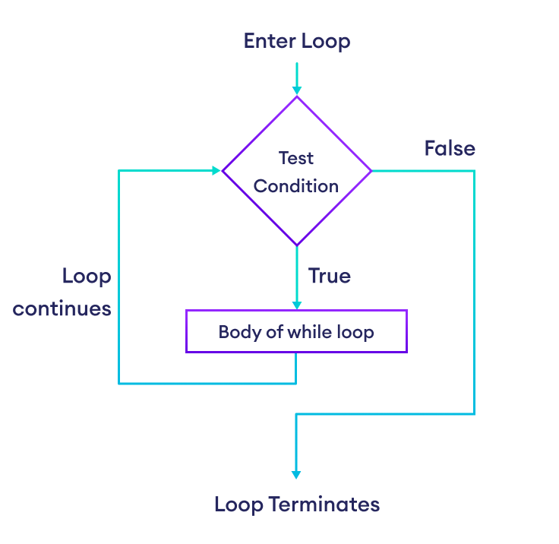
Example:
number = 1
while number <= 3:
print(number)
number = number + 1

- for Loop
In Python, we use a for loop to iterate over sequences such as lists, strings, dictionaries, etc.
Syntax:
for val in sequence:
body of for loop
Example:
languages = [C, 'Python', 'Java']
# access elements of the list one by one
for lang in languages:
print(lang)

for Loop with Python range()
In Python, the range() function returns a sequence of numbers. For example,
# iterate from i = 0 to i = 3
for i in range(0, 4):
print(i)
Flowchart:
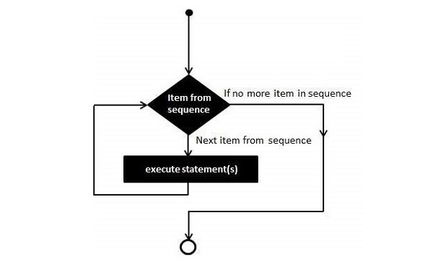
Explain break and continue statement with suitable example.
The break and continue statements are used to alter the flow of loops.
- Break statement:
Python break statement is used to terminate the current loop.
Syntax:
looping statement:
condition check:
break
Example:
numbers = [1,2,3,4,5]
for num in numbers:
if num == 3:
break
print(num)
output: 1,2

- Continue statement
Python continue statement is used to skip the execution of the program block.
Syntax:
looping statement:
condition check:
continue
Example:
numbers = [1,2,3,4,5]
for num in numbers:
if num == 3:
continue
print(num)
output: 1,2,4,5
Explain range () and Pass() function in python.
- range()
Python's built-in range() function returns an iterator object that streams a sequence of numbers. This object contains integers from start to stop, separated by step parameter.
Syntax:
range(start, stop, step)
where,
- Start − Starting value of the range. Optional. Default is 0
- Stop − The range goes upto stop-1
- Step − Integers in the range increment by the step value. Option, default is 1.
Example:
for num in range(5):
print (num) # output= 1,2,3,4

- pass()
Python pass statement is used when a statement is required syntactically but you do not want any command or code to execute.
Suppose we have a loop or a function that is not implemented yet, but we want to implement it in the future. In such cases, we can use the pass statement.
Syntax:
Pass
Example:
for letter in hello:
if letter == 'e':
pass
print ('This is pass block')
print ('Current Letter :', letter)
output:
Current Letter : h
This is pass block
Current Letter : e
Current Letter : l
Current Letter : l
Current Letter : o

Explain the following data types : i)list ii)tuple iii)Dictionary iv) Set

- List
A list is a sequence of elements or objects, i.e. an ordered collection of objects. Similar to arrays, each element in a list corresponds to an index.
Lists are defined using square brackets [ ].
List are mutable. It means, the contents of list can be modified in place.
Example: my_list=[1,2,3,4]
print(‘‘my_list [0] ='’, my_list [0]) # access the first element by using index

List Operations
- Concatenation using +
Ex. L1=[10,20,30]
L2=[40,50]
L=L1+L2
Print(L) # output=[10,20,30,40,50]
- Repetition using *
Ex. L1=[10,20,30]
Print(L*2) # output=[10,20,30,10,20,30]

List Methods
- Append
The append method adds the elements at the end of the list
Ex. L1=[1,2,3,4]
L1.append(5)
print(L1) # output [1,2,3,4,5]

- Extend
The extend method takes the list as an argument and appends this list at the end of the old list
Ex. L1=[1,2,3,4]
L2=[‘a’,’b’]
L1.extend(L2)
print(L1) # output [1,2,3,4,‘a’,’b’]

- Sort
The sort Method arranges the elements in increasing order
Ex. L1=[4,2,7,1]
L1.sort()
print(L1) # output [1,2,4,7]

- Tuple
Tuple is one of the built-in data types in Python.
A Python tuple is a sequence of comma separated items, enclosed in parentheses ().
The items in a Python tuple need not be of same data type.
Tuples are immutable.It means, the contents of list cannot be modified in place.
Example: my_tuple=(1,2,3,4)
print(‘‘my_tuple [0] ='’, my_tuple [0]) # access the first element by using index

- Dictionary
In Python, a dictionary is a built-in data type that stores data in key-value pairs.
It is an unordered, mutable, and indexed collection.
Each key in a dictionary is unique and maps to a value.
Example:
numbers = {10:"Ten", 20:"Twenty", 30:"Thirty",40:"Forty"}
print (numbers [10]) ]) # access the first element by using key

Dictionary Operations
- Adding item to dictionary
We can add the item to dictionary
Ex. My_dict={1:'Red',2:'Yellow'}
My_dict[3]='Green'
print(My_dict) #output={1:’Red’,2:’Yellow’,3:’Green’}
- Remove item from dictionary
We can remove the item to dictionary using del keyword
Ex. My_dict={1:'Red',2:'Yellow'}
del My_dict[2]
print(My_dict) #output={1:’Red’}

- Update
We can update the item to dictionary
Ex. My_dict={1:'Red',2:'Yellow'}
My_dict[2]='Green'
print(My_dict) #output={1:’Red’, 2:'Green'}

- Len
Ex. My_dict={1:'Red',2:'Yellow'}
len(My_dict) #output=2

Dictionary Method ----Do it yourself
- Clear()
- Copy()
- Fromkeys()
- Keys()
- Values()
- Update()
- get()

4. Set
In Python, a set is an unordered collection of unique elements.
Unlike lists or tuples, sets do not allow duplicate values i.e. each element in a set must be unique. Sets are mutable, It means we can add or remove items after a set has been created.
Sets are defined using curly braces {} or the built-in set() function.
Example:
my_set = {1, 2, 3, 4, 5}
print (my_set)
#using set function
my_set = set([1, 2, 3, 4, 5])
print (my_set)

