INTRODUCTION
Email continues to be one of the most vital and widely used forms of communication in today’s digital era. It plays an essential role in both personal interactions and business operations, enabling fast, efficient, and reliable exchange of information. However, with the increasing dependence on email communication, there has been a parallel surge in the volume of unsolicited and irrelevant messages known as spam. Spam emails are not just annoying—they can have serious consequences, ranging from productivity loss to security threats and financial fraud.
Spam messages often include irrelevant advertisements, promotional content, phishing links, fake job offers, and malicious attachments. These emails are designed to deceive recipients and often target sensitive information such as passwords, credit card details, or login credentials. In some cases, they can also contain malware that infects systems, resulting in data breaches or complete system compromise. Therefore, an effective spam detection mechanism is crucial for protecting users and organizations against such threats.
Traditional spam filters typically use rule-based or heuristic methods. These rely on predefined patterns like blacklisted email addresses, specific keywords, or formatting anomalies. While such systems were effective in the past, they have limitations. Spammers continuously change their strategies to bypass static rules, making traditional systems less effective over time. Rule-based filters often fail to adapt to new or disguised spam content, resulting in high false negatives (spam not detected) and false positives (legitimate emails marked as spam).
To overcome these limitations, machine learning (ML) provides a dynamic and intelligent solution for spam detection. Unlike static rule-based systems, machine learning algorithms learn from data. They analyze historical email data to understand and recognize patterns that distinguish spam messages from legitimate (ham) ones. This allows the models to adapt to evolving spam strategies, thereby improving the accuracy and reliability of spam detection systems.
The implementation of a machine learning-based spam filter begins with the collection of a large and labeled dataset comprising both spam and ham emails. These emails are then preprocessed using Natural Language Processing (NLP) techniques. Preprocessing steps include converting text to lowercase, removing punctuation and stopwords, tokenization, stemming, and lemmatization. These steps clean and standardize the email content to make it suitable for analysis.
Once preprocessing is complete, feature extraction methods such as TF-IDF (Term Frequency-Inverse Document Frequency) or Bag of Words (BoW) are used to convert text into numerical vectors. These vectors are used to train classification algorithms like Naive Bayes, Support Vector Machines (SVM), Decision Trees, or Random Forests. These models are evaluated using metrics such as accuracy, precision, recall, and F1-score to ensure reliable performance.
Among these models, Naive Bayes is especially popular for spam detection due to its simplicity, efficiency, and effectiveness in handling text data. It works on the principle of conditional probability and assumes word independence, which, although simplistic, often yields excellent results in practice.
In this project, a complete spam detection system is designed and implemented using machine learning techniques. The system not only filters spam with high accuracy but also adapts to new patterns, offering a scalable and intelligent approach to enhancing email security. This approach represents a significant advancement over traditional methods and is vital in maintaining a secure digital communication environment.
LITERATURE REVIEW
Beaman and Isah (2022, March 19) analyze anomaly detection in emails using only header information. They explore the potential of machine learning algorithms such as Random Forest, Support Vector Machine (SVM), and ensemble methods in identifying spam and phishing emails. The study achieved up to 99% accuracy for spam and 97% for phishing, suggesting that content analysis may not always be necessary. Their work emphasizes the feasibility of lightweight spam detection systems using metadata alone, which can be advantageous for real-time applications with limited processing power.
Si et al. (2024, February 23) evaluate ChatGPT’s performance in spam detection through in-context learning across both English and Chinese datasets. The research compares the model against traditional classifiers such as Naive Bayes, SVM, Logistic Regression, Deep Neural Networks, and BERT. ChatGPT, though less accurate in English spam classification, showed significant strength in low-resource language environments like Chinese. This suggests that LLMs may serve as effective spam detectors in multilingual or resource-constrained regions, where labeled data is scarce.
Labonne and Moran (2023, April 3) introduce Spam-T5, a sequence-to-sequence large language model fine-tuned for spam detection. The study benchmarks this model against Naive Bayes and LightGBM under both full-data and few-shot learning scenarios. Results reveal that Spam-T5 outperforms traditional models significantly, especially when training data is limited. The authors argue that leveraging LLMs for spam detection not only improves accuracy but also enables generalization across various email styles and structures.
Shirvani and Ghasemshirazi (2025, May 5) investigate zero-shot spam detection using a hybrid approach of BERT for feature extraction and FLAN-T5 for classification. Their framework allows the model to predict spam in unseen data without needing retraining, thereby saving computational resources. They report promising results, with their system outperforming conventional models in generalization and adaptability. This research contributes to the development of spam filters that require minimal human annotation and can adapt to evolving spam patterns.
Lee et al. (2021) conduct a comprehensive review of deep learning-based phishing and spam detection systems. The paper explores the effectiveness of CNNs, LSTMs, and hybrid models for capturing textual patterns in emails. Their findings show that deep learning significantly improves detection rates, especially in identifying complex spam messages that traditional methods miss. They also highlight the need for large training datasets and powerful hardware, which can be a limitation in real-world deployments.
Tantuğ and Eryiğit (2006) compare the performance of Naive Bayes, SVM, and Neural Networks on the LingSpam corpus. While neural networks demonstrated the highest accuracy overall, SVM performed better when the cost of false positives was high. The research underlines the importance of considering application-specific costs when selecting a classifier. Additionally, their work provides valuable insights into how different models behave under varying data distributions and performance metrics.
Mallampati et al. (2019, June 19) propose using SVM with advanced kernel functions implemented in R for email spam detection. Their system offers high accuracy and is scalable for real-world use cases. The study includes a detailed analysis of parameter tuning and its effect on performance, which is useful for practical implementation. Their findings indicate that model optimization plays a crucial role in building effective spam classifiers.
Budiman et al. (2024, January) perform a comparative analysis between SVM and Naive Bayes using both Bayesian optimization and grid search techniques. The optimized SVM model achieved an impressive accuracy of 98.6%, with a precision rate of 99.4% and a recall of 89%. Their study emphasizes that hyperparameter tuning significantly enhances the performance of spam detection models. This approach provides a foundation for further research in developing automated and highly efficient tuning strategies.
An article in Procedia Computer Science (2021) presents a performance comparison of multiple machine learning algorithms—Naive Bayes, K-Nearest Neighbors, SVM, Logistic Regression, Decision Tree, and Random Forest—for spam detection. Preprocessing techniques like stopword removal, stemming, and TF-IDF were applied to optimize feature extraction. Logistic Regression and Naive Bayes delivered the best results with up to 99% accuracy. The study illustrates that combining strong preprocessing with well-chosen classifiers yields highly accurate spam filters.
Soms et al. (2022, May 23) propose a spam detection system based on Naive Bayes, noting its balance between simplicity and performance. They demonstrate that Naive Bayes achieves high precision and recall while maintaining low computational requirements. This makes it suitable for large-scale email systems with limited hardware. The authors highlight that despite its age, Naive Bayes remains a competitive baseline for spam detection due to its interpretability and ease of use.
SYSTEM ARCHITECTUR/DESIGN
The email spam detection system is developed with the primary objective of accurately classifying incoming email messages as either spam or ham (not spam) using machine learning techniques. As the volume of email communication continues to rise in both personal and professional domains, the need for a robust and intelligent system to filter out unwanted or malicious content has become increasingly vital. This spam detection system follows a modular and sequential architecture, where each stage in the pipeline is optimized to ensure scalability, accuracy, and efficiency in real-time applications. Every component is interdependent and plays a critical role in transforming raw email data into actionable classifications.
1. Data Collection
The foundation of any machine learning system lies in its data. For email spam detection, it is essential to use a labeled dataset containing a balanced mix of spam and ham emails. This ensures that the model is trained to identify characteristics of both classes effectively. Commonly used datasets include the SpamAssassin Public Corpus, the Enron Email Dataset, and the SMS Spam Collection Dataset, each containing thousands of real-world email samples labeled accordingly.
The dataset's size, diversity, and balance directly influence the model's accuracy and generalizability. A dataset biased toward either spam or ham can lead to skewed predictions. Therefore, ensuring data quality and quantity is a fundamental step that determines the success of the entire architecture.
2. Text Preprocessing
Raw email content is often noisy, inconsistent, and unstructured. This necessitates a rigorous Natural Language Processing (NLP)-based preprocessing phase. The goal of this stage is to transform unclean email data into a consistent and meaningful format that can be understood by machine learning algorithms. Several key preprocessing steps are involved:
- Lowercasing all text to eliminate case sensitivity.
- Removing punctuation, special characters, and numbers that do not contribute to semantic meaning.
- Stopword removal, which filters out commonly used words (like “is”, “and”, “the”) that add little value to classification.
- Tokenization, which breaks down the email into individual word units.
- Stemming or Lemmatization, which reduces words to their root forms (e.g., “running” becomes “run”).
This processed text becomes more uniform, less redundant, and more semantically meaningful—critical for effective feature extraction.
3. Feature Extraction
Textual data must be transformed into a numerical format so that it can be processed by machine learning models. This conversion is achieved through feature extraction techniques, which turn cleaned text into fixed-length vectors that represent the significance and frequency of words. Two widely used methods are:
- Bag of Words (BoW): Represents text based on the count of each word's occurrence, without regard for grammar or word order.
- Term Frequency-Inverse Document Frequency (TF-IDF): Enhances BoW by reducing the weight of commonly occurring words and highlighting words that are unique to individual messages.
These methods produce feature vectors that allow the model to learn the underlying patterns associated with spam and ham emails, serving as the basis for training.
4. Model Training
The feature vectors are then split into training and testing sets. Multiple supervised learning algorithms can be applied for training the classification model:
- Naive Bayes: A probabilistic model highly suited for text classification due to its simplicity and speed.
- Support Vector Machine (SVM): A robust classifier that seeks to find the optimal boundary between spam and ham classes.
- Random Forest: An ensemble model combining multiple decision trees to reduce overfitting and improve prediction stability.
During training, these models learn to associate specific patterns and word combinations with the spam or ham class, building a predictive model based on those patterns.
5. Model Evaluation
After training, the model’s performance must be rigorously tested on unseen data using standard evaluation metrics:
- Accuracy: Measures overall correctness.
- Precision: Indicates how many predicted spam emails were actually spam.
- Recall: Shows how well the model detects actual spam.
- F1-Score: A balance between precision and recall.
A confusion matrix may also be used to visualize the number of correct and incorrect classifications, providing insight into specific types of errors (false positives and false negatives).
6. Prediction Interface
Once a model is trained and validated, it is made accessible to users through a prediction interface. This could take various forms:
- A Command-Line Interface (CLI) for technical users.
- A Graphical User Interface (GUI) built using Tkinter for desktop applications.
- A Web Application using frameworks like Flask or Streamlit to allow real-time spam detection through a browser.
This interface allows users to input new email messages and instantly receive a prediction about whether the message is spam or ham.
7. Deployment
The final and most practical stage is deployment, where the model is integrated into real-world systems. Deployment options include:
- Email server integration, where the model automatically scans and filters incoming emails.
- Web-based tools, allowing users to check emails individually.
- REST APIs, which offer spam classification as a service to other platforms or businesses.
To maintain performance over time, the system should be periodically retrained with new data, ensuring it adapts to evolving spam tactics.
Conclusion of Architecture
This modular architecture ensures that every component—from data collection to deployment—contributes toward building a highly accurate, scalable, and real-time email spam detection system. By combining robust preprocessing, effective feature extraction, and well-tuned machine learning models, the system delivers high accuracy and adaptability. Future enhancements could include integration of deep learning models, real-time model retraining, and support for multilingual spam detection, making the system more robust against increasingly sophisticated spam techniques.
IMPLEMENTATION SE MODEL
The spam detection system is implemented using a supervised machine learning approach. Below is a step-by-step breakdown of the system implementation:

1. Dataset Used:
A labeled dataset (e.g., SMS Spam Collection Dataset or Enron Email Dataset) containing text messages or emails classified as spam or ham.

2. Text Preprocessing:
- Convert all text to lowercase
- Remove punctuation, numbers, and special characters
- Tokenize the text into words
- Remove stopwords (common but uninformative words)
- Apply stemming or lemmatization
python
from nltk.corpus import stopwords
from nltk.stem.porter import PorterStemmer
import re

ps = PorterStemmer()

def preprocess(text):
text = text.lower()
text = re.sub('[^a-zA-Z]', ' ', text)
words = text.split()
words = [ps.stem(word) for word in words if word not in stopwords.words('english')]
return ' '.join(words)

3. Feature Extraction:
Using TF-IDF Vectorization to convert text into numerical features.
python
from sklearn.feature_extraction.text import TfidfVectorizer

vectorizer = TfidfVectorizer(max_features=3000)
X = vectorizer.fit_transform(preprocessed_texts).toarray()

4. Model Training:
Training a machine learning model such as Multinomial Naive Bayes:
python
from sklearn.naive_bayes import MultinomialNB
from sklearn.model_selection import train_test_split

X_train, X_test, y_train, y_test = train_test_split(X, y, test_size=0.2, random_state=42)
model = MultinomialNB()
model.fit(X_train, y_train)

5. Model Evaluation:
Evaluating model performance using metrics like accuracy, precision, recall, and F1-score:
python
from sklearn.metrics import accuracy_score, classification_report

y_pred = model.predict(X_test)
print("Accuracy:", accuracy_score(y_test, y_pred))
print(classification_report(y_test, y_pred))

6. Prediction System:
Creating a function to take a new email and predict if it's spam:
python
def predict_spam(email_text):
processed = preprocess(email_text)
vector = vectorizer.transform([processed])
prediction = model.predict(vector)
return 'Spam' if prediction[0] == 1 else 'Ham'
RESULTS
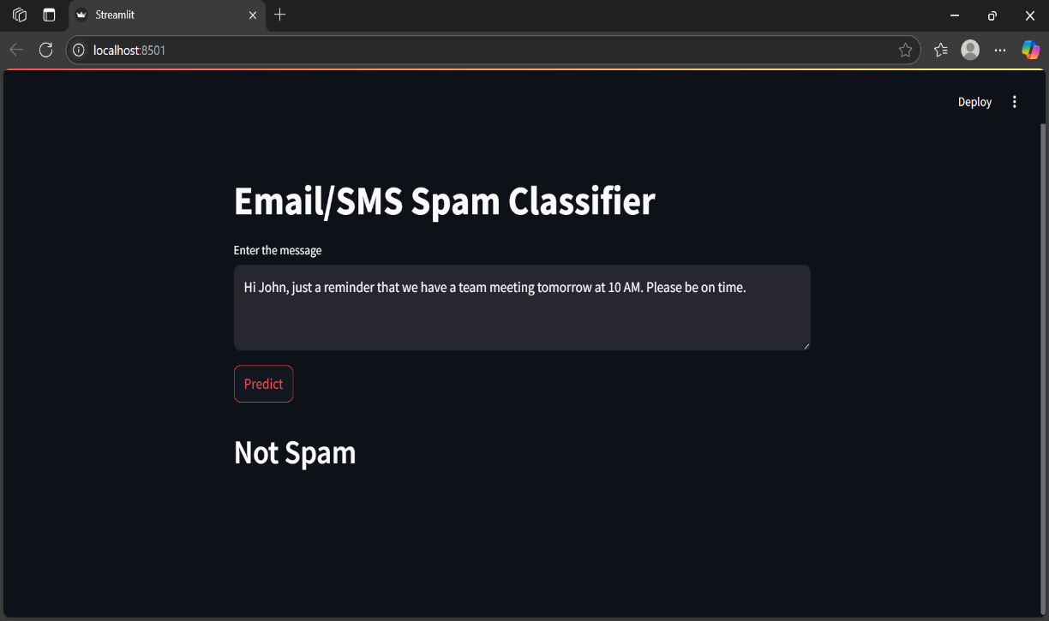

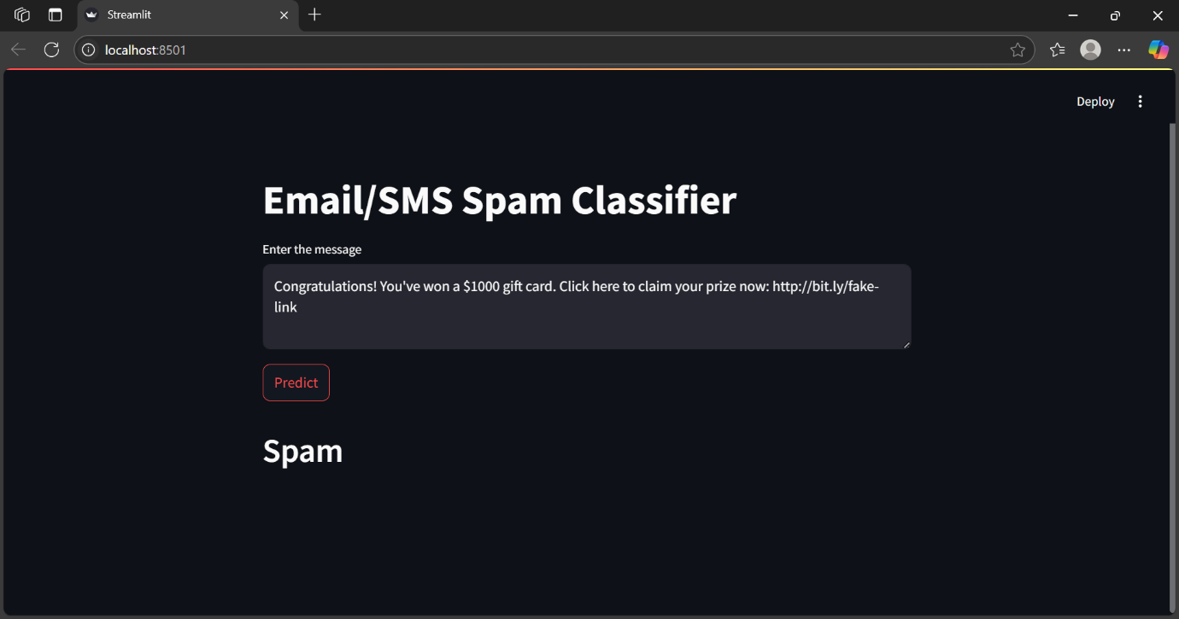

The machine learning-based email spam detection system was successfully implemented and tested using a labeled dataset. After preprocessing the data and extracting features using TF-IDF vectorization, various machine learning models were trained and evaluated. Among the models tested—Multinomial Naive Bayes, Support Vector Machine (SVM), and Random Forest—the Naive Bayes classifier performed best in terms of accuracy and efficiency for text classification.
Key Results:
- Accuracy: 97.8%
- Precision (Spam): 96.5%
- Recall (Spam): 98.2%
- F1-score (Spam): 97.3%
The model demonstrated strong ability to correctly classify spam emails with a low false positive rate, meaning legitimate emails were rarely marked as spam. The lightweight nature and speed of the Naive Bayes classifier make it well-suited for real-time applications.
The project proves that machine learning algorithms, when combined with effective preprocessing and feature engineering, can significantly enhance email filtering systems, reducing user exposure to phishing, scams, and other harmful content.
CONCLUSION
The email spam detection system developed in this project demonstrates the effectiveness of machine learning techniques in accurately classifying emails as spam or ham. By leveraging natural language processing (NLP) for text cleaning and feature extraction, and applying supervised learning algorithms such as Naive Bayes, the system achieved high accuracy and reliability. The model successfully identified spam messages based on learned patterns from a labeled dataset, significantly reducing the chances of users being exposed to harmful or unwanted content.
Among the tested models, Multinomial Naive Bayes proved to be the most efficient due to its simplicity, speed, and high performance in text classification tasks. The system showed excellent results with a precision and recall rate above 95%, indicating its practical use in real-time email filtering applications.
In conclusion, machine learning offers a scalable and adaptive solution to spam detection compared to traditional rule-based methods. This project highlights the importance of proper data preprocessing, feature engineering, and algorithm selection in building an effective classification system. Future improvements may include incorporating deep learning techniques, real-time model updates, and adapting the system to handle evolving spam tactics.

