Question 1 : Retrieve the total number of orders placed.

Query :

SELECT

COUNT(order_id) AS total_orders

FROM

ORDERS;

Input: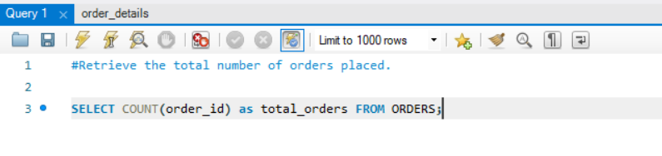

Output:

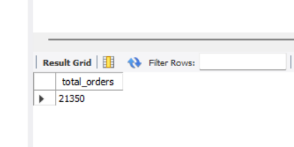

Question 2: Calculate the total revenue generated from pizza sales.

Query : SELECT

round(sum(order_details.quantity * pizzas.price),1) as total_revenue

from order_details join pizzas

on pizzas.pizza_id = order_details.pizza_id;

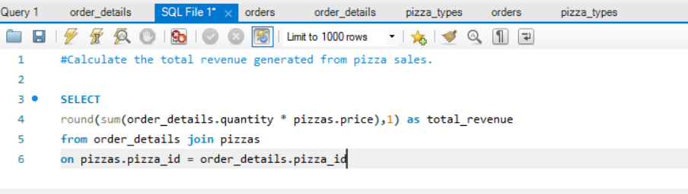

Output :

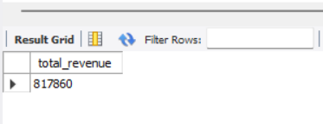

Question 3 : Identify the highest-priced pizza.

Query:

SELECT

pizza_types.name, pizzas.price

FROM

pizza_types

JOIN

pizzas ON pizza_types.pizza_type_id = pizzas.pizza_type_id

ORDER BY price DESC

LIMIT 1;

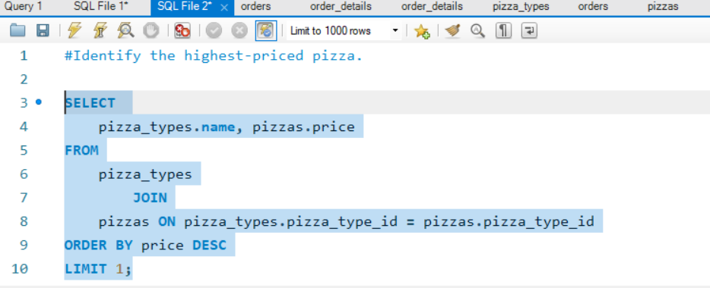

Output:

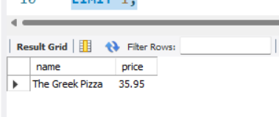

Question 4 : Identify the most common pizza size ordered.

Query:

SELECT pizzas.size, count(order_details.order_details_id) as order_count

from pizzas join order_details

on pizzas.pizza_id = order_details.pizza_id

group by pizzas.size order by order_count desc limit 1;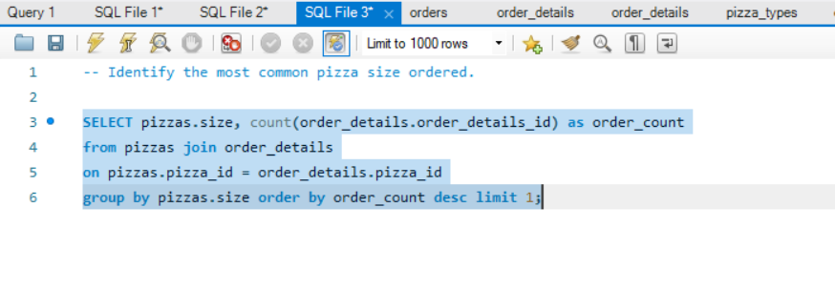

Output

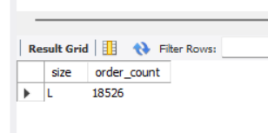

Questions 5: List the top 5 most ordered pizza types along with their quantities.

Query:

SELECT pizza_types.name,

sum(order_details.quantity) as quantity

from pizza_types join pizzas

on pizza_types.pizza_type_id = pizzas.pizza_type_id

join order_details

on order_details.pizza_id = pizzas.pizza_id

group by pizza_types.name order by quantity desc limit 5;

Input:

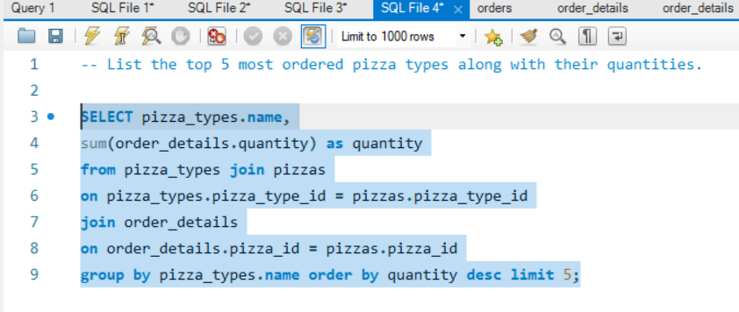

Output:

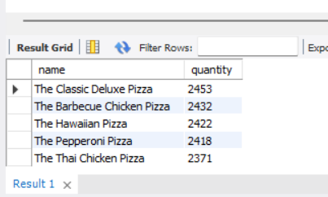

Question 6: Join the necessary tables to find the total quantity of each pizza category ordered.

Query:

SELECT pizza_types.category, sum(order_details.quantity) as quantity

from pizza_types join pizzas

on pizza_types.pizza_type_id = pizzas.pizza_type_id

join order_details

on order_details.pizza_id = pizzas.pizza_id

group by pizza_types.category order by quantity desc;

Input:

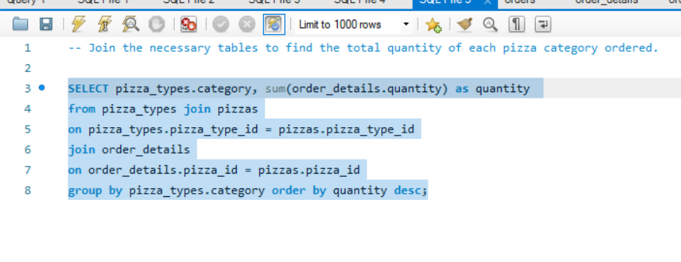

Output:

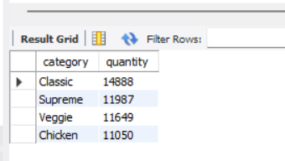

Question 7 : Determine the distribution of orders by hour of the day.

Query:

SELECT

HOUR(time), COUNT(order_id)

FROM

orders

GROUP BY HOUR(time)

ORDER BY COUNT(order_id) DESC;

Input:

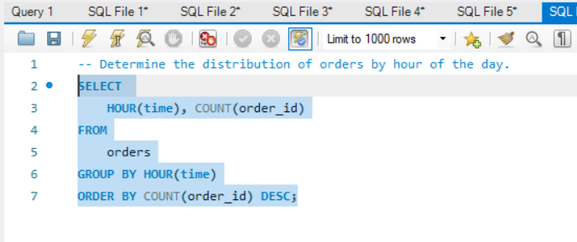

Output:

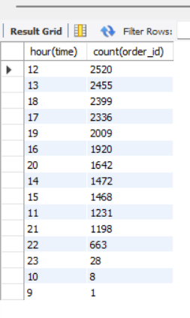

Question 8 - Join relevant tables to find the category-wise distribution of pizzas.

Query:

SELECT

category, COUNT(name)

FROM

pizza_types

GROUP BY category;

Input:

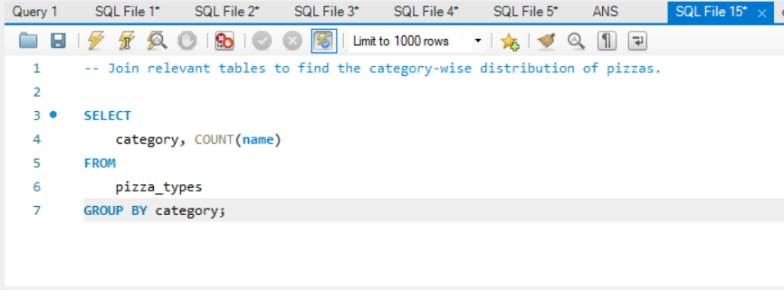

Output:

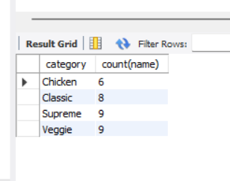

ss