PERFORMANCE EVALUATION REPORT
Beauty Connect AI Campaign
AI-Powered Beauty & Wellness Marketing Campaign
Campaign Period: August – October 2026 | Simulated Campaign

1. Executive Summary
- This report presents a performance evaluation of the BeautyConnect AI campaign, a simulated AI-powered beauty and wellness marketing initiative conducted from August to October 2026. The evaluation is based on the interactive performance dashboard developed for this campaign, which visualizes key metrics, channel performance, customer segments, sentiment distribution, and content preferences.
- According to the campaign dashboard, the key headline metrics are: Total Impressions of 2,598, Total Purchase of 73, Total Orders of 36, Total Revenue of 19.47K, and Total Market Channel count of 42. Customer sentiment is strongly positive (75.67%), with Instagram emerging as the clear leading marketing channel and Value Seeker as the top-performing customer segment. Monthly revenue showed growth from August to September, followed by a moderate decline in October.
- The campaign demonstrates the potential of AI personalization in beauty and wellness marketing. The following sections provide a detailed breakdown of performance, critical assessment, and actionable recommendations for future improvement.

2. Campaign Performance Dashboard
The interactive dashboard below summarizes the overall campaign performance, including KPI cards, orders by marketing channel, customer segment performance, monthly revenue trend, customer sentiment distribution, and preferred content themes.
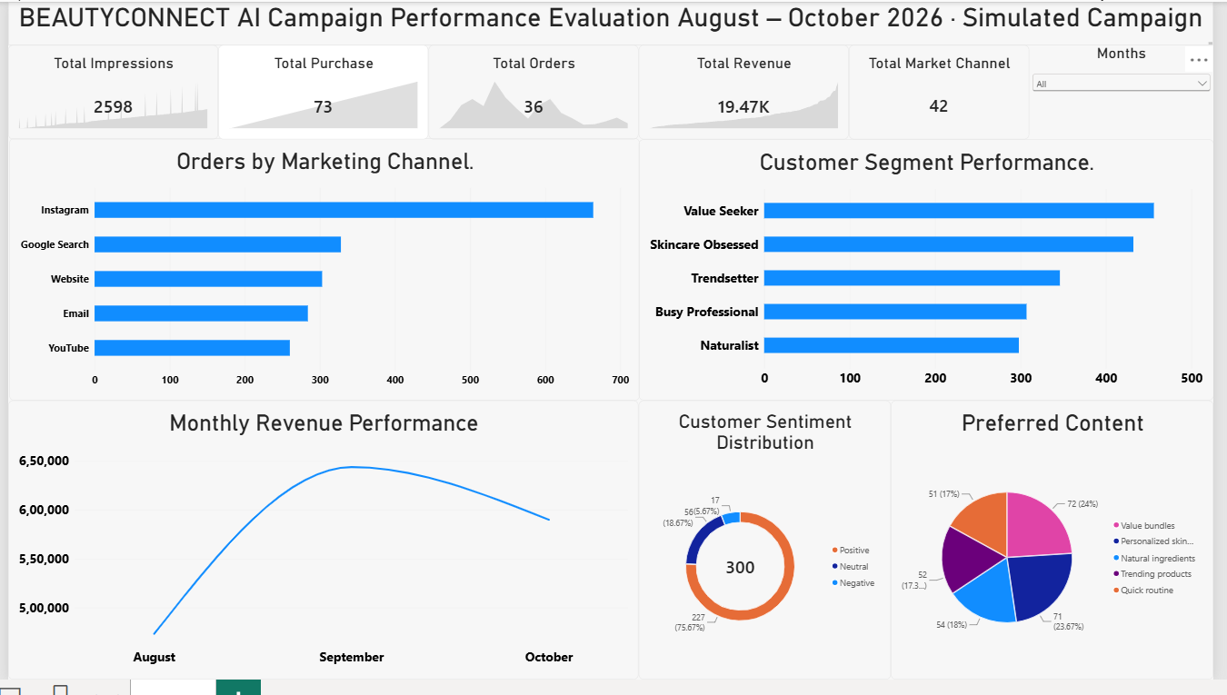
Figure 1. BeautyConnect AI Campaign Performance Evaluation Dashboard (August – October 2026)

3. Campaign Definition & Objectives

3.1 Campaign Overview
BeautyConnect AI is a simulated AI-powered beauty and wellness campaign designed to evaluate the effectiveness of personalized marketing. The campaign ran for three months (August–October 2026) and covered multiple Gujarat cities. Key components include:
- AI Personalized recommendations versus Generic Control messaging.
- Product categories: Skincare, Haircare, Body Care, and Wellness.
- Customer segments: Value Seeker, Skincare Obsessed, Trendsetter, Busy Professional, and Naturalist.
- Marketing channels: Instagram, Google Search, Website, Email, and YouTube.
- Content themes: Value bundles, Personalized skincare, Natural ingredients, Trending products, and Quick routine.

3.2 Strategic Objectives
- Measure the impact of AI personalization on engagement and conversion.
- Identify the best-performing marketing channels and customer segments.
- Track customer sentiment and satisfaction levels.
- Analyze monthly revenue trends to detect growth or decline patterns.
- Generate data-driven recommendations for future campaign optimization.

4. Key Performance Indicators (from Dashboard)
The following KPIs are taken directly from the BeautyConnect AI Campaign Performance Evaluation dashboard shown in Figure 1.

4.0 KPI Selection Rationale
The KPIs used in this evaluation were carefully selected to provide a balanced view of campaign performance across four layers: Reach & Engagement, Conversion, Financial Impact, and Customer Experience.
Why These KPI Layers Were Chosen
• Reach & Engagement (Total Impressions, Total Purchase/Clicks): To measure whether the campaign successfully attracted attention and interaction from the target audience.
• Conversion (Total Orders): To assess whether engagement translated into actual business outcomes (purchases).
• Financial Impact (Total Revenue, Total Market Channel): To evaluate the monetary contribution and multi-channel spread of the campaign.
• Customer Experience (Sentiment Distribution, Satisfaction): To ensure that commercial success did not come at the cost of customer satisfaction.
Rationale for Individual KPIs
Total Impressions — Selected as the top-of-funnel metric. It shows how widely the campaign content reached potential customers and is the foundation for all downstream performance.
Total Purchase / Clicks — Selected to measure engagement quality. High impressions with low interaction would indicate weak creative or poor targeting.
Total Orders — Selected as the primary conversion metric. Orders represent the direct commercial success of the AI recommendations.
Total Revenue — Selected to capture the financial value generated. Revenue provides a more complete picture than order count alone.
Total Market Channel — Selected to reflect the multi-channel nature of the campaign and to support channel-level optimization decisions.
Customer Sentiment (Positive / Neutral / Negative) — Selected to provide qualitative insight into how customers felt about the AI experience, beyond simple star ratings.
Channel, Segment, and Content breakdowns — Selected because they turn the evaluation into an actionable report. Knowing that Instagram, Value Seeker, and Value bundles perform best allows precise future budget and messaging decisions.
Monthly Revenue Trend — Selected to detect time-based patterns (such as the October decline) that a single aggregate number would hide.
Overall Selection Logic
KPIs were chosen based on five principles: (1) full funnel coverage from awareness to loyalty, (2) clear business impact, (3) experience quality, (4) actionability for future decisions, and (5) ability to demonstrate the value of AI personalization. This combination makes the evaluation comprehensive, balanced, and useful for decision-making.

4.1 Headline KPI Cards
Table 1. Dashboard KPI Summary
KPI | Dashboard Value | Observation
Total Impressions | 2,598 | Peak / highlighted impression value from dashboard
Total Purchase | 73 | Purchase-related metric displayed on dashboard
Total Orders | 36 | Order volume shown on dashboard KPI card
Total Revenue | 19.47K | Revenue value displayed on dashboard
Total Market Channel | 42 | Channel-related count from dashboard

4.2 Customer Sentiment Distribution
As shown in the dashboard donut chart (based on 300 records):
Table 2. Customer Sentiment
Sentiment | Count / Share | Assessment
Positive | 227 (75.67%) | Strong – majority of customers responded positively
Neutral | 56 (18.67%) | Moderate – room to convert neutrals to positive
Negative | 17 (5.67%) | Low but needs monitoring and reduction

5. Channel & Segment Performance Analysis
The dashboard bar charts provide clear visibility into channel and segment performance.

5.1 Orders by Marketing Channel
From the “Orders by Marketing Channel” horizontal bar chart in the dashboard:
- Instagram is the clear leader, generating the highest number of orders (approaching 650–700 range on the chart).
- Google Search ranks second.
- Website, Email, and YouTube follow in descending order.
- Insight: Instagram should receive priority budget allocation for future campaigns.

5.2 Customer Segment Performance
From the “Customer Segment Performance” bar chart:
- Value Seeker is the top-performing segment (highest bar, approaching 450–500).
- Skincare Obsessed is a close second.
- Trendsetter, Busy Professional, and Naturalist follow in that order.
- Insight: Value Seeker and Skincare Obsessed should be prioritized for targeting and product offers.

5.3 Preferred Content Themes
From the Preferred Content pie chart on the dashboard:
- Value bundles – 72 (24%)
- Personalized skincare – 71 (23.67%)
- Natural ingredients – 54 (18%)
- Trending products – 52 (17.3%)
- Quick routine – 51 (17%)

6. Monthly Revenue Performance
The Monthly Revenue Performance line chart on the dashboard shows the following trend:
- August: Lowest point (around ₹4.5–4.8 Lakh range on the chart).
- September: Peak performance (approaching ₹6.5 Lakh).
- October: Moderate decline from the September peak (around ₹5.9 Lakh).
Interpretation: The campaign gained strong momentum in September but experienced a soft patch in October. This pattern suggests possible creative fatigue, seasonal factors, or reduced engagement that should be investigated and addressed in future planning6.

7. Critical Assessment of Strategies

7.1 Strengths
- Strong positive sentiment.
- With 75.67% positive sentiment, the campaign experience was well received by the majority of customers.
- Clear channel and segment winners.
- Instagram dominates order generation. Value Seeker and Skincare Obsessed segments consistently outperform others, providing clear direction for media and product focus.
- Balanced content preference distribution.
- Value bundles and Personalized skincare together account for nearly half of preferred content, confirming that both value-driven and personalization-driven messaging resonate with the audience.

7.2 Weaknesses
October revenue decline.
The drop from the September peak indicates a need for creative refresh, new offers, or better frequency management in the third month.
Residual negative sentiment.
Although only 5.67% of responses were negative, these cases should be reviewed to prevent future dissatisfaction.
Lower-performing channels.
YouTube and Email generate fewer orders compared with Instagram and Google Search. These channels need creative or targeting improvements.

7.3 Opportunities
- Scale investment in Instagram and high-performing segments (Value Seeker, Skincare Obsessed).
- Strengthen Value bundles and Personalized skincare content, as they are the most preferred themes.
- Address the October soft patch with new creative and seasonal promotions.
- Improve Naturalist segment messaging and underperforming channels (YouTube, Email).

8. Recommendations for Future Improvement

8.1 Near-Term (0–3 Months)
- Increase budget allocation to Instagram, the top-performing channel.
- Prioritize Value Seeker and Skincare Obsessed segments in targeting and offers.
- Launch refreshed creative and promotional offers to reverse the October revenue decline.
- Review the 17 negative sentiment cases and adjust messaging or recommendation logic accordingly.

8.2 Medium-Term (3–9 Months)
- Improve performance of YouTube and Email through better creative testing and audience refinement.
- Enhance Naturalist segment content with stronger natural-ingredient storytelling.
- Expand Value bundles and Personalized skincare content themes, as they show the highest preference.

8.3 Strategic (9–18 Months)
- Build a continuous optimization loop that feeds channel, segment, and sentiment insights back into AI recommendation models.
- Develop deeper personalization features (progress tracking, adaptive routines) to further improve satisfaction and loyalty.

9. Implementation Roadmap
Table 3. Phased Implementation Roadmap
Phase | Key Initiatives | Owner | Success Focus
Phase 1 (0–3 mo) | Boost Instagram & top segments; refresh creative for Oct dip; review negative feedback | Marketing + Analytics | Higher orders from Instagram; reduced negative sentiment
Phase 2 (3–9 mo) | Improve YouTube/Email; strengthen Naturalist content; expand top content themes | Content + Media | Better channel balance; higher Naturalist engagement
Phase 3 (9–18 mo) | Continuous learning loop; advanced personalization features | Data Science + Product | Sustained growth in satisfaction & repeat behaviour

10. Conclusion
- The BeautyConnect AI campaign dashboard provides a clear and actionable view of performance. Headline metrics (Impressions 2,598, Purchase 73, Orders 36, Revenue 19.47K) along with strong positive sentiment (75.67%) and clear leadership of Instagram and the Value Seeker segment indicate that the AI-powered approach is effective.
- The main priorities going forward are to scale the winning elements (Instagram, Value Seeker, Skincare Obsessed, Value bundles, and Personalized skincare), correct the October revenue dip, and reduce the small share of negative sentiment. Following the phased roadmap will help convert current dashboard insights into sustained campaign improvement.

11. Summary
- This performance evaluation of the BeautyConnect AI campaign (August–October 2026) confirms that AI-powered personalization delivers measurable value in beauty and wellness marketing. The dashboard analysis shows strong positive customer sentiment (75.67%), clear leadership of Instagram as the top channel, and Value Seeker and Skincare Obsessed as the highest-performing customer segments.
- Key Findings at a Glance
- Headline dashboard metrics: Impressions 2,598 | Purchase 73 | Orders 36 | Revenue 19.47K | Market Channels 42.
- Customer sentiment is strongly positive (75.67% Positive, 18.67% Neutral, 5.67% Negative).
- Instagram is the dominant marketing channel for orders; Google Search is a solid second.
- Value Seeker and Skincare Obsessed are the top customer segments.
- Preferred content themes are Value bundles (24%) and Personalized skincare (23.67%).
- Monthly revenue peaked in September and declined moderately in October, signalling a need for creative refresh.
- Main Strengths
- Strong positive sentiment, clear channel and segment winners, and balanced content preference distribution that supports both value-driven and personalization-driven messaging.
- Main Weaknesses
- October revenue decline, a small but present negative sentiment pocket (5.67%), and lower order contribution from YouTube and Email channels.
- Priority Actions
- Scale budget toward Instagram and the Value Seeker / Skincare Obsessed segments.
- Refresh creative and offers to reverse the October soft patch.
- Review negative sentiment cases and adjust AI recommendation tone/frequency.
- Improve YouTube, Email, and Naturalist segment performance in the medium term.
- Build continuous learning and deeper personalization features for long-term advantage.
- Overall Verdict
- The BeautyConnect AI campaign is a successful demonstration of AI personalization in beauty and wellness marketing. With strong sentiment, clear winning channels and segments, and actionable insights from the dashboard, the foundation is solid. Executing the recommended near-term, medium-term, and strategic actions will convert these results into sustained growth.

Appendix: Dashboard Reference
- This report is prepared according to the values and visuals displayed in the BeautyConnect AI Campaign Performance Evaluation dashboard (August–October 2026 · Simulated Campaign). The dashboard screenshot is included as Figure 1. All KPI figures, sentiment shares, channel rankings, segment rankings, content preferences, and monthly revenue trends referenced in this document are taken from the dashboard.
- Document prepared for Task 5 — Performance Evaluation of an AI-Powered Beauty & Wellness Campaign.
- October 2026

