**This sign indicates that the road ahead turns sharply to the right**

**Ohio's legal drinking age for alcohol is 21. In Ohio as in the rest of the nation, it is illegal to drive if your BAC is 0.08% or higher.**

**If an oncoming vehicle has its high-beam headlights on, don't stare at the lights. Look toward the right edge of the road to prevent being temporarily blinded. Steer by the line at the right edge of the road.**

**Infants and children who are under the age of four or weigh less than 40 pounds must be properly restrained in an approved child safety seat while being transported in a motor vehicle.**

**Many authorities recommend the "three-second rule": Maintain a following distance of at least three seconds behind the vehicle in front of you. You can measure your following distance by noting when the vehicle in front of you passes some stationary object and then counting the seconds that elapse before you reach the same object. If driving conditions are poor, you should increase your following distance.**

**Within a municipal corporation, the speed limit in alleys is 15 mph.**

**If you start to skid, stay calm, ease your foot off the gas pedal, and carefully steer in the direction in which you want the front of your car to go. Avoid braking, especially if your car is not equipped with antilock brakes (ABS). This procedure, known as “steering into the skid,” will bring the rear end of your car into line with the front.**

**You must use your headlights whenever bad weather or insufficient light makes it impossible for you to see objects 1,000 feet ahead clearly. (A thousand feet is about two-tenths of a mile.) You must also use your headlights between sunset and sunrise and whenever you use your windshield wipers.**

**Broken yellow lines allow passing. Solid yellow lines indicate that passing is prohibited.**

**Fog is one of the most hazardous conditions a motorist can drive in. Slow down and increase your following distance. Dim your headlights. The bright light from high beams can reflect off precipitation or fog and cause glare. Turn off your radio and open your window. You may hear an approaching vehicle before you're able to see it.**

**On a one-way roadway, a solid yellow line indicates the left edge, and a solid white line indicates the right edge. The same holds true for divided roadways, where the "left edge" of the roadway is between the leftmost lane and the divider.**

**Every Ohio driver who is convicted of a traffic violation is assessed a specific number of penalty points according to the type of violation. If you are convicted of willingly fleeing or eluding a law enforcement officer, six points will be added to your driving record. (You will also face a jail sentence of up to 180 days.) If you are convicted of driving in willful or wanton disregard of the safety of persons or property, four points will be added. If you are convicted of speeding, between zero and four points will be added depending on how fast you were driving. Other traffic violations typically add two points each. [OH R.C. § 2921.331], [OH R.C. § 2929.24]**

**This triangular emblem on the rear of a vehicle identifies it as a low-speed or slow-moving vehicle, which Ohio defines as a vehicle that can travel faster than 20 mph but not faster than 25 mph. Slow-moving vehicles include farm tractors and roadway maintenance vehicles. If you approach one of these vehicles, slow down and proceed with caution. Be patient; the driver may pull over to let you pass. [OH R.C. § 4501.01]**

**This is a Do Not Enter sign. It indicates that you are not allowed to enter the roadway at which the sign is posted. You will see such signs at roadway openings that you are not to enter or where you would be driving the wrong way on a one-way roadway. You will see these signs at exit ramps, in crossovers on divided roadways, and at numerous locations on one-way roads.**

**In Ohio, you are not allowed to pass in the opposing lane when you are within 100 feet of an intersection, a railroad crossing, a bridge, a viaduct, or a tunnel. You are also not allowed to pass when you are on a curve or near the crest of a hill if your view is obstructed.**

**Under Ohio law, the passing driver must sound the horn to warn you that he or she intends to pass. When you hear the horn of the passing vehicle or see it passing you, you must maintain a constant speed and keep right until the other vehicle has safely passed. [OH R.C. § 4511.27]**

**Before turning right at an intersection, make sure that there is no traffic approaching from your left and no oncoming traffic turning left into your path. Also yield to pedestrians who are crossing the road that you are going to enter.**

**According to the Digest of Ohio Motor Vehicle Laws, if you are convicted of OVI for the first time, the court will suspend your license for a minimum period of six months and up to a maximum period of three years. This is in addition to any administrative suspension already imposed. [Penalties; Operating a Vehicle While Impaired (OVI); 6 - Traffic Laws; Digest of Ohio Motor Vehicle Laws]**

**If you are stopped for suspected OVI but you refuse to submit to chemical testing, the Registrar of Motor Vehicles will suspend your driver license for a period of one to five years, even if you are ultimately acquitted of OVI in court. If you are convicted of OVI, the court will impose another suspension as well as criminal penalties. [Administrative License Suspension/Refusal; Operating a Vehicle While Impaired (OVI); 6 - Traffic Laws; Digest of Ohio Motor Vehicle Laws], [Ohio Impaired Driving Law Chart, Garfield Heights Municipal Court, https://www.ghmc.org/sites/default/files/pdfs/ovichart.pdf]**

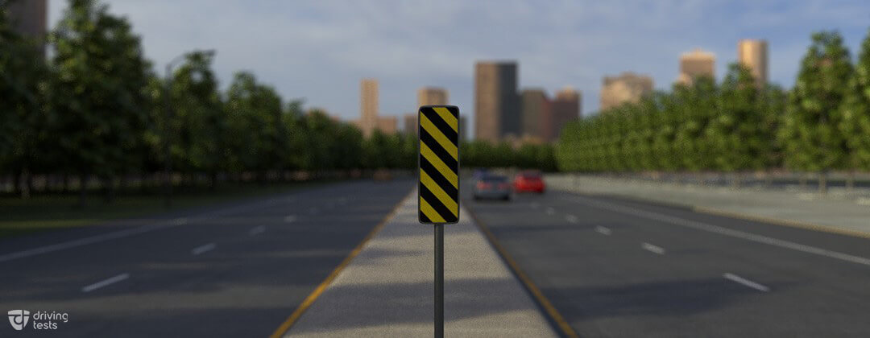

**This is an object marker sign, which is used to notify drivers of objects in the roadway or very close to the edge of the roadway. The stripes point downward toward the safe side of the roadway. This sign indicates that you should keep right to pass the object.**

**The penalties for a fourth OVI offense in ten years include a prison sentence of 60 days to 30 months. (Note: The Digest of Ohio Motor Vehicle Laws states incorrectly that the "look-back" period for prior offenses is six years. This used to be the case, but it was increased to ten years, effective April 6, 2017.) [Penalties; Operating a Vehicle While Impaired (OVI); 6 - Traffic Laws; Digest of Ohio Motor Vehicle Laws], [Ohio Impaired Driving Law Chart, Garfield Heights Municipal Court, https://www.ghmc.org/sites/default/files/pdfs/ovichart.pdf], [Ohio R. C. § 4511.19]**

**If you are convicted of a fifth OVI offense since September 30, 2008, your name will be placed on Ohio's Habitual OVI/OMVI Offender Registry. This registry lists the names, addresses, and offenses of drivers who have been convicted of OVI five or more times. The public may access the Registry online at https://services.dps.ohio.gov/OMVI/SearchAndList.aspx. (Note: The earlier term "OMVI" meant "Operating a Motor Vehicle while Impaired." The laws have since been changed. Today, you can be charged with OVI for operating any vehicle while under the influence, even a bicycle.) [Penalties; Operating a Vehicle While Impaired (OVI); 6 - Traffic Laws; Digest of Ohio Motor Vehicle Laws]**

**When you parallel park facing uphill next to a curb, you should point your wheels away from the curb and then roll back slowly so that the rear part of the front wheel rests against the curb. If your brakes fail, the curb will block your vehicle from rolling backward. Make sure you still set your parking brake and leave your transmission in the correct gear (Park for an automatic transmission or first gear for maximum forward torque with a manual transmission).**

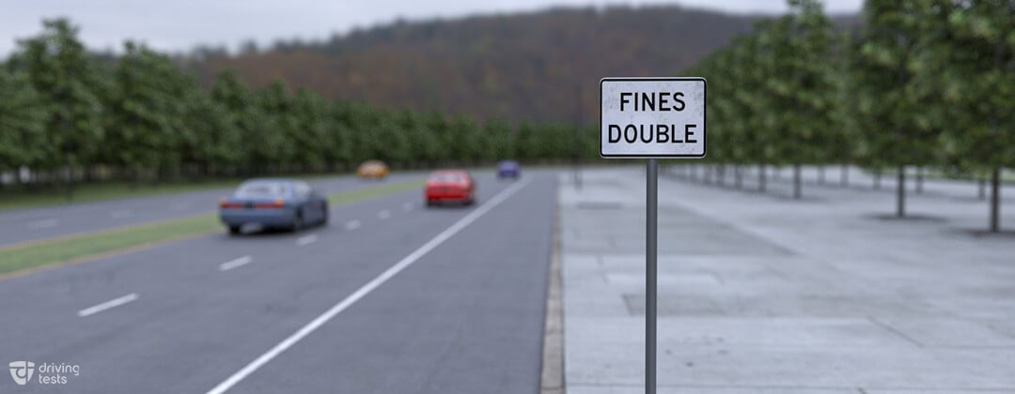

In Work zones **Most US states impose additional penalties for certain traffic violations in work zones under certain conditions, although the conditions and additional penalties vary from one state to another. This sign informs drivers that fines for exceeding the posted speed limit in work zones are doubled.**

**This sign is a freeway interchange sign. This sign indicates that you are approaching an interchange.**

**This sign indicates a double curve ahead. The road ahead curves to the right and then to the left. (If there were a triple curve ahead, a winding road sign would be posted instead.) Slow down, keep right, and do not pass.**

**At an uncontrolled intersection (i.e., one without signs or signals), you must yield to vehicles on the right that arrive at about the same time as you do.**

**When several vehicles arrive at a T-intersection without signs or signals, the vehicles on the terminating road must yield to vehicles on the through road.**

**A roundabout is an intersection where traffic circulates counterclockwise around a central island. Approaching vehicles must yield the right-of-way to the traffic in the roundabout. Always enter the roundabout, heading to the right.**

**A double solid yellow line means that no passing is allowed on either side.**

**A flashing yellow arrow means you may proceed with caution in the direction of the arrow after you yield to oncoming traffic and pedestrians.**

**When there is a broken line (either white or yellow) next to your lane, you are allowed to pass if it is safe to do so.**

**Regulatory devices instruct you to stop, proceed in a certain direction, or limit your speed. All regulatory devices indicate actions that you are required to take. There may be penalties for failing to comply.**

**Don't hang out in a No-Zone! No-Zones are large areas around trucks and other large vehicles in which cars may disappear into blind spots or get so close that they restrict the truck driver's ability to stop or maneuver safely. No-Zones greatly increase the likelihood of a crash**

**A barrier of grass, concrete, or other material separating opposing lanes of traffic on a divided roadway is known as a median. Medians are found on highways and some major streets. It is illegal to drive over, across, or on a median.**

**When driving in fog, slow down and use your low-beam headlights. You should also use your fog lights if your vehicle is equipped with them. However, if fog closes in completely and visibility is reduced to near zero, pull as far off the road as possible and remain stopped until conditions improve. Remember: If you can't see, you can't drive.**

**Diagonal yellow striping on streets and highways indicates a narrow road or an obstruction ahead.**

**All temporary signs in construction zones have black letters or symbols on an orange background. These signs provide information and directions to drivers in or near construction zones.**

**If you are in the right lane, leave room for vehicles entering the freeway. The right lane should remain open for traffic entering or leaving the freeway as much as possible.**

**When a traffic signal turns green at an intersection, make sure the way is clear of any other vehicles that might still be in or coming through the intersection. Yield to any pedestrians who are still on the road. Most accidents at traffic signals happen in the first few seconds after the light has changed.**

**A single broken yellow line usually marks the centerline of a two-way roadway on which a vehicle may pass if it is safe.**

**If you keep applying the brakes to control your speed on a steep descent, the brakes will fade (lose their effectiveness). Instead, release the gas pedal and shift into a lower gear (even with an automatic transmission). This will generate a braking effect to slow the vehicle, known as engine braking. The lower the gear, the greater the engine braking effect. Apply the brakes only when engine braking is insufficient or you want to stop.**

**Electronic message signs and flashing arrow panels are mobile devices that are used on some roads to give advance warning of construction zones or unusual conditions at or near construction zones.**

**When two vehicles meet on a steep mountain road where neither can pass, the vehicle traveling downhill must yield the right-of-way by backing up until the vehicle going uphill can pass. The vehicle facing downhill has the greater amount of control when backing.**

**Blind spots are areas near the left and right rear corners of your vehicle that you cannot see in your mirrors. Before you change lanes or pass, turn your head and look to make sure these areas are clear.**

**If your vehicle is hit from the side, your body and any loose objects inside the vehicle will initially seem to be thrown toward the side that is hit – relative to the vehicle, that is. Relative to the ground, the side that is hit is actually being pushed toward you.**

**When making a left turn at a controlled intersection (i.e., one with signs or signals), you must first yield to oncoming vehicles and pedestrians within the crosswalk or intersection.**

**At a railroad crossing, you must wait until there is room for your vehicle on the opposite side. You must yield to crossing trains. Do not stop on the tracks. It is wise not to shift gears when crossing the tracks, because your vehicle might stall.**

**It is recommended to slow to a crawl on ice. Use chains if necessary for better traction, but do not forget that even chains and snow tires can slide on ice and packed snow.**

**signal for making a right turn is hand and arm extended upward.**

**When you encounter a truck traveling next to you in the same direction, keep as far as possible to the side to avoid being sideswiped and reduce the wind turbulence between the two vehicles.**

**This sign tells you to turn right to go north on route 47.**

**Treat a flashing red light like a stop sign. That is, you must stop before entering the intersection, yield to pedestrians and traffic, and then proceed when it is safe to do so.**

**At a railroad crossing, don't try to cross the tracks until you can cross them without stopping. Don't shift gears while crossing the tracks, because your vehicle might stall.**

**When approaching or driving through a construction zone, observe what other drivers are doing and avoid sudden moves. Do not weave from lane to lane. Brake gradually to give drivers behind you ample time to slow down. Keep up with the flow of traffic.**

**Aggressive driving is the operation of a motor vehicle in a manner that endangers or is likely to endanger persons or property. If the driver behind you repeatedly flashes his or her headlights, do not retaliate or engage the driver in any way. Instead, get out of the way.**

**Under Ohio law, you may not make a U-turn on a curve or near the top of a hill if you cannot be seen by other drivers approaching from either direction within 500 feet. Also, you may not make a U-turn where signs prohibit doing so. [OH R. C. § 4511.37]**

**While you are driving, talking on a cell phone will increase your chances of being in a crash by as much as four times. This is because the conversation is distracting you from your driving. Sending text messages (texting) while you are driving will increase your chances of being in a crash by as much as eight times.**

**When approaching a roundabout, yield to vehicles and bicyclists within the circulating roadway. Look to your left to see if there is an appropriate gap in traffic. (If one is not available, you may need to stop until an appropriate gap becomes available.) Always enter the roundabout to the right and proceed on the right side of the central island.**

**This sign indicates a rest area open on the right.**

**This is a U.S. Route marker sign. The shape and color of a route marker sign indicate the type of road you are traveling on. Signs that identify U.S. Routes and interstate highways are typically shield shaped. This sign indicates that you are traveling on U.S. Route 40. The U.S. Routes are a network of roads and highways whose construction began decades before the start of the Interstate Highway System. U.S. Route 40 began construction in 1926 and currently runs from Silver Summit, UT to Atlantic City, NJ.**

**This is a speed advisory sign at a roundabout. The permitted speed limit is 15 mph in the roundabout.**



**This warning sign indicates to the driver that farm equipment may be crossing the road. Be ready to slow down for slow-moving equipment.**

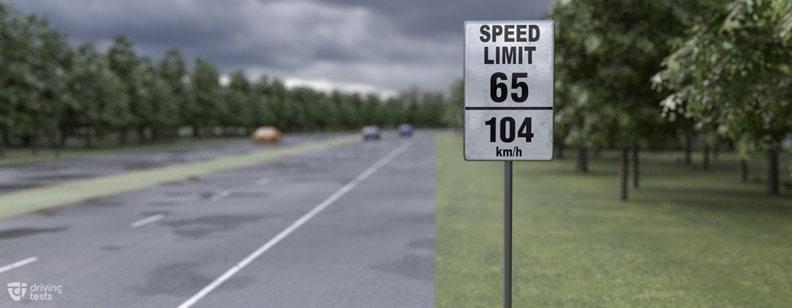

**A speed limit sign indicates the legal maximum speed allowed on the expressway under ideal driving conditions.**

**This sign accompanies a route marker sign. It means that you must soon turn right to enter or continue on that route.**

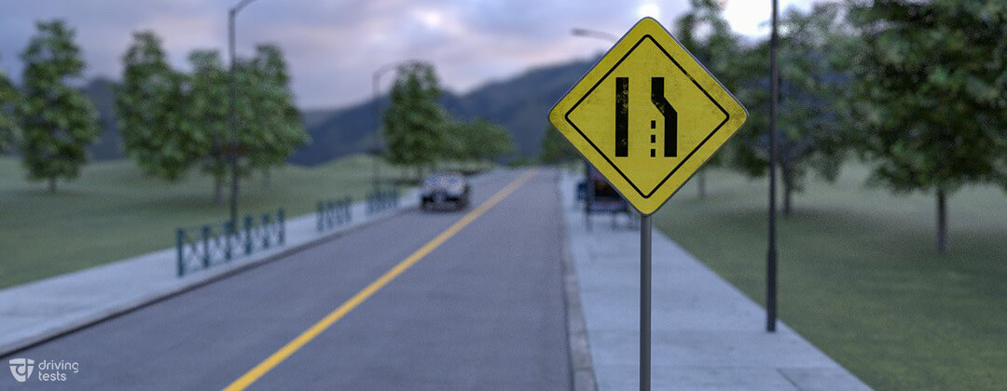

**This type of warning sign gives advance notice of a reduction in the number of lanes ahead. This particular sign indicates that the right lane ends ahead. Drivers in the right lane must merge left. Drivers in the left lane should allow vehicles in the right lane to merge smoothly.**

**This sign warns that you are approaching a T-intersection from the terminating roadway. At the T-intersection, you must turn either left or right after yielding the right-of-way to through traffic if necessary**

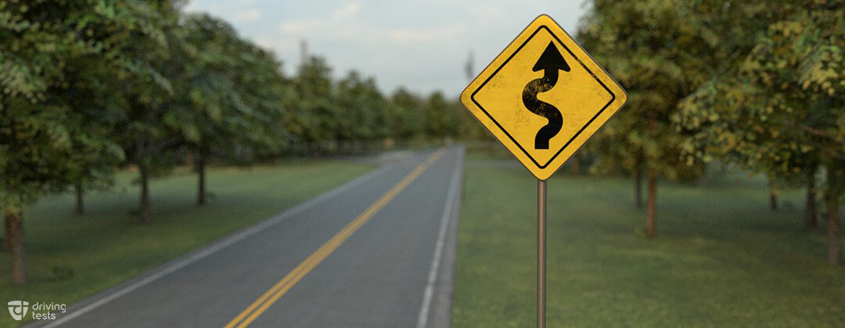

**The shape of the arrow tells you that you're entering a winding road. A winding road has at least three curves. Slow down and proceed with caution.**

**This sign indicates that a four-way intersection is ahead. Drivers should be alert for cross traffic entering the roadway.**

**This sign shows the maximum recommended safe speed for entrance or exit on an expressway. Slow down to whatever speed (in this case, 30 mph) is shown.**

**This sign is a freeway interchange sign. This sign indicates that you are approaching an interchange.**

**A diamond-shaped marking shows that a lane is reserved for certain purposes or certain vehicles. The lanes are usually reserved for buses or carpool vehicles during rush hour traffic.**

**When two vehicles enter an uncontrolled intersection (i.e., one without signs or signals) from different roadways at about the same time, the driver of the vehicle on the left must yield to the vehicle on the right.**