**CTopic Name:**

The main aim of this lab session is to provide hands-on experience on

* Getting Help
* Basic Commands
* Navigation
* File System
* simple shell script

1. Getting Help

|  |  |  |  |  |
| --- | --- | --- | --- | --- |
| Task | Command Name | Syntax | Example | Screenshots |
| To get manual page for the known command | **man** | man command_name | man ls |  |
| To get manual page for the unknown command | **man -k** | man -k command_name | man -k list |  |
| To know the source file binary | **readelf -a** | readelf -a /bin/ls | readelf -a /bin/ls |  |
| To know the path of the command | **type -a** | type -a command_name | type -a ls |  |
| To know the command is external or internal | **type** | type command_name | type ls |  |
| To get help for the internal command | **help** | help command_name | help ls |  |
| To list out bash commands | **help** | bash --help | bash –help |  |
| To know the usage of the command | **apropos** | apropos command_name | apropos cd |  |

1. **Basic Commands**

|  |  |  |  |  |
| --- | --- | --- | --- | --- |
| Task | Command Name | Syntax | Example | Screenshots |
| To know today’s date | **date** | date | date |  |
| To print calendar | **./calendar** | ./calendar.py year month | ./calendar.py 2024 1 |  |
| To print kernel version | **uname** | uname -a | uname -a |  |
| To print default shell | **echo** | echo $shell | echo $shell |  |
| To print currently logged in user | **whoami** | whoami | whoami |  |
| To create shortcut for command | **alias** | alias name = command_name | alias c=clear |  |
| To delete shortcut | **unalias** | unalias name | unalias c |  |
| To change the timestamp of the file | **touch** | touch -t <yearmonthdaytime> file_name | touch -t 202401040910 |  |
| To clear the screen | **clear** | clear | clear |  |
| To create empty files | **touch** | touch filename | touch a1.txt |  |
| To know disk usage | **du** | du[options][path] | du -h |  |
| To know free space in the system | **df** | df[options] | df -h |  |
| To know about the Linux release | **lsb_release** | lsb_release -a | lsb_release -a |  |

1. **Navigation**

|  |  |  |  |
| --- | --- | --- | --- |
| Task | Command | Syntax | Screenshots |
| To navigate home directory | **cd** | cd |  |
| To navigate to the parent directory | **cd ..** | cd .. |  |
| To navigate to the child directory | **cd<directory_name>** | cd<directory_name> |  |
| Alternate command to cd | **pushd** | pushd<directory_name> |  |
| To go back to the previous directory | **cd -** | cd - |  |
| To go to the root directory | **cd/** | cd/ |  |

1. **File System**

|  |  |  |
| --- | --- | --- |
| **Task** | **Syntax** | **Command** |
| **How to identify the file system** | lsblk -f | **lsblk -f** |

1. Create Folder “CYS”

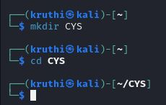

1. Navigate to CYS

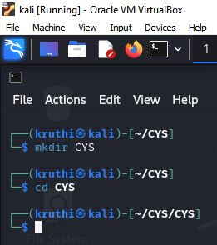

1. Create folder LS1 and LS2 under CYS

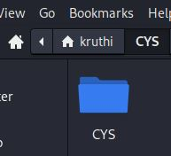

1. Go back to CYS



1. Working with Files
2. Add commands which you learnt during lab session in the file commands.txt

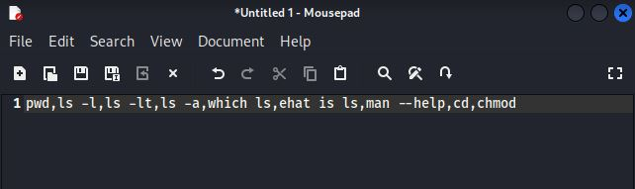

ii)Change the timestamp of the file to yesterday

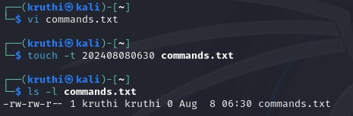

iii)Copy the contents from the file commands.txt to commands_demo.txt



iv) Rename the file commands_demo.txt to duplicate

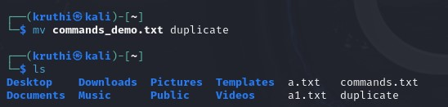

1. Rename all .html to .hldd

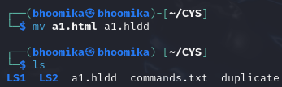

1. Delete the file duplicate

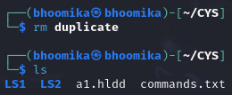

1. Copy the contents commands.txt to unit4 and unit5 (using relative path)



1. Delete the contents from unit5 (using absolute path)

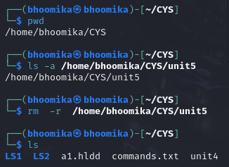

1. Navigate to root

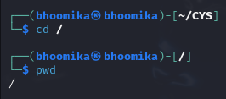

1. List all the files under root



1. Explore all the folders (Do not delete any folder)



1. Navigate to /etc/passwd

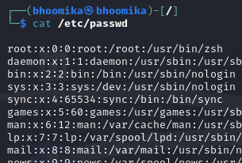

1. Open the file passwd



1. Explore the file passwd
2. Navigate to /etc/group and explore

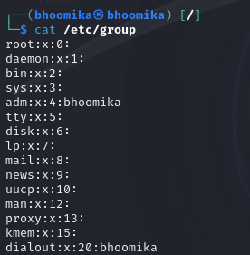

1. **Difference between** 
   * + 1. GUI vs. CLI

GUI stands for graphical user interface, it contains the interaction with graphical elements like icons and windows

CLI stands for command line interface, Here the interaction with the system is through the commands.

* + - 1. man vs info

man command provides the manual page of the command/ filename which we give and is succinct where info provides the hierarchical structure and interconnected information.

* + - 1. which vs. whereis

“which” is used to locate a distinct known path whereas the command “whereis” gives the path containing source, manual page , and binary files.

* + - 1. Terminal vs shell

Terminal is an interface, it provides the environment where shell can be run, where as shell is a interpreter that allows to interact with the operating system through commands.

1. Write a simple shell script to print your name and your hobbies!

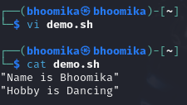

**Interesting commands to Explore**

Banner

History

**Note:** Include your screenshots

Evaluation :

Marks : 10 (Deadline : 4 – Originality :3 – Completeness :3 )

Deadline: 06.08.2024

“All our dreams can come true if we have the courage to pursue them.”

Walt Disney