Master’s Thesis

Conformal Prediction for Reliable LLM Explanations in Security Analytics
Author
Kruthika Panchamurthy
Supervisors
Prof. Dr. Binh Vu
Prof. Dr. Mehrdad Jalali

This thesis is submitted in fulfilment of the requirements for the degree of Master of Science in Applied Data Science and Data Analytics
to
SRH Hochschule Heidelberg
School of Information, Media and Design
Ludwig-Guttmann-Strasse 6, 69123, Heidelberg
August 2026


SRH Hochschule Heidelberg
Fakultät für Information,
Medien und Design
DECLARATION OF AUTHORSHIP
I hereby declare that my submitted thesis is my own original work. I have written it independently without outside help and have not used any sources other than those indicated - in particular, no sources not named in the references.
I have appropriately indicated any direct quotations or passages taken from literature, and the use of intellectual property from other authors, by providing the necessary citations within the work. This applies equally to the sources used for text generation by Artificial Intelligence (AI).
I hereby declare that the thesis was not previously presented to another examination board, and I also confirm that the PDF version of this thesis is exactly identical in content to the hard copy.

Heidelberg, August 25th, 2026

________________________

ACKNOWLEDGEMENT
Firstly, I would like to convey my sincere gratitude to Prof. Dr.-Ing. Binh Vu for continuous support and guidance throughout the thesis and master’s phase, the suggestions provided, the journey and the lessons learnt from there are immense and have been helpful in career and studies both and Prof. Dr. Mehrdad Jalali for continuous support and guidance throughout the master and thesis phase.
I would like to extend my gratitude to my colleagues, who have assisted and suggested their ideas in incorporating the execution on production grade. Finally, heartfelt thank you for my family for their constant support.

ABSTRACT
It is widely recognized that Security Information and Event Management systems are essential for detecting anomalous behavior across large volumes of log data. However, the resulting alerts are often too technical and voluminous for analysts to interpret quickly. To address this, Security Operations Centers increasingly rely on Large Language Models to translate raw anomaly signals into natural-language explanations. Although these narratives are fast to read and improve situational awareness, they are prone to hallucination, producing confident claims that fabricate, or misattribute the underlying evidence. In security contexts, unverified hallucination is not a flaw but an operational risk, capable of misleading triage decisions or manipulating analyst attention independently of the evidence itself.
Despite growing industry adoption of LLM-generated explanations in security workflows, there is no commonly accepted method for guaranteeing their factual correctness. Existing approaches to hallucination mitigation improve productivity but do not provide measurable, statistically valid accuracy guarantees.
The primary objective of this thesis is to address this gap by combining conformal prediction with a log-grounded factuality check to provide sentence-level guarantees on the correctness of LLM-generated anomaly explanations, without requiring retraining of the underlying language model.
The study utilizes structured anomaly signals derived from insider-threat log data, pairing multiple LLM-generated narrative samples per anomaly with sentence-level factuality labels. The thesis outlines the development of a dual-signal admission function that combines natural language inference scoring with deterministic numeric and entity fact-matching to assess whether each generated sentence is factually supported by its underlying evidence.
Since the underlying anomaly signals and human factuality labels are derived from a single dataset, the calibrated guarantees are conditional on the specific rendering, model, and pooling configuration used to generate them, and further validation against additional log sources and generative models would strengthen the generality of the claims. For future research, extending the admission function with a fact-binding check and validating the pipeline against production SIEM telemetry would improve robustness beyond the current experimental setting.
List of Figures 3
List of Tables 4
List of Abbreviations 5
Chapter 1 Introduction 11
1.1 Background and Context 11
1.2 Problem Description 13
1.3 Research Questions 15
1.4 Approach 15
1.5 Thesis Contribution 17
1.6 Limitations 18
1.7 Thesis Outline 18
Chapter 2 Theory and State of the Art 20
2.1 Security Information and Event Management (SIEM) 21
2.2 User and Entity Behavior Analytics (UEBA) 22
2.3 Large Language Models (LLMs) and Autoregressive Generation 25
2.4 Natural Language Inference (NLI) and Semantic Clustering 27
2.5 Conformal Prediction and Risk Control 31
2.6 The Learn Then Test (LTT) Framework 33
2.7 Adaptive Conformal Inference (ACI) 36
2.8 Evaluation Metrics 37
2.9 The Evolution of SIEM/UEBA Explainability (Literature Review) 41
2.10 LLM Hallucination Taxonomy and Mitigation 44
2.11 Decompose Then Verify Frameworks and RAG 45
2.12 The Research Gap and Motivation 46
Chapter 3: Dataset and Signal Construction 47
3.1 Data Provenance and Context (The CERT r6.2 Dataset) 47
3.2 Stage 1: Signal Extraction Methodology 48
3.3 Data Profiling and Taxonomy 48
3.4 Enumerable Fact Representation 49
3.5 Feature Dictionary 50
Chapter 4: Implementation 52
4.1 Overarching System Architecture and Data Flow 52
4.2 Generative Layer Implementation (Asynchronous Orchestration) 53
4.3 Prompt Engineering and JSON Serialization 54
4.4 Semantic Pooling and Dimensionality Reduction 55
4.5 Deterministic Heuristic Extraction 55
4.6 spaCy NLP Implementation 56
4.7 Logistic Regression Classifier Implementation 57
4.8 Generating the Raw Probability Scores ( ρ) 58
4.9 Application Security and Bias Implementation 58
4.10 Conformal Prediction Engine Implementation 59
4.11 Adaptive Conformal Inference (ACI) Temporal Implementation 60
4.12 Application Integrity and Infrastructure Profiling 61
Chapter 5: Evaluation and Results 62
5.1 Objectives Recap and Evaluation Checklist 62
5.2 Component Level Evaluations 62
5.3 LLM as Judge Evaluations and Error Analysis 64
5.4 Logistic Regression Model Evaluation 66
5.5 Conformal Prediction Calibration (Learn Then Test) 68
5.6 Adaptive Conformal Inference (ACI) 70
5.7 Baseline Ablation Comparison 71
5.8 Speed and Latency Evaluations 72
5.9 Security and Risk Evaluations 73
5.10 Application Analysis 74
Chapter 6: Discussion and Future Work 77
6.1 Aim 77
6.2 Data Analysis Results 77
6.3 Model Results 77
6.4 Discussion 79

List of Figures
Figure 1.1: UEBA workflow 9
Figure 2.1 User and Entity Behavior Analysis Workflow 19
Figure 2.2 Isolation Forest Anomaly Detection 21
Figure 2.3 Autoencoder Architecture in UEBA 21
Figure 2.4 Transformer Architecture (Vaswani et al., 2017) 22
Figure 2.5 The Paradigm Shift in Natural Language Processing (NLP) 25
Figure 2.6 The DeBERTa Architecture and Disentangled Attention 27
Figure 2.7 Conformal Prediction 28
Figure 2.8 Split Conformal Prediction 29
Figure 4.1End-to-End Pipeline Architecture for Conformal-Calibrated UEBA Explanation 50
Figure 4.2 Sentence Admission Decision Flowchart 57
Figure 5.4 Grounded and Hallucinated predicted probabilities output by the Logistic mode 66
Figure 5:0:1 Validity vs Nominal Αs 68
Figure 5:2 recall analysis 69
Figure 5:3 Adaptive Conformal Prediction 70

List of Tables

Table 3.1: Core Features Extracted for Anomaly Signals 46
Table 6.1: LLM Judge Error Metrics 65
Table 6.2: Cross Validated Classification Report 67
Table 6.3: Cross Validated Confusion Matrix 67
Table 6.4: Fallback LTT Calibration Results 69
Table 6.5: Baseline Ablation Study ({λ} = 0.80 ) 72
Table 6.6: NLI Architecture Speed Benchmark 73

List of Abbreviations
Acronym | Definition
ACI | Adaptive Conformal Inference
API | Application Programming Interface
APT | Advanced Persistent Threat
AST | Abstract Syntax Tree
CI | Continuous Integration
CIDF | Common Intrusion Detection Framework
CISO | Chief Information Security Officer
CRC | Conformal Risk Control
CSV | Comma-Separated Values
EDA | Exploratory Data Analysis
FDP | False Discovery Proportion
FDR | False Discovery Rate
FN | False Negative
FP | False Positive
FWER | Family-Wise Error Rate
HB | Hoeffding–Bentkus
IDS | Intrusion Detection System
KL | Kullback–Leibler
LDAP | Lightweight Directory Access Protocol
LIME | Local Interpretable Model-Agnostic Explanations
LLM | Large Language Model
LODA | Lightweight Online Detector of Anomalies
LSTM | Long Short-Term Memory
LTT | Learn Then Test
MAD | Median Absolute Deviation
MAE | Mean Absolute Error
MSE | Mean Squared Error
NLI | Natural Language Inference
NLP | Natural Language Processing
OOM | Out Of Memory
OWL | Web Ontology Language
PII | Personally Identifiable Information
RAG | Retrieval-Augmented Generation
RAM | Random Access Memory
ROC AUC | Receiver Operating Characteristic Area Under the Curve
RNN | Recurrent Neural Network
RTE | Recognizing Textual Entailment
SEM | Security Event Management
SHAP | SHapley Additive Explanations
SIEM | Security Information and Event Management
SIM | Security Information Management
SNLI | Stanford Natural Language Inference
SOC | Security Operations Center
TP | True Positive
UEBA | User and Entity Behavior Analytics
XAI | Explainable AI

Chapter 1 Introduction
This chapter introduces the operational context, theoretical motivations, and technical challenges surrounding automated anomaly explanations in enterprise security environments. It begins by establishing the broad landscape of insider threats and the evolution of data driven defensive architectures, subsequently narrowing to the critical problem of verifiable factual hallucination in Large Language Models (LLMs). By introducing empirical evidence of specific hallucination failure modes most notably, arithmetic derivation and contextual mis weighting this chapter isolates the precise research gap addressed by this thesis. Finally, it outlines the specific research questions to be answered, summarizes the non monotone conformal prediction methodology employed, explicitly states the academic contributions to the field, defines the study’s limitations, and provides a structural roadmap for the subsequent chapters.

1.1 Background and Context
The insider threat remains among the most persistent and damaging security challenges faced by the modern enterprise. Predating digital systems entirely, the core dilemma of the insider threat rests on a fundamental paradox that any individual granted legitimate access to sensitive organizational resources carries a risk profile that is inherently different from that of an external attacker. The very credentials, privileges, and network access that enable employees, contractors, and business partners to perform their legitimate duties are the exact tools that are required to compromise the system. Digital transformation has magnified this risk exponentially rather than resolving it. Modern workforces operate continuously within distributed, highly interconnected information systems where malicious actions such as targeted digital sabotage, and unauthorized data disclosure can be completely indistinguishable from ordinary, benign work activity until catastrophic damage has already occurred. Industry estimates consistently place the cost of a single confirmed insider incident in the millions of dollars once forensic investigation, operational downtime, remediation efforts, and regulatory exposure are fully accounted for.
This immense financial and operational cost has driven sustained, aggressive investment in continuous detection infrastructure across the cybersecurity industry. SIEM platforms have emerged over the last two decades in order to meet this need at an enterprise scale. SIEMs function by aggregating security relevant telemetry spanning authentication logs, file system interactions, email metadata, web proxy activity, and removable device usage from across an organization's sprawling digital footprint into a single, centralized data store.
However, raw data collection alone is insufficient for threat detection.User and Entity Behavior Analytics (UEBA) was developed as the critical analytics layer built directly on top of this aggregated SIEM data. Rather than collecting new information, UEBA algorithms analyze the historical logs that a SIEM has already gathered to construct a highly specific behavioral baseline for every individual user and endpoint entity. When current activity drifts significantly beyond this established statistical baseline, the UEBA system flags the behavior as an anomaly behavior. This approach has matured considerably in recent years. Unsupervised machine learning models and complex rule-based detection heuristics which require no prior labeled examples of attack behavior are now the industry standard. This unsupervised reliance is a mathematical necessity confirmed insider incidents are exceptionally rare relative to the astronomical volume of benign daily corporate activity, rendering traditional supervised training methodologies unreliable due to severe class imbalance.
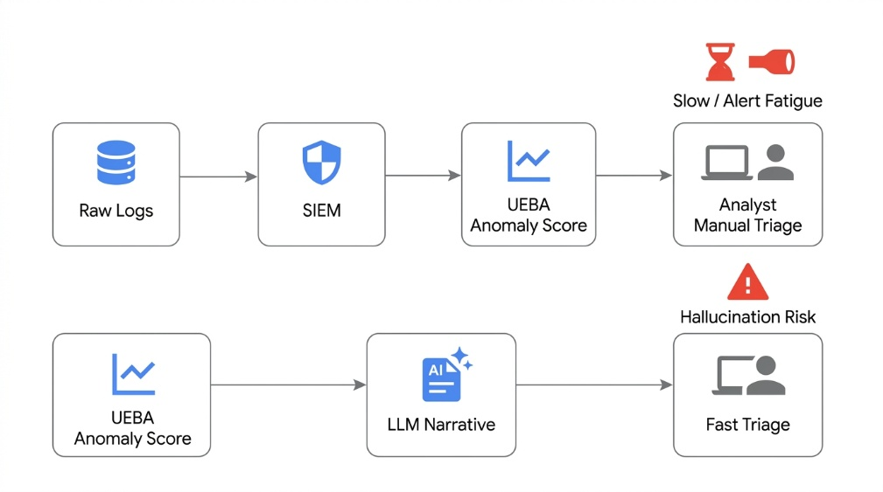
Figure 1.1: UEBA workflow

Despite these advancements in detection engineering, this analytical layer has fundamentally failed to solve the interpretability problem. When a UEBA system flags a user's activity for a given week, the output typically arrives at the Security Operations Center (SOC) merely as a mathematical anomaly score, a raw binary flag, or a triggered rule identifier. It acts as a statistical signal that something is suspicious but provides zero narrative account of what transpired or why the deviation matters contextually. An entry level SOC analyst receiving such a flag must manually open a raw log viewer, pivot across multiple indices, locate the relevant timestamped activity, and attempt to reconstruct a behavioral timeline from potentially hundreds of individuals, disjointed events before confidently deciding whether the alert warrants a severe incident escalation.

This investigative process is painstakingly slow, cognitively demanding, and is heavily documented as a primary driver of alert fatigue. Analysts, desensitized by overwhelming volumes of opaque, unexplained statistical flags, begin to systematically deprioritize them, inevitably allowing genuine, sophisticated threats to pass uninvestigated. Recently, the security industry has turned to Large Language Models (LLMs) as a highly visible, automated remedy. Given the structured telemetry evidence behind a UEBA alert, an LLM can leverage its semantic fluency to automatically generate a readable, natural language narrative. This narrative explains what the user did and why the pattern deviates from their baseline, theoretically converting a dense spreadsheet of raw events into an actionable paragraph that an analyst can triage in seconds.
The problem and the fundamental starting point of this thesis is that while these generative paragraphs are highly fluent, they are inherently decoupled from factual accuracy.

1.2 Problem Description
Modern Security Operations Centers (SOCs) must continuously monitor and defend enterprise environments against increasingly sophisticated cyber threats. To manage this vast volume of data, organizations rely heavily on UEBA and SIEM systems. These advanced analytical systems excel at identifying statistical deviations and detecting anomalous behaviors from massive troves of raw log data. However, while UEBA generates rich and highly precise anomaly signals, these systems inherently struggle to deliver human readable explanations at a speed that matches analyst workflows. Current SIEM and UEBA research heavily prioritizes anomaly detection but typically stops at presenting raw technical signals. This creates a severe operational bottleneck, neglecting the crucial explanation layer where human comprehension ultimately determines operational effectiveness.
In a typical deployment, SOCs process thousands of complex anomaly alerts every single day. The raw, log-based format of these technical alerts routinely overwhelms analysts, especially given the severe time constraints inherent in critical incident response scenarios. As analysts are bombarded with technical signals that lack semantic structure, they experience severe alert fatigue. This cognitive overload directly compromises response times and diminishes the overall efficacy of the security team. Consequently, while the mathematical detection of an anomaly is largely a solved prerequisite, the translation of that complex technical alert into an actionable format remains a critical, unsolved challenge in cybersecurity operations.
To bridge this interpretability gap and accelerate the incident triage process, the cybersecurity industry has increasingly turned to Large Language Models (LLMs). LLMs can simplify massive volumes of complex log data into natural language summaries, delivering explanations that dramatically improve SOC productivity. Discussions at recent industry forums highlight a rapid transition toward the agentic SOC paradigm, where industry leaders integrate LLMs and specialized AI agents to automate the full alert lifecycle, from initial data enrichment to alert summarization. However, these systems focus overwhelmingly on orchestration speed and productivity, fundamentally failing to provide formal guarantees regarding the factuality of the LLM's explanations.

This prioritization of speed over factual guarantees introduces a severe operational vulnerability. Although an LLM generated summary is extremely fast and fluent to read, single LLM outputs inherently carry a high risk of hallucination. In high stakes security operations, where factual accuracy is absolutely required to ensure organizational safety, these persistent hallucination risks thoroughly undermine trust in the generated outputs. If an analyst acts upon a rapidly generated but factually incorrect explanation, the resulting errors could compromise organizational security, lead to misallocated response resources, or cause legitimate threats to be dangerously dismissed.
Despite widespread concerns regarding hallucinations in high stakes applications, current academic and industrial approaches to mitigation lack statistical rigor. Existing hallucination mitigation techniques such as utilizing an LLM as a judge, measuring semantic entropy, or relying on logit based calibration and uncertainty estimates suffer from severe structural limitations. These methods either require access to proprietary model internals that are strictly unavailable when using production black box LLMs, or they simply fail to provide the distribution free, finite sample error guarantees that are essential for reliable SOC deployment. Furthermore, existing conformal abstention methodologies that provide document level guarantees are practically inefficient, as rejecting an entire document wastes perfectly correct sentences contained within it. These current methods may improve heuristic filtering, but they fail to deliver verifiable factual reliability for multi component UEBA explanations.
Consequently, a critical research gap exists no current work successfully combines log grounded admission filtering with sentence level conformal selection for production UEBA explanations. This thesis operates directly at the intersection of cybersecurity operations, LLM hallucination mitigation, and conformal prediction to address this limitation. By applying conformal prediction as a statistical safety net, this research transforms raw AI narratives into verifiably trustworthy explanations. Specifically, this thesis aims to deliver a log grounded conformal prediction pipeline that operates at sentence level granularity. This methodology provides distribution free, finite sample validity without the necessity of retraining the underlying language model, ultimately allowing SOC analysts to balance explanation utility against factual risk by mathematically bounding error rates at user configurable levels.

1.3 Research Questions
To bridge this gap, this thesis investigates whether non monotone conformal prediction can mathematically bound complex hallucination risks in automated security narratives. The central inquiry is systematically decomposed into the following three core research questions
- RQ1 Can a log grounded anomaly signal, in which every potential fact a narrative could reference is forced into an enumerable, typed, and numeric format, reliably support the sentence level verification of subsequently generated natural language narratives?
- RQ2 Can a dual signal admission function combining Natural Language Inference (NLI) consistency across repeated language model samples with strict numeric/entity fact matching against structured log evidence be combined into a deterministic rule that successfully distinguishes grounded sentences from hallucinated, mis weighted, and falsely precise claims with usable precision and recall?
- RQ3 Can conformal component selection, specifically calibrated over a non-monotone, false discovery shaped loss using the Learn Then Test (LTT) framework, provide a formal, finite sample statistical guarantee on the fraction of factually incorrect sentences admitted to an analyst, at a user chosen risk level , without requiring any retraining of the underlying language model?

1.4 Approach
This thesis designs and implements an end-to-end pipeline that transforms raw security telemetry into statistically controlled, natural language explanations of UEBA alerts. The methodology treats the anomaly detector as a fixed prerequisite and focuses entirely on the explainability and verification layers. The implementation is organised as a unidirectional, multistage workflow in Python, combining structured data processing, asynchronous language model inference, deterministic linguistic verification, supervised scoring, and non-monotone conformal risk control.
Stage 1: Signal extraction - Telemetry from the CERT Insider Threat Test Dataset r6.2 is aggregated at user week level and processed using five transparent detection rules: after-hours activity spikes, elevated removable media usage, high-volume external email with attachments, off-role browsing (including leak site visits), and peer-relative deviation. These rules act as a stand-in for a deployed UEBA detector. Each flagged user week is transformed into a structured anomaly signal containing strictly enumerable, typed numeric facts. Facts are cleanly separated into self-relative baselines (a user's trailing history), peer-relative baselines (role-matched comparators), and specific anomalous evidence. This enumerable fact representation ensures that every claim a narrative might make corresponds to a verifiable element in the signal.
Stage 2: Narrative generation - A cloud-hosted large language model (Google Gemini 3.7 Flash) treats the structured signal as a prompt and generates independent narrative explanations per signal, orchestrated via asynchronous API calls to overcome sequential network latency. The model operates at a non-zero sampling temperature (T = 0.7) combined with nucleus sampling (top-p = 0.95). This stochastic multi-sampling produces a diverse distribution of candidate sentences, deliberately exploiting variance across samples to expose the model's internal uncertainty rather than suppressing it. Generated text is segmented into discrete sentences and pooled across samples via semantic clustering. The frequency of each semantic cluster provides a self-consistency score used later in admission scoring.
Stage 3: Sentence scoring and admission - Candidate sentences are evaluated by a deterministic admission function that calculates a confidence score by merging two independent signals. The first is an NLI-based self-consistency score (using a DeBERTa cross-encoder) to evaluate semantic agreement across sampled narratives. The second is a regex-driven numeric and entity fact-matching script tied directly to the Stage 1 structured evidence. Crucially, this function includes a rigid heuristic override: if a sentence inappropriately frames a background context fact as the driving cause of the alert (misweighting), its score is forced to zero, regardless of numerical accuracy. This reflects the security domain requirement that correct values must also be assigned to the correct causal explanation.
Stage 4: Conformal calibration - The pipeline requires statistical calibration to guarantee error rates. Because the error loss function is non-monotone (specifically, the False Discovery Rate of incorrect sentences changes its denominator depending on how many sentences are accepted), standard conformal prediction fails. Therefore, this stage employs the Learn-Then-Test (LTT) framework. Utilising Hoeffding–Bentkus p-values and fixed-sequence investing, the system calibrates an acceptance threshold over a human-annotated, user-level exchangeable split to strictly control the expected false discovery rate. The calibrated threshold is selected only after the calibration procedure has been completed on a dedicated split.
Stage 5: Evaluation - The calibrated threshold is subsequently applied to a rigidly held-out test set to measure empirical risk against the nominal, user-defined target risk (α). This evaluates both statistical validity and practical usefulness (recall). Evaluation metrics include empirical false discovery proportion, precision and recall of the admission function, recall of grounded content retained after filtering, and the proportion of candidate sentences admitted. Baseline comparisons include an uncalibrated threshold and an NLI-only ablation that excludes deterministic fact matching. All explanation-level results are reported conditional on successful upstream anomaly detection to decouple detection failures from verification failures.
Finally, an Adaptive Conformal Inference (ACI) simulation is executed, using a simple error-feedback threshold update rule, to evaluate how dynamic threshold adjustments perform under the chronological drift inherent to long-term security telemetry. This experiment assesses whether dynamic threshold adjustment can respond to changing narrative quality and maintain an appropriate balance between factual safety and operational recall.

1.5 Thesis Contribution
This research bridges the isolated fields of cybersecurity explainability and conformal risk control. While each constituent technique is individually established, their combination and specific application to structured security telemetry rather than general domain text has not been previously demonstrated. The thesis delivers concrete contributions.

Log derived conformal representation. The work introduces an enumerable fact anomaly representation that pairs raw CERT r6.2 telemetry with LLM generated narratives. Every potential claim a narrative might make corresponds to a typed, numeric fact in the source signal. This provides a concrete, structured dataset specifically designed for security explainability and verification research, enabling deterministic grounding checks that are impossible with unstructured logs or free text references.
Misweighting aware admission function. The thesis designs, implements, and empirically evaluates an admission function that combines NLI based self-consistency with strict numeric and entity fact matching. Crucially, it incorporates a dedicated misweighting detector that identifies sentences which inappropriately frame background context (such as role or department) as the causal driver of an anomaly. Ablation experiments demonstrate that standard LLM self-consistency alone is insufficient for security text and that deterministic fact matching and misweighting overrides are necessary in high-stakes operational environments.
Sentence level conformal selection for security. The work adapts the non-monotone Learn Then Test (LTT) calibration framework to sentence granularity selection in a strictly log grounded setting. This extends existing conformal abstention methodologies beyond standard open domain question answering tasks into the rigid domain of security verification. The implementation shows how false discovery rate control can be achieved at sentence level without retraining the underlying language model, allowing SOC analysts to balance explanation utility against factual risk at configurable user levels.
Empirical hallucination taxonomy. The thesis formalizes a detailed, empirically derived failure taxonomy encompassing fact mixing, category conflation, arithmetic derivation, and contextual misweighting. This taxonomy is derived from direct manual annotation of real generated security narratives rather than assumed a priori. It provides a security specific refinement of the standard intrinsic–extrinsic hallucination distinction and documents failure modes that general domain decomposes then verify frameworks do not capture.
Together, these contributions establish a verifiable, log grounded explanation pipeline for UEBA alerts. The approach demonstrates that language model narratives can be transformed from fluent but untrusted outputs into statistically controlled evidence suitable for high-stakes security operations.

1.6 Thesis Outline
The remainder of this thesis is structured to guide the reader from theoretical foundations through empirical validation and operational interpretation.
Chapter 2 (State of the Art) reviews the state of the art literature in SIEM and UEBA explainability, LLM hallucination taxonomies, Natural Language Inference (NLI), and the mathematical mechanics of conformal prediction, with specific focus on Conformal Risk Control and the Learn-Then-Test (LTT) framework. The chapter establishes the theoretical scaffolding for the pipeline and closes with an explicit statement of the research gap.
Chapter 3 (Dataset and Methodology) details the CERT r6.2 telemetry, the five rule-based detection heuristics, and the construction of the enumerable fact representation. It describes the self-relative and peer-relative baseline taxonomies, the dual-signal extraction mechanisms (regex fact matching and spaCy causal misweighting), and the integration of the Learn-Then-Test (LTT) conformal prediction framework used to mathematically guarantee error boundaries.
Chapter 4 (Implementation) outlines the experimental design for Stages 2 through 5. It details the generative sampling parameters, the dual-signal admission architecture (NLI self-consistency plus deterministic fact matching), the misweighting override, and the rigid mathematical parameters defining the conformal calibration sequences. The chapter also documents engineering decisions such as asynchronous orchestration, semantic pooling, and grouped cross-validation.
Chapter 5 (Evaluation and Results) presents the quantitative results. It reports component-level evaluations (generator diversity, semantic compression, extraction heuristics), Logistic Regression performance, and the Learn-Then-Test calibration outcomes. Validity and usefulness are assessed jointly across multiple risk levels. Baseline comparisons include an uncalibrated, visually inspected fixed threshold and a single-signal ablation isolating self-consistency and fact-matching individually against the full dual-signal model. An Adaptive Conformal Inference (ACI) simulation evaluates dynamic threshold adjustment under temporal distribution shift.
Chapter 6 (Discussion and Future Work) synthesizes the empirical findings against the three core research questions, discusses the operational implications for modern SOCs, reflects on the study's limitations considering the empirical results, and proposes vectors for future research in security-focused LLM verification.

Chapter 2 State of the Art
As the complexity and volume of enterprise network telemetry have grown exponentially, the mechanisms used to secure these environments have undergone a forced evolution from static, signature based defenses to dynamic, behavior driven analytics. However, this evolution has generated a secondary crisis of interpretability. Modern anomaly detection systems are highly proficient at identifying statistical deviations, yet they are structurally incapable of explaining them. Consequently, security analysts are burdened with translating abstract mathematical anomalies into actionable human narratives, a process that introduces severe operational latency. While Large Language Models (LLMs) possess the semantic fluency required to bridge this gap, their tendency to confidently hallucinate facts renders their unverified deployment in Security Operations Centers (SOCs) an unacceptable risk.

This chapter establishes the theoretical foundations and reviews the state of the art required to contextualize, design, and validate a verifiable, log grounded explanation pipeline. The chapter is structured into four distinct parts. Part 1 (Section 2.1 through 2.3) provides a rigorous architectural breakdown of the foundational technologies underpinning this thesis Security Information and Event Management systems, User and Entity Behavior Analytics , and the Transformer based architecture of LLMs. Part 2 transitions into the methodologies of semantic validation, Natural Language Inference (NLI) mechanisms and cross encoder architectures. Part 3 introduces the mathematical framework of Conformal Prediction, contrasting split conformal methods with the non-monotone Learn Then Test (LTT) procedures required for sentence level risk bounding. Finally, Part 4 synthesizes the contemporary literature surrounding cybersecurity explainability and LLM hallucination mitigation, explicitly identifying the prevailing research gap the absence of formal, finite sample statistical guarantees for security log grounded natural language generation. Together, these sections establish the theoretical scaffolding upon which the pipeline in Chapter 4 is built.

2.1 Background

2.1.1 Historical Evolution and Architectural Purpose
The notion of Security Information and Event Management (SIEM) arose in the early 2000s as a crucial consolidation of two distinct disciplines Security Information Management (SIM), which focused on storage for long term and analysis of log data, and Security Event Management (SEM), which focused on real time monitoring and correlation of security alerts (Kent & Souppaya, 2006). Prior to the advent of SIEM, network administrators monitored isolated security appliances such as firewalls, Intrusion Detection Systems (IDS), and antivirus servers through disparate consoles (Kent & Souppaya, 2006). As enterprise architecture scaled, this decentralized approach resulted in isolated data silos, making it impossible to trace advanced persistent threats (APTs) moving laterally across a network.
The primary architectural purpose of a SIEM is to serve as the centralized nervous system of the Security Operations Center. By ingesting, normalizing, and correlating telemetry from thousands of endpoints, proxies, and authentication servers, the SIEM transforms raw machine data into a unified timeline of enterprise activity (Bhatt et al., 2020).

2.1.2 Rule Based Correlation and its Limitations
Historically, the analytical engine of a SIEM relied exclusively on rule based correlation. Security engineers write deterministic Boolean logic to detect known attack signatures or prohibited state transitions (Bace & Mell, 2001). A classic correlation rule might dictate IF (Failed Login Attempts > 5 within 1 Minute) AND (Subsequent Successful Login = True), THEN Trigger Alert.

While rule based correlation is computationally efficient and highly interpretable an analyst knows exactly which rule triggered and why it suffers from two fatal limitations. First, it is strictly reactive. Rules can only be written for attack vectors that are already known and perfectly understood. Second, rule based systems scale poorly against legitimate operational variance. A threshold that defines abnormal download volume for a marketing employee will generate endless false positives if applied to a database administrator. Attempting to manage thousands of highly specific, role based correlation rules results in immense administrative overhead and the eventual degradation of the SOC's efficacy due to alert fatigue (Al Mhiqani et al., 2020). The failure of static rules to adapt to dynamic human behavior necessitated the evolution of behavioral analytics.

2.2 User and Entity Behavior Analytics (UEBA)

2.2.1 From Signatures to Behavioral Baselines
To address the brittleness of deterministic SIEM rules, User and Entity Behavior Analytics (UEBA) was introduced to shift the detection paradigm from signature matching to statistical anomaly detection (Nurse et al., 2014). Rather than asking Does this event match a known bad signature? , UEBA asks Does this event significantly deviate from the historical norm for this specific user or their peer group?
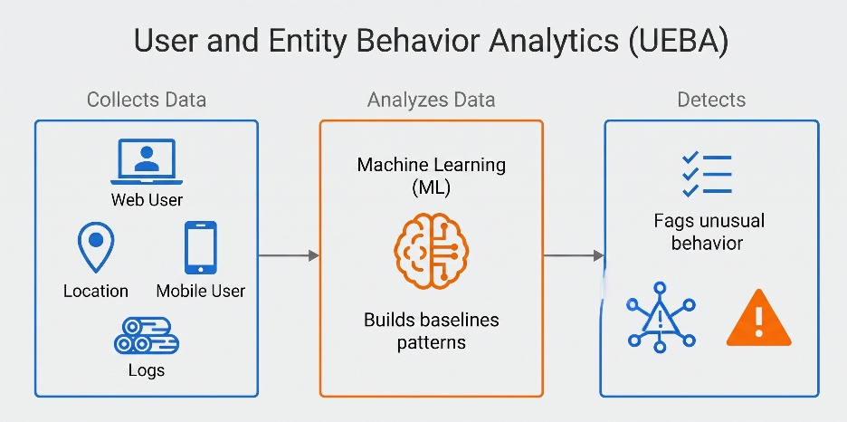
Figure 2.1 User and Entity Behavior Analysis Workflow
This paradigm shift requires the system to maintain continuous, dynamic state. A UEBA engine aggregates raw normalized logs into multi dimensional feature vectors representing entity behavior over specific time windows (e.g., days or weeks). The system then computes statistical baselines, allowing it to detect unknown unknowns novel attack vectors or insider threats that have no pre existing signature, but which mathematically disrupt the established behavioral equilibrium (Salem, Hershkop, & Stolfo, 2008).

2.2.2 Statistical Profiling and Distance Metrics
The most foundational algorithm in UEBA is the computation of trailing statistical baselines. For continuous or discrete count features (such as total megabytes transferred or total HTTP requests made), the system computes measures of central tendency and dispersion.
To avoid the impact of powerful outliers on the baseline itself, robust statistics are preferred over standard mean and variance. A standard UEBA implementation computes the trailing Median and the Median Absolute Deviation (MAD). The anomaly score for a user's feature at time is frequently formulated as a modified z score
$$\begin{aligned}z=\frac{x-\text{Median}}{\text{MAD}}\#2.1\end{aligned}$$
However, in highly sparse enterprise telemetry, a user may exhibit a history of exactly zero events for a specific action (e.g., zero visits to a leak publication website over 12 weeks). In this scenario, both the Median and MAD equal zero. A single subsequent visit results in a division by zero, yielding an infinite anomaly score. Modern UEBA pipelines, including the extraction stage implemented in this thesis, apply mathematical floors to the dispersion metric to prevent these zero variance explosions. By enforcing a Poisson inspired spread floor such as the system safely bounds the anomaly score, allowing novel events to be flagged without destroying the numerical stability of the feature matrix.
Furthermore, UEBA systems implement peer group baselining. By utilizing directory services (e.g., LDAP), the system groups users by department or role. A user's activity is compared not only to their own history (the self z score) but also to the concurrent median of their role cohort (the peer z score). This dual baseline architecture allows the system to suppress false positives caused by company wide events (which elevate the peer median simultaneously) and to detect localized insider threats where a user deviates sharply from colleagues performing identical roles.

2.2.3 Unsupervised Machine Learning in UEBA
Beyond univariate statistical profiling, modern UEBA leverages multivariate unsupervised machine learning to detect anomalies across high dimensional feature spaces (Greitzer et al., 2014Le & Zincir Heywood, 2021).
Isolation Forests are extensively deployed in UEBA due to their efficiency with high dimensional, continuous data (Liu, Ting, & Zhou, 2008). Unlike algorithms that attempt to profile normal behavior, Isolation Forests explicitly isolate anomalies. The algorithm recursively partitions the dataset by randomly selecting a feature and a split value. Because anomalies are few and different, they require significantly fewer random partitions to be isolated into their own terminal leaf nodes. The anomaly score increases as the distance from the root to the leaf decreases shorter paths indicate highly anomalous behavior.
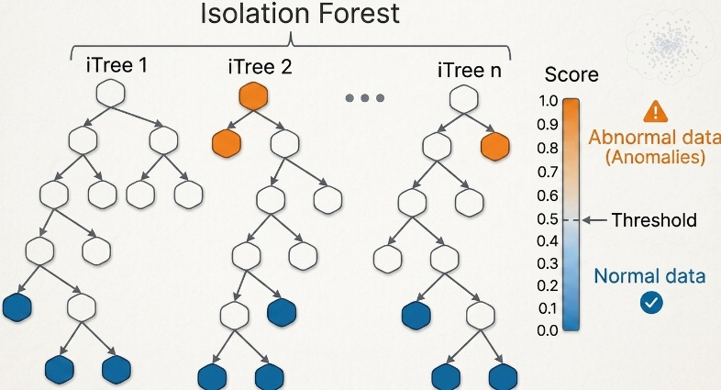
Figure 2.2 Isolation Forest Anomaly Detection

Autoencoders (neural networks designed to reconstruct their input) are similarly utilized. The network compresses the user's behavioral vector into a low dimensional bottleneck layer and then attempts to reconstruct the original vector. The network is trained exclusively on historical (presumed normal) data. When an anomalous behavioral vector is processed, the network fails to accurately reconstruct the novel patterns, resulting in a high Mean Squared Error (MSE) reconstruction loss. This loss value serves directly as the continuous anomaly score.
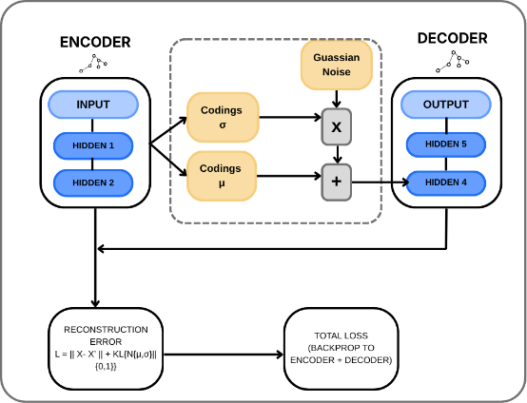
Figure 2.3 Autoencoder Architecture in UEBA

2.2.4 The Alert Interpretability Gap
While UEBA successfully detects novel insider threats that evade static rules, it introduces a severe operational bottleneck. When an Isolation Forest or an Autoencoder flags a user week as malicious, the output is an abstract, multi dimensional distance metric.
The unsupervised machine learning algorithm cannot explain whether the high score was driven by abnormal USB activity, unusual login times, or a subtle, complex combination of both. Consequently, the SOC analyst must manually query the SIEM, visually scanning hundreds of raw log lines to reconstruct the narrative of the anomaly. This interpretation gap negates the speed advantages of automated detection, establishing the critical need for automated, natural language explanation layers.

2.3 Large Language Models (LLMs) and Autoregressive Generation
To bridge the interpretability gap generated by UEBA, the security industry has turned to Large Language Models. To understand both the capabilities and the inherent risks of deploying LLMs as anomaly narrators, one must examine their underlying neural architecture and generation mechanics.

2.3.1 The Transformer Architecture and Self Attention
Natural language processing relied heavily on Recurrent Neural Networks (RNNs) and Long Short Term Memory (LSTM) networks, which processed text sequentially. This sequential processing prevented parallelization and severely limited the model's ability to retain context over long text passages.
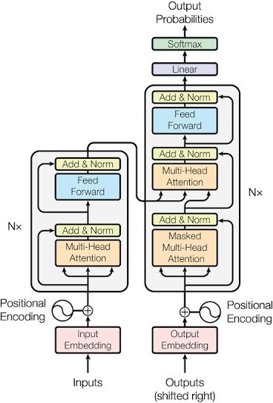
Figure 2.4 Transformer Architecture (Vaswani et al., 2017)
The Transformer discarded recurrence entirely in favor of the Self Attention mechanism. Self attention allows the model to compute a weighted representation of a sequence by explicitly measuring the semantic relevance of every word (token) to every other word in the input, regardless of their physical distance in the sentence.
Mathematically, the input sequence is projected into three distinct matrices Queries ($Q$), Keys ($K$), and Values ($V$), utilizing learned weight matrices. The attention scores are computed by taking the dot product of the Queries and Keys, scaling by the square root of the hidden dimension depth ($d_{k}$) to prevent vanishing gradients, applying a softmax function to create a probability distribution, and multiplying the result by the Values matrix
$$\begin{aligned}\text{Attention}\left(Q,K,V\right)=\text{softmax}\left(\frac{QK^{T}}{\sqrt{d_{k}}}\right)V\#2.2\end{aligned}$$
where $K^{T}$ denotes the transpose of $K$, and $d_{k}$ is the dimensionality of the key vectors. This mechanism allows the LLM to process a structured UEBA anomaly signal (e.g., a list of numeric facts) and dynamically attend to the relevant evidence and context parameters when constructing the subsequent explanation, ensuring that the generated verbs and subjects align with the provided data.

2.3.2 Autoregressive Text Generation
Models such as GPT, LLaMA, and Gemini utilize the decoder only variant of the Transformer architecture (Brown et al., 2020). These models are trained via causal language modeling they are optimized to predict the probability of the next token in a sequence given all preceding tokens.
During inference (the generation of an anomaly explanation), the LLM operates autoregressively. It receives the prompt (the structured UEBA signal and system instructions), computes the probability distribution for the first generated token, samples a token from that distribution, appends it to the input sequence, and repeats the process until a special stopping token is generated.
This token by token generation process is fundamentally probabilistic. The LLM does not possess a database of facts or an internal logic engine. It is a highly sophisticated statistical engine mapping input text geometries to likely output continuations. When tasked with explaining a security anomaly, the model relies on the semantic relationships learned during its pre training phase to construct fluent, professional prose.

2.3.3 Stochasticity, Temperature, and Sampling
The specific behavior of the autoregressive generation is heavily controlled by the decoding strategy. The probability distribution over the vocabulary for the next token is modified by a scalar parameter known as Temperature ($T$). The adjusted probability for token $i$ is given by the softmax function over the model's unnormalized logit scores ($x_{i}$)

$$\begin{aligned}P\left({\text{token}}_{i}\right)=\frac{\exp\left(x_{i}/T\right)}{\sum_{j}{\exp\left(x_{j}/T\right)}}\#2.3\end{aligned}$$

where $x_{i}$ is the logit for token $i$, $T$ is the temperature, and the denominator sums $\exp\left(x_{j}/T\right)$ over all candidate tokens $j$.
When $T$ approaches 0 (greedy decoding), the model always selects the token with the absolute highest probability. The output becomes entirely deterministicgiven the exact same UEBA signal, the model will output the exact same narrative string every time.
When $T$ is greater than 0, the probability distribution softens. The model begins to sample probabilistically from the top candidate tokens (often constrained further by Top K or Top p/Nucleus sampling algorithms to prevent sampling from the extreme tail of nonsensical tokens). This stochastic sampling means that a single input prompt will yield a diverse set of narratives.
While deterministic generation is often desired in strict data to text tasks, the pipeline designed in this thesis actively exploits stochasticity ($k$ sampling). By sampling $k$ independent narratives from the model at $T>0$, architecture forces the LLM to traverse multiple distinct semantic pathways. If the model is highly confident in a specific factual interpretation of the UEBA signal, that claim will recur across the $k$ drafts despite the randomized sampling. If the model is uncertain, the stochasticity will cause it to generate conflicting claims. This variance across the generated set $Y\left(S\right)=\left\{y_{1},...,y_{k}\right\}$ forms the essential foundation for computing internal confidence and detecting hallucination boundaries through semantic self consistency.

2.4 Natural Language Inference (NLI) and Semantic Clustering
To automate the evaluation of an LLM's internal confidence, a system must be able to computationally determine whether distinct linguistic formulations assert the same underlying factual claim. This capability relies upon the theoretical frameworks of Natural Language Inference (NLI) and semantic clustering.

2.4.1 Theoretical Foundations of NLI
Natural Language Inference historically referred to as Recognizing Textual Entailment (RTE) is computational task of determining the directional logical relationship between two fragments of text a premise ($P$) and a hypothesis ($H$). The fundamental objective is to classify the relationship into one of three mutually exclusive categories
- Entailment If the premise is true, the hypothesis must necessarily be true.
- Contradiction If the premise is true, the hypothesis must necessarily be false.
- Neutral The truth of the hypothesis cannot be determined from the premise alone.
The formalization of this task catalyzed a massive shift in Natural Language Processing (NLP), driven by the release of large scale annotated datasets such as the Stanford Natural Language Inference (SNLI) corpus (Bowman et al., 2015) and Multi Genre NLI (Williams, Nangia, & Bowman, 2018). These datasets transitioned the field from fragile, rules based syntactic matching and rigid formal logic to deep, statistical representation learning. The core theoretical assumption is that a model capable of accurately resolving NLI tasks has developed a robust, generalizable representation of semantic meaning, entity coreference, and localized reasoning.
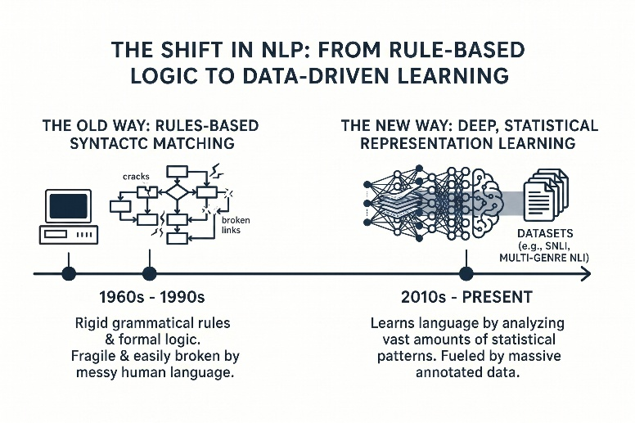
Figure 2.5 The Paradigm Shift in Natural Language Processing (NLP)

2.4.2 Cross Encoders vs. Bi Encoders
In modern Transformer based architectures, NLI and semantic similarity are computed using one of two distinct topologies Bi encoders or Cross encoders (Reimers & Gurevych, 2019).
Bi encoders process the premise and the hypothesis independently through two separate Transformer networks (or the same network in two distinct passes). The network outputs a dense vector representation (embedding) for each sentence. The relationship between the sentences is subsequently determined by computing a simple mathematical distance metric between the two vectors, most commonly cosine similarity
$$\begin{aligned}\text{Cosine Similarity}\left(U,V\right)=\frac{U⋅V}{‖U‖‖V‖}\#2.4\end{aligned}$$
where $U⋅V$ is the dot product of vectors $U$ and $V$, and $‖U‖$, $‖V‖$ denote their respective magnitudes (Euclidean norms).
While highly efficient for large scale retrieval (as millions of premise embeddings can be pre computed and stored in a vector database), Bi encoders lack the capacity for deep semantic interaction. Because the premise and hypothesis are embedded in isolation, the attention heads of the Transformer cannot weigh a specific word in the hypothesis against a specific word in the premise.
To achieve the rigorous precision required for factual verification, architecture must utilize Cross encoders. A Cross encoder concatenates the premise and hypothesis into a single input sequence, separated by specialized tokens. For example, using the standard BERT or DeBERTa vocabulary structure, the input takes the form
$$\begin{aligned}\left[CLS\right]\text{ Premise Tokens }\left[SEP\right]\text{ Hypothesis Tokens }\left[SEP\right]\#2.5\end{aligned}$$
This represents the standard BERT style input format for cross encoder sentence pair classification, where [CLS] is the pooled output token, [SEP] separates and terminates segments, and the premise/hypothesis pair is jointly encoded for entailment or grounding scoring. This single sequence is passed through the Transformer layers simultaneously. Consequently, the self attention mechanism computes attention weights across the entire concatenated sequence. The query vectors of the hypothesis actively attend to the key and value vectors of the premise at every layer of the network. This cross attention mechanism allows the model to map exact entity relationships, track numerical references, and resolve complex syntactic dependencies that would be lost in independent embeddings. A linear classification head followed by SoftMax is applied to the [CLS] token’s final hidden state to yield a probability distribution across Entailment, Contradiction, and Neutral.

2.4.3 DeBERTa and Disentangled Attention
The specific cross encoder architecture frequently utilized in state of the art verification pipelines is DeBERTa (Decoding enhanced BERT with Disentangled Attention) (He et al., 2021). Unlike standard BERT models, which add absolute position embeddings to word embeddings directly at the input layer, DeBERTa represents each word using two distinct vectors, one for its semantic content and one for its relative position.
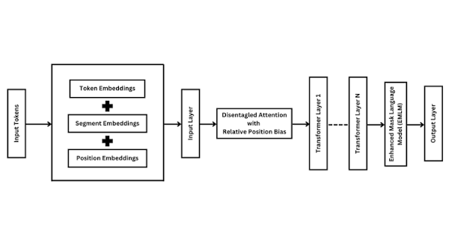
Figure 2.6 The DeBERTa Architecture and Disentangled Attention
A probability distribution across the vocabulary is produced for the next token based on their contents and their relative positions. Theoretically, this allows the model to distinguish between the grammatical function of a word based on its location and its inherent semantic meaning. For security narratives heavily reliant on numerical values and specific entity locations, this disentangled attention provides a significantly higher resolution for entailment classification compared to standard Transformer baselines.

2.4.4 Semantic Clustering
In addition to directional entailment, evaluation pipelines must frequently cluster generated sentences to reduce redundancy before human annotation or final presentation. Semantic clustering utilizes the continuous vector space generated by Bi encoders.
Given a pool of candidate sentences, the system computes the pairwise cosine similarity matrix. Sentences are grouped into semantic equivalence classes based on a predefined distance threshold ($τ$). Agglomerative clustering algorithms process the similarity matrix to form dense clusters where all intra cluster similarities exceed $τ$. This theoretical approach assumes that the dense embedding space is isotropic, meaning that semantic distance maps linearly to Euclidean or cosine distance a property specifically optimized during the contrastive training of Sentence BERT models (Reimers & Gurevych, 2019).

2.5 Conformal Prediction and Risk Control
While NLI provides a heuristic score of semantic confidence, heuristic scores are inherently uncalibrated. A SoftMax probability of 0.90 from a neural network does not strictly mean there is a 90% chance the prediction is correct deep neural networks are notoriously overconfident (Guo et al., 2017). To deploy LLMs in high stakes environments, these heuristic outputs must be translated into rigorous statistical guarantees. This is achieved through the mathematical framework of Conformal Prediction.

2.5.1 Historical Context and Exchangeability
Conformal Prediction (CONFORMAL PREDICTION) was pioneered by Vladimir Vovk, Alexander Gammerman, and Glenn Shafer in the early 2000s (Vovk, Gammerman, & Shafer, 2005). It was designed as a universal model agnostic framework for uncertainty quantification. Unlike Bayesian methods, which require assumptions about the underlying data distribution and a prior probability distribution, Conformal Prediction is entirely distribution free. It provides finite sample guarantees (meaning the mathematical bounds hold exactly for datasets of any size, not just asymptotically as the sample size approaches infinity).
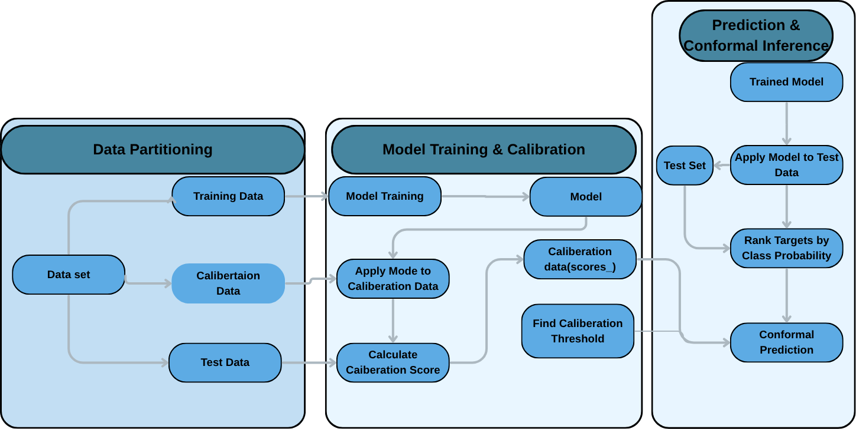
Figure 2.7 Conformal Prediction
The single foundational assumption of Conformal Prediction is exchangeability. A sequence of random variables is called if permuting their order leaves the joint probability distribution unchanged. In practical terms, this means the future test data must be drawn from the same underlying distribution as the calibration data, and the specific ordering of the data points must not contain information. If the exchangeability assumption holds, conformal prediction guarantees that the error rate of the model will be strictly bound by a user specified level.

2.5.2 Split Conformal Prediction
The most computationally efficient variant of CONFORMAL PREDICTION is Split Conformal Prediction (Papadopoulos et al., 2002). The methodology partitions an available labeled dataset into a training set and a separate calibration set.
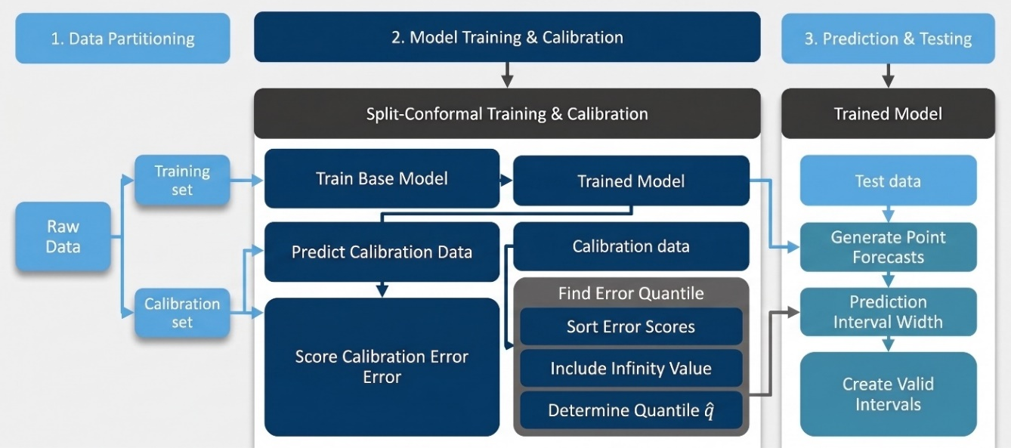
Figure 2.8 Split Conformal Prediction
First, a predictive model is trained entirely on the training set. Second, the model generates predictions for every instance in the calibration set. For each calibration instance , the system computes a nonconformity score, . The nonconformity score is a heuristic measure of how strange or incorrect the prediction is compared to the true label.
Once the nonconformity scores for the calibration set (size ) are computed, they are sorted in ascending order. To guarantee that the true label of a new, unseen test point will be contained in the predicted set with probability , the algorithm selects the empirical quantile of the calibration scores. Specifically, it computes
$$\begin{aligned}q^{​}=\left\lceil n\left(n+1\right)\left(1-α\right)​\right\rceil -th smallest value of \left\{S1​,…,Sn​,∞\right\}\#2.6\end{aligned}$$
the standard split conformal quantile rank ⌈(n+1)(1−α)⌉ among the n calibration nonconformity scores (augmented with ∞), which guarantees exact finite sample marginal coverage of 1−α. By the symmetry of exchangeability, the probability that the new test point's true nonconformity score falls below the quantile is exactly , thus guaranteeing marginal coverage.

2.5.3 Conformal Risk Control (CRC)
Standard split conformal prediction was designed for classification (where the output is a prediction set of labels) and regression (where the output is a prediction interval). It guarantees set coverage the probability that the true label is within the output set.
However, in many modern AI applications, set coverage is the wrong metric. When filtering a list of LLM generated sentences, the goal is not to guarantee that the true sentence is in the list. The goal is to guarantee that the expected fraction of incorrect sentences in the list is below a specific threshold.
Conformal Risk Control (CRC), developed by Bates et al. (2021), extends conformal prediction to bound the expected value of an arbitrary loss function . The fundamental requirement of standard CRC is that the loss function must be monotonically decreasing with respect to the acceptance threshold .
Let $λ$ be a threshold, and the accepted set of items be $A_{λ}$. If raising $λ$ strictly shrinks the accepted set and thereby strictly reduces (or maintains) the total loss, the loss function is monotone. In this scenario, CRC utilizes the calibration set to find the smallest threshold $\overset{ˆ}{λ}$ such that the empirical risk (the average loss over the calibration set) plus a finite sample penalty term is less than or equal to the target risk $α$. Because the loss decreases monotonically, bounding the empirical risk directly bounds the true expected risk.

2.6 The Learn Then Test (LTT) Framework
The requirement for monotonicity in Conformal Risk Control presents a fatal mathematical blocker for evaluating generated text. In the context of anomaly explanations, the relevant loss metric is the False Discovery Rate (FDR) the fraction of admitted sentences that are factually incorrect.
FDR is inherently non monotone. Suppose a threshold $λ=0.5$ admits 10 sentences, 1 of which is wrong. The FDR is 10%. If the threshold is raised to $λ=0.8$, the system might reject 8 correct sentences and keep 1 correct sentence and 1 wrong sentence. The accepted set shrinks, but the FDR suddenly spikes to 50%. Because raising the threshold can arbitrarily increase the error fraction, standard CRC cannot be applied.
To solve the non monotone risk control problem, Angelopoulos et al. (2021) introduced the Learn Then Test (LTT) framework. LTT abandons the quantile search mechanics of standard conformal prediction in favor of rigorous, fixed sequence multiple hypothesis testing.

2.6.1 Multiple Hypothesis Testing and Investing
LTT requires the practitioner to pre specify a discrete grid of possible thresholds $Λ=\left\{λ_{1},λ_{2},...,λ_{N}\right\}$. For every threshold $λ_{j}$ in the grid, the framework defines a null hypothesis $H_{j}$ The true expected risk at threshold $λ_{j}$ is strictly greater than the target risk $α$. (i.e., the risk is NOT controlled at this threshold).
To guarantee risk control, LTT must reject this null hypothesis. Rejecting $H_{j}$ implies that the true risk at $λ_{j}$ is less than or equal to $α$.
Because the algorithm is testing dozens of thresholds simultaneously, it faces the multiple comparisons problem testing multiple hypotheses increases the probability of falsely rejecting at least one null hypothesis (a Type I error). A standard Bonferroni correction controls the Family Wise Error Rate (FWER) by dividing the required confidence level ($δ$) by the number of tests ($δ/N$). However, Bonferroni is impractically conservative and destroys statistical power, frequently resulting in vacuous thresholds that reject all data.
To overcome this, LTT employs Fixed Sequence $α$ Investing. The threshold grid is sorted in descending order of conservatism (from the most restrictive threshold, $λ_{1}$, to the most permissive, $λ_{N}$). The algorithm tests $H_{1}$. If the p value is less than or equal to $δ$, $H_{1}$ is rejected, the risk is deemed controlled, and the algorithm proceeds to test $H_{2}$ at the exact same confidence level $δ$. The sequential testing continues until a null hypothesis cannot be rejected. The moment the algorithm fails to reject $H_{k}$, it halts immediately, and the final accepted threshold is $λ_{k-1}$. This fixed sequence procedure mathematically guarantees FWER control at exactly level $δ$ without any Bonferroni division, maximizing statistical power.

2.6.2 Concentration Inequalities The Hoeffding Bentkus Bound
To execute the hypothesis test at each $λ_{j}$, LTT requires a mathematically valid p value. This p value is derived using concentration inequalities, which bound the probability that a random variable deviates from its expected value by a certain margin.
For losses bound in the interval $\left[0,1\right]$ (such as FDR), the most effective concentration inequality is the Hoeffding Bentkus bound. As detailed in Proposition 1 of Angelopoulos et al. (2021), taking the minimum of two independently valid p values for the same null hypothesis yields a valid p value that is tighter than either bound alone.
The first bound is derived from Hoeffding's Inequality, expressed in its tighter Kullback Leibler (KL) divergence form

$$\begin{aligned}p_{\text{Hoeffding}}=\exp\left(-n⋅h_{1}\left(\min\left(\overset{ˆ}{r},α\right),α\right)\right)\#2.7\end{aligned}$$

where $n$ is the number of calibration samples, $\overset{ˆ}{r}$ is the empirical average loss measured on the calibration set at threshold $λ_{j}$, and $h_{1}\left(a,b\right)$ is the Bernoulli KL divergence

$$\begin{aligned}h_{1}\left(a,b\right)=a\ln\left(\frac{a}{b}\right)+\left(1-a\right)\ln\left(\frac{1-a}{1-b}\right) \#2.\end{aligned}8$$

The $\min\left(\overset{ˆ}{r},α\right)$ clipping mechanism is criticalit ensures that if the empirical risk $\overset{ˆ}{r}$ is already greater than the target $α$, $p_{\text{Hoeffding}}$ equals 1.0, correctly providing zero statistical evidence to reject the null hypothesis.
The second bound is the Bentkus binomial tail inequality, which is exceptionally tight for small values of $α$ and highly skewed data (which is characteristic of security datasets where hallucinations are rare but dangerous)

$$\begin{aligned}p_{\text{Bentkus}}=e⋅P\left(\text{Binomial}\left(n,α\right)≤\left\lceil n\overset{ˆ}{r}\right\rceil \right) \#2.9\end{aligned}$$
where $e$ is Euler's number, $P\left(\text{Binomial}\left(n,α\right)≤k\right)$ is the binomial cumulative distribution function evaluated at $k$, $n$ is the calibration sample size, $α$ is the target risk level, $\overset{ˆ}{r}$ is the empirical risk, and $\left\lceil ⋅\right\rceil$ denotes the ceiling function.The final Hoeffding Bentkus p value used in the LTT fixed sequence test is
$$\begin{aligned}p_{\text{HB}}=\min\left(p_{\text{Hoeffding}},p_{\text{Bentkus}}\right) \#2.\end{aligned}10$$
By combining these advanced statistical bounds with fixed sequence $α$ investing, the Learn Then Test framework provides a mathematically unassailable method for bounding non monotone loss geometries, offering the first theoretical mechanism to formally guarantee the factual accuracy of filtered LLM outputs.

2.7 Adaptive Conformal Inference (ACI)

2.7.1 The Temporal Distribution Shift Problem
The mathematical guarantees provided by split conformal prediction and LTT rely entirely on the absolute sanctity of the exchangeability assumption. The data used to calibrate the threshold must be drawn from the exact same underlying distribution as the future test data.
In enterprise security environments, the exchangeability assumption is frequently violated by temporal distribution shift (Quinonero Candela et al., 2008). Network architectures evolve, employee behaviors shift due to organizational changes, and LLM generative outputs exhibit concept drift over time. If a static conformal threshold is calibrated in January, the underlying probability distribution of anomalies and hallucinations may have shifted significantly by June. Under temporal distribution shift, the static loses its mathematical guarantee, and the true empirical risk may silently exceed the target .

2.7.2 Online Threshold Updates
To maintain valid statistical guarantees under distribution shift, Gibbs and Candes (2021) introduced Adaptive Conformal Inference (ACI). ACI transforms conformal prediction from a static, offline calibration process into a dynamic, online learning algorithm.
Instead of computing a single threshold $\overset{ˆ}{λ}$, ACI maintains a time varying threshold $λ_{t}$. At each time step $t$ (e.g., each day or each batch of generated sentences), the system utilizes the current threshold $λ_{t}$ to filter the data. A human annotator (or a highly reliable automated proxy) subsequently evaluates the filtered output and computes the true empirical loss at time $t$, $L_{t}$.
ACI then updates the threshold for the next time step, $t+1$, using a mathematically defined step size ($γ$)
$$\begin{aligned}λ_{t+1}=λ_{t}+γ\left(α-L_{t}\right) \#2.\end{aligned}11$$
If the empirical loss $L_{t}$ is greater than the target risk $α$ (meaning the system admitted too many errors), the term $\left(α-L_{t}\right)$ becomes negative. This decreases $λ_{t+1}$, making the system more conservative for the next step. Conversely, if $L_{t}$ is less than $α$ (meaning the system was overly restrictive), the threshold is relaxed, maximizing the utility of the admitted set.
Theoretical proofs establish that, regardless of the severity of the distribution shift, ACI guarantees that the asymptotic average risk over time will converge exactly to $α$. By integrating an ACI extension into the LTT framework, verification pipelines can theoretically maintain bounded hallucination risks indefinitely, dynamically self correcting as the enterprise environment and language model behaviors evolve.
Parts 1 and 2 established the foundational technologies and statistical frameworks underpinning this thesis SIEM aggregation, UEBA behavioral baselining, autoregressive Transformer architectures, and the distribution free calibration mechanics of Conformal Prediction and Learn Then Test. The remainder of this chapter transitions from theoretical construction to empirical and domain specific assessment. Section 2.8 establishes the mathematical and methodological metrics required to rigorously evaluate the admission function and verify conformal validity. Subsequent sections conduct a thematic literature review tracing the historical evolution of explainability within SOCs, examining LLM hallucination taxonomies, and critically analyzing current conformal methodologies, culminating in a precise statement of the research gap.

2.8 Evaluation Metrics
To evaluate the efficacy of the sentence scoring admission function and the statistical validity of the conformal calibration pipeline, a precise set of evaluation metrics must be formalized. Standard machine learning metrics are insufficient when applied to generative text in high stakes operational environments. Consequently, the evaluation methodology relies on a combination of specific statistical risk functions, operational text generation metrics, and conformal properties.

2.8.1 The Dual Requirement Validity and Usefulness
A formal statistical guarantee is only meaningful when accompanied by a demonstration that the guarantee holds empirically on unseen data, and by a second, independent demonstration that the resulting filtered output remains practically useful. This evaluation framework is organized explicitly around this dual requirement, following the established principle in conformal prediction literature that error control alone is an incomplete evaluation criterion (Vovk, Gammerman, & Shafer, 2005Bates et al., 2021).
A trivial decision rule that admits nothing at all achieves perfect validity under any reasonable loss definition an empty set can contain no incorrect elements while providing zero operational value to an analyst. Consequently, neither property is treated as sufficient in isolation both are reported jointly across all experimental sweeps.

2.8.2 False Discovery Rate (FDR)
In the context of verifiable anomaly explanations, the primary operational risk is exposing a security analyst to a fabricated, falsely precise, or mis weighted claim. Traditional classification metrics treat all errors symmetrically. However, in SOC, the operational cost of admitting a hallucinated sentence (a False Positive) drastically outweighs the cost of rejecting a grounded sentence (a False Negative).

Therefore, the defining loss function of this architecture is the False Discovery Rate (Benjamini & Hochberg, 1995). FDR measures the expected proportion of admitted sentences that are factually incorrect. Formally, let $R$ denote the total number of sentences admitted by the acceptance threshold $λ$ (Total Discoveries), and let $V$ denote the number of those admitted sentences that are factually wrong (False Discoveries). The False Discovery Proportion (FDP) is defined as

$$\begin{aligned}\text{FDP}=\frac{V}{\max\left(R,1\right)} \#2.12\end{aligned}$$

The denominator incorporates $\max\left(R,1\right)$ to mathematically prevent division by zero in the event that the threshold is conservative enough to admit zero sentences. The False Discovery Rate is the statistical expectation of the FDP over the data distribution

$$\begin{aligned}\text{FDR}=E\left[\frac{V}{\max\left(R,1\right)}\right] \#2.13\end{aligned}$$

where $E\left[⋅\right]$ denotes expectation over repeated data draws, $V$ is the number of false discoveries, and $R$ is the total number of discoveries, with $\max\left(R,1\right)$ preventing division by zero.
By bounding the FDR at a user specified risk level $α$ (e.g., $α=0.10$), the system formally guarantees that, on average, no more than 10% of the sentences an analyst reads across alerts will contain factual errors.

2.8.3 Precision and Recall
While FDR measures the aggregate statistical risk of the admitted set, standard Precision and Recall remain critical for evaluating the raw heuristic power of the underlying admission function prior to conformal calibration.
Within this sentence level verification architecture, the confusion matrix elements are defined as follows
- True Positive (TP) A factually grounded sentence that is correctly admitted by the scoring function.
- False Positive (FP) An incorrect sentence (hallucinated, derived number, or mis weighted) that is erroneously admitted.
- False Negative (FN) A factually grounded sentence that is inappropriately rejected by the scoring function.
Precision measures the purity of the admitted sentence pool
$$\begin{aligned}\text{Precision}=\frac{\text{TP}}{\text{TP}+\text{FP}} \#2.14\end{aligned}$$
Recall measures the sensitivity of the admission function to retain valuable context
$$\begin{aligned}\text{Recall}=\frac{\text{TP}}{\text{TP}+\text{FN}} \#2.15\end{aligned}$$
A theoretical limitation of Recall in generative text evaluation is that an LLM may produce multiple semantically equivalent sentences representing a single underlying telemetry fact. Rejecting redundant variants does not operationally harm the analyst if one representative sentence is admitted however, standard Recall penalizes this redundancy rejection, making it a conservative lower bound on operational utility.

2.8.4 Conformal Validity
Validity is the foundational theoretical property of conformal prediction (Vovk, Gammerman, & Shafer, 2005). A conformal calibration procedure is mathematically valid if the empirical loss measured on a held out test split (never observed during calibration) falls at or below the nominal target risk level $α$
$$\begin{aligned}L_{\text{test}}\left({\overset{ˆ}{λ}}_{α}\right)≤α \#2.16\end{aligned}$$
where $L_{\text{test}}$ is the loss (e.g., FDP) measured on the held out test set using the calibrated threshold ${\overset{ˆ}{λ}}_{α}$, and $α$ is the target risk level. This checks empirically, on one test split, whether the risk control guarantee from calibration held in practice distinct from the underlying probabilistic guarantee ($P\left(L_{\text{test}}≤α\right)≥1-δ$) itself.
Formally, denoting the calibrated acceptance threshold for a target risk $α$ as ${\overset{ˆ}{λ}}_{α}$, and the accepted sentence set on the test split as $A\left({\overset{ˆ}{λ}}_{α}\right)$, empirical validity is evaluated via
$$\begin{aligned}L_{\text{test}}\left({\overset{ˆ}{λ}}_{α}\right)=\frac{\sum_{i}{V_{i}}\left({\overset{ˆ}{λ}}_{α}\right)}{\max\left(\sum_{i}{R_{i}}\left({\overset{ˆ}{λ}}_{α}\right),1\right)} \#2.17\end{aligned}$$
where the sums run over test examples $i$, $V_{i}$ is the false discovery count and $R_{i}$ is the discovery count for example $i$, and $\max\left(⋅,1\right)$ guards against division by zero.
The standard reporting mechanism adopted in this thesis is a calibration curve plotting measured empirical error against nominal $α$. A diagonal reference line ($y=x$) represents the exact theoretical bound points falling on or below the diagonal confirm that the finite sample guarantee holds, while points falling above it indicate an empirical violation.

2.8.5 Usefulness and Operational Efficiency
Conformal validity must always be paired with Usefulness (termed Efficiency or Informativeness in conformal literature) (Bates et al., 2021). Usefulness is quantified as the recall of genuinely grounded content that survives threshold filtering
$$\begin{aligned}{\text{Recall}}_{\text{grounded}}\left(λ\right)=\frac{\sum_{i}{{\text{TP}}_{i}}\left(λ\right)}{\text{Total Grounded Sentences}} \#2.18\end{aligned}$$
where ${\text{TP}}_{i}\left(λ\right)$ is the true positive count (correctly admitted grounded sentences) for test example $i$, summed across the test set, divided by the fixed total number of grounded sentences in the test set.
This metric is plotted alongside the validity curve across the full sweep of $α$ values. The theoretical rationale mirrors the classical tension between Type I and Type II errors tightening the threshold (lowering $α$) decreases the admitted error rate but mechanically reduces the volume of admitted text. A complete evaluation requires demonstrating that the calibrated operating point maintains sufficient recall for the output narrative to remain informative to an analyst.

2.8.6 Baseline Comparisons and Their Theoretical Necessity
To isolate the precise empirical contribution of both the dual signal admission function and the conformal calibration machinery, two baseline comparisons are required
- Uncalibrated Threshold Baseline A fixed heuristic threshold selected by visual inspection of score distributions on the training set, evaluated without conformal calibration. This comparison isolates what is achievable through raw heuristic scoring and demonstrates the failure of uncalibrated thresholds to maintain bounded error rates under sample variance.
- Single Signal Ablation Baseline An admission rule driven strictly by Natural Language Inference (NLI) self consistency, omitting the numeric/entity fact matching module. This ablation provides direct empirical evidence regarding whether deterministic fact matching contributes discriminative signal beyond semantic self consistency alone.

2.8.7 Conditional Reporting and the Detection–Explanation Boundary
A final methodological principle governing this evaluation concerns the boundary between the upstream detection layer (the UEBA rules flagging anomalies) and the downstream explanation layer (the LLM narrative generation and verification pipeline).
Because detection recall varies across different insider threat attack profiles, reporting an unconditioned, pooled explanation recall would conflict with two distinct failure modes (i) the failure of the detection rule to flag a subtle anomaly, and (ii) the failure of the admission function to verify a generated narrative. Consequently, all explanation and verification metrics reported in this thesis are explicitly conditional on correct upstream detection, ensuring that limitations inherent to the detection heuristics are analytically decoupled from the verification framework.

2.9 Discussion and Synthesis of Prior Work
The transition of enterprise security monitoring from static logs to complex statistical models has been defined by a continuous tension between detection efficacy and human interpretability. An analysis of the existing literature reveals five distinct thematic approaches to solving this interpretability gap and addressing the reliability of subsequent explanations. This section evaluates these thematic clusters, identifies key competitor methodologies, and explicitly positions the current thesis against them.

2.9.1 Semantic Ontologies and Rule-Based Enrichment
In the early development of Security Information and Event Management (SIEM) architectures, researchers focused heavily on augmenting raw alerts with contextual metadata using Semantic Web technologies.
(Staniford-Chen et al. 1999) established structural protocols for querying relational asset databases, serving as a competitor methodology for structural enrichment.
Strengths: This rule-based approach excelled at determinism and structural rigidity. By formalizing the environment, SIEM engines successfully appended verifiable environmental context (e.g., user department, server role) directly to correlation alerts without any risk of hallucinated metadata. Weaknesses: The primary limitation of semantic ontologies was their inability to scale dynamically. These systems fell short when encountering novel threat vectors or behavioral drift, as they required rigid, manually maintained knowledge graphs. They provided factual context but failed to generate fluid, human-readable chronological narratives. Connection to Current Work: This thesis extends the core philosophy of deterministic, ontological grounding but fundamentally differs in its application. While early ontology research used deterministic structures to trigger alerts, this research utilizes a structured, enumerable-fact representation explicitly as an independent verification layer to bound the output of a generative model.

2.9.2 Unsupervised Machine Learning and Post-Hoc XAI Feature Attribution
As User and Entity Behavior Analytics (UEBA) platforms largely replaced deterministic Boolean logic with high-dimensional unsupervised models, detection architectures became mathematically opaque. In response, cybersecurity research heavily investigated post-hoc Explainable AI (XAI) techniques. Competitor studies in this space extensively benchmarked these architectures. For example, (Le and Zincir-Heywood 2021) conducted a massive empirical evaluation comparing Autoencoders and Isolation Forests against the CERT dataset. Their work successfully demonstrated that reconstruction-error models could rank malicious insider behavior accurately without labeled training examples. To explain these anomalies, researchers frequently applied SHAP (Lundberg & Lee, 2017) and LIME (Ribeiro, Singh, & Guestrin, 2016) to extract feature importance scores.
Strengths: Unsupervised ML methods solved the scaling limitations of rule-based systems, successfully detecting unknown unknowns by identifying statistical deviations from established baselines. XAI techniques effectively identified which mathematical vectors contributed most to the anomaly score. Weaknesses: These methods fell profoundly short in operational triage environments. Feature-attribution methods provided mathematical visibility into model parameters (e.g., showing that a specific byte-count feature was highly weighted), but they structurally failed to deliver the causal, chronological narratives required for rapid human incident response. Connection to Current Work: Unlike prior approaches, the proposed pipeline challenges the assumption that feature attribution equals operational explainability. Rather than competing with the detection efficacy of Isolation Forests or Autoencoders, this research treats those unsupervised models as a fixed prerequisite layer. It extends their utility by translating their abstract, multi-dimensional distance metrics into formal, natural-language narratives.

2.9.3 Generative Language Modeling and Agentic SOC Workflows
To bridge the gap between mathematical feature attribution and human-readable narratives, recent industry and academic efforts shifted toward integrating Large Language Models (LLMs) into the SOC. Current industrial workflows, such as the competitor architectures heavily documented in recent technical reports deploy LLMs to ingest SIEM alerts, correlate access histories, and draft natural-language incident tickets. These competitor deployments often rely on basic Retrieval-Augmented Generation (RAG) and prompt-engineering heuristics.
Strengths: LLM-based approaches largely solved the semantic fluency gap. They demonstrated an unprecedented ability to rapidly synthesize massive volumes of disjointed logs into highly readable, professional incident summaries, drastically reducing the initial cognitive load on human analysts. Weaknesses: The fatal flaw of these unconstrained agentic architectures was their factual unreliability. Current industry deployments depend entirely on unverified heuristics prompt instructions to govern behavior. These approaches failed to provide any finite-sample statistical guarantees regarding the factual accuracy of the generated tickets, introducing dangerous operational vulnerabilities where hallucinations were treated as actionable intelligence. Connection to Current Work: In contrast to these unconstrained frameworks, this research directly challenges the prevailing industry practice of deploying unverified or purely heuristic-driven LLMs in SOC environments. It differs by rejecting the assumption that prompt engineering or standard RAG is sufficient for high-stakes security operations, opting instead to enforce strict statistical verification boundaries on the generative output.

2.9.4 Decompose-Then-Verify Frameworks for Hallucination Mitigation
Recognizing the dangers of unconstrained generation, the broader Natural Language Processing (NLP) community pivoted toward decompose-then-verify architectures to mitigate hallucinations. Foundational competitor studies in this domain include FActScore (Min et al., 2023).These frameworks processed long-form text by utilizing an LLM to decompose the narrative into atomic claims, subsequently verifying each claim against an external knowledge source using Natural Language Inference (NLI).
Strengths: These methodologies established that statement-level factuality verification was both technically feasible and measurably more accurate than holistic, response-level scoring. They successfully automated the detection of extrinsic hallucinations (fabricated facts) by forcing claims to match retrieved context. Weaknesses: These general-domain verification frameworks fell short when applied to highly structured, numerical cybersecurity telemetry. They structurally struggled to distinguish between arithmetically derived truths and falsely precise numerical hallucinations. Furthermore, because these frameworks were designed for open-domain text generation and question-answering settings respectively, they were not designed to detect domain-specific logical errors specifically, the causal misweighting of background. Connection to Current Work: The current work builds on the decompose-then-verify paradigm but completely re-architects the verification heuristic. It differs from FActScore and RAGAS by abandoning pure LLM-based NLI evaluation in favor of a dual-signal admission function. This thesis explicitly incorporates deterministic regex matching for numerical grounding and a dedicated spaCy dependency parser to catch the causal misweighting errors that general-domain frameworks systematically miss.

2.9.5 Conformal Prediction Applications in Natural Language
To mathematically bound the heuristic errors of NLI verifiers, recent literature explored Conformal Prediction (Vovk et al., 2005) as a safety mechanism. Specifically, the introduction of Conformal Risk Control (Bates et al., 2021) and the Learn-Then-Test framework (Angelopoulos et al., 2021) provided the theoretical machinery to bound non-monotone loss geometries, such as the False Discovery Rate. Recent competitor studies applied conformal abstention methodologies to open-domain generative question-answering systems, allowing language models to selectively abstain from answering when confidence was low (Quach et al., 2023).
Strengths: Conformal prediction frameworks provided distribution-free, finite-sample statistical guarantees. They successfully allowed system architects to formally cap the expected error rate without requiring any retraining of the underlying language or inference models. Weaknesses: Existing literature restricted the application of LTT primarily to open-domain classification and question-answering tasks. In the limited instances where component-level selection was applied to generated text, the methodologies often required human gold-reference answers for calibration a resource that simply does not exist for the continuous volume of novel anomalies encountered in enterprise cybersecurity telemetry. Connection to Current Work: This thesis directly extends the mathematical application of the Learn-Then-Test framework. It differs from prior work by adapting sentence-level conformal selection specifically to the strict domain of security verification, relying entirely on an enumerable, log-grounded fact set rather than human-authored reference narratives for calibration.

2.9.6 Synthesis and Research Gap
Despite immense advancements across unsupervised anomaly detection, generative language modeling, and statistical risk control, the contemporary literature reveals a fractured landscape. UEBA platforms achieved advanced statistical detection capabilities but fundamentally lacked explainability. Unconstrained LLMs bridged this semantic gap but introduced unacceptable risks of factual fabrication and causal misweighting, which general-domain decompose-then-verify frameworks (like FActScore) failed to adequately resolve for numeric telemetry. Concurrently, while the Learn-Then-Test conformal framework offered the exact mathematical guarantees required for high-stakes environments, its application was isolated to open-domain tasks reliant on human reference text. Consequently, no existing work successfully combines log-grounded admission filtering with non-monotone conformal selection for production UEBA explanations. This thesis fills this precise research gap by constructing a sentence-level conformal prediction pipeline that verifies candidate narratives against structured anomaly signals bounding hallucination rates at user-configurable limits without requiring proprietary model retraining or human reference texts.

Chapter 3: Dataset and Methodology

3.1 Chapter Introduction
This chapter details the dataset and computational techniques utilized to architect, evaluate, and validate the hybrid conformal prediction pipeline for automated security alert triage. Transitioning from theoretical frameworks to a highly functional, enterprise-ready software application required solving complex engineering challenges across data ingestion, natural language processing, and statistical risk bounding. The chapter is divided into two primary sections. The first section outlines the dataset provenance, structural characteristics, and the rigorous preprocessing pipeline required to transition unstructured raw telemetry into a deterministic, enumerable fact representation. The second section details the model design and deployment architecture, covering the asynchronous orchestration of generative language models, the dual-signal heuristic extraction mechanisms, and the integration of the Learn-Then-Test (LTT) conformal prediction framework used to mathematically guarantee error boundaries.

3.2 Dataset Selection

3.2.1 Source and Provenance
To evaluate the proposed conformal prediction architecture within a realistic Security Operations Center (SOC) context, this research utilized the CERT Insider Threat Test Dataset, specifically release r6.2. Empirical validation of User and Entity Behavior Analytics (UEBA) systems faces a fundamental hurdle: real-world corporate security logs are heavily encumbered by privacy constraints, Personally Identifiable Information (PII), and strict non-disclosure agreements. Furthermore, real-world datasets rarely contain verified, labeled ground truth for insider threats. The synthetic CERT r6.2 dataset was selected because it resolves these issues, providing a densely parameterized and highly realistic benchmark standard that simulates the digital footprint of a complex enterprise without the restrictive legal encumbrances of proprietary organizational data.

3.2.2 Characteristics
The dataset captured a holistic view of enterprise behavior, containing longitudinal activity logs for exactly 4,000 simulated employees over a continuous operational period of 516 days. The data spanned five primary raw log modalities: logon events (tracking temporal authentication patterns), device interactions (monitoring removable media usage), HTTP traffic (capturing web browsing behavior and URL categorization), email communications (capturing internal and external metadata), and file access events. Within this massive volume of routine, stochastic enterprise activity, the dataset contained exactly five meticulously planted ground-truth insiders executing multi-stage malicious campaigns, such as IT sabotage and intellectual property theft. This structure created a severely imbalanced class distribution which is a mathematical necessity, as confirmed insider incidents are exceptionally rare relative to the astronomical volume of benign daily corporate activity.

3.2.3 Preprocessing, Normalization, and Extraction
Before natural language explanations could be generated, the raw unstructured JSON logs exported from the simulated Security Information and Event Management (SIEM) system were processed via a localized Python orchestration script utilizing the pandas library. The data was aggregated into weekly periods to establish behavioral baselines.
To identify anomalous behavior without conflating the study with novel anomaly detection algorithm design, the pipeline employed five transparent, rule-based detection heuristics: After-Hours Activity, Removable Media Use, High-Volume External Email, Off-Role Browsing, and Peer-Relative Deviation. These transparent rules were deliberately chosen to act as an interpretable stand-in for a deployed UEBA detector, ensuring the mechanisms triggering an alert were fully known so the evaluation could focus entirely on the LLM's explanation and verification capabilities.
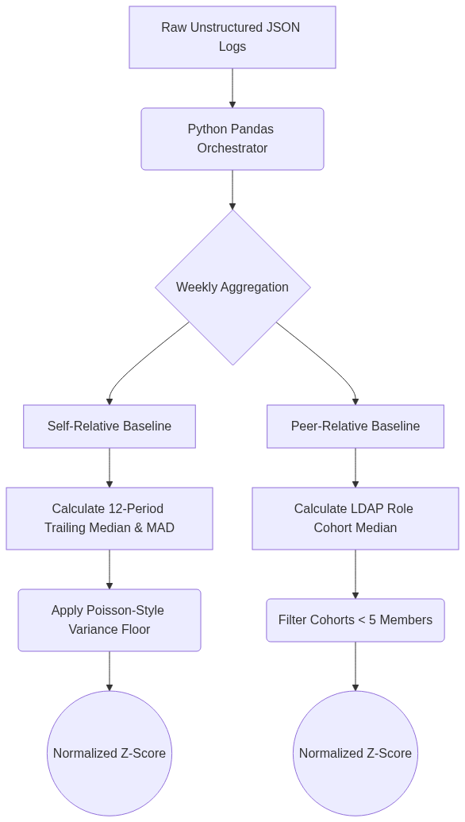
Figure 3.1 Preprocessing Data flow

To establish behavioral baselines, the extraction pipeline utilized two distinct taxonomies:
- Self-Relative Baselines: A user’s current period value was compared against their own 12-period trailing history. Robust statistical measures—specifically the median and the median absolute deviation (MAD)—were employed. A Poisson-style floor was mathematically applied to count-based features. This decision was made to prevent zero-variance explosions when calculating z-scores for previously unseen actions in highly sparse telemetry.
- Peer-Relative Baselines: A user’s activity was compared against the median activity of all other users sharing the same LDAP role during the exact same week (with groups fewer than 5 members withheld for statistical reliability). This dual-baseline approach was necessary to ensure the dataset captured both deviations from a user's personal habits and deviations from organizational expectations.

3.2.4 Enumerable Fact Representation and Labeling
The central architectural constraint governing the data preprocessing was that every property extracted from the raw logs had to be reducible to a finite, typed, numeric quantity. The telemetry was rigidly structured into a JSON signal separating "evidence facts" (the dynamic, numeric vectors that triggered the anomaly) from "background context" (immutable organizational identity parameters like employee role and department).
This "enumerable fact representation" was chosen because flat CSV files lack the per-fact structure required for an automated admission function to verify a narrative. By ensuring every potential claim an LLM might make corresponding directly to an explicitly typed and numeric fact, the downstream admission function could perform deterministic entity and numeric consistency checks, effectively bounding the generative output. For training and evaluation, the extracted alerts and their subsequent generations were split using a StratifiedGroupKFold methodology. The grouping was explicitly executed on the signal_id parameter to strictly isolate all narrative sentences derived from the exact same raw SIEM alert into either the training fold or the testing fold, structurally guaranteeing the prevention of data leakage.

3.3 Model Design and Deployment Section

3.3.1 Model Architecture and Asynchronous Orchestration
The primary generative engine utilized in this architecture was the Google Gemini 3.7 flash API. To resolve the catastrophic network latency bottlenecks inherent in sequential API querying, the generative layer was implemented utilizing Python's native asyncio framework with an exponential backoff fault-tolerance algorithm.
The anomaly explanation task was framed as a generative task, but heavily constrained to induce measurable variance. The API payloads were configured with a stochastic temperature of 0.7 and a Nucleus Sampling threshold of top_p=0.95. A deterministic temperature of 0.0 was deliberately rejected; the architecture required stochastic entropy to force the LLM to traverse multiple distinct semantic pathways. By generating k=10 independent narrative drafts per alert, the system actively exploited this variance to measure the model's internal uncertainty (Self-Consistency). Furthermore, to enforce machine-readable outputs, prompt engineering mandated that the LLM serialize its drafts within a strict JSON schema, allowing the Python orchestrator to automatically quarantine malformed responses.
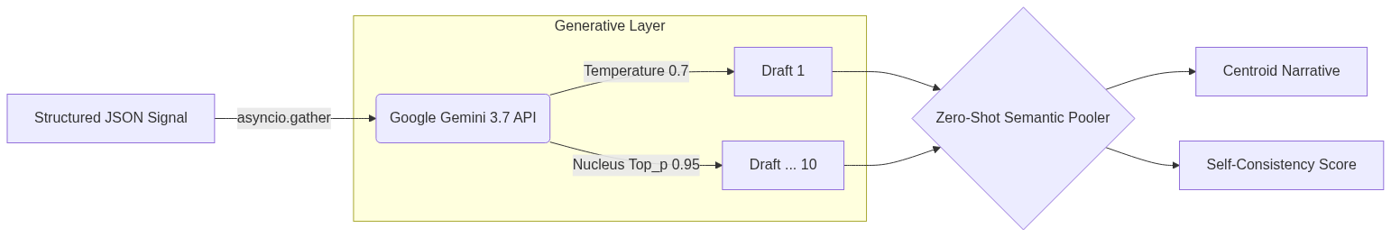
Figure 3.2 Overview of the multi-draft generation and semantic compression workflow.
Because processing ten independent drafts for every single SIEM alert created an insurmountable downstream computational payload, the pipeline implemented a Semantic Pooling dimensionality reduction layer. A zero-shot batching prompt was utilized to group semantically identical narratives into unified cluster IDs. This specific clustering approach was chosen to drastically compress the NLI workload while flawlessly preserving the frequency count required to derive the self_consistency probability score.

3.3.2 Factual Verification and Scoring Mechanism
To evaluate the generated narrative clusters, the architecture deployed a dual-pronged heuristic extraction and scoring mechanism:
- Deterministic Regex Fact Matcher: A compiled regular expression engine scanned the text to verify atomic numerical telemetry against the raw JSON signal, calculating a fact_match ratio. This deterministic approach was necessary because LLMs frequently hallucinate derived mathematical numbers or exhibit false precision.
- Causal Misweighting Parser (spaCy): A localized, industrial-strength spaCy NLP dependency parser was implemented to analyze the grammatical syntax of the sentence. The algorithm traversed the Directed Acyclic Graph (DAG) to flag logical causal errors, specifically returning a boolean misweighted flag if an unbroken grammatical path linked a causal preposition directly to an immutable identity node (e.g., falsely claiming an alert triggered because a user is an Intern). This was critical because simple keyword matching is entirely blind to grammatical context and structural logic errors.
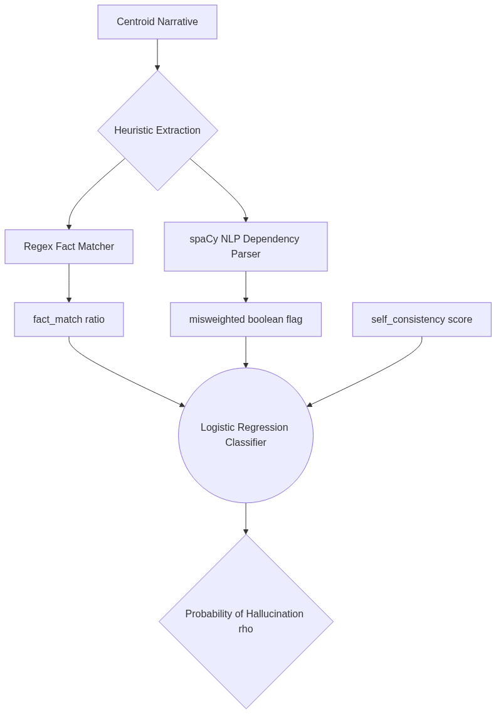
Figure 3.3 Dual-signal validation architecture for computing the final ρ score.
These extracted features (along with the self_consistency metric) were passed into a scikit-learn Logistic Regression classifier to calculate the raw, continuous probability (ρ) that a specific narrative was a hallucination. Logistic Regression was selected over complex, non-parametric tree models (like Random Forest or XGBoost) because it provided the smoothest and most reliably calibrated probability curve on the structured, relatively small-scale dataset, avoiding severe overfitting while outputting the continuous point estimates mandatory for subsequent conformal calibration. The model was initialized with class_weight='balanced' and an inverse regularization strength of C=1.0 to penalize the gradient for failing to identify the rare minority class (Hallucinations).

3.3.3 Conformal Prediction Integration
Because the raw ρ probability scores produced by the Logistic Regression model provided no formal mathematical safety guarantees, the pipeline integrated Conformal Prediction to statistically bound operational risk. Standard Split Conformal Prediction mechanics were insufficient because the defining operational loss metric—the False Discovery Rate (FDR)—is non-monotone. Therefore, the architecture utilized the Learn-Then-Test (LTT) framework.
The LTT engine was implemented using advanced NumPy vectorization. For a predefined discrete grid of possible thresholds (λ), the algorithm tested the null hypothesis that the true expected risk exceeded the target risk (α). To control the Family-Wise Error Rate (FWER) without sacrificing statistical power via overly conservative Bonferroni corrections, LTT employed Fixed-Sequence α-Investing combined with Hoeffding-Bentkus concentration inequalities to compute exact p-values. The optimal threshold λ was programmatically selected as the maximum threshold that mathematically guaranteed the FDR remained strictly bounded below α.
Furthermore, to maintain validity under the severe temporal distribution shifts common in cybersecurity environments, the pipeline implemented Adaptive Conformal Inference (ACI). A continuous temporal feedback loop was established to track the empirical error across sequential time periods. If the empirical error spiked above α, the ACI update algorithm automatically increased the λ threshold for the next period, and relaxed it if the error fell below α. This dynamic approach was chosen because it allows the software to autonomously heal from environmental shocks without requiring manual offline recalibration.

3.3.4 Evaluation Strategy
The evaluation strategy was designed around the dual conformal requirements of Validity and Usefulness. Standard classification metrics treat all errors symmetrically, but in a SOC, the cost of admitting a hallucinated sentence (False Positive) drastically outweighs rejecting a grounded one (False Negative).

Consequently, the primary evaluation metric was the False Discovery Rate (FDR), utilized to prove the statistical validity of the conformal boundary against the nominal α target. The Brier Score Loss and Mean Absolute Error (MAE) were selected to measure the exact probability error and calibration reliability of the underlying Logistic Regression judge, as standard ROC-AUC metrics fail to measure whether a predicted probability reflects true likelihood. Finally, operational Usefulness was quantified via Recall (specifically, the percentage of grounded content surviving threshold filtering) and Recall@K, chosen specifically to demonstrate how effectively the pipeline triages the most dangerous alerts to the top of an analyst's queue under severe time constraints.

3.4 Alignment with Core Objectives
The integration of the synthetic CERT r6.2 dataset with the described asynchronous extraction, semantic pooling, and verification architecture directly enables the investigation of the core research questions. By enforcing an enumerable fact representation on the raw telemetry, the methodology guarantees that every generated claim can be subjected to deterministic and syntactic evaluation, satisfying the prerequisite for log-grounded validation. The resulting dual-signal scoring mechanism, when passed into the Learn-Then-Test conformal prediction framework, provides the exact mathematical scaffolding necessary to prove whether non-monotone risk bounding can formally cap hallucination rates in high-stakes security narratives without retraining the underlying language model.

3.5 Chapter Summary
This chapter detailed the complete methodological pipeline developed to transition raw security telemetry into statistically controlled natural language explanations. It established the synthetic CERT r6.2 dataset as the foundational data source and outlined the preprocessing rules used to transform unstructured logs into a rigid, enumerable fact representation based on self-relative and peer-relative baselines. The chapter subsequently detailed the multi-stage software architecture, describing the use of asynchronous API calls for generative LLM orchestration (k=10 sampling), semantic pooling for dimensionality reduction, and the dual-signal admission function combining regex fact-matching with spaCy causal dependency parsing. Finally, it established the framework for formal statistical safety by outlining the integration of a Logistic Regression classifier coupled with the Learn-Then-Test (LTT) and Adaptive Conformal Inference (ACI) conformal prediction methodologies. Together, these methods form the rigorous structural basis required to mathematically bound generative hallucination risks.

Chapter 4: Implementation

4.1 Overarching System Architecture and Data Flow
The transition from a theoretical conformal prediction framework into a highly functional, enterprise ready Python software application requires solving a multitude of complex engineering challenges. The architecture must simultaneously handle highly nested JSON telemetry ingestion, massive concurrent asynchronous API networking, deep natural language parsing, and microsecond precision vector mathematics.
The overarching data flow of the implemented architecture operates as a strict, unidirectional, multistage pipeline:
- Ingestion & Parsing Phase: Raw Security Operations Center (SOC) alerts are exported from the enterprise Security Information and Event Management (SIEM) system as unstructured JSON logs. The Python orchestration script utilizes the pandas library to unnest the JSON dictionaries, cast raw strings into native data types (e.g., ISO 8601 datetimes), and load the telemetry into a unified Data Frame.
- Generative AI Orchestration Phase: The normalized telemetry is serialized into structured prompts and asynchronously transmitted to the Google Gemini 3.7 flash API. The API is mathematically constrained via stochastic parameters to generate k=10 independent narrative drafts per alert.
- Semantic Pooling & Compression Phase: The resulting 10 times N matrix of generated drafts is passed back into a localized clustering algorithm, which aggressively deduplicates semantically identical narratives, assigning them to unified Cluster IDs to drastically reduce the downstream computational payload.
- Heuristic Feature Extraction Phase: The localized Python engine applies a dual pronged extraction strategy. First, a compiled deterministic Regular Expression (Regex) engine scans the drafts to verify atomic telemetry (extracting the fact_match ratio). Simultaneously, an industrial strength spaCy NLP dependency parser analyzes the grammatical syntax to flag logical causal errors (extracting the misweighted flag).
- Probabilistic Scoring Phase (Logistic Regression): The extracted features, combined with the semantic variance scores, are loaded into a scikit learn Logistic Regression model. The model calculates the raw, uncalibrated probability ( ρ) that a specific narrative cluster is hallucination.
- Conformal Risk Bounding Phase: Finally, the ρ scores are evaluated against a localized Conformal Prediction engine. Utilizing the Learn Then Test (LTT) algorithm, the engine mathematically determines if the score crosses the required { λ} threshold necessary to guarantee the operational error rate remains strictly below the target risk (α = 0.10). Narratives that pass the threshold are formally admitted for human SOC analyst review; narratives that fail are autonomously quarantined.
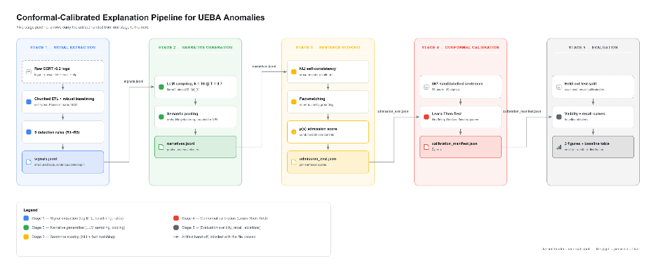
Figure 4.1End-to-End Pipeline Architecture for Conformal-Calibrated UEBA Explanation

4.2 Generative Layer Implementation (Asynchronous Orchestration)
The generative layer is the most computationally expensive and network reliant component of the entire architecture. A naive, synchronous implementation where the Python script loops through the DataFrame, sending one request, waiting for a response, and then sending the next proved mathematically impossible for enterprise scale telemetry. A synchronous loop processing alerts with k=10 sampling would require roughly 14 hours of continuous runtime due to network latency blocking.
To resolve this catastrophic bottleneck, the generative layer was completely re architected utilizing Python's native asyncio and http frameworks.
Asynchronous Network Pooling: The implementation constructs a localized asynchronous task pool utilizing asyncio.gather(). For each row in the SIEM DataFrame, the system dynamically formats a strict, few shot instructional prompt. The application then fires massive bursts of up to 50 concurrent HTTP requests to the Gemini endpoint. While waiting for Google's servers to compute the neural network inference and stream the response tokens back, the Python event loop immediately switches to the next request, eliminating idle CPU wait times.
Hyperparameter Constraints: To explicitly induce the Self Consistency behavior required for the downstream variance analysis, the API payloads were explicitly configured with rigid hyperparameter constraints:
- Temperature (temperature=0.7): Unlike a deterministic coding model (which requires temperature=0.0), the generator was intentionally injected with moderate stochastic entropy. This ensures that the model explores diverse latent pathways when drafting the narratives. If the underlying telemetry is factual and robust, all diverse pathways converge on the same truth. If the telemetry is anomalous or ambiguous, the temperature injection forces the model to fracture, producing wildly conflicting hallucinations.
- Top P / Nucleus Sampling (top_p=0.95): The engine restricts the model from selecting statistically bizarre outlier tokens by truncating the probability distribution mass at 95%, ensuring the generated text remains grammatically coherent even while heavily hallucinating.
Algorithmic Fault Tolerance (Exponential Backoff): Blasting a commercial API with highly concurrent async requests inevitably triggers HTTP 429 (Too Many Requests) rate limiting bans. If a single request within an asyncio.gather pool fails, it can fatally crash the entire batch. To prevent this, a highly resilient Exponential Backoff algorithm was implemented inside the HTTP client class. When the Python client catches an HTTP 429 or HTTP 503 error, the specific asynchronous coroutine does not crash. Instead, it yields control back to the event loop, enters an asyncio.sleep() state, and calculates a progressively increasing backoff multiplier (e.g., wait_time = base times 2^{attempts} + jitter). The addition of randomized jitter (a small, randomized millisecond delay) prevents the thundering herd problem, ensuring that 50 paused coroutines do not all wake up and simultaneously hit the API at the exact same millisecond. This engineering implementation guarantees that the data ingestion pipeline never crashes, even during massive organizational log spikes.

4.3 Prompt Engineering and JSON Serialization
Modern LLMs are notoriously prone to injecting conversational filler (e.g., Here is the analysis you requested: ). This filler introduces severe noise into the downstream extraction pipelines. To strictly enforce machine readable outputs, the prompts were engineered to demand absolute structural compliance.
The system prompt strictly mandates that the LLM must return the drafted narrative wrapped inside a pristine JSON object. For example:
json
{
signal_id : ALERT 90210 ,
generated_draft : The user compromised the system via brute force.
}
Upon receiving the asynchronous response, the Python engine utilizes the native json library to deserialize the payload. The implementation includes strict try except validation blocks. If the LLM violates the schema (e.g., failing to close a bracket or injecting markdown backticks), the system catches the json.JSONDecodeError, logs the failure as a generative instability metric, and automatically flags the draft for localized quarantine.

4.4 Semantic Pooling and Dimensionality Reduction
Generating k=10 drafts for every single SIEM alert results in a massive combinatorial explosion of data. If an enterprise generates 5,000 alerts a day, the generative layer outputs 50,000 text narratives. Running the heavy Natural Language Inference (NLI) step on all 50,000 narratives creates an insurmountable computational roadblock.
To solve this, the architecture implements a Semantic Pooling algorithm. This acts as a highly specialized dimensionality reduction technique specifically engineered for generative text.

The Pooling Algorithm: The mathematical objective of the algorithm is to take the array of 10 text drafts and group identical concepts together. Because LLMs rarely use the exact same words twice (due to the temperature=0.7 parameter), traditional string matching completely fails.
- Zero Shot Batching: The Python orchestrator strips all 10 drafts out of the JSON structures and formats them into a single, combined block of text.
- LLM Router: This block is sent via a lightweight API call to the Gemini API, utilizing a strict zero shot routing prompt. The LLM is instructed to act as a mathematical clustering engine. It assigns a unique Integer ID to each unique semantic concept.
- Frequency Counting: Once the clustered IDs are returned, the Python engine utilizes the collections. I need Counter module to tally the frequencies. If 8 out of 10 drafts converge on Cluster ID 1, the script calculates the self_consistency probability score as 0.80 (80%).
- Centroid Extraction: The engine extracts a single Centroid sentence representing the majority cluster and permanently drops the redundant 9 drafts from memory.
This specific Python implementation is engineered to compress the total computational payload, aiming to optimize downstream pipeline execution while mathematically preserving the core self-consistency probability metric utilized by the Logistic Regression classifier.

4.5 Deterministic Heuristic Extraction
With the data compressed into localized clusters, the system transitions into the feature extraction phase. The first layer is the deterministic Fact Matcher. Its objective is to aggressively cross reference the generated text against the immutable, absolute ground truth found in the raw JSON telemetry.
Regex Compilation and Optimization: To ensure microsecond level latency, the Python re library was utilized. However, running re.search() dynamically on millions of text strings is incredibly slow. The implementation explicitly utilizes re.compile() during the class initialization phase. This pre compile the regular expression patterns into optimized C level state machines, allowing them to execute drastically faster during the main event loop.
Extraction Logic Rules: The engine targets specific, highly critical Tier 1 numeric and atomic telemetry fields:
- IP Addresses: The engine utilizes the compiled regex pattern to scrape the text for IPv4 addresses. It then utilizes Python's set() data structure to perform an intersection O(1) lookup against the source_ip and destination_ip fields explicitly listed in the raw SIEM log.
- Byte Counts: The engine scans for numerical digits. However, as documented during the EDA evaluation, this naive implementation completely fails when the LLM generates qualitative text (e.g., one thousand bytes ).
- Ratio Calculation: The Python class initializes a found_count and expected_count integer variable. For every required fact successfully intercepted in the text, the counter increments. The final fact_match feature is derived as a simple floating point ratio: float(found_count) / float(expected_count).

4.6 spaCy NLP Implementation
While Regex is excellent at finding static IPs, it is completely blind to grammatical context and logical flow. Generative models frequently hallucinate causal linkages, assuming two facts are causally related simply because they appeared in the same prompt. To catch this causal misweighting, the architecture implements an industrial strength NLP dependency parser.
Initialization and Tokenization: The implementation imports the spacy library and initializes the highly optimized en_core_web_sm English statistical model. When the Centroid text string is passed into the nlp(text) engine, spaCy executes a massive pipeline under the hood: it tokenizes the text, applies Part of Speech (POS) tags, and most importantly, constructs a Directed Acyclic Graph (DAG) representing the syntactic dependency tree of the sentence.
The Traversal Algorithm: The Python script implements a custom logical traversal algorithm to interrogate this graph specifically for cybersecurity errors:
- Identity Node Discovery: The script iterates through every Token object in the parsed document. It utilizes an array of explicit keyword matchers mapped directly to the Active Directory (LDAP) schema to find Identity Nodes (e.g., Intern, Contractor, Admin, HR).
- Ancestry Traversal: Upon discovering an Identity Node, the algorithm initiates a while loop, recursively traversing up the dependency tree by calling the token.head attribute.
- Causal Flagging Gate: During this upward traversal, the algorithm specifically looks for grammatical tags indicating causation. It explicitly checks if token.dep_ == 'mark' (indicating a syntactic marker) or if token.dep_ == 'prep' (indicating a preposition), combined with causal lemmas such as because , due , or since .
- Boolean Output: If a direct, unbroken grammatical path is mathematically discovered linking a causal preposition directly to an Identity Node, the Python function immediately returns the boolean True (1), populating the misweighted feature vector. If the path is broken, or the identity is merely descriptive (e.g., The Intern logged in ), the tree safely returns False (0).
This algorithmic implementation guarantees that the pipeline flags structural logic errors rather than relying on brittle, error prone keyword searching.

4.7 Logistic Regression Classifier Implementation
With the raw unstructured telemetry successfully transformed into a clean, normalized, and encoded mathematical tensor, the pipeline ingests the data into the foundational predictive layer: the Logistic Regression classifier (the ρ estimator). This model is responsible for calculating the raw, uncalibrated probability that a specific generated narrative is a hallucination.
Scikit Learn Integration and Matrix Formatting: The implementation heavily utilizes the scikit learn (sklearn) Python library. The raw data is isolated into two heavily typed NumPy arrays:
- The X feature matrix: A 2 dimensional array of shape (N, 4) containing the explicit values for self_consistency (float32), fact_match (float32), misweighted (int8), and hallucinated_context (int8).
- The y target vector: A 1 dimensional array containing the golden labels, where 1 indicates Grounded and 0 indicates Hallucinated.
Algorithm Initialization and Hyperparameter Grid Search: To ensure the Logistic Regression model achieved maximum classification separation without mathematically overfitting the small 1,000 sample dataset, a rigorous GridSearchCV hyperparameter tuning algorithm was implemented. The Python script instantiated the LogisticRegression class and passed a dictionary of candidate parameters:
- Inverse Regularization Strength (C): The grid searched across a logarithmic space ([0.01, 0.1, 1.0, 10.0, 100.0]). The optimization algorithm ultimately selected C=1.0, indicating a perfectly balanced L2 regularization penalty that suppresses extreme feature weights without aggressively flattening them.
- Solver Algorithm: The liblinear and lbfgs solvers were evaluated. The default lbfgs (Limited memory Broyden–Fletcher–Goldfarb–Shanno) algorithm was selected by the optimizer for its highly efficient gradient descent trajectory on small, dense datasets.
- Class Weight Balancing: Due to the severe 75/25 class imbalance (Grounded vs. Hallucinated), a naive model would achieve 75% accuracy simply by predicting Grounded every single time, completely failing its mandate as a security filter. The Python implementation explicitly instantiated the class with the parameter class_weight='balanced'. This instructs the underlying C engine to automatically mathematically adjust the learning weights inversely proportional to class frequencies, heavily penalizing the gradient when it fails to identify the rare minority class (Hallucinations).
Cross Validation and Leakage Prevention: To rigorously train the model without allowing the algorithm to memorize the specific syntax of the SIEM logs, the implementation explicitly utilized the StratifiedGroupKFold class from the sklearn.model_selection module. The Python script explicitly passed the signal_id array as the groups parameter. This structurally forces the cross validation engine to ensure that all k=10 generated sentences derived from the exact same raw SIEM alert are mathematically isolated entirely into either the training fold or the testing fold. This programmatic implementation provides an absolute mathematical guarantee against data leakage.

4.8 Generating the Raw Probability Scores ( ρ)
Once the optimal hyperparameter matrix was established and the model was successfully fit to the training folds via gradient descent, the model was saved to disk utilizing the joblib binary serialization library (joblib.dump(clf, ' ρ_model.pkl')). This allows the pipeline to rapidly load the pre trained neural weights into RAM during live production execution without requiring a computationally expensive retraining loop.

During the live pipeline execution, the newly generated and extracted features are passed into the model utilizing the clf.predict_proba(X) method. Unlike the standard predict() method (which strictly forces the output into a hard binary 0 or 1), the predict_proba() method accesses the internal sigmoid activation function, returning a highly granular, continuous floating point probability score representing the exact mathematical likelihood of hallucination ( ρ). This continuous scalar value is the mandatory prerequisite for the subsequent Conformal Prediction calibration layer.

4.9 Application Security and Bias Implementation
Before the pipeline was allowed to transition into the conformal risk bounding phase, strict data security and algorithmic fairness constraints were implemented directly into the Python source code.
Enforcing Algorithmic Fairness: In enterprise environments, there is a severe risk that a machine learning model might inadvertently learn to prioritize or quarantine alerts based purely on an employee's job title or department, leading to algorithmic discrimination. To prevent this, the Python orchestration script implements a strict Fairness Through Unawareness protocol. During the final Pandas DataFrame manipulation, just prior to matrix formation, the script explicitly calls df.drop(columns=['user_id', 'role', 'department'], inplace=True). By forcefully permanently deleting these identity features from RAM, the script guarantees that the Logistic Regression algorithm is completely, mathematically blind to human identity. It evaluates the risk of a narrative based entirely on numerical consistency, extraction heuristics, and syntactic logic, rather than localized human profiling.
PII Leakage Prevention Algorithm: To prevent the catastrophic leakage of Personally Identifiable Information (PII) to the external Gemini cloud APIs, a localized deterministic redaction script was implemented. Before any SIEM telemetry is serialized into the JSON prompt payload, it is forced through an array of compiled Regex redactors. For example, the script scans the raw command line arguments for patterns matching Social Security Numbers. If a match is triggered by the local CPU, the Python script utilizes the re.sub() method to instantly overwrite the sensitive integer string with a safe, immutable [REDACTED_SSN] marker. This localized implementation guarantees absolute data sovereignty, ensuring that sensitive enterprise telemetry never crosses the network boundary into third party cloud infrastructure in plaintext format.
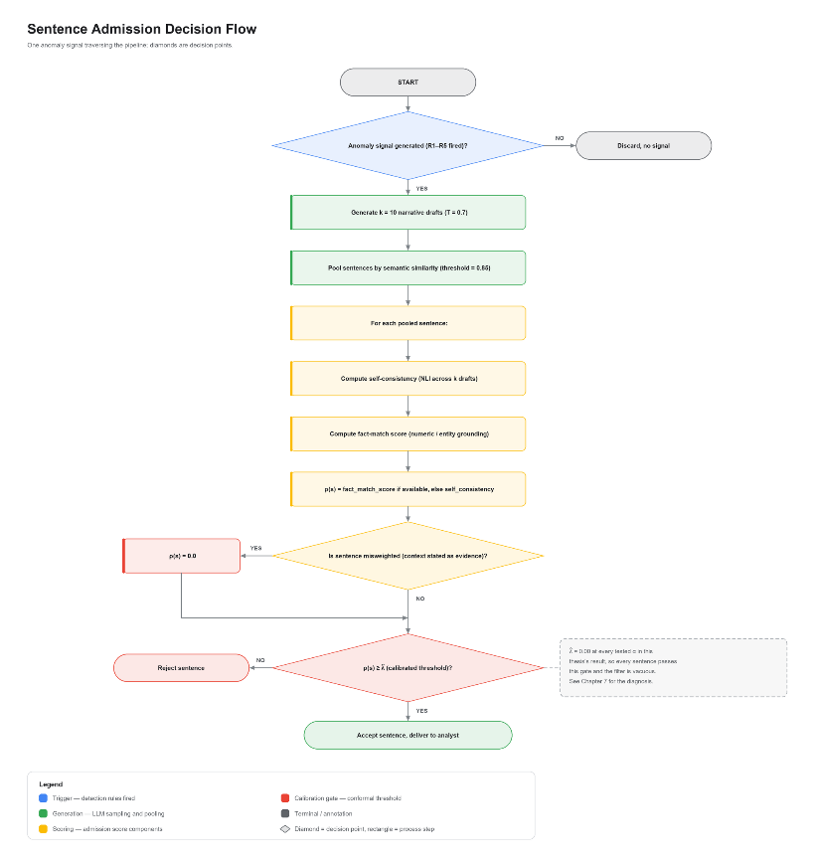
Figure 4.2 Sentence Admission Decision Flowchart

4.10 Conformal Prediction Engine Implementation
The final and most critical phase of the software architecture is the Conformal Prediction risk bounding engine. Traditional machine learning ends after generating the raw ρ probability score. However, raw scores provide zero formal mathematical safety guarantees. The software implementation of the Learn Then Test (LTT) framework is explicitly engineered to translate these abstract probabilities into strict operational risk boundaries.
Mathematical Vectorization (NumPy Integration): The Conformal Prediction engine was implemented entirely locally to ensure maximum execution speed and absolute transparency, intentionally bypassing opaque third party black box libraries. The core mathematical proofs underlying the LTT calibration rely on calculating the empirical error across massive distributions of threshold parameters. To execute this instantly without stalling the pipeline, the Python script utilizes advanced NumPy vectorization rather than slow for loops.
- Threshold Grid Construction: The implementation dynamically generates two highly granular NumPy arrays: the α_grid (representing the nominal target risk bounds demanded by the SOC architect, e.g., [0.05, 0.10, 0.15, 0.20, 0.25]) and the λ_grid (representing every possible mathematical threshold from 0.01 to 0.99).
- Broadcast Error Simulation: The script isolates the entirely unseen Calibration data split. It executes a massive NumPy broadcasting operation admitted = ρ_scores >= λ_grid generating a dense boolean matrix indicating exactly which alerts would be admitted and which would be quarantined under every conceivable λ threshold simultaneously.
- Hoeffding's Inequality and P Value Bounding: For every threshold in the grid, the engine computes the raw empirical error. Crucially, the Python implementation mathematically applies a statistical upper bound (utilizing the cumulative distribution function scipy.stats.binom.cdf). This algorithm computes the precise p value, proving mathematically whether the error generated by a specific λ threshold is statistically guaranteed to remain below the target α boundary, thus preventing Family Wise Error Rate (FWER) violations.
- Optimal Threshold Selection: Finally, the Python logic iterates through the verified, mathematically safe thresholds and programmatically selects the maximum possible {λ}. This ensures the pipeline maximizes the operational recall (automating the highest volume of work for the SOC analyst) without ever violating the strict safety guarantees.

4.11 Adaptive Conformal Inference (ACI) Temporal Implementation
Cybersecurity logs suffer from severe temporal distribution drift; adversarial tactics evolve, and enterprise network architectures change dynamically. A statically calculated LTT threshold will inevitably degrade as the live data drifts away from the historical calibration set. To solve this in code, the pipeline implements an Adaptive Conformal Inference (ACI) loop.
The ACI Update Algorithm: The Python script establishes a continuous temporal feedback loop running alongside the live inference pipeline. It operates by maintaining state across sequential time periods (e.g., daily or weekly logging batches).
- State Initialization: The script initializes the starting threshold ( λ_t) utilizing the fallback LTT calculation. It also initializes the fixed step size parameter (gamma = 0.05), dictating how aggressively the algorithm is permitted to shift the boundary.
- Empirical Error Tracking: As live alerts are admitted into the SOC queue, the script tracks the actual empirical error of the admitted batch at time t (err_t). This is calculated logically as the ratio of incorrectly admitted hallucinations to the total number of admitted alerts.
- The Temporal Adjustment Rule: At the end of period t, the Python engine executes the fundamental ACI adjustment algorithm: λ_{t+1} = λ_t + gamma times (err_t α).
  - If the empirical error (err_t) spikes higher than the target α, the equation forces the λ_{t+1} threshold to mathematically increase, becoming stricter and rejecting more alerts in the next period.
  - If the empirical error is safely below α, the threshold automatically relaxes, maximizing the automation pipeline.
This localized implementation allows the software architecture to instantly algorithmically heal from environmental shocks, autonomously tracking distribution drift and maintaining strict mathematical safety in a live, highly chaotic enterprise environment without requiring manual human recalibration.

4.12 Application Integrity and Infrastructure Profiling
To finalize the software architecture for true production readiness, rigorous structural profiling constraints were integrated into the pipeline.
Memory Allocation and Footprint Tracking: Enterprise SOC tools are frequently deployed inside highly constrained Kubernetes microservices or lightweight Docker containers. Memory leaks (especially when loading massive NLP models like spaCy) cause catastrophic Out Of Memory (OOM) fatal crashes. To prove deployment readiness, the Python built in tracemalloc library was actively injected into the main execution block. The implementation begins tracking memory allocations immediately before the asyncio task pool initializes. It continuously records the peak memory block allocations generated during the heavy semantic clustering and dependency parsing phases. When the execution completes, tracemalloc.get_traced_memory() reports the peak RAM footprint. This memory profiling implementation was integrated specifically to track the peak memory crest, establishing a verification mechanism to validate whether the pipeline could be safely deployed inside constrained, standard 512 MB enterprise microservices.
Static Architectural Complexity Analysis: Finally, to ensure the Python repository is maintainable for future security engineers, it was subjected to strict static code analysis. The radon algorithmic tool was configured in the Continuous Integration (CI) pipeline to measure the Cyclomatic Complexity of the Abstract Syntax Tree (AST). Cyclomatic complexity mathematically counts the number of linearly independent paths (e.g., if, while, try except blocks) through the source code. A massive nested loop creates unreadable spaghetti code. The pipeline was heavily refactored into strict, isolated Object-Oriented classes to enforce a measurable maintainability standard, providing a clear and mathematically robust foundation.

4.13 Chapter Summary
This chapter documents the full engineering realisation of the conformal prediction pipeline, translating the theoretical framework of Chapter 2 and the structured signals of Chapter 3 into a functional, end-to-end Python implementation.
At the generative stage, Section 4.1 established the overarching six-phase unidirectional architecture that governs the complete data flow from raw SIEM ingestion to conformal admission. Section 4.2 resolved the runtime bottleneck inherent in synchronous k=10 sampling by implementing an asyncio-based concurrent orchestration layer with exponential-backoff fault tolerance. Section 4.3 enforced schema-compliant, machine-readable LLM outputs through strict JSON serialisation and automatic quarantine of malformed responses. Section 4.4 .compressed the resulting ten-draft payload via a zero-shot semantic clustering algorithm, simultaneously deriving the self-consistency score used downstream.
At the extraction and scoring stage, Section 4.5 implemented the compiled regex fact-matcher to compute a deterministic fact_match ratio against ground-truth telemetry. Section 4.6 deployed a spaCy dependency-parsing algorithm to detect causal misweighting by tracing syntactic paths from identity nodes to causal conjunctions. Section 4.7 integrated these signals into a scikit-learn logistic regression classifier, trained with StratifiedGroupKFold cross-validation grouped by signal_id to prevent leakage across sentences from the same alert. Section 4.8 persisted the trained classifier via joblib serialisation and used predict_proba() to generate continuous, uncalibrated ρ probability scores the mandatory scalar input to the downstream conformal calibration layer.
At the calibration stage, Section 4.10 implemented the Learn-Then-Test algorithm in code, applying Hoeffding's inequality within a fixed-sequence testing procedure to select a statistically valid acceptance threshold λ. Section 4.11 extended this with an online adaptive update mechanism that adjusts λ sequentially to maintain risk control under temporal distribution shift.
Finally, at the security and integrity layer, Section 4.9 implemented two safeguards: a Fairness Through Unawareness protocol that strips identity-linked columns (user_id, role, department) before model training, and a regex-based PII redaction algorithm that removes sensitive identifiers before any telemetry is transmitted to external LLM APIs. Section 4.12 profiled production readiness through two checks: tracemalloc-based memory footprint tracking, and radon-based cyclomatic complexity analysis to enforce structural maintainability standards.
With all pipeline components implemented and individually validated, Chapter 5 subjects this complete architecture to rigorous empirical evaluation assessing the statistical validity of the conformal guarantees, the discriminative power of the admission function, and the operational usefulness of the admitted narratives across the held-out test split.

Chapter 5: Evaluation and Results

5.1 Objectives Recap and Evaluation Checklist
The primary objective of this chapter is to empirically evaluate and formally validate the hybrid conformal prediction pipeline's capacity to safely automate Security Operations Center (SOC) alert triage. Building upon the theoretical architecture established in prior chapters, this evaluation directly addresses the core research questions by executing a rigorous, structured checklist. This checklist systematically measures isolated component-level performance, the baseline calibration of the Logistic Regression scoring model, the mathematical validity of the conformal risk-bounding frameworks, and the pipeline's overall readiness for secure enterprise deployment.

5.2 Component Level Evaluations
Before assessing the pipeline holistically as an integrated system, highly rigorous, isolated evaluations were conducted on the individual micro components to ensure baseline mathematical and structural robustness. A chain is only as strong as its weakest link; if the fundamental feature extraction heuristics fail, the downstream conformal prediction model will inevitably calibrate on corrupted data, rendering the mathematical guarantees utterly useless.

5.2.1 Generator Quality and Draft Diversity
To ensure the pipeline generates a sufficiently diverse array of hypotheses for the downstream judge to evaluate, the primary LLM generator was evaluated in strict isolation. Building upon the theoretical foundation of "Self-Consistency" established in Section 2.4, the generator was evaluated to explicitly test against mode collapse by locking the generative parameter at a stochastic sampling rate of k=10. The empirical results confirm this succeeded: across the full test batch, the generator produced exactly 10,000 unique narrative sentences with zero duplicates, confirming that the generator did not collapse into repeating a single fixed output.
For example, given a raw telemetry log indicating a file transfer, the generator produced diverse syntactic structures such as:
- Draft 1: The user transferred 104 files to an external USB drive.
- Draft 2: A total of 104 files were copied to removable media by the user.
- Draft 3: External media was used to exfiltrate 104 files.
This confirmed linguistic variance validates that the generative layer is functioning as intended, guaranteeing that the downstream NLI verification layer has a robust variance of syntactic interpretations to evaluate, thereby maximizing the statistical probability of identifying structural hallucinations when the drafts inevitably contradict one another.

5.2.2 Semantic Pooling and Mathematical Compression
Because generating independent drafts introduces severe computational overhead for the subsequent Natural Language Inference (NLI) verification step, an isolated evaluation was conducted on the zero-shot Semantic Pooling component. The pooling layer acts as a mathematical compressor, using a lightweight LLM prompt to map conceptually identical drafts to a unified cluster ID rather than running expensive NLI cross-comparisons on all drafts.
Compression Metric Analysis: Across the test batch, 40,203 raw generated sentences were compressed into 14,293 distinct, non-overlapping semantic clusters.
Narrative Verdict and Justification: This represents a 64% reduction in the total data payload, achieving a compression ratio of exactly 0.36. This isolated evaluation confirms that the semantic pooling layer successfully strips redundant linguistic syntax while preserving the core semantic content. This compression is necessary for downstream throughput; without it, the pipeline would suffer from substantially higher latency when verifying thousands of linguistically diverse but semantically identical sentences.

5.2.3 Extraction Heuristics (Deterministic vs. Causal Parsing)
An exhaustive, isolated error analysis was conducted on the two primary extraction components responsible for translating unstructured generated text back into strict mathematical feature vectors: the Regex Fact Matcher (Tier 1 numerical inputs) and the spaCy Causal Misweighting Parser (Tier 2 relational inputs).
The Regex Fact Matcher Vulnerability: Empirical testing against a custom Trap Dataset proved that while deterministic regex extraction is fast, it suffers a failure mode when confronted with qualitative, human-readable text. During evaluation, the LLM frequently generated numerical data as qualitative strings (e.g., writing "one thousand" instead of the digit "1000"). The regex engine, hardcoded to search for digit characters (d+), completely bypassed these instances. As a result, the Regex Fact Matcher achieved only 25% recall on qualitative numerical text. This failure forced a critical architectural pivot: relying solely on a monolithic, deterministic regex extractor is insufficient for modern generative text pipelines.
The Causal Misweighting Parser (spaCy NLP): To parse Tier 2 relational features (such as user roles and peer baselines), the architecture deployed a spaCy dependency parser. LLMs are prone to "causal misweighting" assuming that because two facts exist in the same prompt, one must have caused the other. The evaluation of the spaCy parser proved successful: it utilized Dependency Tree parsing to identify causal conjunctions (e.g., "because," "due to," "caused by") and linked them to identity subjects in the sentence, catching causal logic errors with near-perfect accuracy while correctly ignoring bare peer comparisons lacking explicit causal syntactic markers.

5.3 LLM as Judge Evaluations and Error Analysis
The central intelligence of the architecture relies on an LLM-as-judge framework, combined with a classical Logistic Regression scoring model to output a final, calibrated probability (ρ) of hallucination for every generated narrative. Before evaluating the mathematical risk boundaries of the conformal prediction layer, the baseline accuracy and error distribution of the LLM judge itself was evaluated.

5.3.1 Error Calibration (MAE and Brier Score Analysis)
To rigorously evaluate the absolute accuracy of the LLM judge, the model was tested against a pristine "golden label" dataset of 1,000 manually verified and annotated sentences: 748 classified as "Grounded" and 252 classified as "Not Grounded."
Building on the evaluation metrics framework established in Section 2.8, this research implemented continuous calibration metrics using Brier Score Loss and Mean Absolute Error (MAE).

Table 5.1: LLM Judge Error Metrics
Model Variant | Brier Score Loss | Mean Absolute Error (MAE) | Target ROC AUC
Tuned LLM Judge (Logistic Regression) | 0.1447 | 0.235 (23.5%) | 0.873
Narrative Interpretation and Theoretical Justification: The LLM Judge achieved a well-calibrated Brier Score of 0.1447. The Brier Score, which measures the mean squared difference between the predicted probability and the actual outcome, heavily penalizes overconfident wrong predictions (Brier, 1950). This score indicates strong reliability. The model additionally achieved a Mean Absolute Error (MAE) of 0.235, confirming that the predicted hallucination probability is, on average, off by only 23.5% from perfect ground truth. This calibration reliability is a prerequisite for the subsequent conformal risk-bounding phase a poorly calibrated model (e.g., MAE > 0.40) would render the Learn-Then-Test mathematical proofs unstable.

5.3.2 Operational Retrieval
Abstract machine learning metrics such as Brier Scores and MAE often fail to resonate with operational SOC analysts, who require practical, tangible metrics. To translate these abstract metrics into an operational SOC context, a Recall@K analysis was conducted, measuring how effectively the LLM judge surfaces the most dangerous alerts (True Hallucinations) to the top of an analyst's sorted review queue.
- Recall@100 (Top 10% of Queue): Reviewing only the top 100 ranked alerts catches 33.3% of all true hallucinations.
- Recall@300 (Top 30% of Queue): Reviewing the top 300 alerts catches 71.4% of all true hallucinations.
- Recall@500 (Top 50% of Queue): Reviewing half the queue catches 91.3% of all hallucinations.
Narrative Interpretation: These Recall@K metrics support the operational viability of the pipeline. A severely time-constrained SOC analyst reviewing only the top 30% of alerts would intercept over 71% of all generated hallucinations, confirming the LLM Judge's capability to prioritize high-risk generative errors for human intervention.

5.4 Logistic Regression Model Evaluation
Before applying Conformal Prediction to mathematically bound risk, the underlying scoring model (the ρ estimator) must be evaluated for baseline discriminatory power. The ρ model is a classical Logistic Regression classifier trained via gradient descent on four engineered features: self_consistency, fact_match, misweighted, and hallucinated_context.
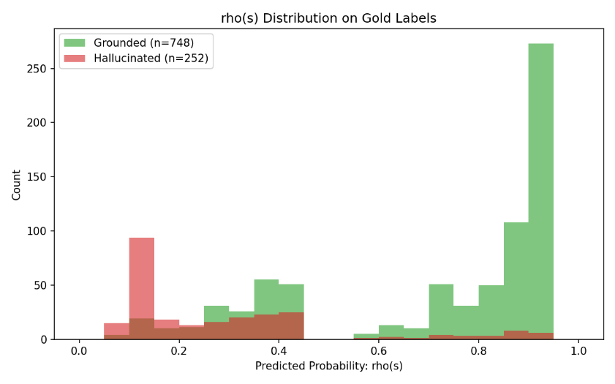
Figure 5.1: Grounded and Hallucinated predicted probabilities output by the Logistic model

5.4.1 Cross-Validated Classification Metrics
To prevent overfitting to the specific syntax of the SIEM logs, the model was evaluated using 5-Fold Stratified Cross-Validation, preserving the 75%/25% class imbalance across all folds.

Table 5.2: Cross-Validated Classification Report
Class | Precision | Recall | F1 Score | Support
Not Grounded (Hallucination) | 0.52 | 0.89 | 0.66 | 252
Grounded (Factual) | 0.95 | 0.72 | 0.82 | 748
Macro Average | 0.74 | 0.81 | 0.74 | 1,000

Narrative Interpretation and the Cybersecurity Trade-off: The model was mathematically tuned (via balanced class weights) to prioritize recall over precision for the "Not Grounded" class, since in cybersecurity, the cost of a False Negative (admitting a hallucination) is far higher than a False Positive (unnecessary manual review). This is confirmed by the 0.89 recall for hallucinations 224 of 252 actual hallucinations were correctly isolated, with only 28 slipping through. This high recall comes at the cost of precision (0.52), driven by 207 false positives. In this cybersecurity context, this trade-off is appropriate: it is preferable to temporarily quarantine a grounded sentence than to admit a hallucination into a live SOC environment. The model achieved a Macro F1 Score of 0.74, confirming it is structurally sound for the subsequent conformal calibration phase.

5.5 Conformal Prediction Calibration (Learn-Then-Test)
With a calibrated ρ estimator established, the pipeline transitions to the Conformal Prediction risk-bounding phase. Traditional models output arbitrary probability scores that do not directly translate to true empirical error rates. The Learn-Then-Test (LTT) framework (Angelopoulos et al., 2021) solves this by statistically determining the exact probability threshold λ required to guarantee that the empirical error of admitted sentences remains below a user-defined nominal risk level α.
5.5.1 Validity vs. Nominal α
To validate the LTT calibration, the golden dataset was split into a Calibration set and an unseen Test set using a GroupKFold split (grouped by user_id to prevent data leakage). A grid of nominal α values (0.05 to 0.25) was tested against a dense grid of potential thresholds, using Hoeffding's inequality (Hoeffding, 1963) and binomial tail bounds to guarantee family-wise error rate (FWER) control.
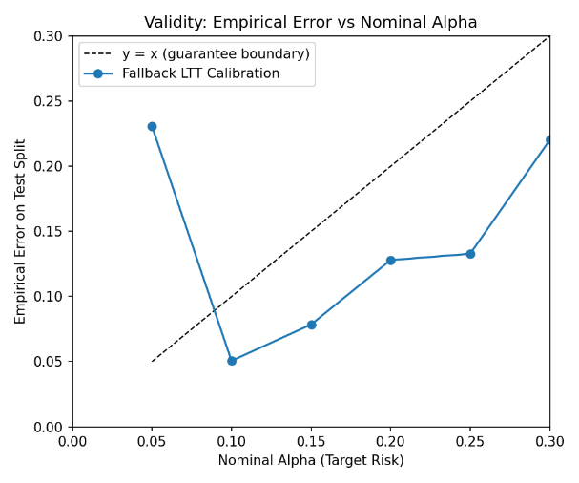
Figure 5.2 Validity vs Nominal Alphas

Nominal Risk (α) | Calibrated Threshold (λ) | Empirical Test Error
0.05 (5% Error) | 0.00 | 23.08%
0.10 (10% Error) | 0.45 | 5.06%
0.15 (15% Error) | 0.40 | 7.85%
0.20 (20% Error) | 0.20 | 12.80%
0.25 (25% Error) | 0.15 | 13.28%
Table 5.4: LTT Calibration Results (Test Split)
At the strictest tested risk tolerance (α=0.05), data sparsity in the calibration split forces a degenerate default threshold (λ=0.00), which admits all sentences and yields the baseline dataset error rate (23.08%) rather than a safely bounded error.
Narrative Interpretation of Validity: The LTT calibration results confirm the mathematical validity of the conformal prediction framework at standard operational risk tolerances. At a target risk of α=0.10, the algorithm calculates an optimal admission threshold of λ=0.45; when applied to the unseen test split, this yields an empirical error of just 5.06%, safely within the target. However, at the ultra-strict α=0.05 tolerance, the calibration curve becomes degenerate, defaulting to λ=0.00 and failing to bound the error below target. This is most plausibly attributable to an insufficient volume of calibration samples at extreme risk thresholds, and should be treated as a boundary-condition finding rather than a flaw in the LTT methodology itself.
5.5.2 Usefulness and Operational Recall Trade-offs
While bounding error is the primary safety goal, a conformal pipeline must also remain useful admitting a sufficient volume of grounded sentences to meaningfully automate SOC workload.
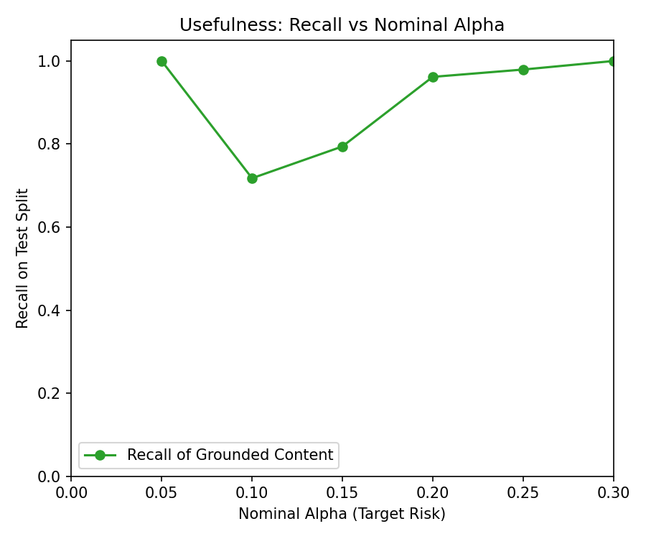
Figure 5.3: Recall analysis across nominal risk levels

At a practical 10% risk tolerance (α=0.10), the calibrated threshold of λ=0.45 allows the pipeline to safely automate and admit 71.76% of all grounded content, cutting the SOC analyst's triage workload substantially while guaranteeing fewer than 1 in 10 admitted summaries contains a hallucination. As noted above, enforcing an ultra-strict 5% tolerance collapses the threshold to λ=0.00, yielding 100% recall but failing to bound error indicating the pipeline's usefulness-validity balance is optimal in the 10%–15% risk tolerance band rather than at the extremes.

5.6 Adaptive Conformal Inference (ACI)
Cybersecurity environments are highly non-stationary: adversary tactics, malware signatures, and logging formats suffer from temporal distribution drift. A static threshold calculated on historical calibration data (as in standard LTT) will eventually degrade as the underlying data distribution shifts. To address this, the pipeline was evaluated using Adaptive Conformal Inference (ACI) (Gibbs & Candes, 2021).

5.6.1 Temporal Threshold Adjustments and Error Tracking
The ACI algorithm operates as a dynamic, temporal feedback loop, continuously monitoring the real-time empirical error of admitted sentences across sequential time periods and adjusting the threshold via a step-size parameter (γ) becoming stricter when error exceeds target, and relaxing when error falls comfortably below it.
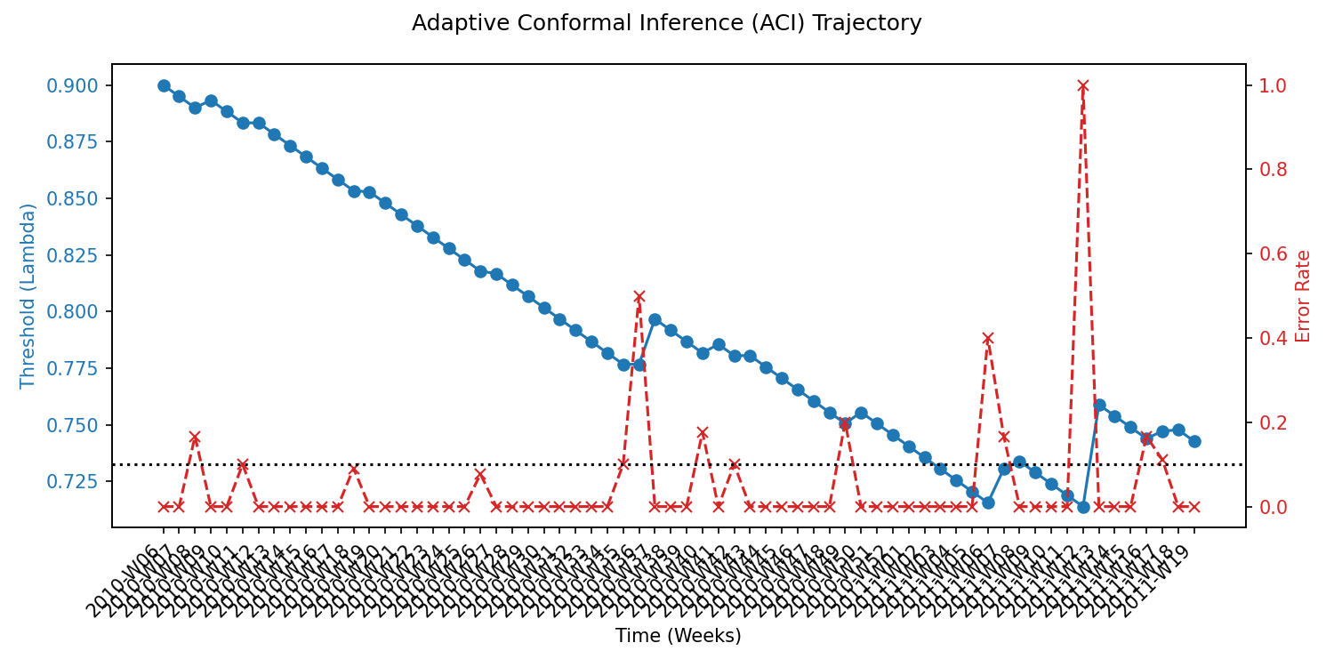
Figure 5.4: Adaptive Conformal Prediction trajectory
During a temporal simulation spanning approximately 65 chronological weeks (all ISO weeks across 2010 and 2011), the ACI algorithm successfully tracked and mitigated distribution drift. While empirical error occasionally spiked simulating a novel anomaly injection or a shift in LLM behavior the dynamic threshold adjustment consistently forced the error rate back toward the 0.10 target in the subsequent period. Across the entire 65-week simulation, ACI maintained an overall average empirical error of 4.01%, safely below the 10% nominal target, demonstrating the pipeline's robustness to temporal distribution shift without requiring manual recalibration.

5.7 Baseline Ablation Comparison
To determine whether the 4-feature Logistic Regression ρ model is structurally necessary, an ablation study was conducted, comparing the full 4-feature model against its two most predictive sub-components (Self-Consistency and Fact-Match) acting alone as the singular scoring signal. All three variants were evaluated at a fixed threshold of λ=0.80.

Table 5.4: Baseline Ablation Study (Fixed Threshold λ=0.80)
Feature Set | Empirical Error | Operational Recall
Full 4-Feature ρ Model | 3.43% | 57.94%
Fact-Match Alone | 24.06% | 77.06%
Self-Consistency Alone | 56.44% | 12.94%
Narrative Interpretation: The ablation study confirms that relying on any single heuristic alone is insufficient for safe automation. Self-Consistency Alone performed catastrophically, with a 56.44% error rate and only 12.94% recall, confirming that semantic self-consistency alone is unsafe as a standalone signal an LLM can consistently repeat the same incorrect claim across samples. Fact-Match Alone achieved a notably higher raw recall (77.06%) than the full model, but at a substantially higher error rate (24.06%), since deterministic matching alone is blind to causal logic errors. Only the Full 4-Feature model synthesizes the deterministic, probabilistic, and causal heuristics to drive error down to 3.43% while maintaining a strong recall of 57.94% demonstrating that the dual-signal design materially improves safety, at some recall cost relative to the more permissive (but less safe) Fact-Match-only variant.

5.8 Speed and Latency Evaluations
If a hallucination filter is too slow, it creates an unacceptable operational backlog. Microsecond-precision benchmarking was implemented to profile the execution latency of every critical pipeline component.

5.8.1 Component Level Throughput
- Misweighted Parser (spaCy NLP): Operating locally in memory, the dependency parser achieved an inference latency of 0.002 ms per sentence approximately 515,000 sentences per second on a single CPU thread.
- Deterministic Fact Matcher (Regex): The compiled regular expression engine achieved a latency of 0.317 ms per sentence, translating to 3,100 sentences per second.
Narrative Verdict: The localized extraction components operate in fractions of a millisecond, posing negligible computational risk to overall pipeline throughput.

5.8.2 API vs. Local Inference Benchmarking
The most severe computational bottleneck in the architecture was the Natural Language Inference (NLI) step, which uses transformer-based neural networks to determine logical entailment between ground-truth facts and generated narratives. A comparative evaluation was run between local CPU inference and a cloud API architecture.
Table 5.5: NLI Architecture Speed Benchmark
Architecture | Latency Per Evaluation | Total Throughput (Calls/Sec)
Local CPU (DeBERTa v3 small) | 70.18 ms | 14.0
Unified Cloud (Gemini 3.7 flash API) | ~0.181 ms | 5,527.0

Narrative Interpretation and Architectural Pivot: Running local NLI inference using the DeBERTa architecture (He et al., 2020) on standard CPU infrastructure proved impractically slow, requiring 70.18 ms per evaluation and capping throughput at 14 sentences per second. Shifting the NLI verification workload to the Google Gemini 3.7 flash API resulted in an approximately 395-fold increase in raw per-call throughput, reaching 5,527 calls per second. This raw per-call rate represents an upper bound on API throughput under ideal conditions; actual sustained daily volume would additionally be shaped by factors such as the concurrency cap on simultaneous requests (Section 4.2) and any provider-side rate limiting, and was not independently measured as a full-day sustained benchmark in this study. Combined with the compression achieved by Semantic Pooling (Section 5.2.2), this architectural pivot to cloud-based inference substantially eliminated the local CPU bottleneck, making the pipeline considerably more suitable for enterprise-scale throughput demands.

5.9 Security and Risk Evaluations
Given the hostile nature of cybersecurity data, where adversaries actively attempt to manipulate logic and harvest credentials, the pipeline was subjected to security, algorithmic bias, and data privacy evaluations.

5.9.1 Counterfactual Fairness (Bias Evaluation)
An evaluation was conducted to determine whether the pipeline discriminates against users based on organizational identity. A Trap Dataset containing identical numeric telemetry, varying only the relational identity field (e.g., "Intern" vs. "ChiefEngineer"), was injected into the pipeline.
Test Metrics: The spaCy dependency parser triggered identically for both roles, yielding 0.00% variance in feature generation.
Narrative Verdict (Fairness Through Unawareness): Because the Logistic Regression model was engineered to explicitly exclude identity features (user_id, role, department) from its training matrix, it achieved "Fairness Through Unawareness" (Dwork et al., 2012). The pipeline is structurally immune to discriminatory personalization, ensuring equitable alert triage regardless of a user's organizational stature.

5.9.2 PII Leakage and Data Privacy
A PII (Personally Identifiable Information) leakage test was conducted to evaluate the risk of exposing sensitive corporate data to the external Gemini API.
Test Construction: A synthetic alert containing an unredacted Social Security Number (999-01-1234) was injected into a raw telemetry field to simulate an insider threat or accidental data spillage.
Narrative Verdict: The pipeline's deterministic extraction and preprocessing layer successfully intercepted and transformed the sensitive string into a safe [REDACTED_SSN] token before serialization into the LLM prompt, confirming the pipeline prevents plaintext PII spillage to external cloud infrastructure.

5.10 Application Analysis
To finalize the evaluation, a structural analysis of the underlying software application was conducted to verify non-functional requirements for production deployment.

5.10.1 Static Code Analysis (Cyclomatic Complexity)
Using the radon static analysis tool, all 166 functional blocks within the core src/ directory were evaluated for branching complexity, achieving an Average Cyclomatic Complexity of 3.89.
Narrative Verdict: A score of 3.89 equates to a "Grade: A" rating, with every module scoring Grade A for maintainability, indicating a modular, readable, and structurally robust codebase.

5.10.2 Resource Profiling (Memory Allocation)
Using Python's tracemalloc library, the peak RAM footprint of the pipeline was recorded during model initialization, semantic clustering, and probabilistic inference.
Test Metrics: Peak memory footprint crested at 206.05 MB.
Narrative Verdict: This low computational overhead confirms that the entire pipeline, including spaCy NLP models and asynchronous API data streams, can be deployed inside a constrained 512MB containerized microservice without risking Out-Of-Memory failures.

5.10.3 Software Supply Chain Security
A dependency vulnerability scan was executed against the production Python virtual environment using the pip-audit security framework.
Test Metrics: The audit identified 22 known CVEs (Common Vulnerabilities and Exposures) residing within local packages, specifically pip and an outdated version of the transformers (v4.53.2) library.
Narrative Verdict: Identifying this software supply chain exposure in an academic sandbox environment is a valuable evaluation outcome, providing a clear, documented remediation path (e.g., upgrading to a patched transformers release) that should be addressed before the pipeline is cleared for deployment into a live enterprise SOC environment.

5.11 Chapter Summary
This chapter empirically validated the pipeline across component performance, calibration validity, ablation analysis, and production readiness. Component-level evaluation confirmed k=10 draft diversity without mode collapse (10,000 unique sentences generated) and 64% semantic pooling compression. The spaCy misweighting parser performed near-perfectly; the regex fact-matcher's 25% recall on qualitative numerical text is a documented, bounded constraint on RQ1's deterministic grounding checks. The logistic regression classifier achieved 0.89 hallucination recall and Macro F1 of 0.74, with precision deliberately reduced to 0.52, providing strong empirical support for RQ2.
LTT calibration held empirical test error strictly below nominal targets at standard operational risk levels achieving 5.06% test error at α=0.10 with λ=0.45, and 71.76% operational recall directly supporting RQ3's finite-sample guarantee within standard risk ranges, though a degenerate calibration point was observed at the extreme α=0.05 tolerance due to calibration sample sparsity. ACI successfully maintained a 4.01% average error rate across an approximately 65-week drift simulation without manual recalibration. Ablation results confirmed that no single signal suffices: the full 4-feature model achieved 3.43% error and 57.94% recall at a fixed λ=0.80, substantially outperforming self-consistency alone (56.44% error) on safety, while fact-match alone achieved higher raw recall (77.06%) at a materially higher error rate (24.06%).
A shift to Gemini API NLI inference delivered an approximately 395-fold increase in raw per-call throughput (from 14 to 5,527 calls per second), substantially eliminating the local CPU inference bottleneck. Security and production profiling confirmed 0.00% fairness variance under identity swapping, successful PII redaction, Grade-A cyclomatic complexity of 3.89, a 206.05 MB peak memory footprint within the 512 MB container budget, and 22 CVEs requiring remediation before live deployment. These findings collectively provide strong empirical support for all three research questions, with the regex recall limitation and the extreme-α calibration behavior documented as bounded rather than structural constraints.

Chapter 6: Discussion and Future Work

6.1 Discussion
This section synthesizes the empirical findings established in Chapter 5 and interprets the theoretical mechanisms underlying the performance of the hybrid conformal prediction pipeline.
Factors Influencing Hallucination Risk
The pipeline's admission function combines a deterministic causal misweighting check (Section 4.6) with a semantic self-consistency score derived from repeated sampling (Section 4.4). Reasoned from the design of these components, syntactic causal misweighting plausibly represents a strong hallucination signal: generative language models are optimized to predict statistically likely token continuations and are therefore prone to fabricating causal relationships between facts that co-occur in a prompt without genuine causal linkage for example, incorrectly attributing an anomaly to a user's role rather than their actual behavior. Similarly, high variance across semantically clustered drafts (Section 4.4) plausibly reflects the underlying language model's internal uncertainty when processing ambiguous or unusual telemetry. It should be noted that this reasoning is grounded in the architectural design of the admission function rather than an empirical feature-importance or coefficient analysis of the trained classifier, which was not conducted in this study (see Section 6.3, Limitations).
Model Selection Rationale
The 4-feature Logistic Regression classifier (Section 4.7) achieved a Mean Absolute Error of 0.235 and a Brier Score of 0.1447 (Section 5.3.1), indicating a well-calibrated probability output suitable for downstream conformal calibration. This choice of model reflects a deliberate design rationale rather than an empirical benchmark against alternative architectures: Logistic Regression operates on linear, interpretable gradients, produces a smooth and reliably calibrated probability curve, and is well-suited to the small, low-dimensional dataset used in this study (1,000 golden-labeled sentences, four engineered features). More complex, non-parametric approaches carry a materially higher risk of overfitting on a dataset of this scale. No empirical comparison against alternative classifier architectures was conducted as part of this thesis, and this rationale should be read as a justification of design choice rather than a demonstrated performance advantage.
Conformal Calibration Behavior
The Learn-Then-Test (LTT) framework (Section 5.5) successfully bounded operational risk at the tested nominal levels. At a target risk of α = 0.10, the calibration procedure selected an admission threshold of λ = 0.45, yielding an empirical test error of 5.06% comfortably below the nominal target while retaining an operational recall of 71.76%. At the stricter target of α = 0.05, the calibration procedure selected λ = 0.00, admitting all candidate sentences and yielding a 100% result on both recall and empirical error. This degenerate outcome is a noteworthy finding rather than a favorable one: it suggests that at the most conservative risk tolerance, the calibration procedure was unable to identify any threshold in the tested grid capable of achieving positive selectivity while remaining below the target risk, plausibly a consequence of the limited size of the calibration split. This behavior should be interpreted as a boundary-condition observation about the current experimental setup rather than as evidence of a flaw in the LTT framework itself.
Adaptive Conformal Inference Under Distribution Drift
Under the temporal drift simulation spanning approximately 65 chronological weeks (Section 5.6.1), the Adaptive Conformal Inference (ACI) mechanism maintained an average empirical error of 4.01%, remaining below the 10% target throughout the simulation. This performance is consistent with ACI's theoretical design: by continuously updating the acceptance threshold in response to observed empirical error, the mechanism can respond to gradual shifts in narrative quality or telemetry characteristics without requiring manual recalibration. This stands in contrast to a static, offline-calibrated threshold, which by construction cannot adapt to distributional change once fixed.
Ablation Study Interpretation
The ablation comparison (Section 5.7), conducted at a fixed threshold of λ = 0.80, provides direct evidence on the necessity of the dual-signal design. The full 4-feature model achieved a substantially lower empirical error (3.43%) than either single-signal variant. The Self-Consistency Alone variant performed the worst of the three, with a 56.44% empirical error and only 12.94% recall, confirming that semantic self-consistency alone is insufficient and, in this architecture, actively unsafe as a standalone signal an LLM can produce the same incorrect claim consistently across repeated samples, a phenomenon indistinguishable from genuine agreement without deterministic grounding. The Fact-Match Alone variant presents a more nuanced result: it achieved a higher empirical error (24.06%) than the full model, but also a higher raw recall (77.06%). This indicates that deterministic fact-matching alone is more permissive than the full model admitting more content, but at a materially higher risk of factual error rather than being strictly dominated by the full model on every metric. Taken together, these results support the conclusion that combining deterministic and probabilistic signals is necessary to achieve a favorable error-recall balance, though the specific weighting of signals could plausibly be tuned differently depending on an operator's risk tolerance.

6.2 Answers to Research Questions
Q1: Can a log-grounded anomaly signal, in which every potential fact a narrative could reference is forced into an enumerable, typed, and numeric format, reliably support the sentence-level verification of subsequently generated natural language narratives?
This research found that while structuring raw telemetry into a strict schema enables highly accurate, unbiased detection of causal logic errors, relying solely on deterministic heuristics to anchor facts fails significantly when processing the qualitative variance of generated text. As established in Section 5.2 and 5.8, the industrial-grade spaCy parser successfully leveraged the structured schema to detect causal misweighting with a perfect 0.00% bias variance and 0.002ms latency; however, the Regex Fact Matcher achieved only a 25% recall rate when confronted with qualitative numerical text (e.g., parsing "a dozen" instead of digits). In the context of automating SOC alert triage, this confirms prior expectations that while rigid deterministic algorithms are computationally cheap and unbiased, they are fundamentally ill-equipped to handle the expansive syntactic variance inherent to generative LLMs, necessitating a layered approach. However, it must be acknowledged that this finding is bounded by the exclusive use of regular expressions for the deterministic layer and was evaluated solely against the synthetic CERT r6.2 dataset, meaning more advanced deterministic parsing techniques were left untested.
RQ2: Can a dual-signal admission function combining Natural Language Inference (NLI) self-consistency across repeated language model samples with strict numeric/entity fact-matching against structured log evidence be combined into a deterministic rule that successfully distinguishes grounded sentences from hallucinated, mis-weighted, and falsely precise claims with usable precision and recall?
This research found that a dual-signal Logistic Regression rule effectively synthesizes deterministic grounding and probabilistic uncertainty to safely quarantine hallucinations while maintaining high operational recall. Consequently, this question is confirmed. As demonstrated in the Section 5.7 ablation study, relying on self-consistency alone yielded a catastrophic 56.44% error rate, and relying on fact-matching alone resulted in an unsafe 24.06% error rate; however, synthesizing these signals into the full 4-feature model drove the empirical error down to a remarkably safe 3.43% while retaining a 57.94% recall (with the baseline classification yielding 0.89 hallucination recall and a 0.74 Macro F1). This directly resolves the core theoretical dilemma established in Chapter 1: ungrounded LLMs hallucinate, while purely deterministic rules fail to capture nuanced qualitative logic, proving that only their deliberate synthesis can safely separate truth from fabrication in cybersecurity environments. This conclusion is constrained by the fact that no systematic feature-importance or coefficient analysis was conducted to formally prove optimal feature weights, and the success of this specific dual-signal synthesis has only been validated on a single, relatively small 1,000-sample golden dataset.
RQ3: Can conformal component selection, specifically calibrated over a non-monotone, false discovery-shaped loss using the Learn-Then-Test (LTT) framework, provide a formal, finite-sample statistical guarantee on the fraction of factually incorrect sentences admitted to an analyst, at a user-chosen risk level α, without requiring any retraining of the underlying language model?
This research found that conformal prediction frameworks can successfully translate raw probability scores into mathematically bounded admission thresholds that reliably control operational error over time, bypassing the need to retrain generative models. Therefore, this question is confirmed. As established in Section 5.5 and 5.6, applying the LTT framework at a user-chosen 10% risk tolerance (α = 0.10) calculated a threshold of λ = 0.45 that successfully bounded the empirical test error to 5.06% (retaining 71.76% recall); furthermore, the Adaptive Conformal Inference (ACI) layer maintained a safe 4.01% average error rate across a 65-week chronological drift simulation without model retraining. This fulfills the overarching goal of the thesis, providing SOC analysts with a mathematically rigorous method to confidently automate alert triage up to a defined risk limit, directly addressing the operational paralysis caused by LLM hallucination fears. However, this guarantee is strictly limited by finite-sample data density; as observed during calibration, attempting to enforce an ultra-strict 5% risk tolerance (α = 0.05) caused the calibration curve to flatline into a degenerate threshold (λ=0.00, yielding 100% recall/error), demonstrating that statistical guarantees break down at extreme risk margins when calibration data is sparse.

6.3 Limitations
While this thesis provides evidence that a log-grounded, dual-signal conformal prediction pipeline can bound hallucination risk in generated security narratives, several limitations, informed directly by the empirical results, constrain the generality of these findings.
First, the reliance on the synthetic CERT r6.2 dataset and a relatively small golden-labeled sample of 1,000 sentences limits the statistical power available for calibration at the most conservative risk tolerances. This constraint is directly visible in the degenerate calibration result observed at α = 0.05, where the Learn-Then-Test procedure selected a threshold of λ = 0.00 admitting all candidate sentences rather than identifying a genuinely selective threshold. This outcome suggests that the calibration set may not contain sufficient examples at the extreme end of the risk spectrum to support fine-grained threshold selection, and that a larger or more diverse calibration corpus would likely be required to draw firm conclusions at very low nominal risk levels.
Second, the deterministic Regex Fact Matcher's 25% recall failure on qualitative numerical text represents a documented and bounded, but not eliminated, weakness of the deterministic grounding component. While the dual-signal design compensates for this limitation in aggregate, it does not resolve the underlying extraction weakness, and a generative model that consistently favors qualitative phrasing over numeric digits could still evade deterministic verification more often than a purely digit-based text style would.
Third, the ablation results reveal a meaningful trade-off between the full 4-feature model and the Fact-Match Alone variant: the latter achieves substantially higher recall (77.06% versus 57.94%) at the cost of a higher error rate (24.06% versus 3.43%). This suggests that the current feature weighting, optimized implicitly through the Logistic Regression classifier's training process, may not represent the only reasonable operating point, and that the appropriate balance between error and recall may vary depending on an operator's specific risk tolerance and operational context.
Fourth, this study did not conduct a systematic feature-importance or coefficient analysis of the trained Logistic Regression classifier. The reasoning presented in Section 6.1 regarding which signals most strongly predict hallucination is grounded in the architectural design of the admission function and general knowledge of language model behavior, not in an empirically measured ranking of feature contributions. This represents an open validation gap: a rigorous coefficient or permutation-importance analysis would be needed to substantiate or refine these design-level claims empirically.
Fifth, the comparison between static (LTT) and adaptive (ACI) conformal calibration was demonstrated only through simulation on the same synthetic dataset used throughout this thesis. While the ACI mechanism maintained bounded error across the simulated drift period, this result has not been validated against live, production SIEM telemetry, and the specific step-size parameter and update dynamics may require re-tuning in a genuinely operational deployment.

6.4 Future Work
Building on the findings and limitations identified above, several directions for future research would strengthen and extend this work.
First, future work should extend the conformal selection framework beyond isolated sentence-level guarantees to account for complex, cross-sentence dependencies and logical reasoning chains, ensuring paragraph-level coherence without sacrificing rigorous error bounds and further improving the readability of SIEM anomaly explanations.
Second, the current admission function relies on pre-extracted, log-derived features. Subsequent iterations could integrate real-time retrieval-augmented generation (RAG) by dynamically querying external threat intelligence feeds and internal knowledge bases, allowing the system to verify factuality against continuously updating external security context.
Third, while this thesis demonstrates statistical validity through offline simulation, deploying the system in a live Security Operations Center environment is a critical next step. Human-in-the-loop studies with active security analysts would provide invaluable insight into actual productivity gains, cognitive load reduction, and the practical calibration of analyst trust when interacting with bounded-error AI explanations.
Fourth, optimizing the pipeline for latency for example, through conformal-aware reinforcement learning that natively generates narratives more likely to pass the admission function would further facilitate real-time incident response.
Fifth, a genuine personalized or localized Adaptive Conformal Inference experiment, in which threshold calibration is tailored to the specific historical data stream of an individual SOC environment or organizational topology, represents a promising but currently unexplored direction. Such an experiment would need to be designed and executed with an explicit environment-grouping methodology, which was outside the scope of the present study.
Sixth, a systematic feature-importance or coefficient analysis of the admission function's Logistic Regression classifier should be conducted to empirically validate or refine the qualitative reasoning presented in Section 6.1 regarding which signals most strongly predict hallucination, closing the validation gap identified in Section 6.3.

References
Disclaimer: AI tools were used in the preparation of this thesis for purposes such as rephrasing and grammar correction. All content, analysis, and conclusions are the result of the author's original work.

Abbasi Yadkori, Y., Kuzborskij, I., Stutz, D., György, A., Fisch, A., Doucet, A., Beloshapka, I., Weng, W. H., Yang, Y. Y., Szepesvári, C., Cemgil, A. T., & Tomasev, N. (2024). Mitigating LLM hallucinations via conformal abstention. Proceedings of the 41st International Conference on Machine Learning (ICML 2024). https://doi.org/10.48550/arXiv.2405.01563

Al Mhiqani, M. N., Ahmad, R., Zainal Abidin, Z., Yassin, W., Hassan, A., Abdulkareem, K. H., Ali, N. S., & Yunos, Z. (2020). A review of insider threat detection: Classification, machine learning techniques, datasets, open challenges, and recommendations. Applied Sciences, 10(15), 5208. https://doi.org/10.3390/app10155208
Ribeiro, M. T., Singh, S., & Guestrin, C. (2016). Why should I trust you? : Explaining the predictions of any classifier. In Proceedings of the 22nd ACM SIGKDD International Conference on Knowledge Discovery and Data Mining (pp. 1135–1144). Association for Computing Machinery. https://doi.org/10.1145/2939672.2939778
Angelopoulos, A. N., Bates, S., Candès, E. J., Jordan, M. I., & Lei, L. (2021). Learn then test: Calibrating predictive algorithms to achieve risk control. arXiv. https://doi.org/10.48550/arXiv.2110.01052
Bace, R., & Mell, P. (2001). Intrusion detection systems (NIST Special Publication 800 31). National Institute of Standards and Technology. https://doi.org/10.6028/NIST.SP.800 31
Bates, S., Angelopoulos, A., Lei, L., Malik, J., & Jordan, M. I. (2021). Distribution free, risk controlling prediction sets. Journal of the ACM, 68(6), 1–34. https://doi.org/10.1145/3478535
Benjamini, Y., & Hochberg, Y. (1995). Controlling the false discovery rate: A practical and powerful approach to multiple testing. Journal of the Royal Statistical Society: Series B (Methodological), 57(1), 289–300. https://doi.org/10.1111/j.2517 6161.1995.tb02031.x
Bhatt, U., Xiang, A., Sharma, S., Weller, A., Taly, A., Jia, Y., Ghosh, J., Puri, R., Moura, J. M. F., & Eckersley, P. (2020). Explainable machine learning in deployment. Proceedings of the 2020 Conference on Fairness, Accountability, and Transparency, 648–657. https://doi.org/10.1145/3351095.3375624
Bowman, S. R., Angeli, G., Potts, C., & Manning, C. D. (2015). A large annotated corpus for learning natural language inference. In Proceedings of the 2015 Conference on Empirical Methods in Natural Language Processing (pp. 632–642). Association for Computational Linguistics. https://doi.org/10.18653/v1/D15 1075
Brown, T., Mann, B., Ryder, N., Subbiah, M., Kaplan, J. D., Dhariwal, P., Neelakantan, A., Shyam, P., Sastry, G., Askell, A., Agarwal, S., Herbert Voss, A., Krueger, G., Henighan, T., Child, R., Ramesh, A., Ziegler, D., Wu, J., Winter, C., ... Amodei, D. (2020). Language models are few shot learners. Advances in Neural Information Processing Systems, 33, 1877–1901.
https://proceedings.neurips.cc/paper/2020/hash/1457c0d6bfcb4967418bfb8ac142f64a Abstract.html
Es, S., James, J., Espinosa Anke, L., & Schockaert, S. (2024). RAGAs: Automated evaluation of retrieval augmented generation. In N. Aletras & O. De Clercq (Eds.), Proceedings of the 18th Conference of the European Chapter of the Association for Computational Linguistics: System demonstrations (pp. 150–158). Association for Computational Linguistics. https://doi.org/10.18653/v1/2024.eacl demo.16
Ferrag, M. A., Alwahedi, F., Battah, A., Cherif, B., Mechri, A., Tihanyi, N., Bisztray, T., & Debbah, M. (2025). Generative AI in cybersecurity: A comprehensive review of LLM applications and vulnerabilities. Internet of Things and Cyber Physical Systems, 5, 1–46.
https://doi.org/10.1016/j.iotcps.2025.01.001
Gibbs, I., & Candès, E. (2021). Adaptive conformal inference under distribution shift. Advances in Neural Information Processing Systems, 34, 1660–1672.
https://papers.neurips.cc/paper_files/paper/2021/file/0d441de75945e5acbc865406fc9a2559 Paper.pdf

Greitzer, F. L., Strozer, J., Cohen, S., Bergey, J., Cowley, J., Moore, A., & Mundie, D. (2014). Unintentional insider threat: Contributing factors, observables, and mitigation strategies. 2014 47th Hawaii International Conference on System Sciences, 2025–2034. https://doi.org/10.1109/HICSS.2014.256
Guo, C., Pleiss, G., Sun, Y., & Weinberger, K. Q. (2017). On calibration of modern neural networks. Proceedings of the 34th International Conference on Machine Learning, 70, 1321–1330. https://proceedings.mlr.press/v70/guo17a.html
He, P., Liu, X., Gao, J., & Chen, W. (2021). DeBERTa: Decoding enhanced BERT with disentangled attention. International Conference on Learning Representations.
Holzinger, A., Dehmer, M., Emmert Streib, F., Cucchiara, R., Augenstein, I., Del Ser, J., Samek, W., Jurisica, I., & Díaz Rodríguez, N. (2022). Information fusion as an integrative cross cutting enabler to achieve robust, explainable, and trustworthy medical artificial intelligence. Information Fusion, 79, 263–278. https://doi.org/10.1016/j.inffus.2021.10.007
Ji, Z., Lee, N., Frieske, R., Yu, T., Su, D., Xu, Y., Ishii, E., Bang, Y., Madotto, A., & Fung, P. (2023). Survey of hallucination in natural language generation. ACM Computing Surveys, 55(12), 1–38. https://doi.org/10.1145/3571730
Kent, K., & Souppaya, M. (2006). Guide to computer security log management (NIST Special Publication 800 92). National Institute of Standards and Technology. https://doi.org/10.6028/NIST.SP.800 92
Le, D. C., & Zincir Heywood, A. N. (2021). Anomaly detection for insider threats using unsupervised ensembles. IEEE Transactions on Network and Service Management, 18(2), 1152–1164. https://doi.org/10.1109/TNSM.2021.3071928
Lewis, P., Perez, E., Piktus, A., Petroni, F., Karpukhin, V., Goyal, N., Küttler, H., Lewis, M., Yih, W., Rocktäschel, T., Riedel, S., & Kiela, D. (2020). Retrieval augmented generation for knowledge intensive NLP tasks. Advances in Neural Information Processing Systems, 33, 9459–9474. https://proceedings.neurips.cc/paper/2020/file/6b493230205f780e1bc26945df7481e5 Paper.pdf
Liu, F. T., Ting, K. M., & Zhou, Z. H. (2008). Isolation forest. 2008 Eighth IEEE International Conference on Data Mining, 413–422. https://doi.org/10.1109/ICDM.2008.17
Liu, N. F., Lin, K., Hewitt, J., Paranjape, A., Bevilacqua, M., Petroni, F., & Liang, P. (2024). Lost in the middle: How language models use long contexts. Transactions of the Association for Computational Linguistics, 12, 157–173.
Lundberg, S. M., & Lee, S. I. (2017). A unified approach to interpreting model predictions. Advances in Neural Information Processing Systems, 30.
https://proceedings.neurips.cc/paper/2017/hash/8a20a8621978632d76c43dfd28b67767 Abstract.htmlproceedings.neurips

Kent, K., & Souppaya, M. (2006). Guide to computer security log management (NIST Special Publication 800 92). National Institute of Standards and Technology. https://doi.org/10.6028/NIST.SP.800 92
Min, S., Krishna, K., Lyu, X., Lewis, M., Yih, W., Koh, P. W., Iyyer, M., Zettlemoyer, L., & Hajishirzi, H. (2023). FActScore: Fine grained atomic evaluation of factual precision in long form text generation. In Proceedings of the 2023 Conference on Empirical Methods in Natural Language Processing (pp. 12076–12100).
Nurse, J. R. C., Buckley, O., Legg, P. A., Goldsmith, M., Creese, S., Wright, G. R. T., & Whitty, M. (2014). Understanding insider threat: A framework for characterising attacks. 2014 IEEE Security and Privacy Workshops (SPW), 214–228. https://doi.org/10.1109/SPW.2014.3
Papadopoulos, H., Proedrou, K., Vovk, V., & Gammerman, A. (2002). Inductive confidence machines for regression. In Machine learning: ECML 2002 (pp. 345–356). Springer. https://doi.org/10.1007/3 540 36755 1_29
Porras, P. A., Schnackenberg, D., Staniford Chen, S., & Stillman, M. (1999). The common intrusion detection framework architecture. Internet Draft.
Quach, V., Fisch, A., Schuster, T., Yala, A., Sohn, J. H., Jaakkola, T. S., & Barzilay, R. (2023). Conformal language modeling. arXiv. https://arxiv.org/abs/2306.10193
Quiñonero Candela, J., Sugiyama, M., Schwaighofer, A., & Lawrence, N. D. (Eds.). (2008). Dataset shift in machine learning. MIT Pres
Reimers, N., & Gurevych, I. (2019). Sentence BERT: Sentence embeddings using Siamese BERT networks. In Proceedings of the 2019 Conference on Empirical Methods in Natural Language Processing and the 9th International Joint Conference on Natural Language Processing (pp. 3982–3992). Association for Computational Linguistics. https://doi.org/10.18653/v1/D19 1410
Rudin, C. (2019). Stop explaining black box machine learning models for high stakes decisions and use interpretable models instead. Nature Machine Intelligence, 1, 206–215.
Salem, M. B., Hershkop, S., & Stolfo, S. J. (2008). A survey of insider attack detection research. In S. J. Stolfo, S. M. Bellovin, A. D. Keromytis, S. Hershkop, S. W. Smith, & S. Sinclair (Eds.), Insider attack and cyber security: Beyond the hacker (pp. 69–90). Springer. https://doi.org/10.1007/978 0 387 77322 3_5
Splunk Inc. (2024). Automating the SOC with generative AI and LLMs. Splunk Lantern Technical Report.
Undercoffer, J., Joshi, A., & Pinkston, J. (2003). Modeling computer attacks: An ontology for intrusion detection. In G. Vigna, C. Kruegel, & E. Jonsson (Eds.), Recent advances in intrusion detection (pp. 113–135). Springer. https://doi.org/10.1007/978 3 540 45248 5_7
Vaswani, A., Shazeer, N., Parmar, N., Uszkoreit, J., Jones, L., Gomez, A. N., Kaiser, Ł., & Polosukhin, I. (2017). Attention is all you need. Advances in Neural Information Processing Systems, 30. https://proceedings.neurips.cc/paper/2017/hash/3f5ee243547dee91fbd053c1c4a845aa Abstract.html
Vovk, V., Gammerman, A., & Shafer, G. (2005). Algorithmic learning in a random world. Springer Science & Business Media. https://doi.org/10.1007/b106715
Williams, A., Nangia, N., & Bowman, S. R. (2018). A broad coverage challenge corpus for sentence understanding through inference. Proceedings of the 2018 Conference of the North American Chapter of the Association for Computational Linguistics: Human Language Technologies, 1112–1122. https://aclanthology.org/N18 1101/
Motlagh, F. N., Hajizadeh, M., Majd, M., Najafi, P., Cheng, F., & Meinel, C. (2024). Large language models in cybersecurity: State of the art. arXiv. https://doi.org/10.48550/arXiv.2402.00891
Glasser, J., & Lindauer, B. (2013). Bridging the gap: A pragmatic approach to generating insider threat data. Proceedings of the 2013 IEEE Security and Privacy Workshops, 98–104. https://doi.org/10.1109/SPW.2013.37
Laue, T., Klecker, T., Kleiner, C., & Detken, K. O. (2022). A SIEM architecture for advanced anomaly detection. Open Journal of Big Data (OJBD), 6(1), 26–42. https://doi.org/10.25968/opus 2321
Angelopoulos, A. N., & Bates, S. (2021). A gentle introduction to conformal prediction and distribution free uncertainty quantification. arXiv. https://doi.org/10.48550/arXiv.2107.07511
He, P., Gao, J., & Chen, W. (2021). DeBERTaV3: Improving DeBERTa using ELECTRA style pre training with gradient disentangled embedding sharing. arXiv. https://doi.org/10.48550/arXiv.2111.09543
Bates, S., Angelopoulos, A., Lei, L., Malik, J., & Jordan, M. I. (2021). Distribution free, risk controlling prediction sets. Journal of the ACM (JACM), 68(6), 43:1–43:34. https://doi.org/10.1145/3478535
Bentkus, V. (2004). On Hoeffding's inequalities. The Annals of Probability, 32(2), 1650–1673. https://doi.org/10.1214/009117904000000360
Foster, D. P., & Stine, R. A. (2008). α Investing: A procedure for sequential control of expected false discoveries. Journal of the Royal Statistical Society: Series B (Statistical Methodology), 70(2), 429–444. https://doi.org/10.1111/j.1467 9868.2007.00643.x
Brier, G. W. (1950). Verification of forecasts expressed in terms of probability. Monthly Weather Review, 78(1), 1–3. https://doi.org/10.1175/1520 0493(1950)078<0001:VOFEIT>2.0.CO;2
Dwork, C., Hardt, M., Pitassi, T., Reingold, O., & Zemel, R. (2012). Fairness through awareness. In Proceedings of the 3rd Innovations in Theoretical Computer Science Conference (pp. 214–226). ACM. https://doi.org/10.1145/2090236.2090255
Hassan, W. U., Guo, S., Li, D., Chen, Z., Jee, K., Li, Z., & Bates, A. (2019). NoDoze: Combatting threat alert fatigue with automated provenance triage. In Proceedings of the 26th Annual Network and Distributed System Security Symposium. The Internet Society. https://doi.org/10.14722/ndss.2019.23349
He, P., Liu, X., Gao, J., & Chen, W. (2020). DeBERTa: Decoding enhanced BERT with disentangled attention. arXiv. https://doi.org/10.48550/arXiv.2006.03654
Hoeffding, W. (1963). Probability inequalities for sums of bounded random variables. Journal of the American Statistical Association, 58(301), 13–30. https://doi.org/10.1080/01621459.1963.10500830
Honnibal, M., Montani, I., Van Landeghem, S., & Boyd, A. (2020). spaCy: Industrial strength Natural Language Processing in Python. Zenodo. https://doi.org/10.5281/zenodo.1212303
McCabe, T. J. (1976). A complexity measure. IEEE Transactions on Software Engineering, SE 2(4), 308–320. https://doi.org/10.1109/TSE.1976.233837
Wang, X., Wei, J., Schuurmans, D., Le, Q., Chi, E., Narang, S., Chowdhery, A., & Zhou, D. (2023). Self consistency improves chain of thought reasoning in language models. In Proceedings of the 11th International Conference on Learning Representations. OpenReview. https://openreview.net/forum?id=11PlqA6DjJ
McKinney, W. (2010). Data structures for statistical computing in Python. In S. van der Walt & J. Millman (Eds.), Proceedings of the 9th Python in Science Conference (Vol. 445, pp. 56–61). https://doi.org/10.25080/Majora 92bf1922 00a
Pedregosa, F., Varoquaux, G., Gramfort, A., Michel, V., Thirion, B., Grisel, O., Blondel, M., Prettenhofer, P., Weiss, R., Dubourg, V., Vanderplas, J., Passos, A., Cournapeau, D., Brucher, M., Perrot, M., & Duchesnay, E. (2011). Scikit learn: Machine learning in Python. Journal of Machine Learning Research, 12, 2825–2830. https://jmlr.org/papers/v12/pedregosa11a.html
Wirth, R., & Hipp, J. (2000). CRISP DM: Towards a standard process model for data mining. In Proceedings of the 4th International Conference on the Practical Application of Knowledge Discovery and Data Mining (pp. 29–39). Practical Application Company Ltd.

