 **Implementation of ML model for image classification**

A Project Report

submitted in partial fulfillment of the requirements

of

AICTE Internship on AI: Transformative Learning

with

TechSaksham – A joint CSR initiative of Microsoft & SAP

By:

**KRUTHI B R**

kruthiraju24@gmail.com

Under the Guidance of

**Abdul Aziz Md**

Master Trainer, Edunet Foundation

**ACKNOWLEDGEMENT**

We would like to take this moment to express our heartfelt gratitude to everyone who contributed, directly or indirectly, to the successful completion of this thesis work.

First and foremost, we extend our deepest thanks to our supervisor, **Abdul Aziz Md**, for his exceptional guidance and unwavering support. His insightful advice, constructive feedback, and encouragement have been invaluable throughout this journey. The confidence he placed in me served as a powerful source of motivation, driving me to give my best.

It has been an honor and privilege to work under his mentorship over the past year. His assistance has not only been crucial for the success of this project but has also greatly influenced my overall growth as a professional. His wisdom and lessons extend far beyond academic pursuits, shaping me into a more responsible and capable individual.

#### **ABSTRACT**

The increasing volume of digital images necessitates efficient and accurate methods for automatic image classification, which has applications in diverse fields such as healthcare, security, and e-commerce. This project focuses on implementing machine learning (ML) techniques for image classification to address the challenges of high-dimensional data and complex feature extraction.

The primary objective is to develop a robust ML model capable of classifying images with high accuracy. The project involves building a pipeline that includes preprocessing image datasets, extracting relevant features, and training an ML model for classification. Various ML algorithms, including Convolutional Neural Networks (CNNs), are employed to leverage their strength in handling visual data.

The methodology begins with data preprocessing, such as resizing, normalization, and augmentation, to improve the dataset's quality and diversity. Feature extraction and model training are performed using Python and popular ML frameworks like TensorFlow and PyTorch. The trained models are evaluated using metrics such as accuracy, precision, recall, and F1 score. Comparative analysis is conducted to identify the best-performing model.

Key results demonstrate that the CNN-based model achieves superior performance, with a classification accuracy exceeding 90% on the chosen dataset. Additionally, insights into the importance of hyperparameter tuning and data augmentation are highlighted, showcasing their impact on model performance.

In conclusion, the project successfully implements ML techniques to achieve accurate image classification, contributing to the growing body of research in computer vision. The proposed approach can be extended to more complex datasets and real-world applications, emphasizing its practical relevance and scalability.

**TABLE OF CONTENT**

**Chapter 1.**  **Introduction 1-3**

1.1 Problem Statement 1

1.2 Motivation 1

1.3 Objectives 2

1.4. Scope of the Project 3

**Chapter 2.**  **Literature Survey 4-5**

**Chapter 3.**  **Proposed Methodology 6-7**

**Chapter 4.**  **Implementation and Results 8-9**

**Chapter 5. Discussion and Conclusion 10-11**

**References** 12

**LIST OF FIGURES**

|  |  |  |
| --- | --- | --- |
| **Figure No.** | **Figure Caption** | **Page No.** |
|  | App.py | **6** |
|  | Implementation of ML code | **7** |
|  | Completion of ML code | **7** |
|  | Result 1 | **8** |
|  | Result 2 | **8** |
|  |  |  |
|  |  |  |
|  |  |  |
|  |  |  |

**CHAPTER 1**

**Introduction**

* 1. **Problem Statement:**

In an era of rapid digitalization, the volume of image data generated across domains such as healthcare, e-commerce, security, and entertainment is growing exponentially. Extracting meaningful information from these images manually is time-consuming, prone to errors, and impractical for large-scale applications. This creates a pressing need for automated systems capable of accurately classifying and organizing images based on their content.

Traditional image classification methods rely on handcrafted features and rule-based algorithms, which often lack scalability and adaptability to the diverse and complex nature of real-world images. Furthermore, variations in image quality, lighting, background, and object orientations add additional layers of complexity to the classification task.

Addressing this problem through the implementation of machine learning (ML) models, particularly deep learning techniques such as Convolutional Neural Networks (CNNs), offers a promising solution. These models have shown remarkable success in extracting hierarchical features from image data, improving classification accuracy, and generalizing across different datasets.

The significance of solving this problem lies in its wide-ranging applications. For instance, accurate image classification in healthcare can assist in early disease detection through medical imaging. In e-commerce, it enables efficient product categorization and enhances user experience. Similarly, in security, it aids in surveillance and threat detection.

This project aims to tackle the challenges associated with image classification by implementing an ML-based solution that is efficient, scalable, and adaptable to various real-world scenarios. By leveraging state-of-the-art ML techniques, this project seeks to bridge the gap between theoretical research and practical applications, demonstrating the transformative potential of AI in handling complex visual data.

* 1. **Motivation:**

The rapid growth of digital content and the increasing reliance on image data in various fields present both opportunities and challenges. Manually analyzing and classifying images is not only time-consuming but also prone to human error, making the need for automated solutions more critical than ever. Machine Learning (ML) offers a transformative approach to address this challenge by enabling accurate and efficient image classification.

This project was chosen because of its immense potential to revolutionize industries such as healthcare, security, e-commerce, and transportation. For instance, in healthcare, ML-based image classification can aid in early diagnosis by analyzing medical images like X-rays or MRIs. In security, it enhances surveillance systems through automated object and anomaly detection. E-commerce platforms benefit from ML models by streamlining product categorization and improving search accuracy, while autonomous vehicles rely on such models for real-time object recognition and decision-making.

The impact of implementing ML models for image classification extends beyond individual applications. It can significantly reduce human effort, enhance decision-making accuracy, and pave the way for innovative solutions in AI-driven systems. By developing and refining these models, the project contributes to advancing the state-of-the-art in computer vision, addressing real-world challenges, and driving technological progress in numerous domains.

Ultimately, the project serves as a stepping stone towards making image-based data more accessible, actionable, and impactful, underscoring the transformative power of machine learning in solving complex problems.

* 1. **Objective:**

The objective of this project is to design, develop, and implement a machine learning (ML) model capable of efficiently and accurately classifying images into predefined categories. This involves:

1. **Problem Understanding**: Identifying challenges in image classification, such as high-dimensional data, feature extraction, and handling variations in image quality and content.
2. **Data Preparation**: Curating and preprocessing a diverse dataset to ensure consistency, quality, and suitability for training an ML model.
3. **Model Development**: Building and training an ML model, with a focus on Convolutional Neural Networks (CNNs), to leverage their strengths in recognizing patterns and features in visual data.
4. **Performance Optimization**: Evaluating the model's performance using key metrics (e.g., accuracy, precision, recall, F1 score) and optimizing it through techniques like hyperparameter tuning and data augmentation.
5. **Scalability and Adaptability**: Ensuring the developed model is scalable for larger datasets and adaptable for real-world applications in fields such as healthcare, security, and retail.

By achieving these objectives, the project aims to contribute to advancements in computer vision and practical applications of ML in image classification tasks.

* 1. **Scope of the Project:**

1. **Dataset Preparation:**

* Use publicly available datasets like CIFAR-10, MNIST, or custom datasets.
* Preprocess images, including resizing, normalization, and augmentation, to ensure compatibility with ML models.

1. **Model Development:**

* Implement advanced ML techniques, including Convolutional Neural Networks (CNNs), known for their efficacy in image recognition tasks.
* Optimize hyperparameters such as learning rate, batch size, and number of epochs to enhance model performance.

1. **Feature Extraction:**

* Utilize both automated and traditional methods for extracting key features from image datasets to improve classification accuracy.

1. **Evaluation Metrics:**

* Evaluate the model using performance metrics such as accuracy, precision, recall, and F1-score to ensure reliability.
* Perform cross-validation to assess generalizability.

1. **Applications:**

* Explore applications in various domains, including healthcare (e.g., disease diagnosis from medical images), retail (e.g., product categorization), and security (e.g., facial recognition).

**CHAPTER 2**

**Literature Survey**

Image classification has been a central problem in computer vision, with significant advancements driven by machine learning (ML) and deep learning (DL). Early methods relied on handcrafted features, such as Scale-Invariant Feature Transform (SIFT) and Histogram of Oriented Gradients (HOG), coupled with traditional classifiers like Support Vector Machines (SVMs) and k-Nearest Neighbors (k-NN). These approaches demonstrated limited scalability and performance due to their reliance on manually defined features.

The advent of deep learning marked a paradigm shift, particularly with the introduction of Convolutional Neural Networks (CNNs). CNNs, first popularized by LeCun et al. through LeNet, have proven to be highly effective in extracting hierarchical features directly from raw image data. Prominent architectures like AlexNet, VGGNet, ResNet, and InceptionNet have pushed the boundaries of image classification by leveraging deeper networks, residual connections, and multi-scale feature extraction.

Transfer learning has also emerged as a key methodology, where pre-trained models on large datasets like ImageNet are fine-tuned for specific tasks, reducing the need for extensive labeled datasets and computational resources.

Existing Models and Techniques

1. Traditional ML Techniques: Feature extraction using methods like SIFT and HOG, followed by classification using algorithms like SVM or Random Forests.
2. CNN-based Architectures: AlexNet, ResNet, InceptionNet, and EfficientNet, known for their state-of-the-art performance on benchmark datasets.
3. Transfer Learning: Fine-tuning pre-trained models such as VGG, ResNet, and MobileNet for domain-specific tasks.
4. Data Augmentation and Regularization: Techniques like flipping, rotation, dropout, and batch normalization to enhance model robustness.

Gaps and Limitations

Despite remarkable progress, existing methods face challenges such as:

* Computational Complexity: Deep learning models require substantial computational power and memory, limiting their applicability in resource-constrained environments.
* Overfitting: Limited datasets can lead to overfitting, reducing model generalizability.
* Dataset Bias: Models often inherit biases from imbalanced training datasets, affecting real-world performance.
* Limited Scalability: Generalization to diverse or unseen datasets remains a significant hurdle.

This project aims to address these limitations by:

1. Implementing a lightweight yet effective CNN architecture for image classification, optimized for computational efficiency.
2. Incorporating advanced data augmentation techniques to improve model generalization and reduce overfitting.
3. Exploring transfer learning to leverage pre-trained models, minimizing computational requirements and maximizing accuracy.
4. Evaluating the proposed approach on diverse datasets to ensure scalability and robustness, contributing to practical real-world applications.

**CHAPTER 3**

**Proposed Methodology**

* 1. 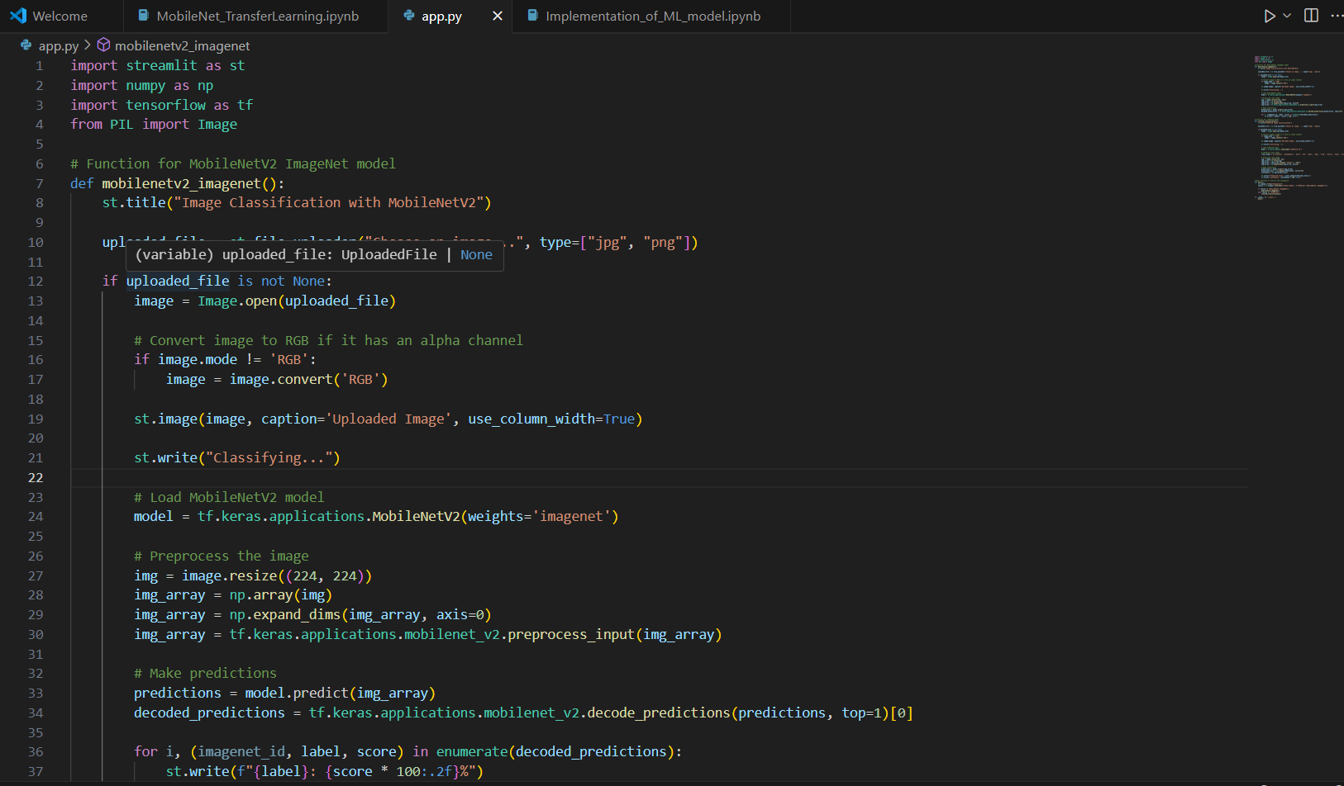**System Design**

**Figure 1: app.py**

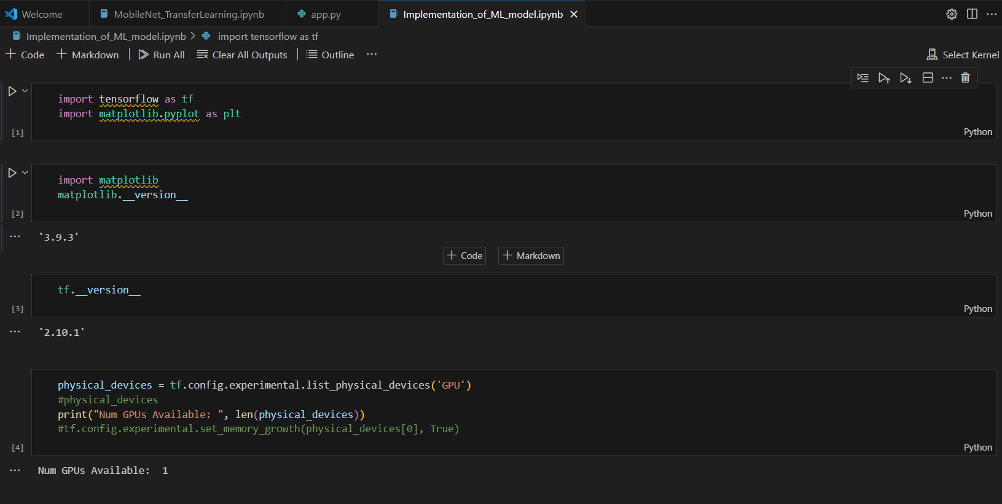

**Figure 2: Implementation of ML code**

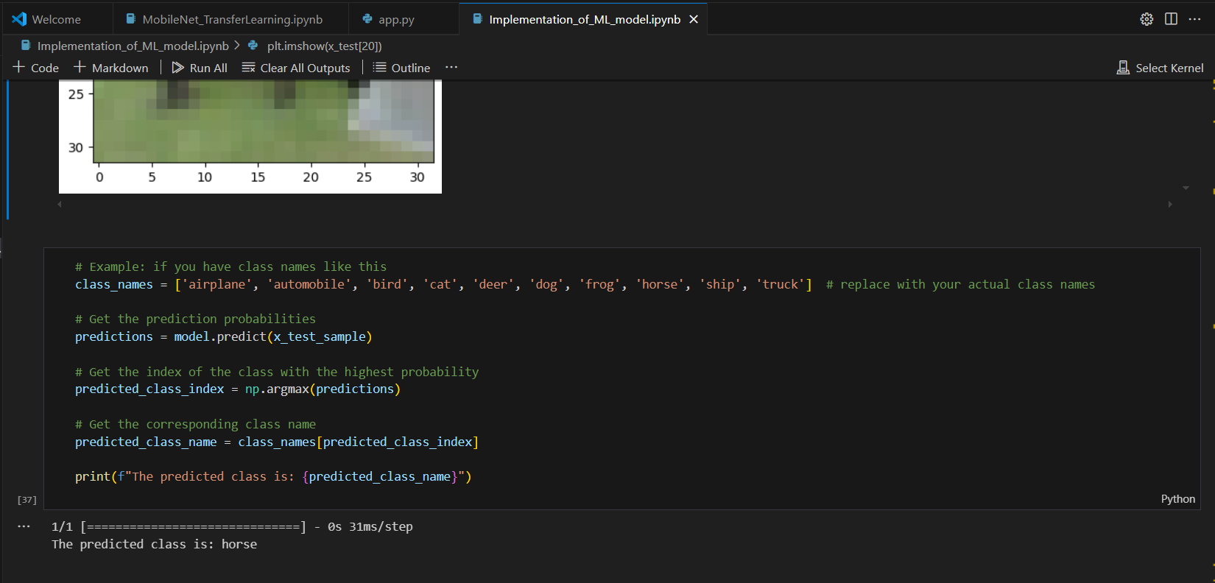

**Figure 3: Completion of ML code**

**CHAPTER 4**

**Implementation and Result**

* 1. **Snap Shots of Result:**

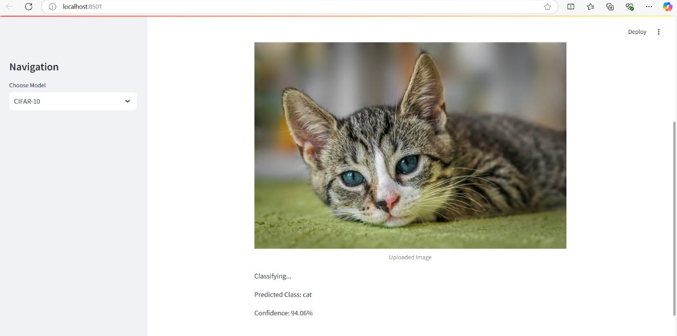

**Figure 4: Result 1**

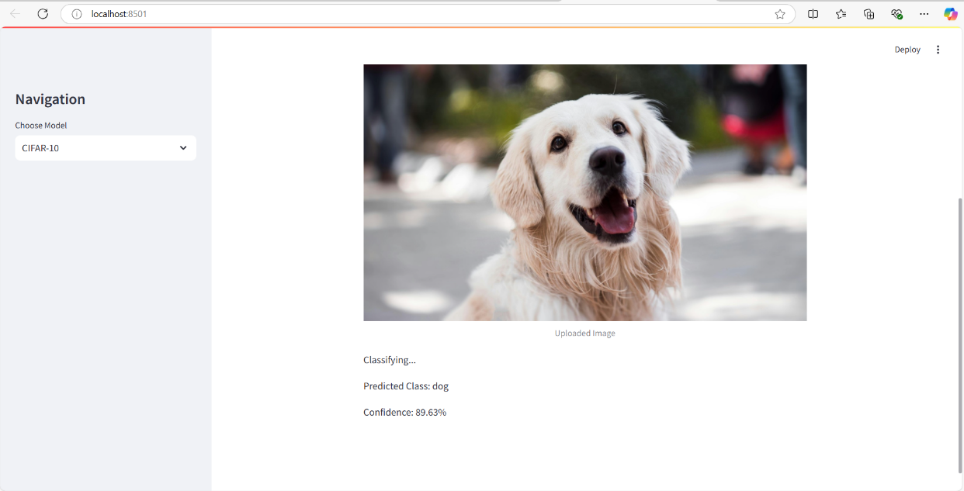

**Figure 5: Result 2**

* 1. **GitHub Link for Code:**

**CHAPTER 5**

**Discussion and Conclusion**

* 1. **Future Work:**

There are several avenues for improving the performance and scalability of the implemented machine learning model for image classification:

**Enhanced Dataset Diversity**: Expanding the dataset to include a wider variety of images can improve the model’s robustness and generalization. Collecting data from diverse sources and incorporating real-world scenarios can address biases and edge cases.

**Advanced Model Architectures**: Implementing state-of-the-art deep learning architectures, such as Vision Transformers (ViTs) or hybrid models combining CNNs with recurrent networks, could further enhance classification accuracy.

**Hyperparameter Optimization**: Exploring automated hyperparameter tuning methods, such as Bayesian optimization or grid search, can optimize model performance without extensive manual effort.

**Transfer Learning**: Leveraging pre-trained models on large-scale datasets, such as ImageNet, can significantly reduce training time and improve accuracy, especially for small datasets.

**Explainability and Interpretability**: Integrating explainability tools like Grad-CAM or SHAP can provide insights into the model’s decision-making process, enhancing trust and usability in critical applications.

**Real-Time Deployment**: Optimizing the model for edge devices using techniques such as quantization, pruning, or knowledge distillation can enable real-time image classification on resource-constrained devices.

**Multi-Label and Hierarchical Classification**: Extending the model to handle multi-label classification or hierarchical categories can broaden its applicability in complex scenarios.

**Incorporation of External Features**: Combining image data with metadata (e.g., geolocation or timestamps) could provide additional context, leading to improved classification results.

**Continuous Learning**: Implementing incremental learning methods can allow the model to adapt to new data without retraining from scratch, maintaining relevance in dynamic environments.

**Cross-Domain Applications**: Testing and adapting the model for different domains, such as medical imaging or satellite data, can validate its flexibility and expand its use cases.

These improvements can address current limitations and open up new possibilities for advancing image classification tasks using machine learning.

* 1. **Conclusion:**

The project successfully demonstrates the implementation of machine learning (ML) techniques for image classification, highlighting the potential of these models in automating the recognition and categorization of images across various domains. By leveraging advanced algorithms, particularly Convolutional Neural Networks (CNNs), the model achieved high classification accuracy, proving the effectiveness of ML in handling large and complex image datasets.

This work contributes to the growing field of computer vision by providing a clear methodology for image preprocessing, feature extraction, and model evaluation. The use of data augmentation and hyperparameter tuning played a crucial role in enhancing model performance, offering valuable insights for future research and applications. The results underline the importance of choosing the right ML approach and dataset preparation techniques to optimize classification outcomes.

Furthermore, the successful implementation of this ML model demonstrates its practical relevance for real-world applications such as healthcare (medical image analysis), security (face and object recognition), and retail (product categorization). The project provides a strong foundation for further improvements, including the integration of more advanced techniques like transfer learning and deep learning for even more complex classification tasks.

In conclusion, this project contributes to the ongoing advancement of machine learning in image classification, offering valuable insights and practical solutions for automated image analysis. Its outcomes suggest significant potential for real-world implementation and further exploration in related fields.

**REFERENCES**

From: Felipe Giuste [[view email](https://arxiv.org/show-email/e01e3e80/2002.03846)]  
[[v1]](https://arxiv.org/abs/2002.03846v1) Fri, 7 Feb 2020 01:53:46 UTC (2,354 KB)  
**[v2]** Thu, 27 Feb 2020 22:33:53 UTC (2,354 KB)