ENTERPRISE PAYROLL & COMPENSATION CALCULATION SYSTEM
Technology for Management
Project Report
Course Code: 2.1
MBA 2nd Semester | Academic Year 2025–2027

SUBMITTED BY

S. No. | Student Name | Student ID
1 | Kruthika M. | P03HB25M015114
2 | Manjali Athulya | P03HB25M015117
3 | Gudi Akhilesh | P03HB25M015152
4 | Gorle Nithin Tejas | P03HB25M015151

Submitted to: Professor Mrinmoy Roy Submission date: 20 October 2026

Document Guide
This report is organized around the six Technology for Management modules and includes system diagrams, database design, sample payroll calculations, SQL examples, security controls, testing plans, and recommendations.

Section | Contents
Executive Summary | Project purpose, system scope, and main outcomes
1–2 | Introduction and Information Systems Foundations
3 | MIS, RDBMS, ERD, normalization, and salary calculation
4 | Systems Analysis and Design and Business Process Reengineering
5 | E-Commerce, payment workflow, TAM, and adoption
6 | IT ethics, privacy, and cyber-risk controls
7 | MySQL implementation, illustrative SQL panels, and MIS outputs
8–10 | Testing, implementation, feasibility, and work allocation
11–13 | Benefits, recommendations, conclusion, references, and appendices

Executive Summary
Payroll management is a recurring organizational process that combines employee information, compensation structures, deductions, payslip preparation, payment status, and financial reporting. Errors or duplication in manual spreadsheets can affect the reliability and timeliness of payroll information. This project proposes an Enterprise Payroll & Compensation Calculation System using a relational database to organize payroll information and support repeatable calculations and reporting.
The system is designed around a Transaction Processing System (TPS) for operational records, a Management Information System (MIS) for routine summaries, and a Decision Support System (DSS) for analysis of payroll expenditure. MySQL is proposed as the database platform. The report also applies systems analysis and design, Business Process Reengineering (BPR), the Technology Acceptance Model (TAM), electronic-payment workflow concepts, data privacy, cybersecurity, and ethical controls.
The prototype scope is deliberately limited. It demonstrates database and reporting concepts using fictional sample data; it does not independently validate statutory payroll rules, provide a complete employee portal, or execute real bank transfers. Before production use, the organization would need validated rules, access controls, approvals, testing, operational training, and legal review.

Project at a glance

Item | Description
Project title | Enterprise Payroll & Compensation Calculation System
Primary users | HR, payroll staff, finance team, and management
Database | MySQL relational database
Core outputs | Salary calculations, payslip records, payment status, and management reports
Core IS concepts | TPS, MIS, and DSS
Project boundary | Academic prototype with illustrative data; no live bank transfer

Introduction

Background
Payroll is a core administrative function because it affects employees, finance operations, regulatory responsibilities, and trust in the organization. Payroll information typically includes employee identifiers, department and designation, pay components, deductions, pay period, net amount, and payment status. When these records are maintained across disconnected spreadsheets or paper documents, repeated data entry and inconsistent versions can create avoidable work.
A computerized payroll system centralizes records, applies defined calculation logic, and provides repeatable reports. The value of the system is not only faster calculation: it also depends on accurate source data, clearly assigned responsibilities, controlled changes, auditability, and secure handling of personal and financial information.

Problem Statement
    - Manual salary calculations may produce arithmetic or transcription errors.
    - Employee and compensation details may be duplicated across separate files.
    - Payslips and deduction summaries may require repetitive preparation.
    - Management may not have consolidated department-wise or month-wise payroll reports.
    - Salary data are confidential and need access controls, secure sharing, and traceable changes.

Objectives
    - Automate gross salary, deduction, and net salary calculations using defined formulas.
    - Maintain structured employee, pay-structure, deduction, payslip, and payment records.
    - Generate payroll and deduction reports using SQL.
    - Support department-wise and monthly payroll expense analysis.
    - Recommend secure payment workflow, privacy, and audit controls.

Scope and boundaries
The proposed prototype covers employee master data, salary structures, deductions, payslip records, payment-status records, and analytical queries. It does not include a complete employee self-service portal or a live bank integration. Statutory calculations and legal obligations must be verified by qualified personnel before operational use.

Assumptions
    - All names and salary values used in examples are fictional.
    - Salary structures are approved before a payroll run is processed.
    - Each payslip is associated with an employee and a defined pay period.
    - Payment status is updated only after an authorized confirmation or reconciliation process.
    - Access rights are assigned according to job responsibilities.

Module 1 — Information Systems Foundations

System classification

System type | Payroll application | Role in the project
TPS — Transaction Processing System | Records payroll runs, deductions, payslips, and payment status. | Core operational record keeping.
MIS — Management Information System | Produces employee-wise, department-wise, and monthly reports. | Routine monitoring and management summaries.
DSS — Decision Support System | Analyses salary expenditure, deduction patterns, and changes over time. | Supports budgeting and planning.
KMS — Knowledge Management System | Could store payroll procedures, HR policies, and user guidance. | Proposed future extension.
AI application | Could flag unusual salary changes for human review. | Future extension only; not implemented in the described prototype.

The core of the proposed solution is a TPS supported by MIS and DSS reporting. KMS and AI should be described as future possibilities unless they are implemented and demonstrated. This distinction is important because a report should not imply that a feature exists when it is only proposed.

Enterprise framework
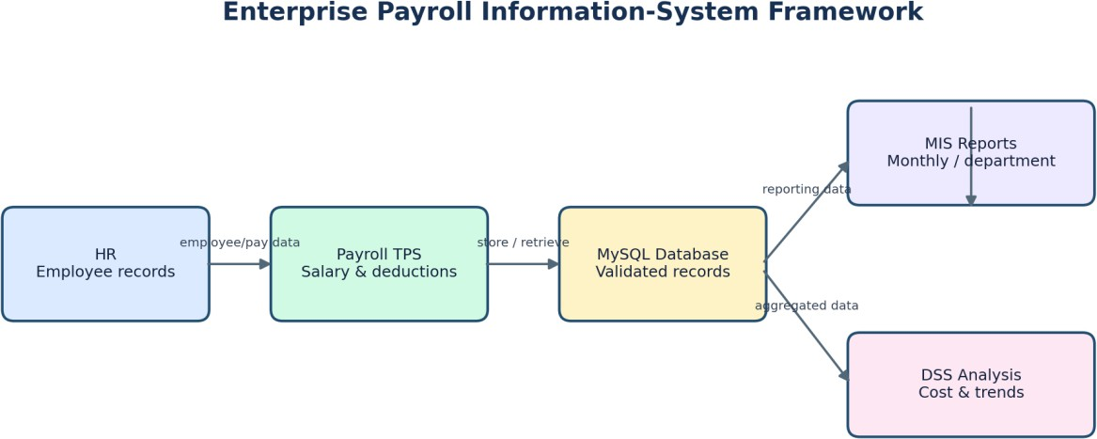

Figure 1. HR and payroll data flow into the database, which supports reporting and analysis.
HR maintains employee information and approved changes. Payroll staff apply the relevant compensation rules and review calculation results. The database stores the structured records. Finance reviews payroll totals and payment status, while management uses aggregated reports for budgeting and compensation decisions.

Inputs, processing, outputs, and feedback

System element | Examples
Inputs | Employee details, approved salary structure, pay period, deductions, attendance or adjustment data if in scope.
Processing | Validation, gross salary calculation, deduction aggregation, net salary calculation, report generation.
Outputs | Payslip data, payroll totals, deduction summaries, payment-status reports.
Feedback and control | Approval checks, exception reports, reconciliations, audit logs, and corrections.

Stakeholders and responsibilities

Stakeholder | Main responsibility
HR | Maintain employee master data and communicate approved changes.
Payroll staff | Prepare payroll, check calculations, and generate payslips.
Finance | Review expenditure, authorize payment workflow, and reconcile transactions.
Management | Review trends and use reports for planning.
IT / database administrator | Maintain database access, backup, security, and technical reliability.
Employees | Review their own payslip and report discrepancies through approved channels.

Module 2 — MIS and Relational Database Management

Why use a relational database?
A relational database stores related information in structured tables. Primary keys uniquely identify records, while foreign keys link records between tables. This design can reduce unnecessary repetition and improve consistency when combined with constraints and disciplined data entry. SQL supports data definition, insertion, retrieval, aggregation, and reporting.

Proposed database schema

Table | Important fields | Purpose
Employees | employee_id (PK), employee_name, department, designation, joining_date, email, status | Stores employee master information.
Pay_Structure | pay_structure_id (PK), employee_id (FK), basic_salary, hra, allowances, effective_from, effective_to | Stores salary components and their effective dates.
Tax_Deductions | deduction_id (PK), employee_id (FK), pay_period, deduction_type, amount | Stores deduction records by type and period.

Payslips | payslip_id (PK), employee_id (FK), pay_period, gross_salary, total_deductions, net_salary, payment_status | Stores calculated payroll results for each period.
Payment_Transactions | payment_id (PK), payslip_id (FK), payment_date, payment_method, transaction_reference, payment_status | Tracks payment attempts and reconciliation status.
Payroll_Run (recommended) | payroll_run_id (PK), pay_period, run_date, prepared_by, approved_by, run_status | Tracks each payroll cycle and its approval state if added to the design.

The original design lists five core tables. Payroll_Run is a recommendation, not an assumed existing table. If it is added, update the ERD, SQL script, sample data, and report references consistently.

Primary keys and foreign keys
    - A primary key uniquely identifies a row, such as employee_id in Employees.
    - A foreign key links a record to a valid parent record, such as employee_id in Payslips.
    - A unique constraint can prevent duplicate payslips for the same employee and pay period, if that is the intended business rule.
    - NOT NULL constraints should be applied to essential fields.
    - Checks or application-level validation should prevent negative salary and deduction amounts where they are not allowed.

Entity Relationship Diagram
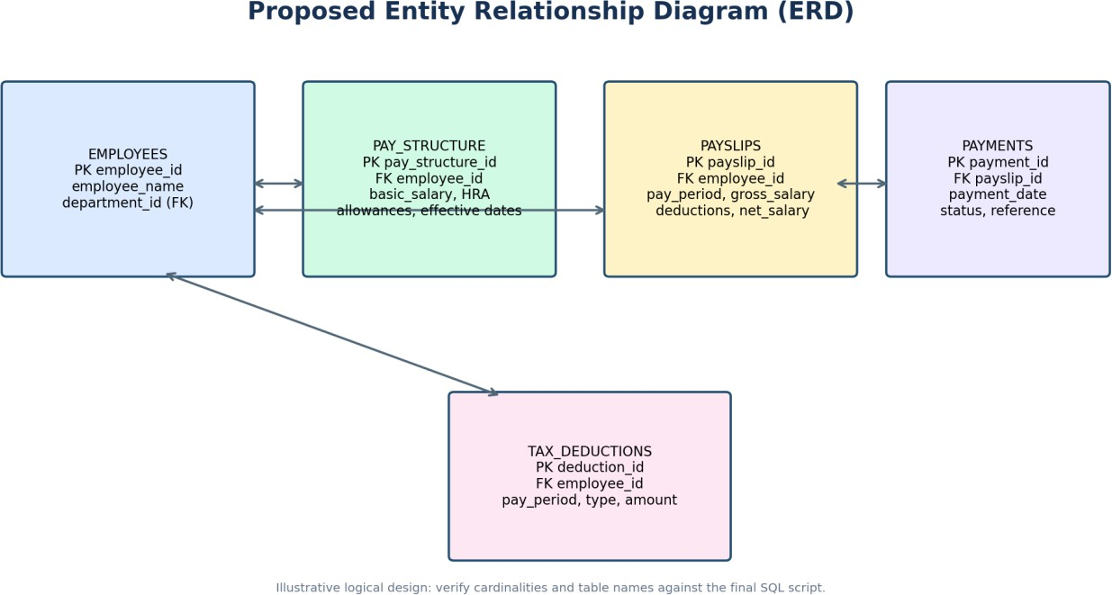

Figure 2. Proposed ERD for payroll, payslip, deduction, and payment records.
The ERD is a logical proposal. Confirm all table names, foreign keys, and relationship cardinalities against the final SQL script. If the final implementation differs, revise the figure rather than leaving a mismatch between the diagram and the database.

Normalization to Third Normal Form
First Normal Form (1NF) requires atomic field values; a list of multiple deductions should not be stored in a single cell. Second Normal Form (2NF) requires each non-key attribute to depend on the full primary key. Third Normal Form (3NF) requires non-key attributes not to depend transitively on a key. Separating employee master details, payslip records, deduction records, and payment transactions helps avoid repeating the same details in several places.
Normalization should be checked using the actual schema and functional dependencies. Merely having separate tables does not automatically prove that a database is in 3NF.

Salary calculation logic
For the simplified example used in this report, gross salary is the sum of basic salary, HRA, and allowances. Net salary is gross salary minus the total deductions associated with the payroll period.

Component | Illustrative amount
Basic salary | ₹30,000
HRA | ₹10,000
Allowances | ₹7,000
Gross salary | ₹47,000
Total deductions | ₹4,000
Net salary | ₹43,000

Gross Salary = Basic Salary + HRA + Allowances Net Salary = Gross Salary − Total Deductions
The system must use the salary structure effective for the relevant payroll period. The sample is deliberately simple and does not include statutory tax calculations, attendance adjustments, overtime, reimbursements, benefits, or other organization-specific rules.

Sample payroll data

Employee | Gross salary | Deductions | Net salary
Asha Rao | ₹47,000 | ₹4,000 | ₹43,000
Rahul Kumar | ₹42,000 | ₹2,500 | ₹39,500
Meera Nair | ₹37,000 | ₹2,000 | ₹35,000
TOTAL | ₹1,26,000 | ₹8,500 | ₹1,17,500

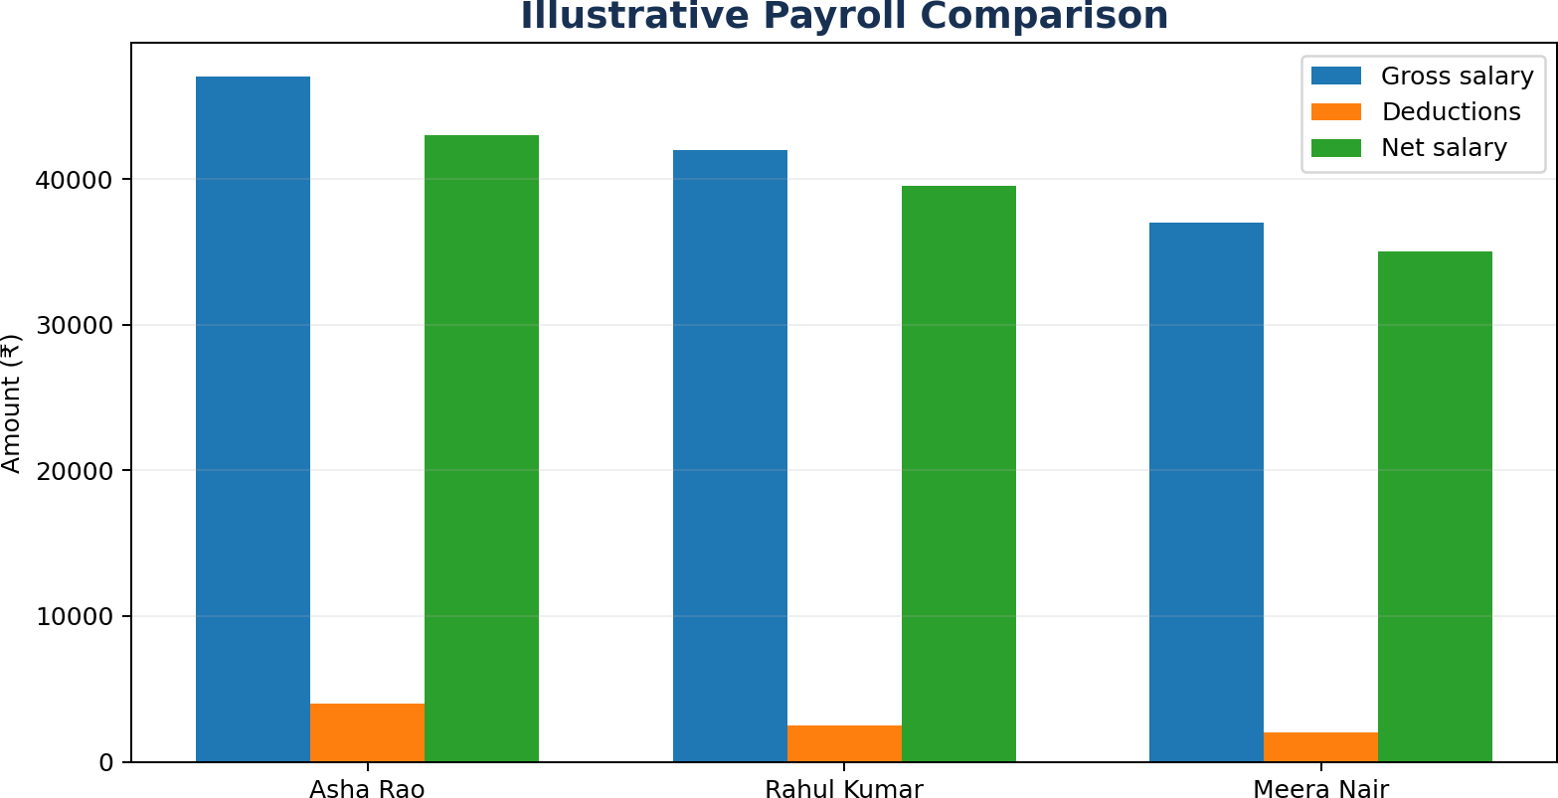

Figure 3. Comparison of illustrative gross salary, deductions, and net salary.

Data quality controls
    - Validate employee identifiers and required fields before payroll processing.
    - Confirm that the correct salary structure applies to the selected pay period.
    - Check that deductions are linked to the right employee and period.
    - Reconcile total gross salary, deductions, and net salary before approval.
    - Restrict changes after payroll approval and preserve an audit trail.

Module 3 — Systems Analysis and Design

SDLC model selection
The Waterfall model is selected because the academic requirements and deliverables are specified in advance. The model organizes the work into sequential phases. Its limitation is that major requirement changes discovered late can require rework, so each phase should be reviewed before moving forward.

Phase | Payroll project activity | Deliverable
Planning | Define objectives, scope, feasibility, and constraints. | Project scope statement.
Requirement analysis | Identify employee, salary, deduction, security, and reporting needs. | Requirements list.

System design | Prepare ERD, normalized schema, context diagram, and Level 1 DFD. | Design diagrams and schema.
Development | Create MySQL tables, insert sample records, and write queries. | SQL script and prototype.
Testing | Verify formulas, constraints, joins, and reports. | Test cases and evidence.
Implementation | Configure access, load approved data, and train users. | Deployment and training plan.
Maintenance | Correct defects and update validated rules. | Maintenance log.

Context diagram
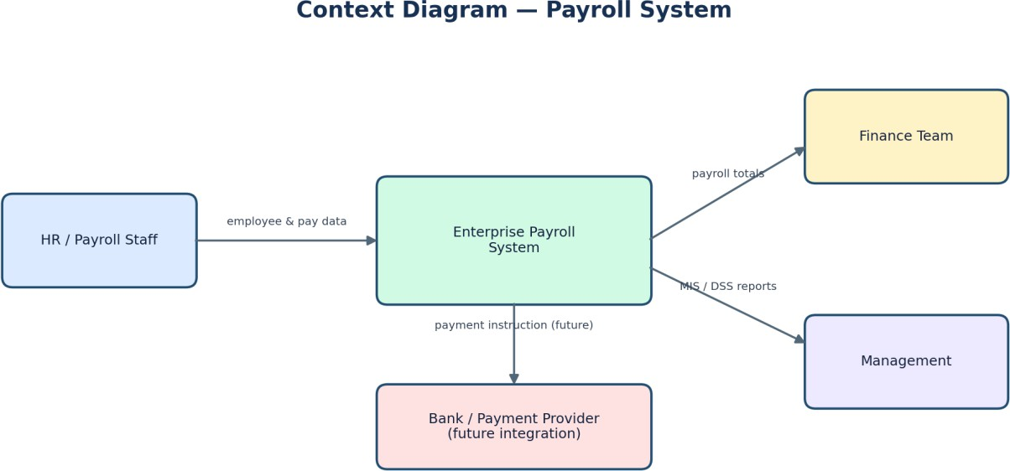

Figure 4. Context diagram showing external users and the proposed payroll system.
The context diagram treats the payroll solution as one process and shows its interactions with HR/payroll staff, finance, management, and a possible future payment provider. The bank/payment-provider link is proposed and must not be interpreted as an implemented integration.

Level 1 Data Flow Diagram
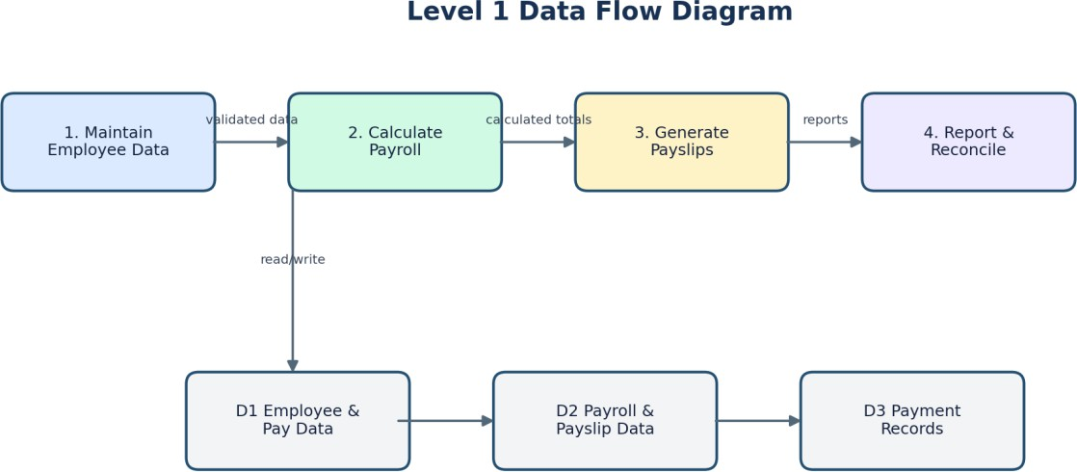

Figure 5. Level 1 DFD showing employee data maintenance, payroll calculation, payslip generation, and reporting.
A Level 1 DFD breaks the overall process into major activities and data stores. For a final submission, make sure the diagram uses consistent names, clearly directed arrows, and data stores that correspond to the actual database tables.

Requirements analysis

Requirement type | Example
Functional | Create and maintain employee records; calculate salary; store deductions; generate payslip data; prepare reports.
Security | Restrict access by role; log sensitive changes; protect backups and data transfers.
Performance | Complete a sample payroll run and generate routine reports within an acceptable time for the intended dataset.
Usability | Use clear field labels, consistent status values, and simple workflows.
Reliability | Back up records and test recovery procedures.
Auditability | Record who prepared, changed, approved, or reconciled a payroll transaction.

Business Process Reengineering (BPR)

Existing versus proposed process

Existing process | Proposed improved process | Expected improvement
Manual salary calculation | Formula-driven calculation with validation. | More consistent calculations.
Repeated employee records | Central relational database. | Less duplication.
Payslips prepared separately | Standardized payslip records and reports. | More repeatable preparation.
Reports assembled manually | SQL aggregation and reusable MIS reports. | Faster routine reporting.
Payment status checked in separate files | Payment-status tracking and reconciliation records. | Better visibility and traceability.
Shared access with unclear ownership | Role-based access and audit trails. | Stronger accountability.

BPR principles applied
    - Review the complete process instead of automating isolated tasks without understanding them.
    - Remove repeated data entry wherever a reliable source record can be reused.
    - Introduce validation at the point where information is entered or changed.
    - Separate preparation, approval, and reconciliation responsibilities where practical.
    - Measure improvements using defined indicators rather than assuming benefits.

Suggested performance indicators

Indicator | How it could be measured
Payroll preparation time | Hours required from data readiness to payroll approval.
Correction rate | Number of payroll records corrected after initial calculation.
On-time payslip rate | Percentage of payslips made available by the target date.
Reconciliation rate | Percentage of payment transactions matched to authorized payroll records.

Access-review completion | Percentage of scheduled access reviews completed on time.

These indicators are recommendations for a future pilot. No measured performance improvement is claimed because the report contains only illustrative data.

Module 4 — E-Commerce and Technology Adoption

Electronic payment workflow

Step | Activity | Control
1 | Approve payroll and validate totals. | Independent review of totals and exceptions.
2 | Generate authorized payment instructions. | Use approved payroll records and access permissions.
3 | Transmit instructions through an authorized bank/provider. | Secure channel and authenticated access.
4 | Receive transaction references and payment status. | Validate response and preserve references.
5 | Reconcile confirmations and update records. | Separate review and exception handling.

The prototype stores payment records only; it does not execute money transfers. Actual integration requires bank/provider authorization, secure transmission, maker-checker approval, reconciliation, and testing.

Technology Acceptance Model (TAM)
The Technology Acceptance Model explains technology acceptance through perceived usefulness and perceived ease of use. In this project, payroll staff may see usefulness in reducing repetitive calculations and producing consistent reports. Employees may value clear payslip information and reliable payment-status visibility. Ease of use can be supported through clear labels, simple navigation, training, and responsive support.

TAM construct | Payroll example | Possible design response
Perceived usefulness | Reports reduce repeated manual preparation. | Provide accurate, relevant, and timely reports.
Perceived ease of use | Users can find payslips or complete routine tasks without confusion. | Use clear labels, simple workflows, and help guidance.
User attitude | Users believe the system is reliable and helpful. | Demonstrate benefits and explain controls.
Intention to use | Users plan to use the system for regular payroll work. | Provide training and a clear support route.

Conceptual adoption curve
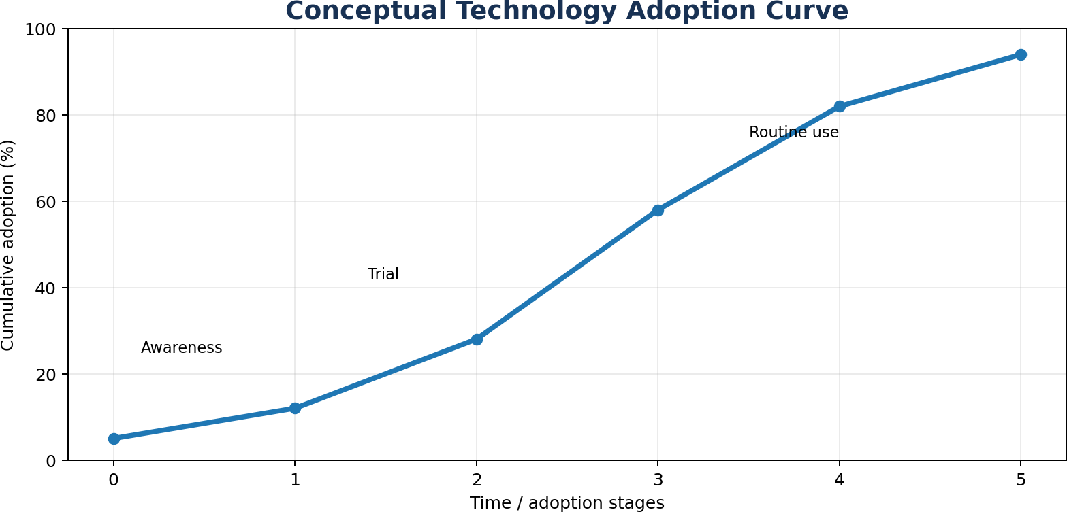

Figure 6. Conceptual adoption curve. Values are illustrative and are not survey results.
The curve is a conceptual illustration of adoption increasing over time. It is not based on measured employee responses. A real assessment could collect user feedback after demonstrations or a pilot and compare acceptance before and after training.

Module 5 — IT Ethics, Privacy, and Security

Data privacy principles
Payroll records may contain personal and financial information. The organization should collect only necessary information, document the purpose of processing, restrict access, define retention and deletion procedures, protect records from unauthorized disclosure, and follow applicable Indian data-protection requirements. Legal requirements and applicable rules should be verified at implementation time.

Security architecture
    - Authentication: unique user accounts and multi-factor authentication for privileged users.
    - Authorization: role-based access and least-privilege permissions.
    - Encryption: protect sensitive data in transit and at rest where supported.
    - Audit logs: record salary changes, approvals, and sensitive access.
    - Backup and recovery: maintain protected backups and test restoration.
    - Secure coding: use parameterized queries and validate input.
    - Payment controls: separate preparation and approval where feasible, then reconcile payment results.
    - Incident response: define how to report, contain, investigate, and recover from a security incident.

Cybercrime risk matrix

Risk | Impact | Mitigation
Unauthorized access | High | MFA, role-based access, and monitoring.
Salary manipulation | High | Approval workflow, audit trails, and periodic review.
Data theft | High | Encryption, restricted access, and incident response.
SQL injection | High | Parameterized queries and input validation.
Ransomware/data loss | High | Isolated backups and recovery testing.
Fraudulent payment instructions | High | Maker-checker approval and bank reconciliation.

Insider misuse | Medium–High | Least privilege and periodic access review.

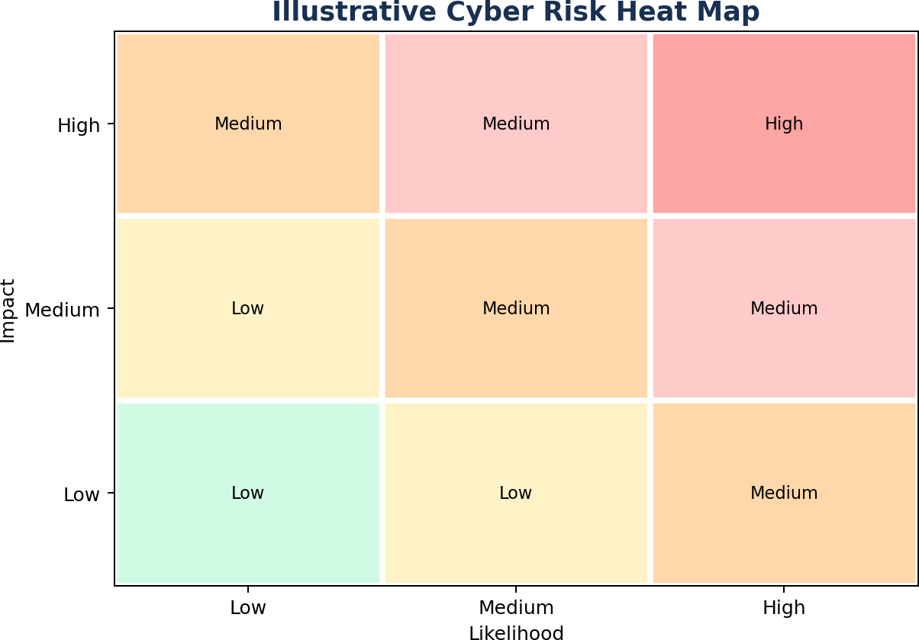

Figure 7. Illustrative risk heat map for likelihood and impact. Rate individual risks using an organization-specific assessment.

Ethical, environmental, and ergonomic audit
    - Confidentiality: disclose salary details only to authorized people.
    - Accuracy: validate calculations before approval and correct errors transparently.
    - Fairness: apply approved compensation rules consistently and without discrimination.
    - Transparency: explain salary components and deductions on payslips.
    - Accountability: preserve traceable approval and change records.
    - Environment: reduce unnecessary printing, conserve energy, and recycle e-waste responsibly.
    - Ergonomics: provide suitable seating and monitor positioning and encourage regular breaks.

Ethics compliance checklist
    - Access is limited to authorized users.
    - Payroll changes are approved and logged.
    - Reports are shared through secure channels.

    - Backups and recovery are tested.
    - Payment records are reconciled.
    - Retention and deletion rules are documented.
    - Security incidents have a response procedure.

Module 6 — Application Software and MySQL

Database implementation overview
The proposed implementation uses MySQL to create structured tables, insert fictional sample records, calculate payroll totals, and run reporting queries. The SQL should be run in a test database first. If a script drops and recreates tables with the same names, running it against a production or valuable database could destroy existing data.

Illustrative SQL — table creation
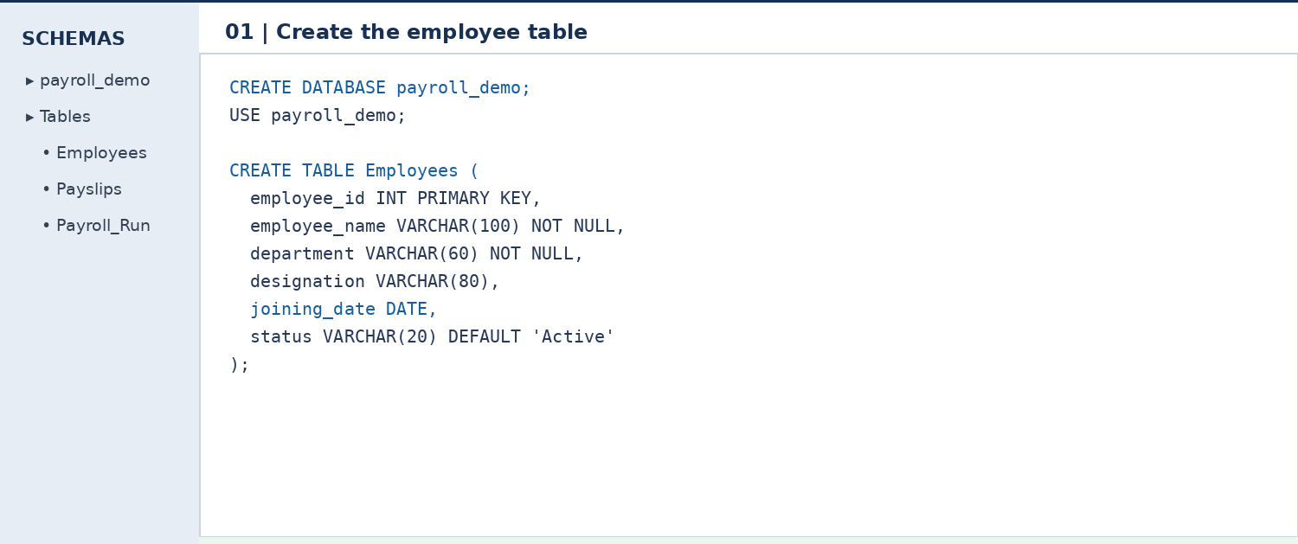
Figure 8. Illustrative SQL code panel for employee-table creation; not execution evidence.
The example demonstrates the structure of a CREATE TABLE statement and the use of a primary key and NOT NULL constraints. Match the field names and data types to the final schema before using the code.

Illustrative SQL — salary calculation
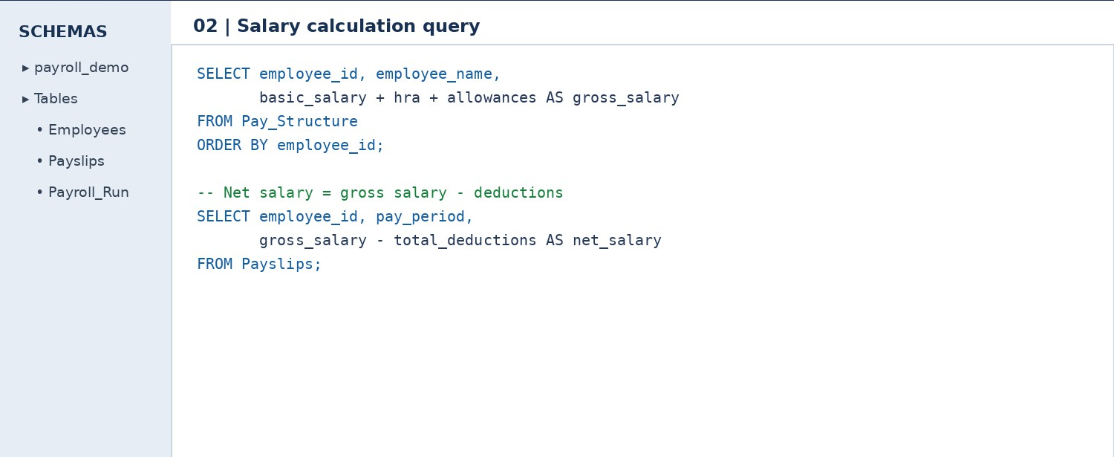
Figure 9. Illustrative SQL code panel for gross and net salary calculations; not execution evidence.
The calculation query should use the correct salary structure effective for the payroll period and should aggregate all deductions linked to that period. Avoid calculating net salary from incomplete or unapproved records.

Illustrative SQL — department-wise MIS
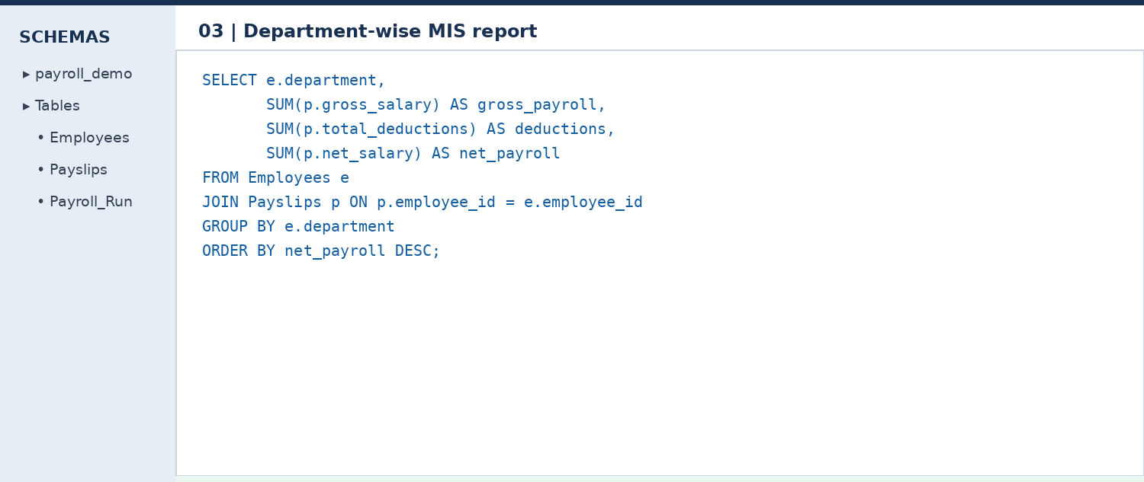
Figure 10. Illustrative SQL code panel for a department-wise payroll report; not execution evidence.
The query uses a join to connect employee information with payslip records, then aggregates gross salary, deductions, and net salary by department. The query depends on the actual column names and relationship in the final database.

Illustrative SQL — payment and deduction reports
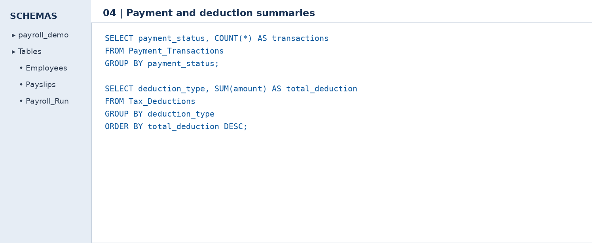
Figure 11. Illustrative SQL code panel for payment-status and deduction summaries; not execution evidence.
These queries show how grouped counts and totals can help finance and payroll staff identify the number of transactions by status and the deduction totals by type. Actual output screenshots should be captured from the executed SQL.

Suggested SQL reports
    - Department-wise payroll summary using JOIN, SUM, and GROUP BY.
    - Deduction summary by pay period and deduction type.
    - Employees with net salary above a selected threshold.
    - Department-wise average salary using GROUP BY and HAVING.
    - Monthly salary-expense trend across pay periods.
    - Subquery to identify employees paid above average net salary.
    - Highest and lowest net salary in a selected payroll period.
    - Payment-status summary for successful, pending, and failed transactions.

MIS Interpretation and Reporting

Sample executive summary

Measure | Illustrative result | Interpretation
Total gross payroll | ₹1,26,000 | Sum of gross salaries for three fictional employees.
Total deductions | ₹8,500 | Sum of the deduction values in the sample.
Total net payroll | ₹1,17,500 | Gross payroll less deductions.
Deductions as a share of gross | Approximately 6.75% | ₹8,500 divided by ₹1,26,000, expressed as a percentage.
Highest gross salary | Asha Rao — ₹47,000 | Highest gross amount among the three sample employees.

One month of sample data is not sufficient to establish a meaningful trend. A month-on-month comparison requires comparable, validated records for several pay periods.

Dashboard design recommendations
    - Display total gross payroll, deductions, and net payroll for the selected period.
    - Show department-level totals and changes from the previous period when data are available.
    - Provide a payment-status summary with pending or failed transactions clearly flagged.
    - Allow authorized users to filter by pay period and department.
    - Keep employee-level salary details visible only to users with a legitimate business need.

Interpreting reports responsibly
Reports should include a clear reporting period, data source, preparation time, and status. Totals should be reconciled before they are used for decisions. A high deduction amount may reflect a legitimate policy or a data-entry error, so exceptions should be investigated rather than interpreted automatically as misconduct.

Software Testing and Validation

Test cases

Test case | Expected result | Evidence to capture
Insert valid employee | Record is created. | Success message and row output.
Duplicate primary key | Database rejects duplicate ID. | Error message or constraint output.
Deduction for missing employee | Foreign key rejects the record. | Constraint error.
Calculate sample payroll | Formulas match expected totals. | Query and result grid.
Duplicate payslip for same employee/month | Unique constraint rejects duplicate if configured. | Constraint output.
Run department report | Totals are grouped by department. | Result grid.
Run deduction summary | Totals are grouped by type and period. | Result grid.
Unauthorized salary access | Application denies access; verify at application layer. | Access-control test record.
Negative salary or deduction | Validation rejects invalid amounts if implemented. | Constraint or validation output.
Invalid payment status | Allowed-status validation rejects unsupported values if configured. | Constraint or application test.

Testing approach
Testing should verify both normal and exceptional conditions. Each test should record the input, expected result, actual result, pass/fail status, date, and evidence. Database-level constraints can reject invalid data, but application-layer access controls need to be tested in the application itself. Do not mark a test as passed until it has actually been executed.

Example acceptance criteria
    - Gross and net salary totals match the approved sample calculations.
    - Foreign-key constraints reject records that reference nonexistent employees or payslips.
    - Duplicate payslips are prevented if the business rule requires one per employee per period.
    - Management queries return the expected totals for the sample dataset.
    - Unauthorized users cannot view or modify salary information in the implemented application.
    - Backup restoration can be demonstrated in a controlled test environment.

Implementation Plan and Feasibility

Six-week implementation plan

Week | Activity | Deliverable
1 | Requirement gathering and feasibility. | Scope and requirements list.
2 | ERD, schema, context diagram, and DFD design. | Reviewed design package.
3 | Create MySQL tables and populate sample data. | Database and sample records.
4 | Implement calculations and MIS/DSS queries. | Queries and reports.
5 | Test calculations, constraints, and security; complete documentation. | Test results and revised report.
6 | Demonstrate the prototype and train intended users. | Demonstration and training record.

Feasibility analysis

Feasibility | Assessment
Technical | MySQL Workbench supports a database prototype. Access controls, backups, and integration require implementation and testing.
Economic | Open-source tools can reduce licensing costs, but development, training, maintenance, and support still require resources.

Operational | Payroll staff need training, documented procedures, and a support process.
Legal | Data processing, retention, deductions, and payments must follow applicable law and organizational policy.

Maintenance considerations
Maintenance may include correcting defects, changing validated compensation rules, adding reports, updating user permissions, reviewing logs, and testing backups. Changes to payroll rules should be approved, documented, tested, and applied consistently. Historical payroll records should remain traceable after updates.

Individual Accountability and Work Allocation
The original report's allocation is inconsistent: four members are listed, but the numbered task allocation does not clearly assign distinct responsibilities to all four. Complete the table below based on the work actually performed. The example areas are suggestions only and should not be treated as factual contributions until confirmed by the team.

Member | Contribution area — confirm and edit
Kruthika M. | Confirm actual work, such as database schema, ERD, or SQL implementation.
Manjali Athulya | Confirm actual work, such as systems analysis, documentation, or testing.
Gudi Akhilesh | Confirm actual work, such as IS framework, BPR, or diagrams.
Gorle Nithin Tejas | Confirm actual work, such as security analysis, payment workflow, or presentation.

Evidence of contribution
    - SQL script and query files authored or tested by the member.
    - Diagram files or documented revisions.
    - Report sections drafted or edited.
    - Test evidence, screenshots, or presentation materials.
    - Agreed task records or version history, where available.

Team coordination
The team should agree on one final version of the schema, diagrams, SQL script, and report before submission. A final cross-check should confirm that each member's contribution is represented accurately and that the same table names and sample values are used throughout.

Expected Benefits, Limitations, and Recommendations

Expected benefits
    - More consistent payroll calculations through defined formulas.
    - Reduced repeated manual data entry through centralized records.
    - Consolidated deduction and salary reports.
    - Better visibility into payroll expenditure.
    - Improved traceability through approvals and audit records.
    - A foundation for future electronic-payment integration.

Limitations
    - The sample dataset is small and illustrative.
    - Actual tax and statutory calculations require validated rules.
    - The described prototype has no complete web interface or employee portal.
    - No real bank transfer is executed by the SQL prototype.
    - Trend analysis requires multiple months of comparable records.
    - Production security controls require further implementation and testing.
    - Illustrative SQL panels do not prove that queries have executed successfully.

Recommendations and future scope
    - Develop an employee self-service portal for secure payslip access.
    - Validate statutory deductions and payroll rules with qualified HR/finance personnel and authoritative legal sources.
    - Introduce maker-checker approvals and auditable payroll-change workflows.
    - Integrate with an authorized bank/payment provider only after formal approval and security testing.
    - Use several months of verified data for meaningful trend analysis.
    - Conduct user acceptance testing and collect feedback from HR, payroll, and finance users.

    - Consider alerts for unusual changes, but require human review before action.

Suggested pilot evaluation
A pilot could compare payroll preparation time, correction rates, on-time payslip availability, reconciliation completion, and user feedback before and after implementation. The evaluation should define the measurement period and data sources in advance. Improvements should be reported only when supported by collected evidence.

Conclusion
The Enterprise Payroll & Compensation Calculation System demonstrates how information systems and database technology can support payroll administration. It combines TPS, MIS, and DSS concepts with relational database design, systems analysis, business process reengineering, an electronic-payment workflow, technology-adoption considerations, and ethical and security safeguards.
The illustrative payroll data show how salary components and deductions can be organized into consistent totals, while the proposed MIS queries show how the records could support department-level and payment-status reporting. The prototype is a foundation rather than a production-ready payroll service. Before operational use, the database and SQL must be tested, statutory rules validated, access controls implemented, payment workflows authorized, and privacy obligations reviewed.

References
- Elmasri, R., & Navathe, S. B. (2016). Fundamentals of database systems (7th ed.). Pearson.
- Laudon, K. C., & Laudon, J. P. (2022). Management information systems: Managing the digital firm (17th ed.). Pearson.
- Pressman, R. S., & Maxim, B. R. (2020). Software engineering: A practitioner's approach (9th ed.). McGraw Hill.
- Davis, F. D. (1989). Perceived usefulness, perceived ease of use, and user acceptance of information technology. MIS Quarterly, 13(3), 319–340. https://doi.org/10.2307/249008
- Government of India. (2023). The Digital Personal Data Protection Act, 2023. Ministry of Law and Justice.
Before submission, verify the reference details and add any course materials, official documentation, or sources actually consulted. Add in-text citations where claims from these sources are discussed.

Appendix A — SQL Review Checklist
  - Run the script only in a test database if it drops and recreates tables.
  - Confirm that each primary key and foreign key is defined as intended.
  - Confirm that amount fields use an appropriate numeric type.
  - Check the effective dates of salary structures.
  - Check duplicate payslip prevention for employee and pay period.
  - Verify how deductions are aggregated for the correct pay period.
  - Run every MIS query and compare output with independently calculated totals.
  - Save genuine screenshots of code and result grids.
  - Remove confidential or real employee information from screenshots before sharing.

Appendix B — Required screenshot pack

Screenshot | What it should show | Caption suggestion
1. Database/schema | MySQL Workbench with the database and tables created. | Figure B1. Payroll database schema created in MySQL Workbench.
2. Sample data | Fictional employee and salary records in the result grid. | Figure B2. Illustrative employee and salary records.
3. Salary calculation | Executed query and visible gross/net results. | Figure B3. Salary calculation query and output.
4. MIS summary | Department-wise or pay-period report result grid. | Figure B4. MIS payroll summary generated using SQL.
5. Validation test | A rejected invalid record or duplicate record, with error visible. | Figure B5. Database validation test.
6. Payment status | Query output grouped by payment status. | Figure B6. Payment transaction status summary.

The SQL code panels included in the report are visual illustrations, not genuine execution screenshots. Replace them with screenshots from the actual MySQL environment if the assignment requires proof of implementation.

Appendix C — Final submission checklist
  - All four student IDs are correct.
  - Faculty name and submission date are verified.
  - ERD, context diagram, and DFD match the implemented schema.
  - SQL script runs successfully in a test database.

  - Actual query outputs are captured and inserted.
  - Test cases include actual results and pass/fail status.
  - All four members' contributions are accurate and agreed upon.
  - All placeholder instructions and verification notes are resolved.
  - References are checked and in-text citations are added.
  - Final Word file is proofread and exported to PDF for page-layout review.

