CI/CD Pipeline for a Spring Boot Application
Using Docker, Kubernetes, and Jenkins

1. Project Overview
This project is a Java Spring Boot application combined with Docker, Kubernetes, and Jenkins to build a complete CI/CD pipeline.

2. The Spring Boot Application
First, I created a simple Spring Boot application with two classes: HelloController and SampleApplication. The HelloController class has two methods:
- hello() – displays the message “Hello World!”.
- greet(String name) – takes a path variable, name, and greets that person with a welcome message.
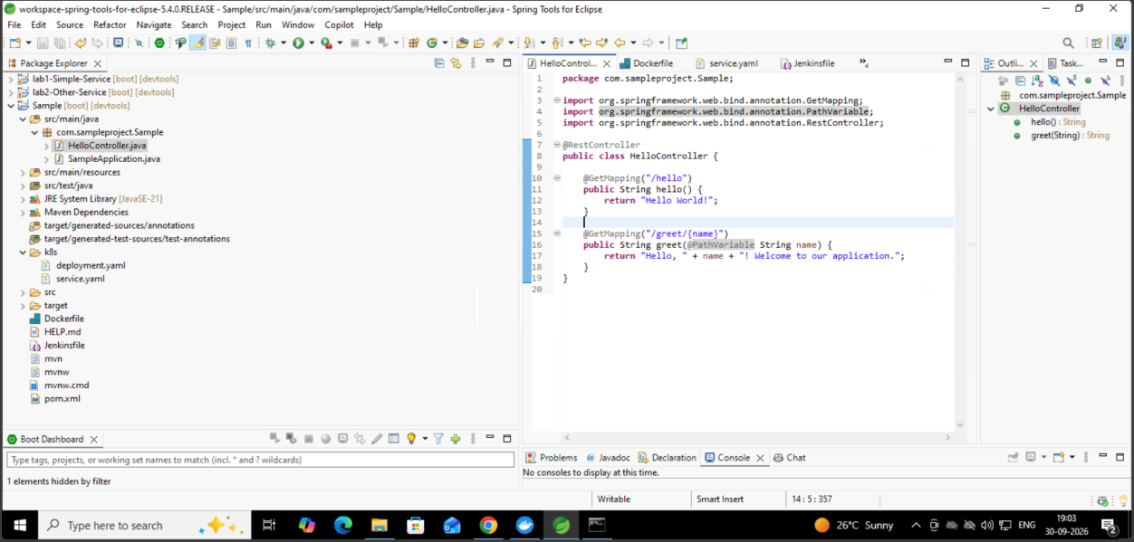
Figure 1: HelloController in Spring Tool Suite

3. Docker and Kubernetes Configuration
To run the project in Docker and Kubernetes, I added two items to the project:
- Dockerfile – defines how the application’s Docker image is built.
- k8s folder – contains deployment.yaml and service.yaml, the Kubernetes configuration files.
These files are used later by Jenkins. A third file, the Jenkinsfile, defines the steps of the build process.
GitHub repository (Dockerfile, Kubernetes, and Jenkinsfile): https://github.com/kruthikkothari/Projects

4. Pushing the Project to GitHub
Next, I created a new GitHub repository named Projects and pushed the Spring Boot project into it.

Commands to push the project
cd /path/to/your/project
git init -b main
git add .
git commit -m "Initial commit"
git push -u origin master

Commands to update the repository
git add .
git commit -m "Describe your changes"
git push
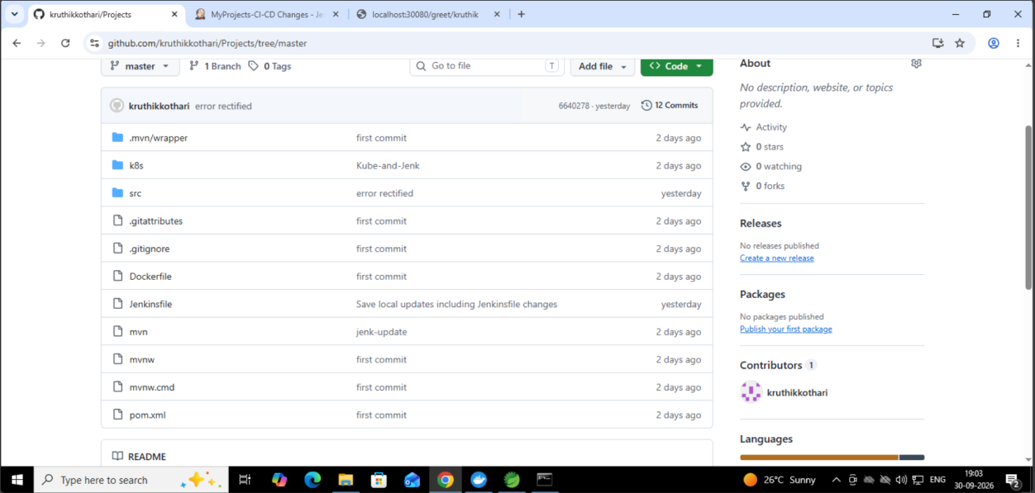
Figure 2: Project files in the GitHub repository

5. Configuring Jenkins
Now that the repository contains the Dockerfile, the Kubernetes configurations, and the Jenkinsfile, Jenkins needs to be connected to the GitHub repository.

Step 1: Create Docker Hub credentials
First, create a credential in Jenkins that links to Docker Hub. Docker Hub stores the Docker images, and Jenkins pushes the images it builds to it.
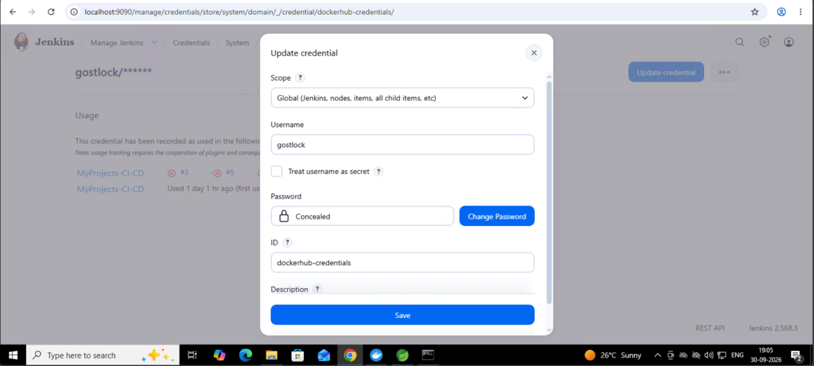
Figure 3: Docker Hub credentials in Jenkins

Step 2: Configure Git
Next, configure Git under Manage Jenkins → Tools, so that Jenkins knows where the Git executable is located.
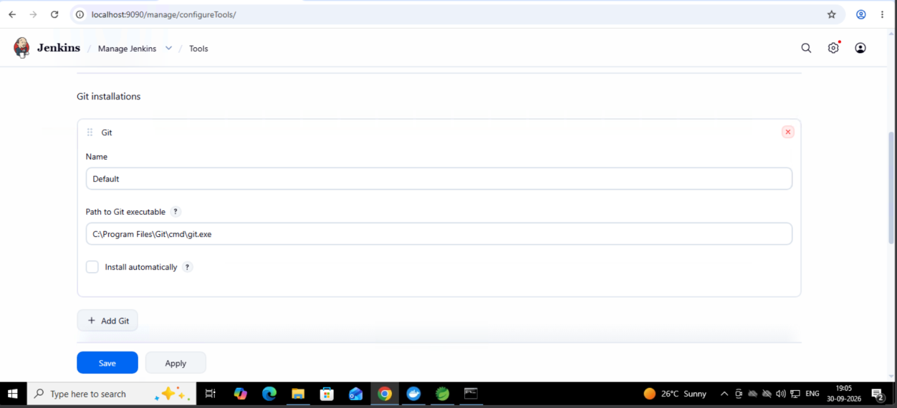
Figure 4: Git installation settings in Jenkins Tools

Step 3: Configure the pipeline
Finally, configure the pipeline to use the GitHub repository:
- Under Definition, select Pipeline script from SCM.
- Set SCM to Git and enter the repository URL.
- Select the branch to build (for example, master, or any other branch you want to use).
- Set the Script Path to Jenkinsfile, the file saved in the project, so the pipeline works properly.
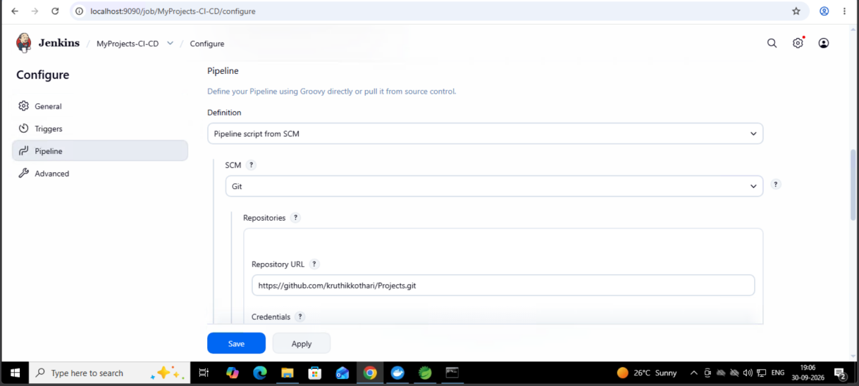
Figure 5: Pipeline definition and repository URL
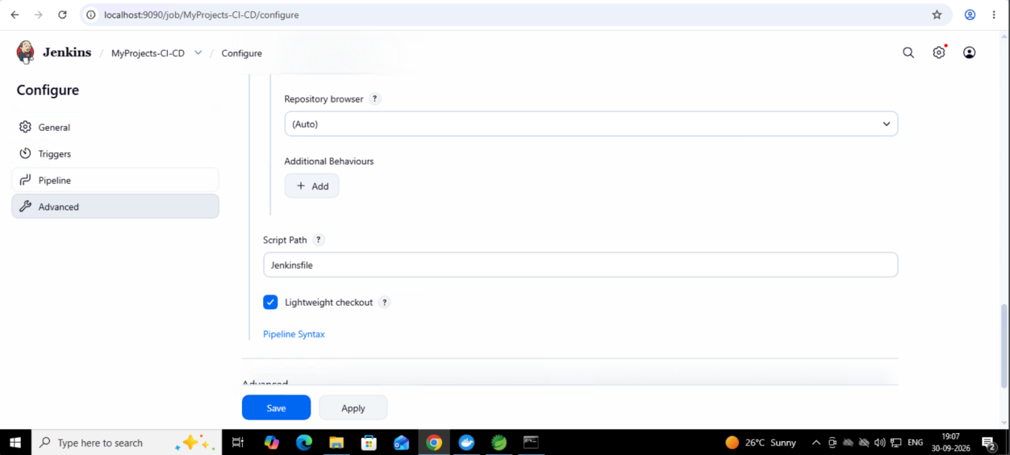
Figure 6: Script Path set to Jenkinsfile

6. Running the Pipeline
Select Build Now on the left side of the Jenkins project page. Jenkins then runs the entire pipeline using the configuration provided. It fetches the Docker and Kubernetes information, builds the project, and deploys it automatically, so no manual deployment is needed.
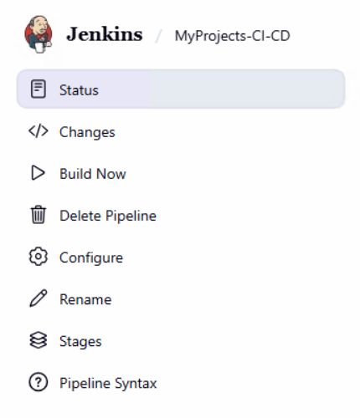
Figure 7: Build Now option in Jenkins

7. Finding the Deployed Application
Once the build and all of its steps succeed, the application is deployed. To find where it is running, you can use either of two methods:
- Console Output – open the build and select Console Output.
- Command prompt – open a local command prompt and run:
kubectl get services
This shows each service and the port it is running on. In this project, the application runs on port 30080, so opening http://localhost:30080 in any browser, followed by an API path, displays the result.
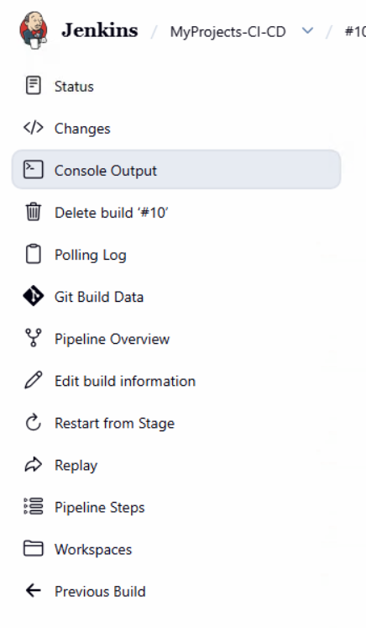
Figure 8: Console Output in the build menu
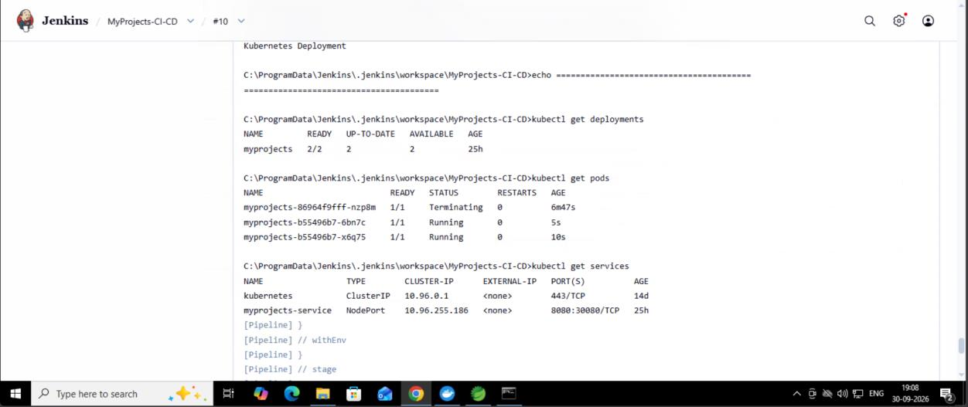
Figure 9: kubectl output in the console log

8. Testing the APIs
The application exposes two APIs. Their output is shown below.
- /hello – displays “Hello World!”.
- /greet/{name} – displays a personalized greeting, for example, /greet/kruthik.
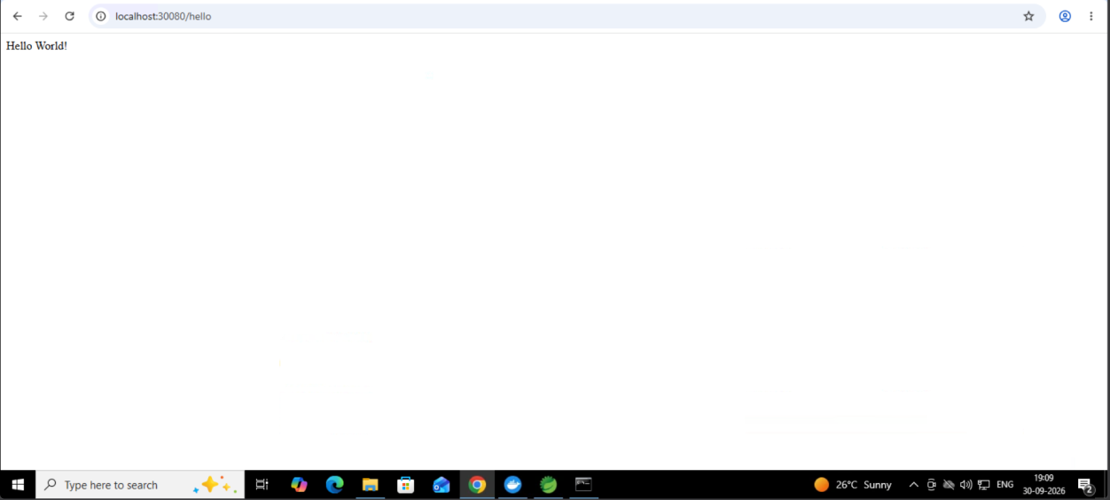
Figure 10: Output of localhost:30080/hello
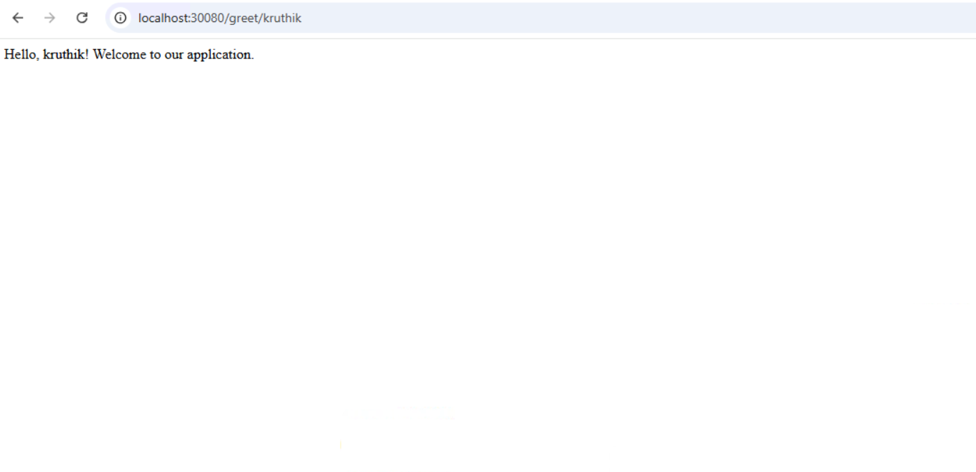
Figure 11: Output of localhost:30080/greet/kruthik

9. Automating Builds with SCM Polling
So far, Jenkins only builds and deploys the project when a build is started manually. To rebuild automatically whenever the project changes, go to Configure → Triggers, enable Poll SCM, and enter the following schedule:
H/5 * * * *
With this schedule, Jenkins checks GitHub every 5 minutes and rebuilds the project whenever it finds changes.
Note: This approach is not very efficient. Each build creates a new Docker image, so many images can accumulate over time. It is, however, one simple way to automate Jenkins.
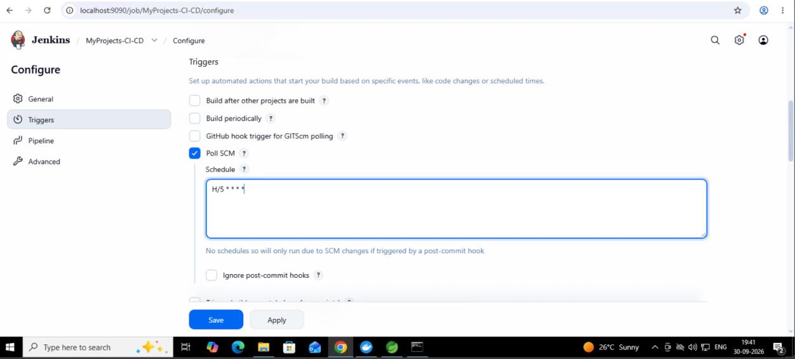
Figure 12: Poll SCM trigger configuration

