Face Recognition using Eigenfaces

Abstract
This paper presents a face recognition system using Eigenfaces and Principal Component Analysis. High-dimensional face images are converted into vectors, reduced into a lower-dimensional subspace, and classified using Euclidean distance.

Introduction
Face recognition is a key application of computer vision. This work applies linear algebra concepts such as matrices, eigenvalues, eigenvectors, basis and orthogonal projection.

Section 1: Imports and Setup

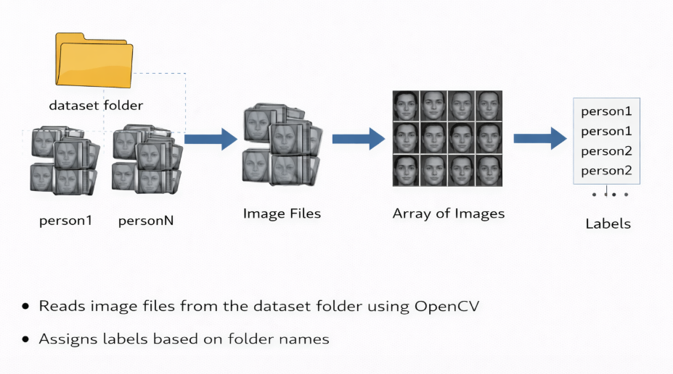

Section 2: Preprocessing Image

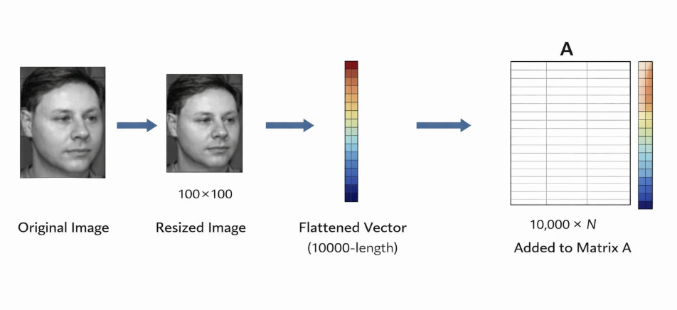

Section 3: Mean Computation
[]
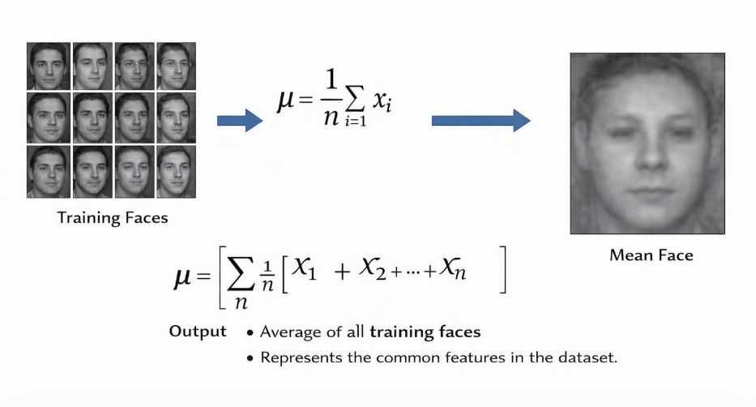

Section 4: Normalization of Data

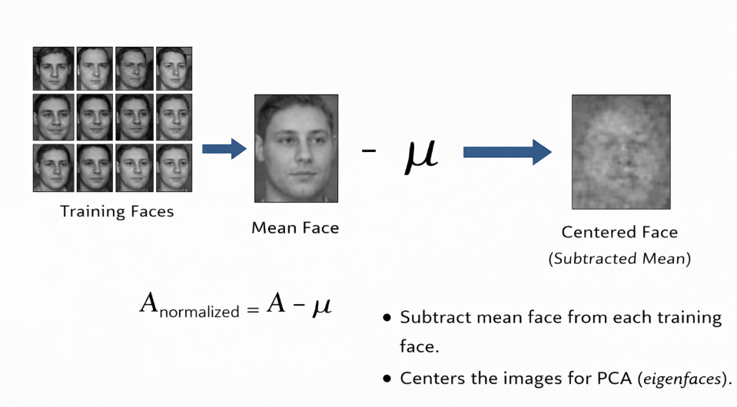

Section 5 : Eigenfaces Computation
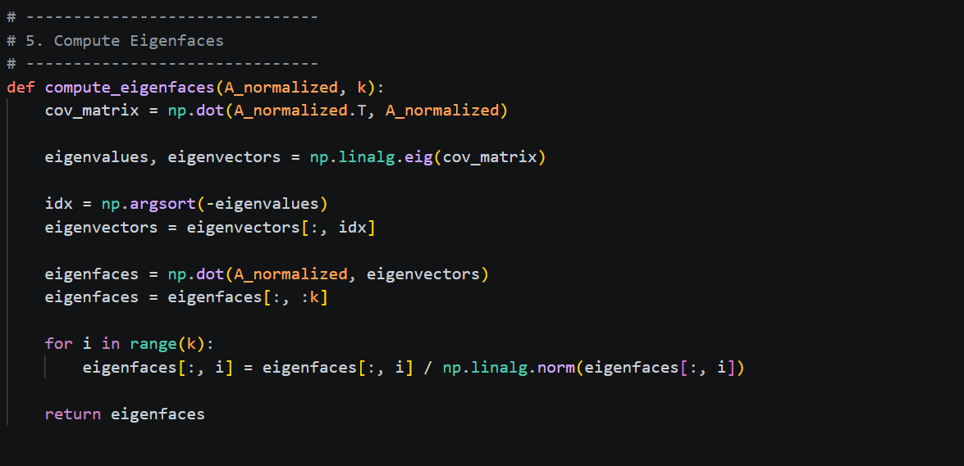

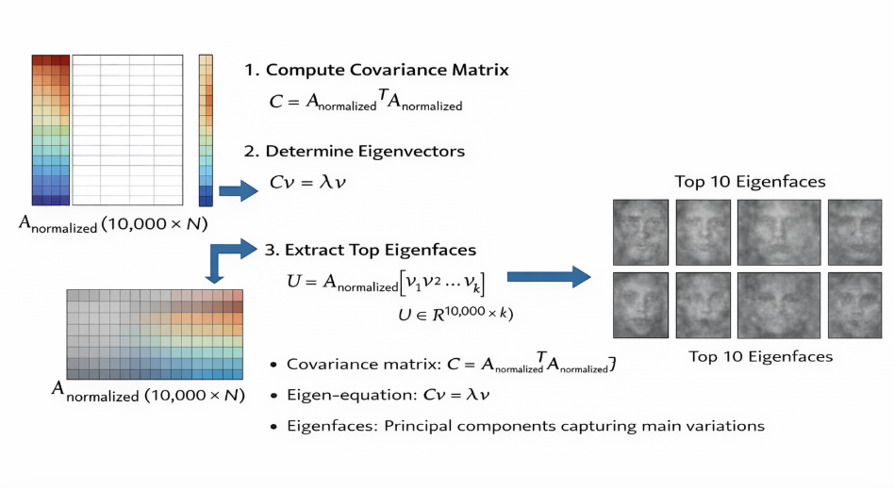

Section 6: Projection of faces

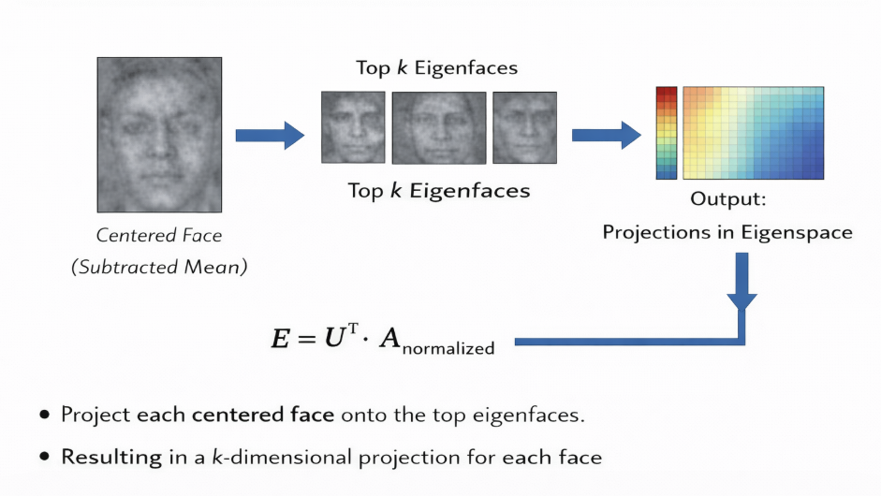

Section 7: Face recognition
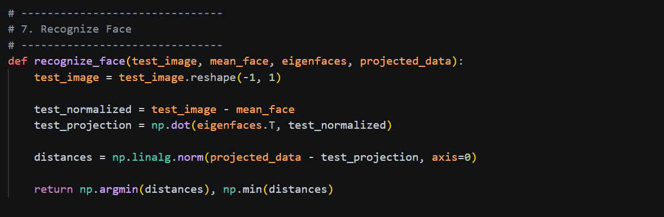
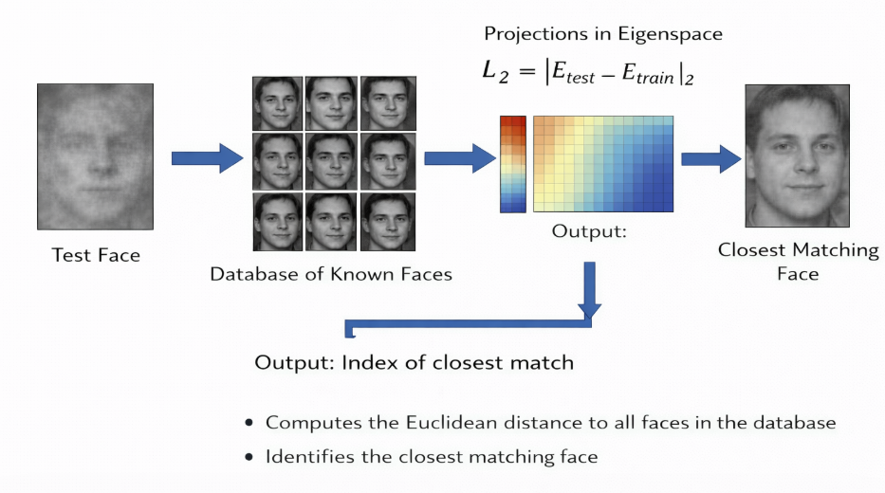

Section 8: Main function
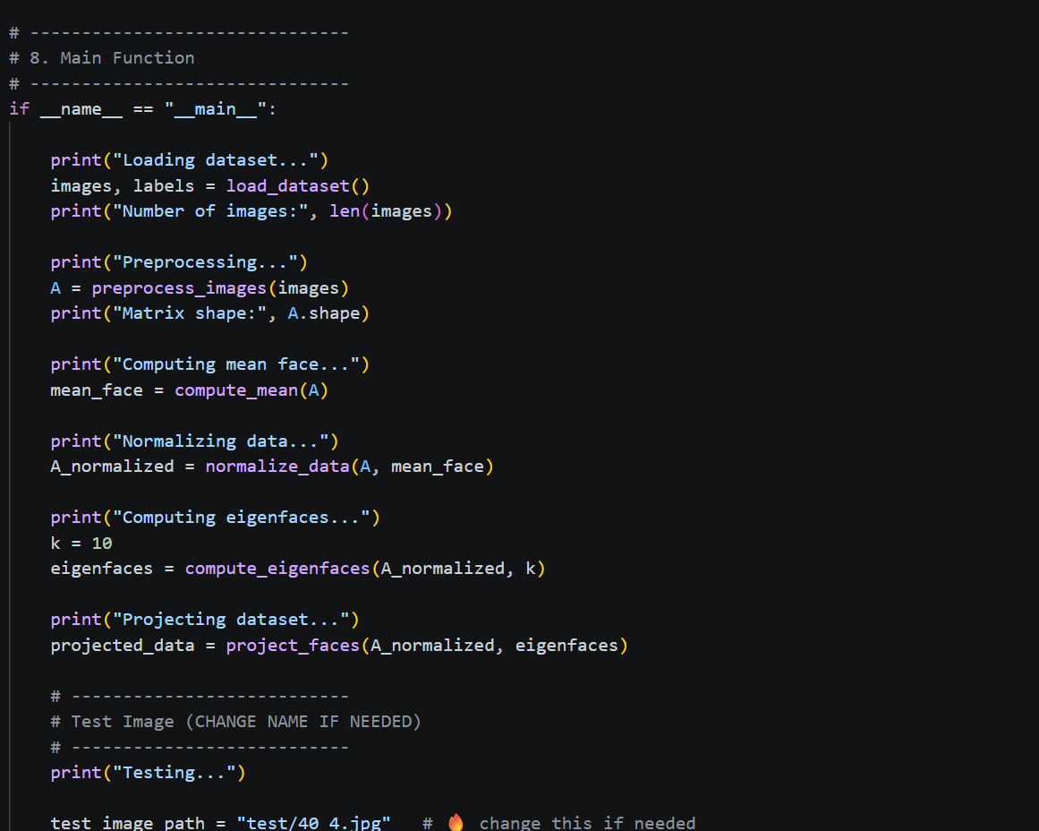
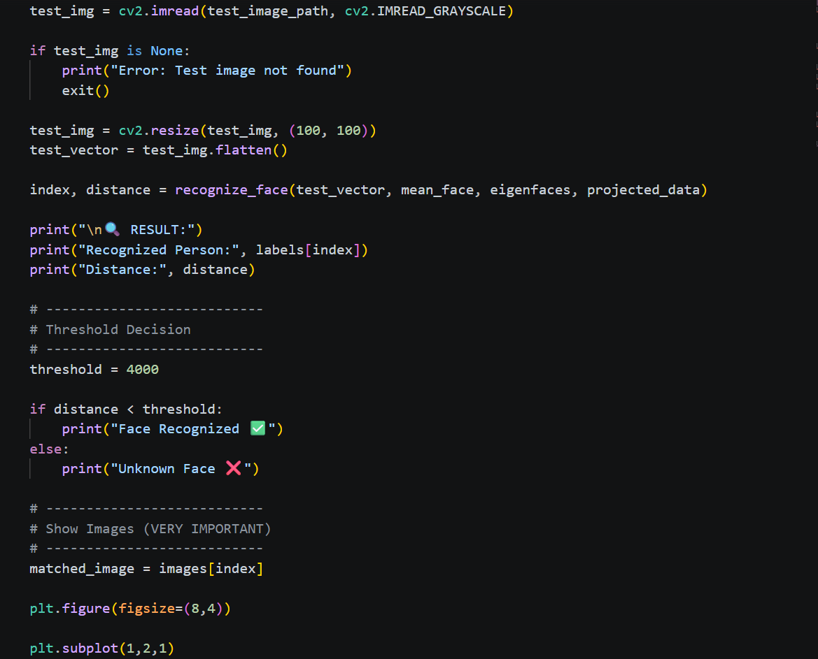


Experimental Result
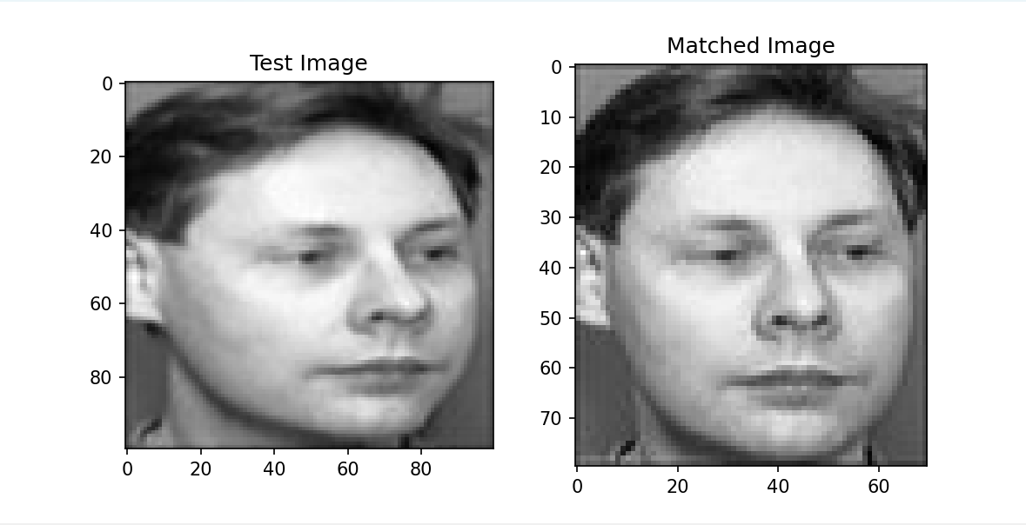
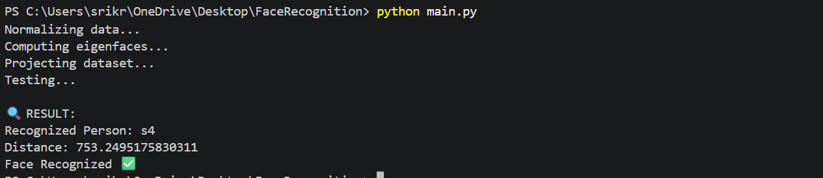

Conclusion
This project successfully demonstrates the practical use of Linear Algebra in face recognition. By using Eigenfaces, the system reduces image dimensions and identifies faces efficiently. It shows how matrices, eigenvalues, eigenvectors, and projection can solve real-world problems.

