Traffic Monitoring and Statistics Collector using SDN Mininet & POX Controller
Name: Vankadara Sri Kruthi
SRN: PES2UG24CS574
Subject: Computer Networks
Institution: PES University

1. Introduction
Software Defined Networking (SDN) separates the control plane from the data plane, allowing centralized management of network devices. In this project, Mininet was used to emulate a network and the POX controller was used to implement custom traffic monitoring logic.

2. Objective
To design and implement a custom SDN controller module that periodically collects and displays network traffic statistics such as packet counts and byte counts from OpenFlow switches.

3. Tools Used
• Ubuntu Linux (VirtualBox)
• Mininet
• POX Controller
• Python
• OpenFlow Protocol

4. Implementation
• A custom controller module named custom_controller.py was created inside the POX framework.
• The controller listens for switch ConnectionUp events.
• PacketIn events are handled to process incoming packets.
• Flood-based forwarding is used for connectivity.
• Flow rules are installed for future packets.
• Every 5 seconds, the controller requests flow statistics from the switch.

5. Code Logic Summary
1. Imports required POX libraries.
2. Creates a SimpleSwitch class.
3. Starts a recurring timer for statistics requests.
4. Handles PacketIn messages and forwards packets.
5. Receives flow statistics and prints packet/byte counters.
CODE:
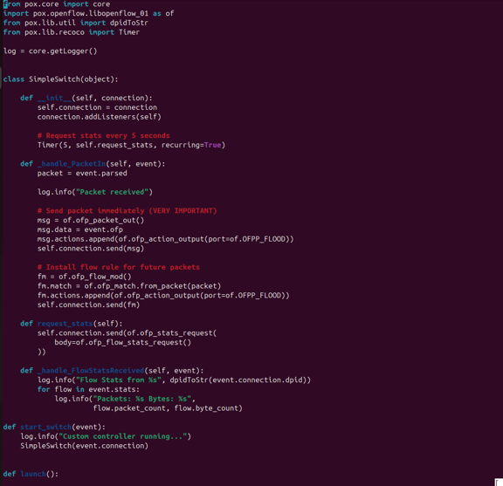

6. Experimental Results
• POX controller started successfully.
• OpenFlow switch connected to controller.
• Mininet topology with 3 hosts and 1 switch was created.
• pingall test showed 0% packet loss.
• Controller logs displayed repeated Packet received messages.
• Flow statistics displayed packet counts and byte counts.
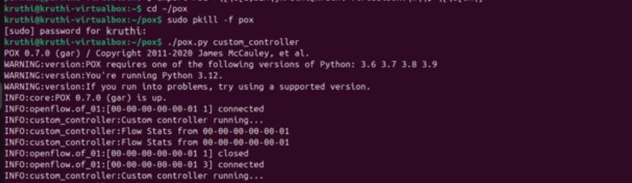
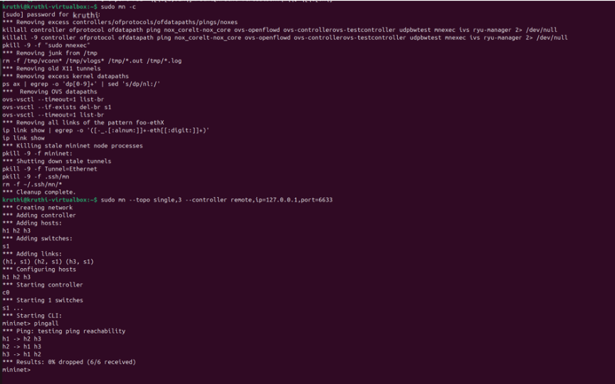
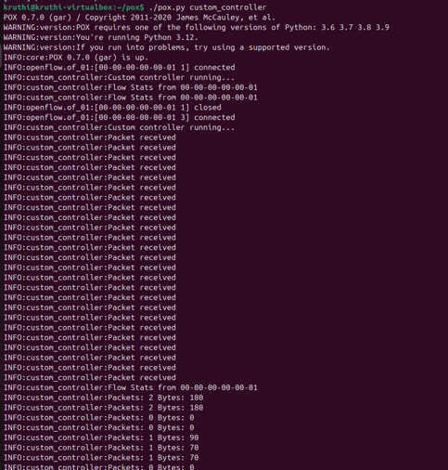

7. Analysis
The successful ping test confirms end-to-end host connectivity. PacketIn messages indicate controller-switch interaction during forwarding decisions. Periodic statistics requests demonstrate monitoring functionality. Displayed packet and byte counters verify traffic measurement capability.

8. Conclusion
This project successfully implemented a Traffic Monitoring and Statistics Collector using SDN principles. Using Mininet and the POX controller, the network behavior was observed and traffic statistics were collected in real time.

