Software Architecture and Design Specification
Project: Event Management System
SRN | Name
PES2UG24CS589 | Vineet Toshniwal
PES2UG24CS915 | Divyanshu Jha
PES2UG24CS585 | Vikhyat Agrawal
PES2UG24CS574 | Kruthi Vankadara

Version | Date | Status
1.0 | 14-09-2026 | Draft

Revision History
Version | Date | Author | Change Summary | Approval Status
1.0 | 14-09-2026 | Vineet Toshniwal | Initial SAD from Event Management System SRS | Pending
1.0 | 14-09-2026 | Divyanshu Jha | Initial SAD from Event Management System SRS | Pending
1.0 | 14-09-2026 | Vikhyat Agrawal | Initial SAD from Event Management System SRS | Pending
1.0 | 14-09-2026 | Kruthi Vankadara | Initial SAD from Event Management System SRS | Pending

Approvals
Role | Name | Signature / Email | Date
Course Coordinator | <Name> | <Signature / Email> | <Date>
Project Guide | <Name> | <Signature / Email> | <Date>

Table of Contents
1. Introduction
2. Document Overview
3. Architecture
4. Design
5. Appendices

1. Introduction

1.1 Purpose
This document specifies the proposed architecture and design of the Event Management System (EMS), translating the SRS into modules, interfaces, interaction flows, security controls, data responsibilities, and traceability.

1.2 Scope
The design covers event creation/scheduling, venue and capacity management, users and roles, event discovery, registration, payment-status recording, ticket/QR generation and validation, notifications, attendance, feedback, reporting, audit logging, and administration. Internal implementation of external payment, email/SMS, and third-party authentication providers is outside scope.

1.3 Audience
Developers, QA engineers, project guides, administrators, organizers, event staff, attendees, security reviewers, and assessment evaluators.

1.4 Definitions

• EMS – Event Management System.
• Admin – system administrator.
• Organizer – person responsible for creating and managing an event.
• Attendee – registered participant.
• Event Staff – user who validates tickets/QR codes and records attendance.
• Venue – physical or virtual event location.
• OTP – One-Time Password.
• QR – Quick Response code.
• RBAC – Role-Based Access Control.
• TLS – Transport Layer Security.

2. Document Overview

2.1 How to Use This Document
Section 3 defines the architecture and rationale. Section 4 defines module-level design, project-specific sequence flows, APIs, error handling, UX, and next steps. Section 5 provides ADRs, threat model, logical data model, glossary, references, tools, and traceability.

2.2 Related Documents
• Software Requirements Specification (SRS) – Event Management System.
• Software Test Plan (STP), when prepared.
• Requirements Traceability Matrix (RTM) from the SRS.

3. Architecture

3.1 Goals & Constraints
Area | Goal / Constraint
Security | Protect personal/payment-related information; HTTPS/TLS 1.2+; RBAC; secure logging.
Performance | 95% of normal requests respond within 3 seconds under expected load.
Reliability | At least 99.5% monthly availability excluding scheduled maintenance.
Scalability | At least 500 concurrent users without critical failure in defined deployment.
Consistency | Keep event, registration, payment-status and attendance records consistent.
Usability | Responsive desktop/mobile browser UI with clear validation and error messages.
Integration | External payment/notification services may be unavailable and must be handled gracefully.
Maintainability | Separate presentation, application, persistence, integration, security, and monitoring concerns.

3.2 Stakeholders & Concerns
Stakeholder | Concerns
Attendee | Discovery, registration, payment status, ticket, check-in, feedback, privacy.
Organizer | Event lifecycle, venue/capacity, participant lists, attendance, notifications, reports.
Event Staff | Fast and reliable ticket/QR validation and attendance recording.
Admin | Users, categories, venues, configuration, reports, audit, monitoring.
Developers / QA | Modularity, testability, traceability, stable interfaces.
Security Reviewers | Confidentiality, integrity, authorization, secure transport, safe logs.

3.3 Component (UML) Diagram
The proposed architecture is a layered web application with modular domain services. External systems are isolated behind adapters.
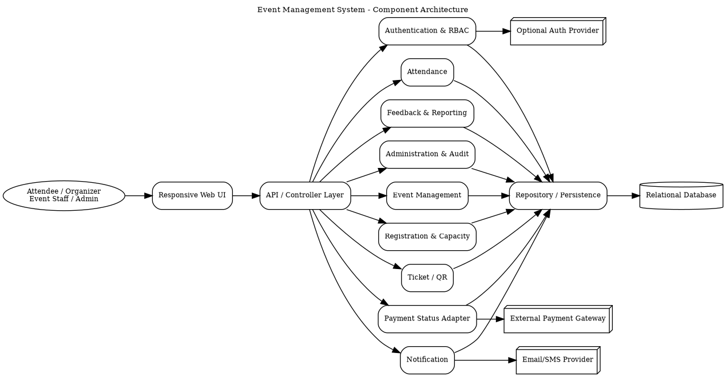

3.4 Component Descriptions
Component | Responsibility
Responsive Web UI | Role-specific dashboards, event pages, forms, ticket display and QR scanning support.
API / Controller Layer | Authenticated API boundary, request validation, authorization handoff and response mapping.
Authentication & RBAC | Registration, login, role checks, session expiry and authorization.
Event Management | Create/edit/publish/postpone/cancel events; schedules, venues, categories and capacity.
Registration & Capacity | Eligibility, availability, registration records and atomic capacity enforcement.
Payment Status Adapter | Records payment state and isolates external gateway behavior.
Ticket / QR | Creates unique digital tickets/QR passes for confirmed registrations.
Attendance | Validates passes and records check-in/check-out state.
Notification | Registration, reminder, update and cancellation notifications.
Feedback & Reporting | Feedback/ratings plus event, registration, attendance, payment and performance reports.
Administration & Audit | Users, venues, categories, system configuration and audit records.
Repository / Database | Transactional persistence for all core EMS data.

3.5 Chosen Architecture Pattern and Rationale
A layered architecture with modular domain services is chosen. It matches the SRS's web UI, server-side application and relational database structure while separating responsibilities. A full microservices deployment is not required by the SRS or its 500-user target, so the design avoids unnecessary operational complexity while keeping module boundaries clear enough for future extraction if justified by load.

3.6 Technology Stack & Data Stores
The SRS specifies technology categories rather than particular products. Therefore, the design does not invent a programming language, framework, database vendor, or cloud provider.
Layer | Technology Category | Design Note
Client | Responsive web application | Modern desktop and mobile browser support.
Application | Server-side API application | Modular business services behind an API boundary.
Persistence | Relational DBMS | Transactions for capacity, registration, payment status and attendance.
Integrations | Payment API; Email/SMS/Notification API; optional authentication API | Provider-specific code isolated behind adapters.
Transport | HTTPS with TLS 1.2+ | Mandatory security requirement.
Operations | Application + audit logging and monitoring | Track security/admin/registration/payment/attendance events and service health.

3.7 Risks & Mitigations
Risk | Mitigation
Payment provider unavailable | Record explicit payment states; do not confirm paid registration on failed payment; allow safe retry/reconciliation.
Notification provider unavailable | Keep event/registration state independent of notification delivery; retry/queue where supported.
Concurrent registrations exceed capacity | Atomic database transaction for availability check and capacity update.
Unauthorized privileged action | RBAC and server-side authorization checks on protected operations.
Sensitive information in logs | Never log passwords, tokens or unnecessary secrets; audit-log review.
Network interruption | Transactional writes, safe errors, and idempotent/retry-aware operations where appropriate.
High load | Load test at 500 concurrent users; monitor latency/errors and scale the application tier if needed.

3.8 Traceability to Requirements
Requirement Group | Architecture Element
F-001/F-002 | Authentication & RBAC + API Layer
F-003/F-004/F-016 | Event Management + Administration
F-005/F-006 | Web UI + Event Management
F-007/F-008 | Registration & Capacity
F-009 | Payment Status Adapter + Registration
F-010/F-011 | Ticket/QR + Attendance
F-012 | Notification Service
F-013/F-015 | Administration + Reporting
F-014 | Feedback Service
F-017/NF-006 | Audit Service
NF-001/NF-004 | API/Application + Deployment
NF-002 | Operations/Deployment
NF-003/SR-001..SR-006 | Security Architecture

3.9 Security Architecture
Threat / Objective | Control
Spoofing | Strong salted password hashes, authenticated sessions, session expiry.
Tampering | TLS, server-side input validation, transactions and authorization.
Information Disclosure | TLS, least-privilege access, no payment-card credential storage, secret-free logs.
Denial of Service | Rate limiting/throttling, input limits, monitoring and graceful integration failure.
Elevation of Privilege | RBAC for Admin, Organizer, Attendee and Event Staff.
Repudiation / Accountability | Timestamped audit records with actor/source and action details.

4. Design

4.1 Design Overview
Each request enters through the API boundary, passes authentication/authorization checks, is handled by the relevant application module, and persists changes through the repository layer. External payment, notification, and optional authentication systems are accessed through adapters.
Module | Primary Responsibilities | Key Data
Auth | Registration, login/logout, role checks, session expiry | User, Role, Session
Event | Event lifecycle, schedule, venue, category, capacity | Event, Venue, Category
Registration | Register, eligibility, capacity enforcement | Registration
Payment | Payment state and provider interaction | PaymentStatus, Reference
Ticket | Unique digital ticket/QR generation | Ticket
Attendance | QR/ticket validation and attendance state | Attendance
Notification | Notification creation/delivery tracking | Notification
Feedback | Post-event feedback and ratings | Feedback
Reporting | Event/registration/attendance/payment/performance reports | Aggregated data
Admin & Audit | Management configuration and audit records | AuditLog, Configuration

4.2 UML Sequence Diagrams

4.2.1 Event Registration and Ticket Generation
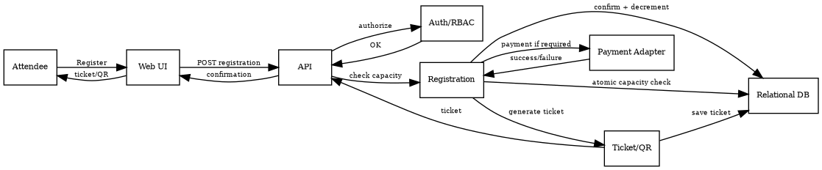
Flow: attendee registers → API authenticates/authorizes → capacity is checked atomically → payment is processed/recorded when required → registration is confirmed → ticket/QR is generated → confirmation is returned.

4.2.2 QR Ticket Validation and Check-in
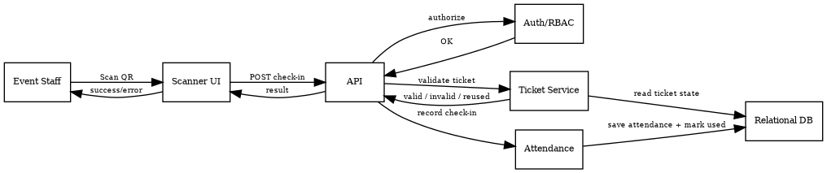
Flow: event staff scans QR → API authorizes staff → ticket service checks validity and reuse state → attendance service records check-in and marks the pass used → result is shown to staff.

4.3 API Design
The following REST-style interfaces are proposed from the SRS requirements. Exact endpoint names and payload schemas can be finalized during implementation.
Component | Endpoint | Method | Request | Response | Typical Errors
Auth | /api/auth/register | POST | {name,email,password,role} | {userId,status} | 400, 409
Auth | /api/auth/login | POST | {email,password} | {session/token,role} | 401
Event | /api/events | POST | {title,description,date,time,venueId,capacity,categoryId,registrationDetails} | {eventId,status} | 400, 403
Event | /api/events/{id} | PATCH | {changed fields/status} | {eventId,status} | 403, 404
Registration | /api/events/{id}/registrations | POST | {attendeeId,paymentInfo/status} | {registrationId,status} | 409, payment failure
Ticket | /api/registrations/{id}/ticket | GET | None | {ticketId,qrPayload,status} | 403, 404
Attendance | /api/attendance/check-in | POST | {ticketId or qrPayload} | {attendanceId,status} | 403, 409
Reports | /api/reports/events | GET | event/date range/type | report data | 400, 403

4.3.1 API Design Rules
• Use HTTPS with TLS 1.2 or higher.
• Validate and sanitize all server-side input.
• Use standardized safe error responses; do not expose stack traces or secrets.
• Enforce RBAC at protected API/service boundaries.
• Use transactions for capacity-sensitive registration and attendance updates.
• Use retry-safe or idempotent behavior for operations that may be repeated after network failures.

4.4 Error Handling, Logging & Monitoring
Concern | Design
Validation | Field-level validation and safe rejection of malformed/malicious input.
Authentication | Generic invalid-credential response without account enumeration.
Authorization | Deny unauthorized access and create an appropriate security/audit event.
Capacity | Atomic rejection when no seats remain; event marked full at zero availability.
Payment | Confirm paid registration only after successful payment state.
Notification failure | Do not roll back successful business transactions solely because notification delivery fails.
Database failure | Rollback transaction and return safe server error.
Logging | Timestamp security, administrative, registration, payment-status and attendance events without passwords/secrets.
Monitoring | Response latency, error rate, registration/payment failures, check-in failures, availability, and integration failures.

4.5 UX Design
• Role-specific dashboards for all four roles.
• Event pages show title, description, date, time, venue, capacity, registration status and fee.
• Registration clearly distinguishes free and paid flows.
• Successful registration provides immediate ticket/QR retrieval.
• Staff scanning gives a fast, clear success/error state for valid, invalid, or reused passes.
• Forms show clear validation and confirmation messages.
• Responsive desktop/mobile browser support.
• Camera-based QR scanning may be used on smartphone or computer as specified in the SRS.

4.6 Open Issues & Next Steps
• Finalize implementation language/framework, database product and deployment platform because the SRS does not prescribe them.
• Finalize payment, notification and optional authentication provider contracts.
• Define exact session/token mechanism and inactivity timeout.
• Define notification retry/queue behavior.
• Complete load testing for 500 concurrent users and tune deployment based on measured results.
• Produce final UML diagrams in PlantUML/draw.io and validate against implementation.
• Prepare OpenAPI documentation, deployment runbook, security test plan and operational dashboards.

5. Appendices

5.1 Design Decision Records (ADRs)
ADR | Decision | Rationale | Status
ADR-001 | Layered modular architecture | Matches web/server/database structure and separates concerns. | Accepted
ADR-002 | External systems behind adapters | Payment, notification and optional authentication are external dependencies. | Accepted
ADR-003 | Relational persistence with transactions | Preserves consistency across capacity, registration, payment status and attendance. | Accepted
ADR-004 | RBAC at API/service boundaries | Required for Admin, Organizer, Attendee and Event Staff. | Accepted
ADR-005 | Technology-neutral core design | SRS does not specify exact language/framework/database/cloud vendor. | Accepted

5.2 Threat Model Summary
STRIDE | EMS Threat | Primary Mitigation
Spoofing | Stolen/guessed credentials | Password hashing, authentication, session expiry.
Tampering | Unauthorized event/registration changes | TLS, validation, RBAC, transactions.
Repudiation | Disputed administrative action | Timestamped audit log with actor/action.
Information Disclosure | Exposure of personal/payment-related data | TLS, least privilege, no card credential storage, safe logs.
Denial of Service | Excessive requests degrade service | Rate limiting, validation, monitoring, load testing.
Elevation of Privilege | Attendee accesses organizer/admin operation | RBAC and authorization checks.

5.3 Data Model Overview
Entity | Purpose | Relationships
User | Account identity and authentication metadata | Has Role; may organize/attend events.
Role | Admin, Organizer, Attendee, Event Staff permissions | Assigned to User.
Event | Event details, schedule, venue, category, capacity, status | Belongs to Organizer; has Registrations.
Venue | Physical/virtual venue details | Referenced by Event.
Category | Event classification | Referenced by Event.
Registration | Attendee participation and registration status | Links User and Event; may have Payment/Ticket.
PaymentStatus | Payment state/reference | Linked to Registration.
Ticket | Unique digital ticket/QR pass | Linked to confirmed Registration.
Attendance | Check-in/check-out state | Linked to Ticket/Registration.
Notification | Notification event and delivery status | Linked to User and relevant event/registration.
Feedback | Post-event rating/feedback | Links Attendee and Event.
AuditLog | Accountability record | Actor, timestamp, action/source.
SystemConfiguration | Admin-managed configurable settings | Managed by Admin.

5.4 Requirements Traceability Matrix (SAD)
Req ID | Short Requirement | Module | Design Spec | Test Ref
EMS-F-001 | User registration | Auth | DS-Auth-01 | TC-REG-01
EMS-F-002 | Authentication | Auth/RBAC | DS-Auth-02 | TC-AUTH-01
EMS-F-003 | Create event | Event | DS-Event-01 | TC-EVT-01
EMS-F-004 | Edit/publish/postpone/cancel | Event | DS-Event-02 | TC-EVT-02
EMS-F-005 | Search/filter | Web UI/Event | DS-Event-03 | TC-SEARCH-01
EMS-F-006 | Event details | Web UI/Event | DS-Event-04 | TC-EVT-03
EMS-F-007 | Registration | Registration | DS-Reg-01 | TC-REG-02
EMS-F-008 | Capacity enforcement | Registration | DS-Reg-02 | TC-REG-03
EMS-F-009 | Payment status | Payment | DS-Pay-01 | TC-PAY-01
EMS-F-010 | Ticket/QR | Ticket | DS-Ticket-01 | TC-TKT-01
EMS-F-011 | Attendance check-in | Attendance | DS-Attendance-01 | TC-CHK-01
EMS-F-012 | Notifications | Notification | DS-Notif-01 | TC-NOTIF-01
EMS-F-013 | Attendee lists | Admin/Organizer | DS-List-01 | TC-LIST-01
EMS-F-014 | Feedback | Feedback | DS-Feedback-01 | TC-FB-01
EMS-F-015 | Reports | Reporting | DS-Report-01 | TC-REP-01
EMS-F-016 | Admin management | Admin | DS-Admin-01 | TC-ADMIN-01
EMS-F-017 | Audit record | Audit | DS-Audit-01 | TC-AUD-01
EMS-NF-001 | Response time | API/Application | DS-Perf-01 | TC-PERF-01
EMS-NF-002 | 99.5% availability | Operations | DS-Rel-01 | TC-REL-01
EMS-NF-003 | Data protection | Security | DS-Sec-01 | TC-SEC-01
EMS-NF-004 | 500 concurrent users | Application/Deployment | DS-Scale-01 | TC-SCALE-01
EMS-NF-005 | Browser usability | Web UI | DS-UX-01 | TC-UX-01
EMS-NF-006 | Timestamped logs | Audit/Operations | DS-Ops-01 | TC-OPS-01
EMS-SR-001 | TLS 1.2+ | Network/API | DS-Sec-02 | TC-SEC-01
EMS-SR-002 | Salted password hashes | Auth | DS-Sec-03 | TC-SEC-02
EMS-SR-003 | RBAC | Authorization | DS-Sec-04 | TC-SEC-03
EMS-SR-004 | Input validation | API | DS-Sec-05 | TC-SEC-04
EMS-SR-005 | Session expiry/logout | Auth | DS-Sec-06 | TC-SEC-05
EMS-SR-006 | Secure audit logging | Audit | DS-Sec-07 | TC-SEC-06

5.5 Glossary
• API – Application Programming Interface.
• EMS – Event Management System.
• HTTPS – HTTP secured using TLS.
• QR – Quick Response code.
• RBAC – Role-Based Access Control.
• SAD – Software Architecture and Design Specification.
• SRS – Software Requirements Specification.
• ADR – Architecture Decision Record.
• RTM – Requirements Traceability Matrix.

5.6 References
• Event Management System SRS supplied for this project.
• Supplied Software Architecture and Design Specification template.
• IEEE 42010, OWASP, and NIST SP 800-160 as referenced by the supplied SAD template.

5.7 Tools
• PlantUML – UML diagrams.
• draw.io – architecture/UML refinement.
• Swagger/OpenAPI – API documentation.
• Microsoft Word / compatible editor – document maintenance.

