|  |  |
| --- | --- |
| **Ex. No: 6** | **Web Server Creation using NodeJS** |
| **2.10.2023** |

**Aim:**

To create a Web Server offering basic web service(s) to the front-end.

**Program:**

Server.js

const http = require('http');

const fs = require('fs');

const path = require('path');

const server = http.createServer((req, res) => {

console.log(`[${new Date().toISOString()}] ${req.method} ${req.url}`);

const publicPath = path.join(__dirname, 'public');

const filePath = path.join(publicPath, req.url === '/' ? 'index.html' : req.url.slice(1));

fs.readFile(filePath, (err, data) => {

if (err) {

res.writeHead(404, {'Content-Type': 'text/plain'});

res.end('404 Not Found');

} else {

const ext = path.extname(filePath).toLowerCase();

const contentType = {

'.html': 'text/html',

'.css': 'text/css',

'.js': 'text/javascript',

'.jpg': 'image/jpeg',

'.png': 'image/png',

'.gif': 'image/gif',

}[ext] || 'application/octet-stream';

res.writeHead(200, {'Content-Type': contentType});

res.end(data);

}

});

});

const port = process.env.PORT || 3000;

server.listen(port, () => {

console.log(`Server running at http://localhost:${port}/`);

});

Index.html

<!DOCTYPE html>

<html lang="en">

<head>

<meta charset="UTF-8">

<meta name="viewport" content="width=device-width, initial-scale=1.0">

<title>Home</title>

<link rel="stylesheet" href="style.css">

</head>

<body>

<h1>Welcome to the Home Page</h1>

<p>This is the home page of our website.</p>

<img src="example.jpg" alt="Example Image">

<script src="script.js"></script>

</body>

</html>

About.html

<!DOCTYPE html>

<html lang="en">

<head>

<meta charset="UTF-8">

<meta name="viewport" content="width=device-width, initial-scale=1.0">

<title>About</title>

<link rel="stylesheet" href="style.css">

</head>

<body>

<h1>About Us</h1>

<p>This is the about page of our website.</p>

<img src="example.jpg" alt="Example Image">

<script src="script.js"></script>

</body>

</html>

**Output:**

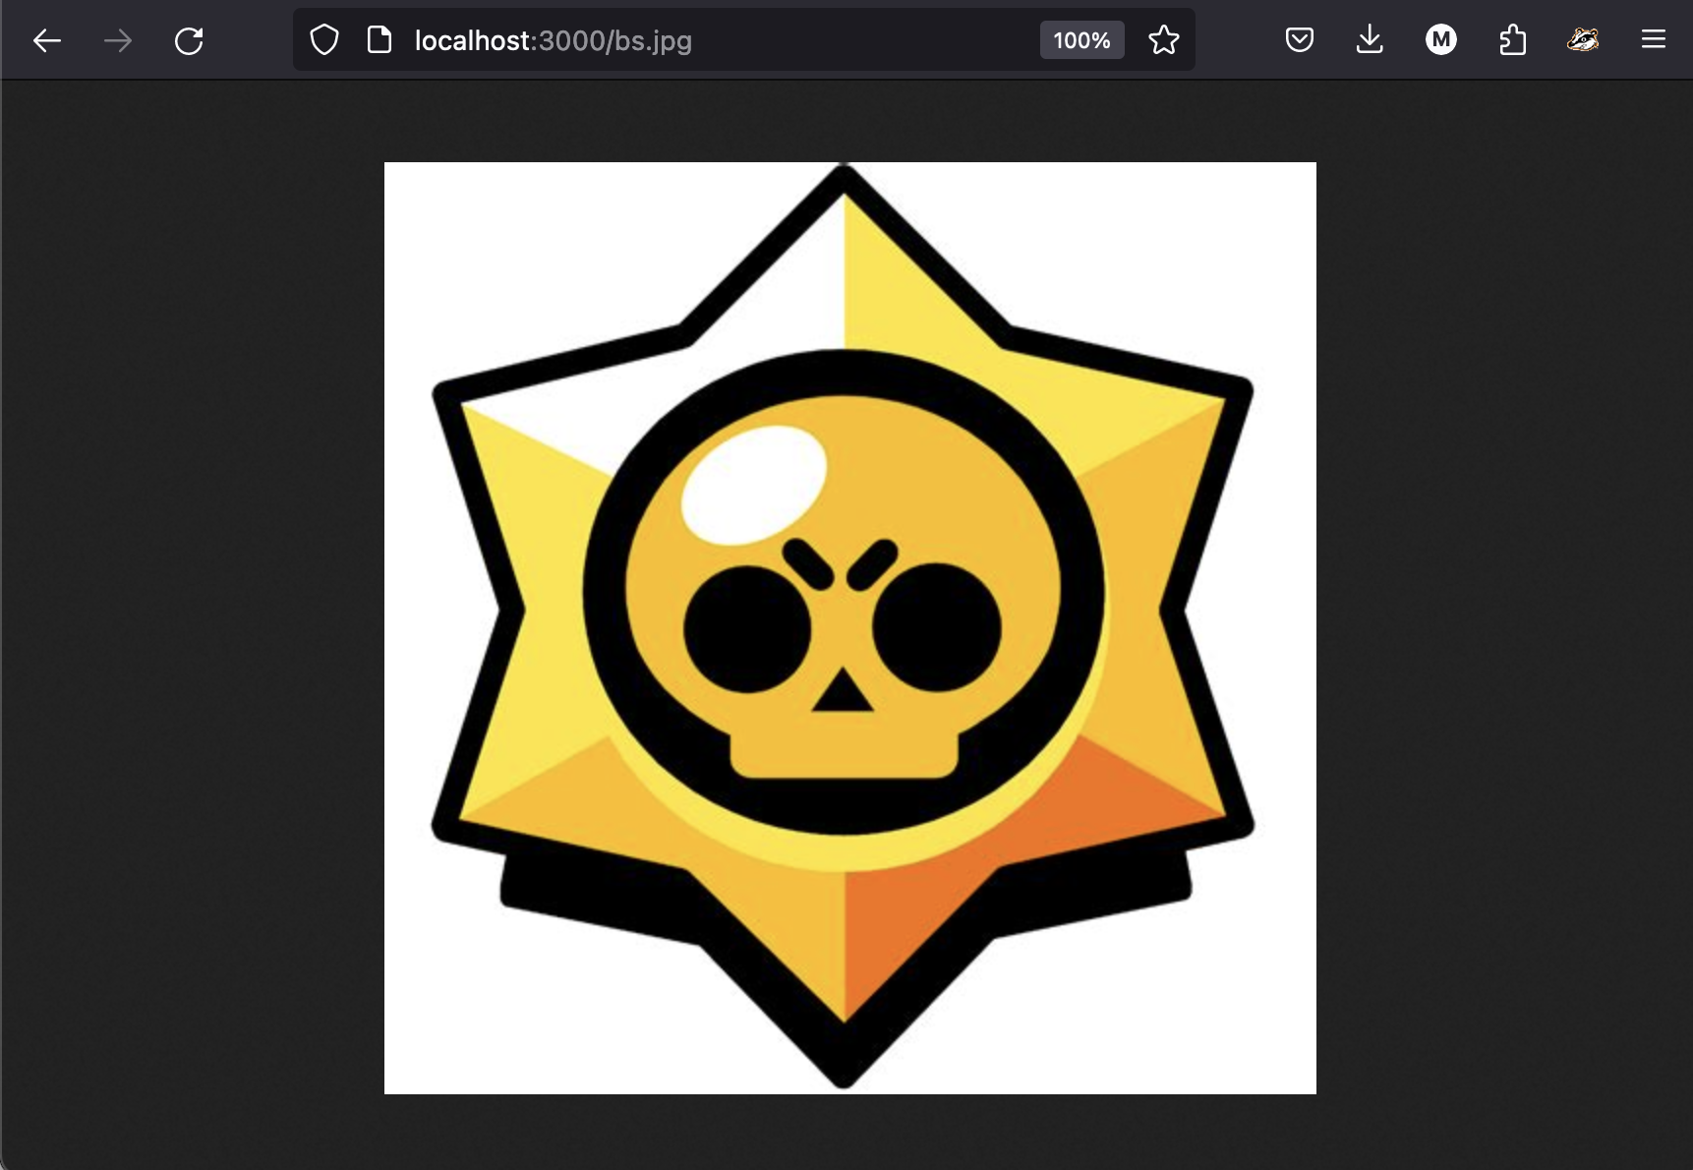

**Result:**

Successfully created a Web Server offering basic web service(s) to the front-end.