In this project student asking to recognize word uttering in audio file and you can use only those files which are given with this project dataset and we need to pass specific input size audio files. Now in this project after uploading test audio then application will recognize person name and then recognize what person is saying and display in text box

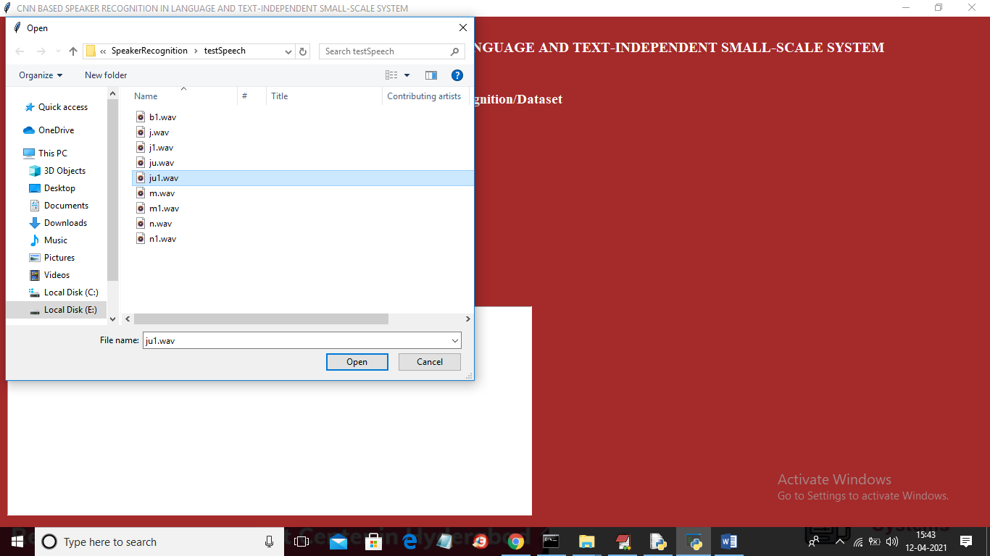

In above screen selecting and uploading ju1.wav file and then click on ‘Open’ button to get below output

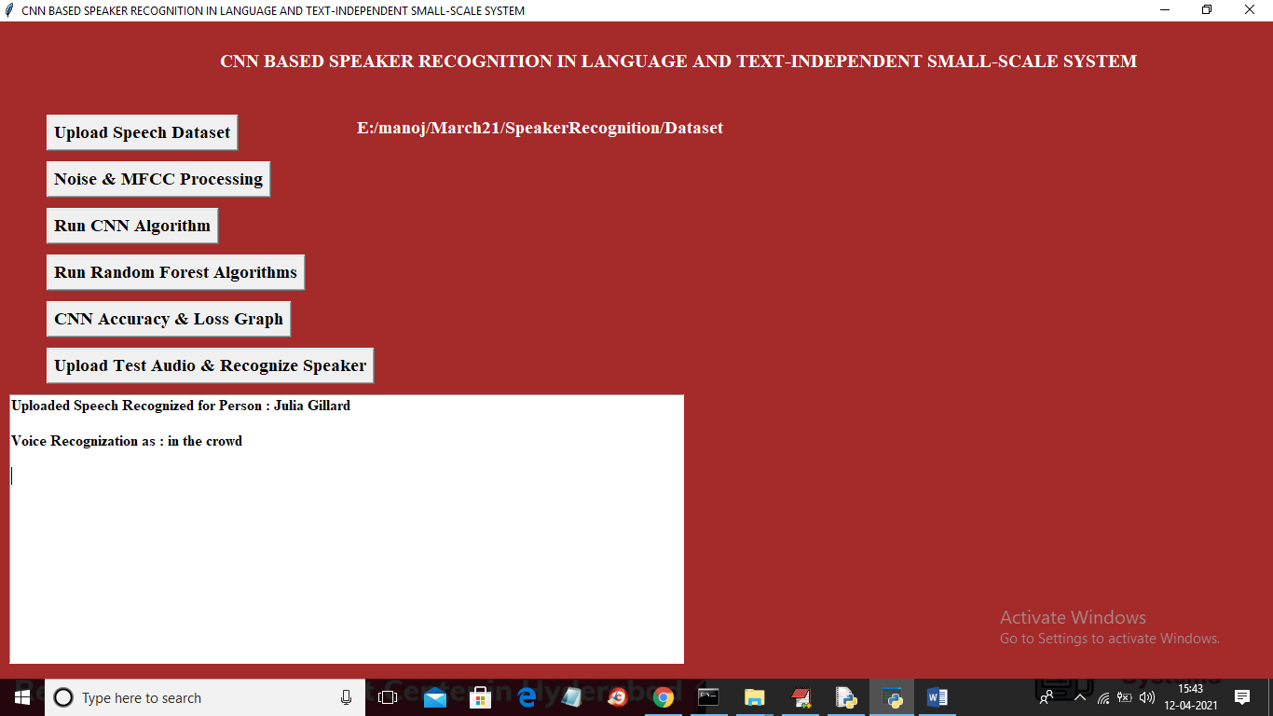

In the above screen we can see application has identified name of speaker and then it identified word in the audio file as ‘in the crowd’. In this application you can upload other audio files and test