Hybrid Information Mixing Module for Stock Movement Prediction

Machine and deep learning algorithms are working vigorously towards stock price prediction as this accurate prediction will save investor from losing his money. All this algorithms were using only stock prices to train models and these prices alone are not sufficient for accurate prediction. To overcome from this issue author of this paper employing both stock prices and news to form a hybrid multi-model which consists of time series stock prices and semantic features from stock news or tweets. Stock news or tweets often contains positive and negative sentiments which help model in knowing weather STOCK PRICES will go up or down in next day.

With the continuing active research on deep learning, research on stock price prediction using deep learning has been actively conducted in the financial industry. This paper proposes a method for predicting stock price movement using stock and news data. The stock market is affected by many variables; thus, market volatility should be considered for predicting stock price movement. Because stock markets are efficient, all kinds of information are quickly reflected in stock prices. We create a new fusion mix by combining price and text data features and propose a hybrid information mixing module designed using two map blocks for effective interaction between the two features. We extract the multimodal interaction between the time-series features of the price data and the semantic features of the text data. In this paper, a multilayer perceptron based model, the hybrid information mixing module, is applied to the stock price movement prediction to conduct a price fluctuation prediction experiment in a stock market with high volatility.

In propose work author using BERT model to extract semantic features from stock tweets and then extracting time series stock prices from stock dataset and then both features will be merge and then train by combining two different models called GRU and LSTM. LSTM will be used to train stock prices and GRU will be used to train on BERT features and then both models will be used to combine features and then trained with MLP (multilayer perceptron) to predict binary classification label as ‘Stock price will go up or down’. Here we have given class label 0 if stock price goes up and 1 if go down. For training this labels are calculated based on yesterday and current day closing price. If yesterday price > today price then stock will go down else go up.

To train model we have used tweets and stock dataset which is showing below

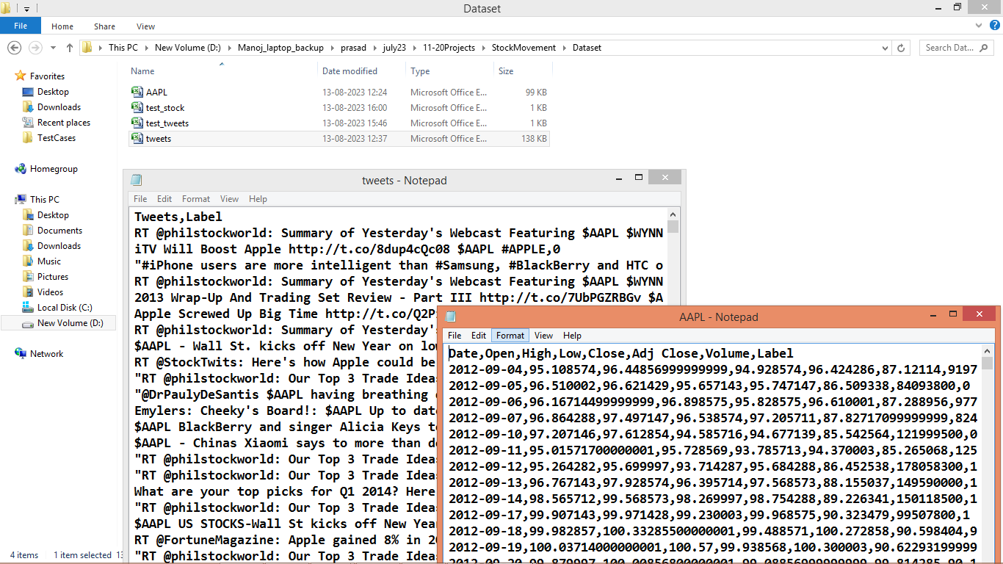

In above screen we can see two dataset where first one contains tweets and second one contains stock prices such as OPEN, CLOSE etc. So by using above datasets we will train multi-model called ‘Hybrid Information Missing Module using (GRU + LSTM)’.

Extension Concept

In propose paper author has used LSTM + GRU to extract tweets and stock prices features and have not used any additional algorithm to optimized those features so as extension we have add BIDIRECTIONAL extra layer which will obtained features from GRU and LSTM and then remove or dropout irrelevant features to collect optimize features and then input to MLP model for classification. Bidirectional layer will move backward and forward direction in search for relevant features which can help in further improvement of accuracy.

SCREEN SHOTS

We have coded this project using JUPYTER notebook and below are the code and output screens with blue colour comments

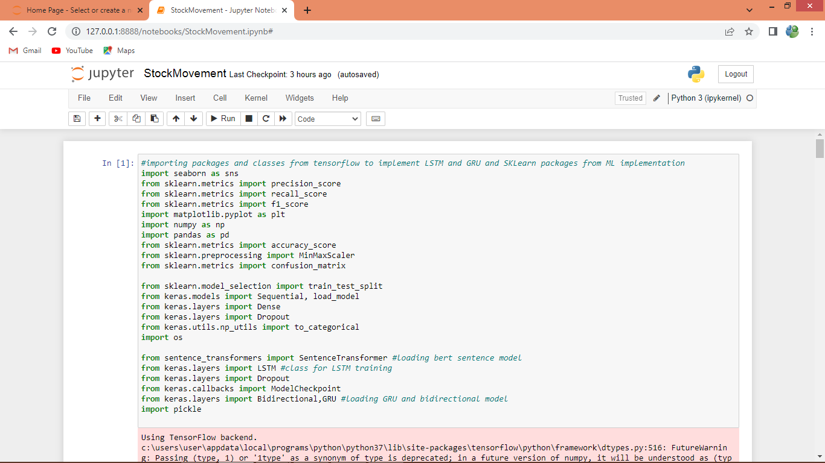

In above screen importing required packages and classes

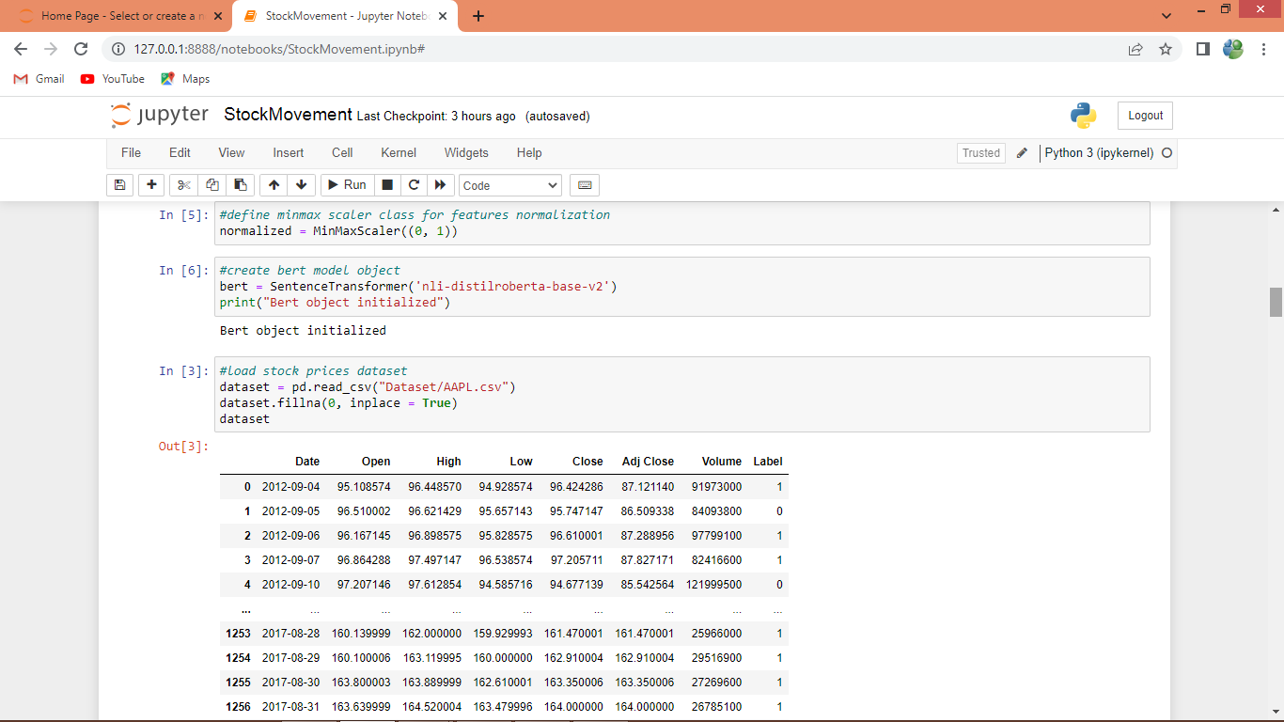

In above screen defining BERT model and then reading and displaying stock dataset

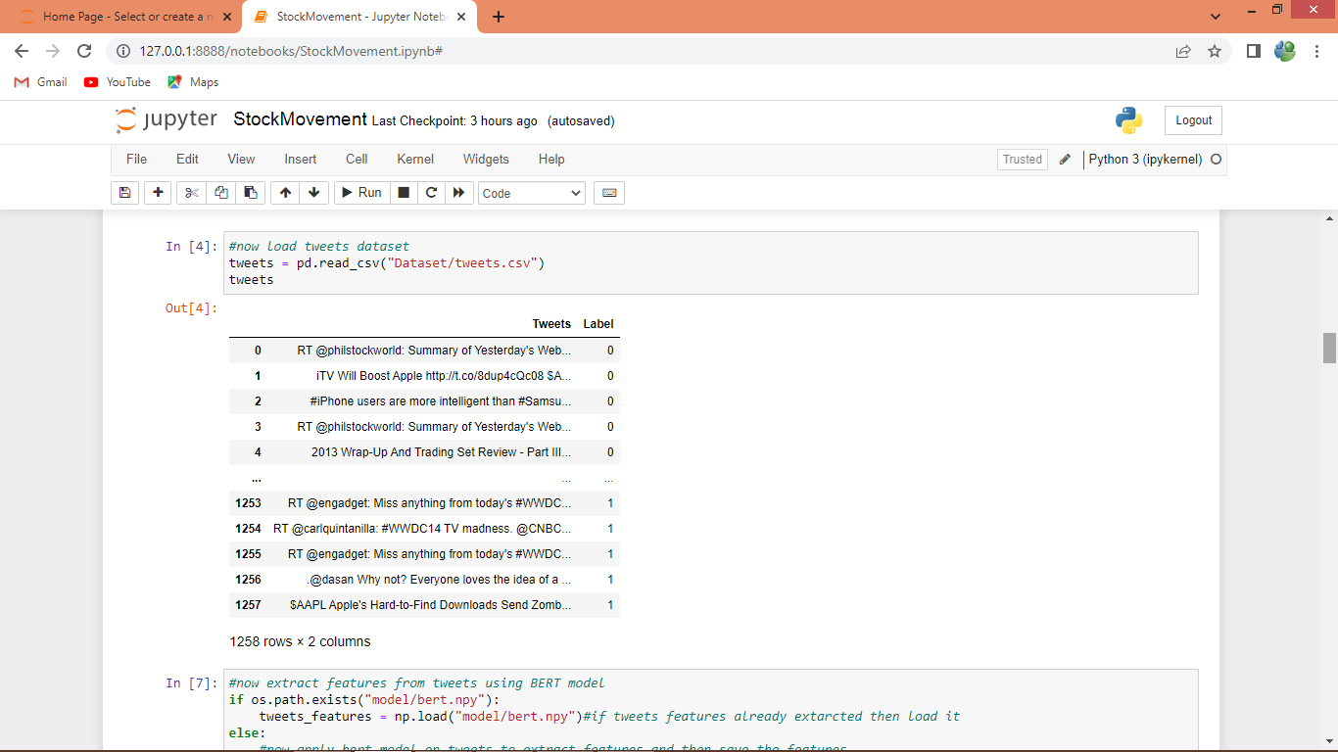

In above screen reading and displaying tweets dataset

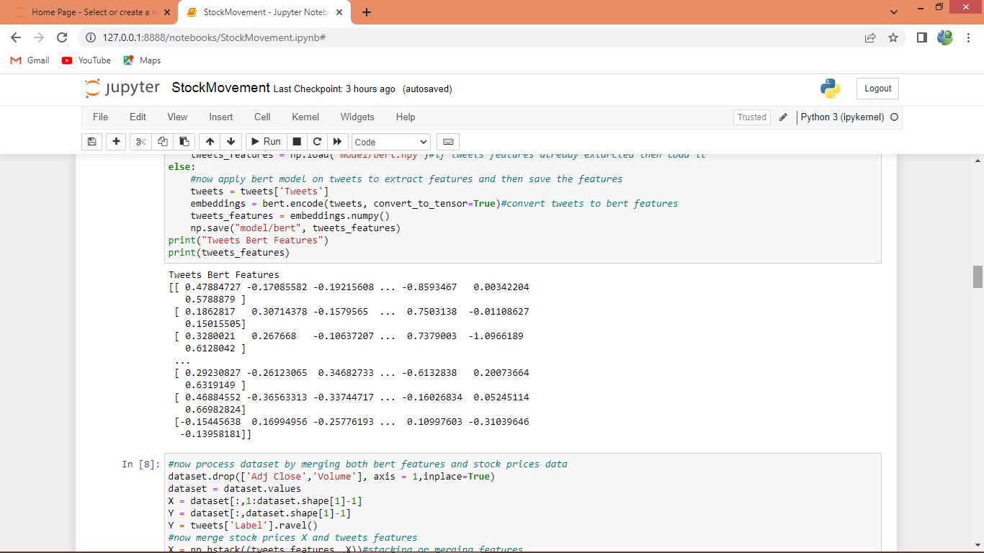

In above screen applying BERT model to convert tweets into BERT features and then displaying BERT features values

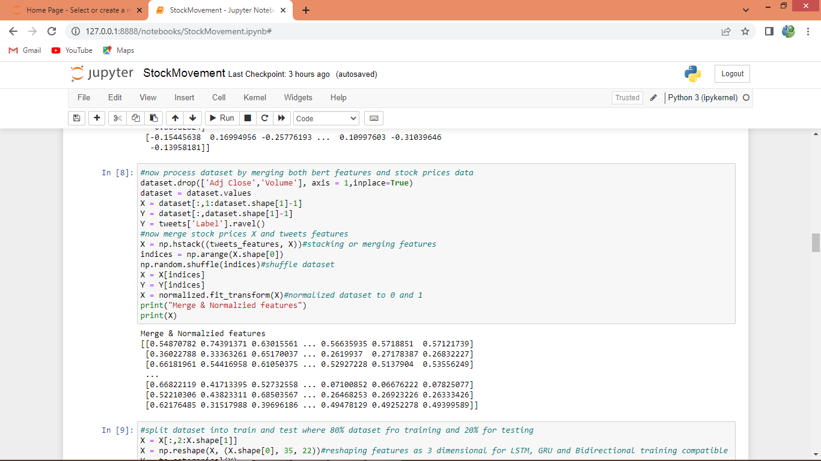

In above screen applying features processing such as normalization and shuffling and then displaying normalized features values

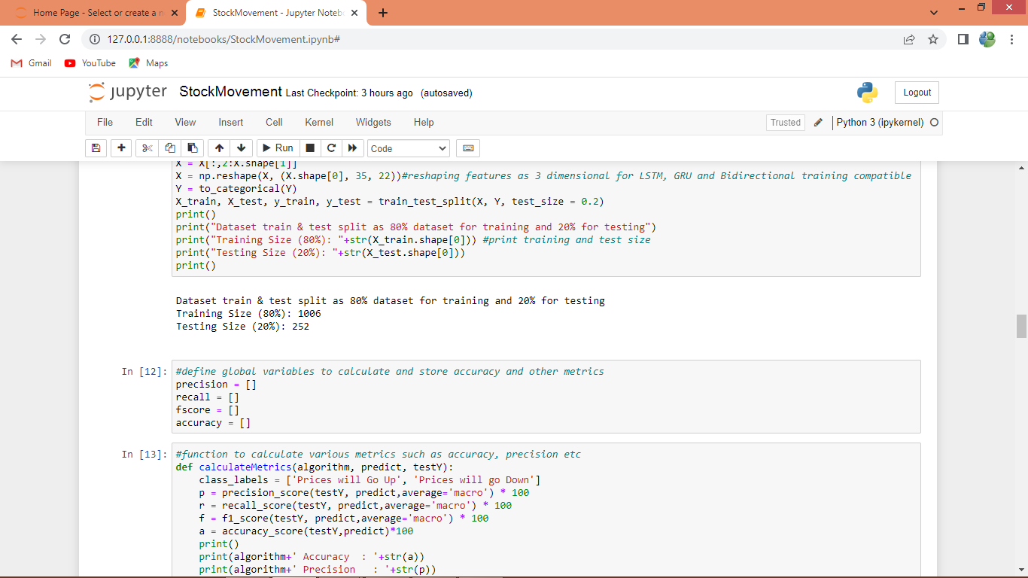

In above screen splitting dataset into train and test and then defining function to calculate accuracy, precision and other metrics

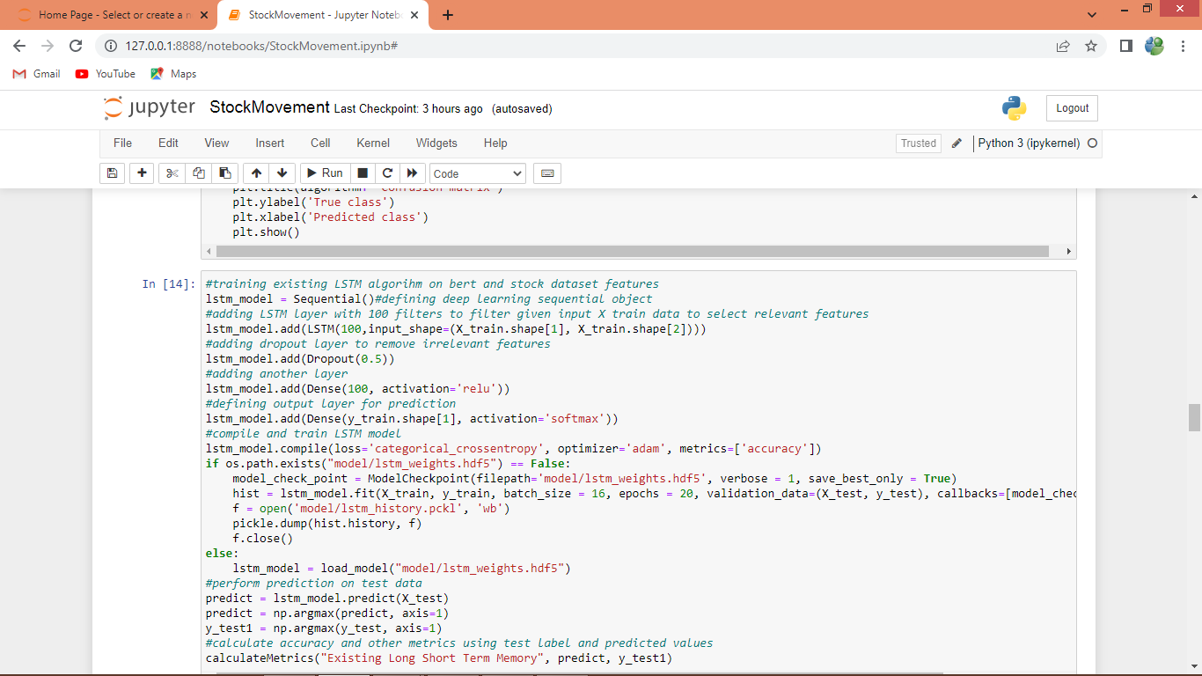

In above screen training existing LSTM model on stock prices and BERT features and after executing above block will get below output

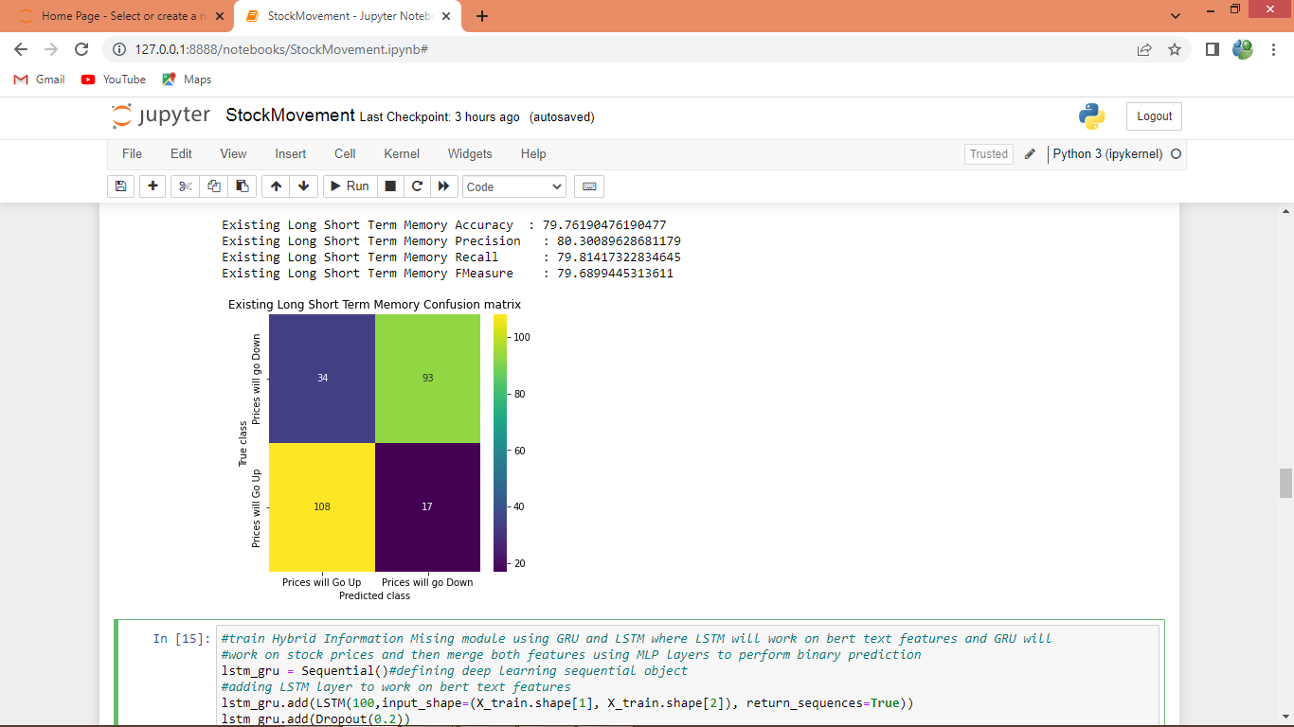

In above screen existing LSTM model got 79% accuracy and can see other metrics also and in confusion matrix graph x-axis represents Predicted Labels and y-axis represents True Labels where yellow and light represents correct prediction count and remaining boxes represents incorrect prediction counts which are very few.

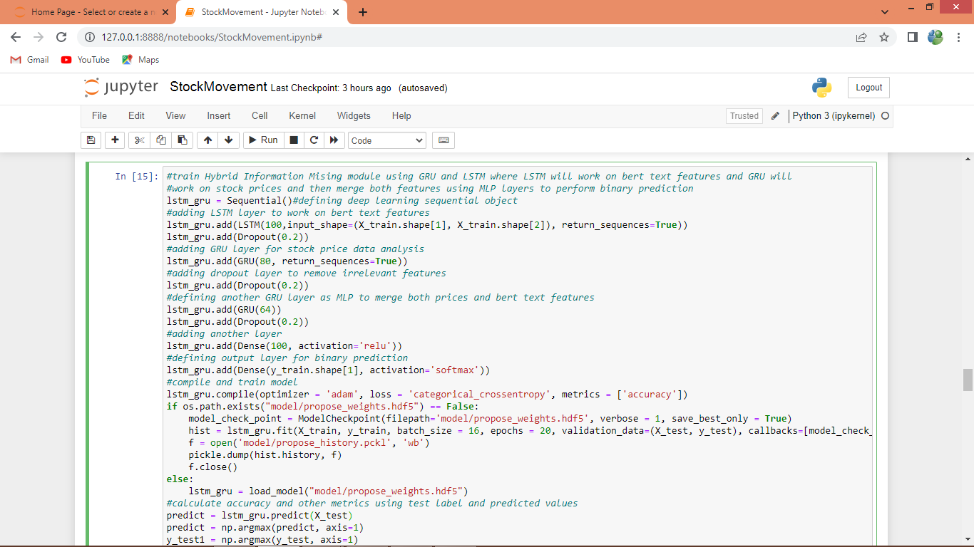

In above screen training propose HYBRID model by combining LSTM and GRU layers and after executing above block will get below output

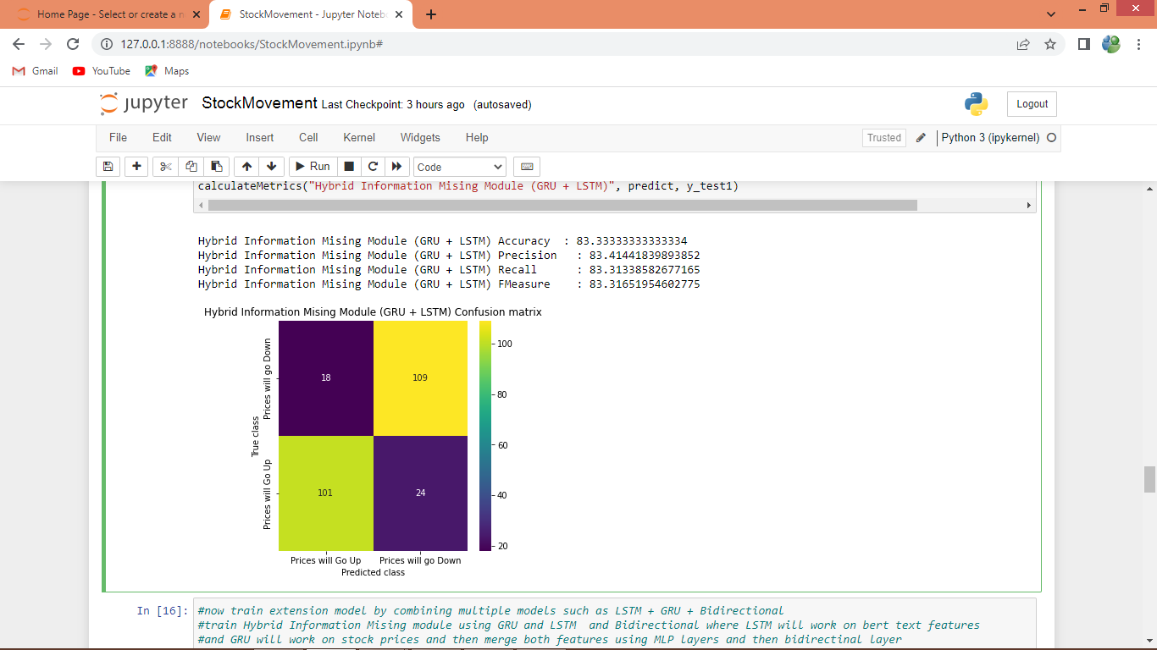

In above screen propose hybrid model got 83% accuracy and can see other metrics also

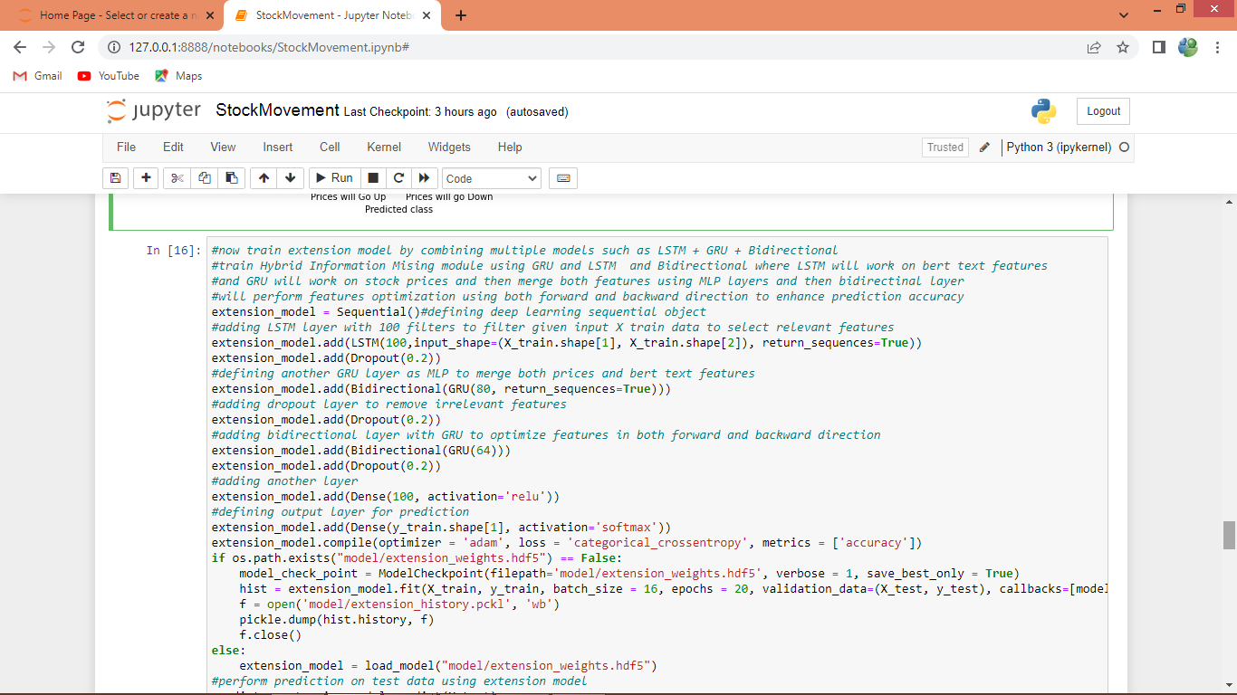

In above screen training extension model by combining LSTM + GRU + Bidirectional algorithms and after executing above block will get below output

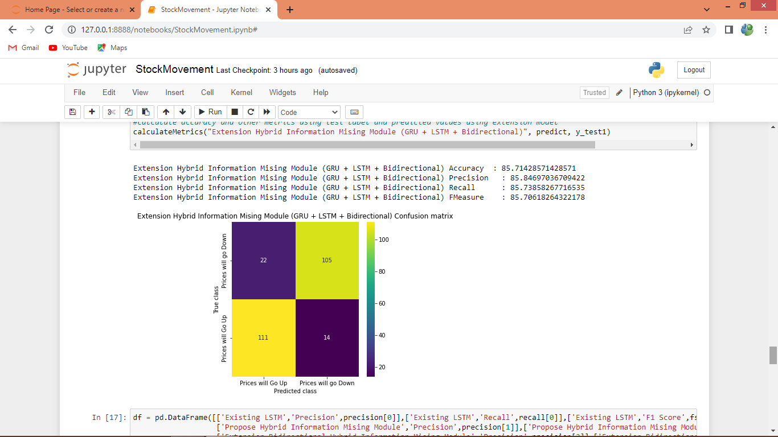

In above screen extension got 85% accuracy which is higher than other algorithms

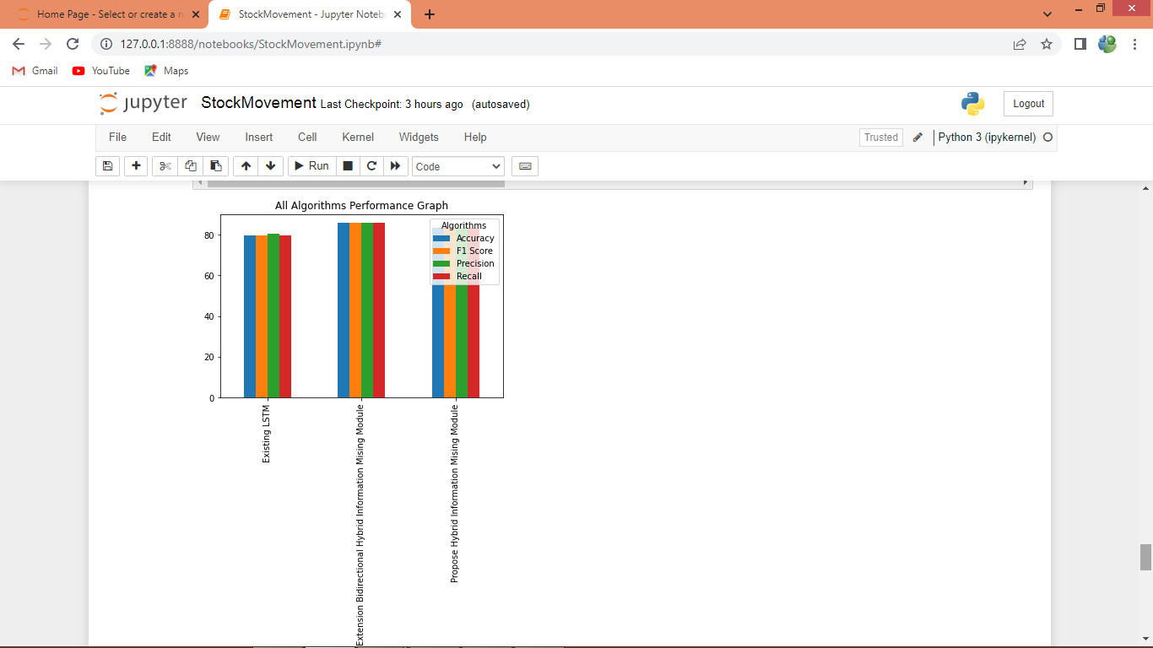

In above comparison graph x-axis represents algorithm names and y-axis represents accuracy and other metrics in different colour bars and in all algorithms extension got high accuracy

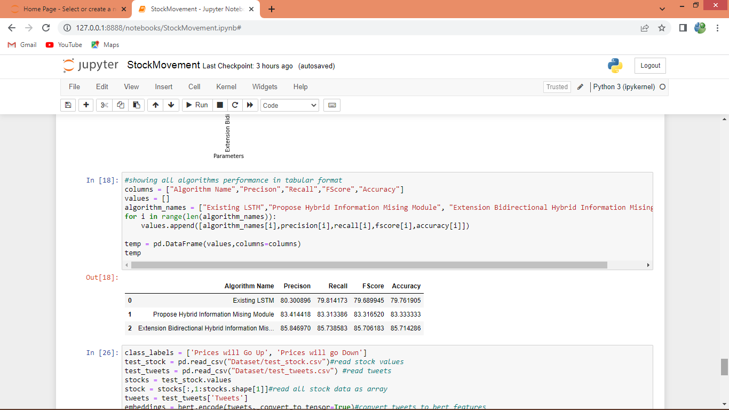

In above screen displaying all algorithms performance in tabular format

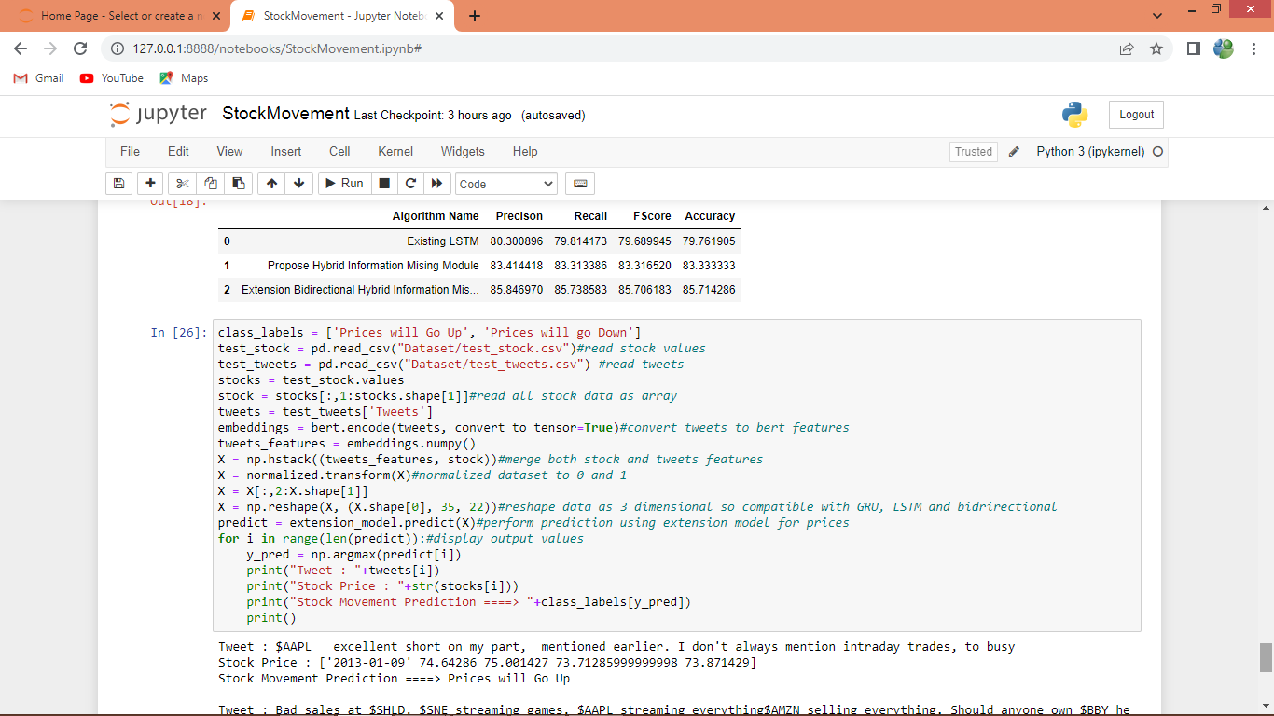

In above screen defining test code to read TWEETS and stock prices and then combining both features to perform stock prediction using extension model and after executing above block will get below output

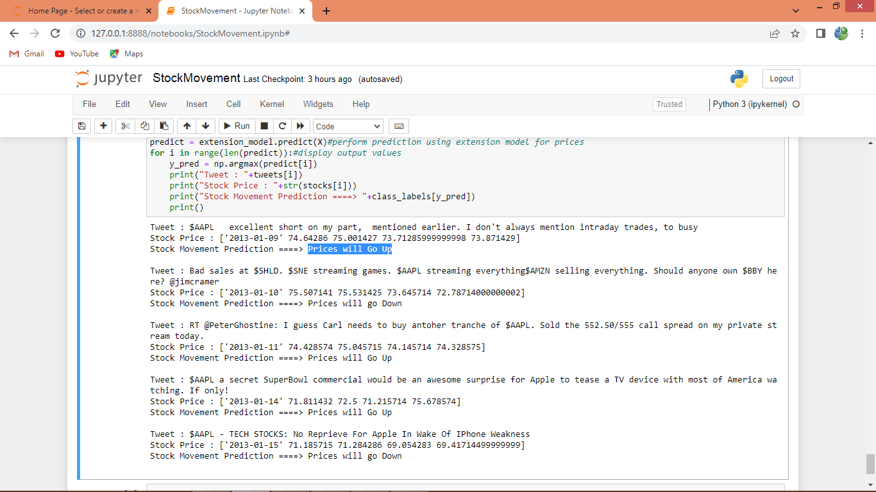

In above prediction output first line displaying tweets and then second line displaying Stock Prices and in 3rd line displaying prediction output as binary class label like ‘stock price will go up or down’. Each test record displaying after line break