FACULTY OF ENGINEERING AND TECHNOLOGY
DEPARTMENT OF COMPUTER SCIENCE & ENGINEERING
OBJECT ORIENTED PROGRAMMING (CEUE203)
LABORATORY PRACTICAL RECORD JOURNAL
Submitted By:
Name : Krutin
Enrolment No : 25CS034
Semester : 3rd Semester
Branch : Computer Engineering
GitHub Repository:
https://github.com/krutinkoradiya24/JAVA.git

PRACTICAL INDEX
Prac No | Practical Title & Problem Focus | Student ID | Status
Prac 01 | Enums, Records, and Switch Expressions  • Vending Machine  • Toll Booth Management | 25CS034 (Krutin) | Completed
Prac 02 | Classes, Constructors, Encapsulation, and Static Members  • Smart Thermostat  • Cinema Show Booking | 25CS034 (Krutin) | Completed
Prac 03 | Overriding Object-Class Methods (equals, hashCode, toString)  • Distinct Coordinates Filter  • Duplicate Playing Card Detector | 25CS034 (Krutin) | Completed
Prac 04 | String Processing, Regular Expressions, and StringBuilder  • Password Strength Evaluator  • Chat-Log Stream Filter | 25CS034 (Krutin) | Completed
Prac 05 | Inheritance, Abstract Classes, and Polymorphism  • Polymorphic Shape Area Calculation  • Employee Payroll & Type Checking | 25CS034 (Krutin) | Completed
Prac 06 | Interfaces, Default Methods, Functional Interfaces, and Marker Interfaces  • Remote Control Switchable Hierarchy  • Broadcast Notification System with Marker Interface | 25CS034 (Krutin) | Completed
Prac 07 | Custom Annotations and Runtime Reflection  • Reflection-Based Form Validator  • Custom Unit Test Runner (@Run) | 25CS034 (Krutin) | Completed
Prac 08 | Exception Handling and Custom Checked Exceptions  • Guarded Robust Calculator  • Warehouse Stock Issue System | 25CS034 (Krutin) | Completed
Prac 09 | Multithreading, Race Conditions, and Synchronization  • Shared Counter Race Condition & Fix  • Seat Booking Race & Thread Safety | 25CS034 (Krutin) | Completed
Prac 10 | ExecutorService Thread Pool & Inter-Thread Coordination  • Fixed Thread-Pool Task Runner  • Producer-Consumer with wait() and notify() | 25CS034 (Krutin) | Completed
Prac 11 | Object Serialization and Java NIO File Handling  • Object Serialization with Transient Fields  • NIO Directory Stream & Log Analyzer | 25CS034 (Krutin) | Completed
Prac 12 | Java Collections Framework (HashMap, Set, and Custom Sorting)  • Word Frequency Analyzer with Comparator  • Unique Visitors Tracker (HashSet & LinkedHashSet) | 25CS034 (Krutin) | Completed
Prac 13 | Java Generics (Generic Classes, Methods, and Bounded Types)  • Generic Containers (Box & Pair)  • Bounded Type Generic Method | 25CS034 (Krutin) | Completed
Prac 14 | Layered Application Architecture, Testing, and State Persistence  • Modular Layered Student Management Service  • Application State Serialization Persistence | 25CS034 (Krutin) | Completed

FACULTY OF ENGINEERING AND TECHNOLOGY
Object Oriented Programming (CEUE203) - Semester 3
Practical 01: Enums, Records, and Switch Expressions
Student Name: Krutin | Enrolment No: 25CS034

Problem 1: Vending Machine
Problem Statement:
(a) Define an enum Coin with constants ONE, TWO, FIVE, TEN.
(b) In main, set a snack price of 15 and a running total of 0; create a Scanner.
(c) Loop: read a coin name, use a switch expression to convert the Coin to its value (ONE->1, TWO->2, FIVE->5, TEN->10), add it to the total, and print the total so far.
(d) Stop the loop once the total reaches 15 or more.
(e) Print the change to return (total - 15).
Expected output: TEN then FIVE prints "Paid. Change: 0"; TEN then TEN prints "Paid. Change: 5".

Java Source Code:
/**
* Student Name : Krutin
* Enrolment No : 25CS034
* Course : CEUE203 - Object Oriented Programming
*/
import java.util.Scanner;
public class VendingMachine {
enum Coin {
ONE, TWO, FIVE, TEN
}
public static void main(String[] args) {
System.out.println("Enrolment No: 25CS034 | Name: Krutin");
final int PRICE = 15;
int total = 0;
Scanner sc = new Scanner(System.in);
System.out.println("Snack price: " + PRICE);
while (total < PRICE) {
System.out.print("Insert coin (ONE, TWO, FIVE, TEN): ");
String input = sc.next().toUpperCase();
try {
Coin coin = Coin.valueOf(input);
int value = switch (coin) {
case ONE -> 1;
case TWO -> 2;
case FIVE -> 5;
case TEN -> 10;
};
total += value;
System.out.println("Total inserted: " + total);
} catch (IllegalArgumentException e) {
System.out.println("Invalid coin.");
}
}
int change = total - PRICE;
System.out.println("Paid. Change: " + change);
sc.close();
}
}

Execution Output Screenshot:

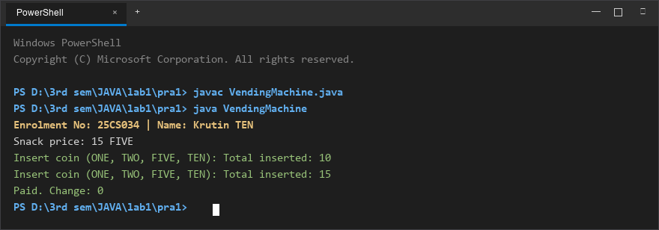
Figure 1: Console execution output for Problem 1 (Student ID: 25CS034)

Problem 2: Toll Booth Management
Problem Statement:
(a) Define a record Vehicle(String number, String type).
(b) In main, keep a running toll total and three counters (bike, car, truck).
(c) Loop until the user types "done" for the number: build a Vehicle, use a switch expression on its type for the toll (bike->20, car->50, truck->150), add to the total, and increment that type's counter.
(d) After the loop, print the total toll and the type with the highest count.
Expected output: two cars + one bike -> "Total toll: 120", "Most frequent: car".

Java Source Code:
/**
* Student Name : Krutin
* Enrolment No : 25CS034
* Course : CEUE203 - Object Oriented Programming
*/
import java.util.Scanner;
record Vehicle(String number, String type) {}
public class TollBooth {
public static void main(String[] args) {
System.out.println("Enrolment No: 25CS034 | Name: Krutin");
Scanner sc = new Scanner(System.in);
int totalToll = 0;
int bikeCount = 0;
int carCount = 0;
int truckCount = 0;
while (true) {
System.out.print("Enter vehicle number (or done to stop): ");
String number = sc.next();
if (number.equalsIgnoreCase("done")) {
break;
}
System.out.print("Enter vehicle type (bike/car/truck): ");
String type = sc.next().toLowerCase();
Vehicle vehicle = new Vehicle(number, type);
int toll = switch (vehicle.type()) {
case "bike" -> 20;
case "car" -> 50;
case "truck" -> 150;
default -> 0;
};
totalToll += toll;
switch (vehicle.type()) {
case "bike" -> bikeCount++;
case "car" -> carCount++;
case "truck" -> truckCount++;
default -> System.out.println("Invalid vehicle type!");
}
}
System.out.println("\nTotal toll: " + totalToll);
if (bikeCount >= carCount && bikeCount >= truckCount) {
System.out.println("Most frequent: bike");
} else if (carCount >= bikeCount && carCount >= truckCount) {
System.out.println("Most frequent: car");
} else {
System.out.println("Most frequent: truck");
}
sc.close();
}
}

Execution Output Screenshot:

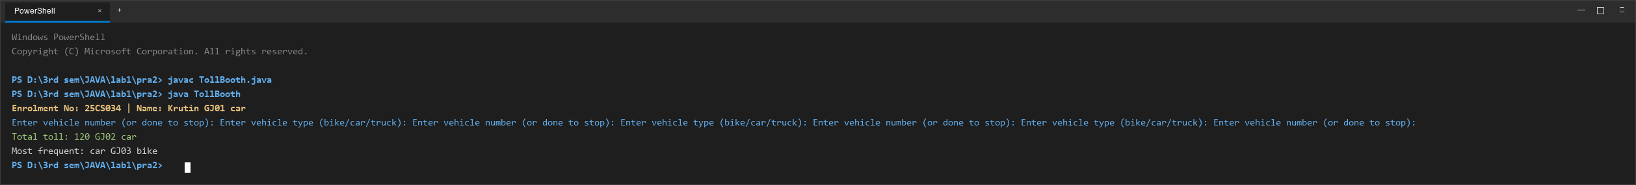
Figure 2: Console execution output for Problem 2 (Student ID: 25CS034)

FACULTY OF ENGINEERING AND TECHNOLOGY
Object Oriented Programming (CEUE203) - Semester 3
Practical 02: Classes, Constructors, Encapsulation, and Static Members
Student Name: Krutin | Enrolment No: 25CS034

Problem 1: Smart Thermostat
Problem Statement:
(a) Create class Thermostat with private String location, private int temperature, private static final int MIN=16 and MAX=30, and private static int activeCount=0.
(b) Constructor(location, startTemp): store location; set temperature to startTemp if it is within MIN..MAX else 22; increment activeCount.
(c) Constructor(location): chain with this(location, 22).
(d) raise(): if temperature < MAX add 1, else print "Already at maximum (30)".
(e) lower(): if temperature > MIN subtract 1, else print "Already at minimum (16)".
(f) Add getTemperature() (no setter) and static getActiveCount().
(g) In main: create two thermostats, call raise() 10 times then lower() 20 times in loops, then print getActiveCount().

Java Source Code:
/**
* Student Name : Krutin
* Enrolment No : 25CS034
* Course : CEUE203 - Object Oriented Programming
*/
public class Thermostat {
private String location;
private int temperature;
private static final int MIN = 16;
private static final int MAX = 30;
private static int activeCount = 0;
public Thermostat(String location, int startTemp) {
this.location = location;
if (startTemp >= MIN && startTemp <= MAX) {
this.temperature = startTemp;
} else {
this.temperature = 22;
}
activeCount++;
}
public Thermostat(String location) {
this(location, 22);
}
public void raise() {
if (temperature < MAX) {
temperature++;
} else {
System.out.println("Already at maximum (30)");
}
}
public void lower() {
if (temperature > MIN) {
temperature--;
} else {
System.out.println("Already at minimum (16)");
}
}
public int getTemperature() {
return temperature;
}
public static int getActiveCount() {
return activeCount;
}
public static void main(String[] args) {
System.out.println("Enrolment No: 25CS034 | Name: Krutin");
Thermostat t1 = new Thermostat("Living Room", 22);
Thermostat t2 = new Thermostat("Bedroom");
for (int i = 0; i < 10; i++) {
t1.raise();
System.out.println("Temperature: " + t1.getTemperature());
}
for (int i = 0; i < 20; i++) {
t1.lower();
System.out.println("Temperature: " + t1.getTemperature());
}
System.out.println("Active Count: " + Thermostat.getActiveCount());
}
}

Execution Output Screenshot:

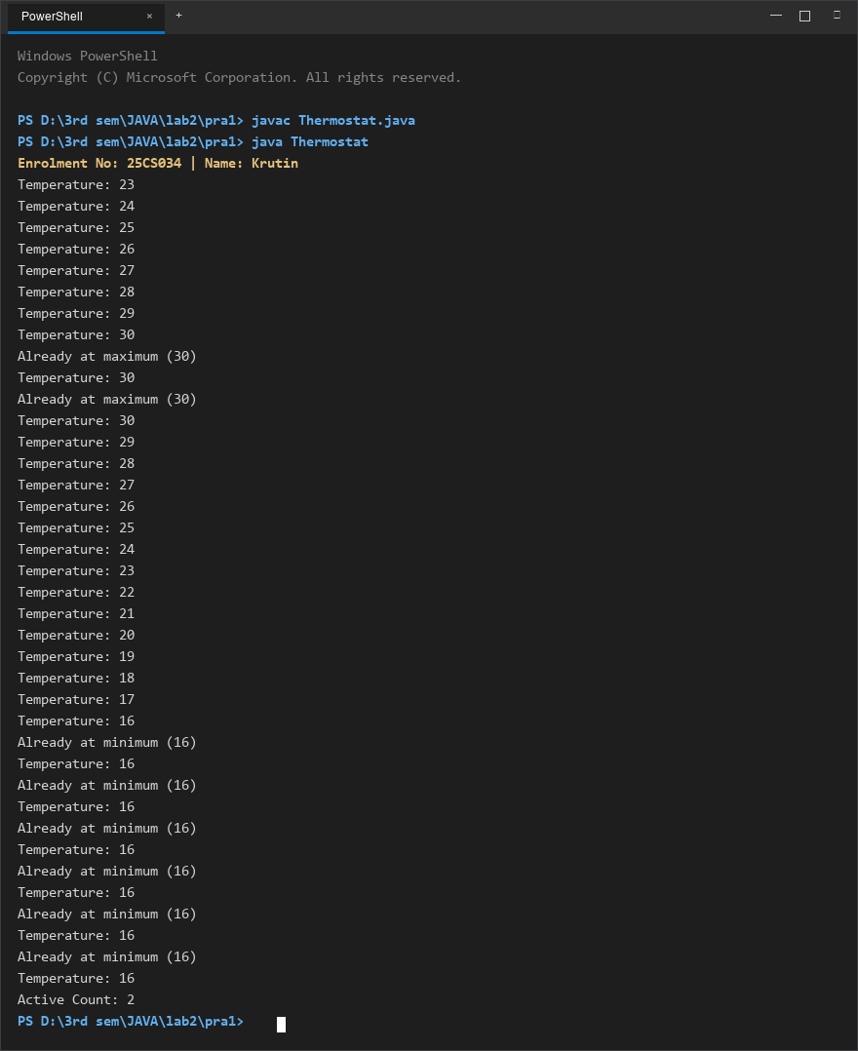
Figure 1: Console execution output for Problem 1 (Student ID: 25CS034)

Problem 2: Cinema Show Booking
Problem Statement:
(a) Create class CinemaShow with private String title, private int seatsAvailable, private final int capacity, and private static int totalBooked=0.
(b) Constructor(title, capacity): set both and seatsAvailable = capacity. Constructor(title): chain with this(title, 100).
(c) book(int n): if n <= seatsAvailable, reduce seatsAvailable by n, add n to totalBooked, return true; else return false unchanged.
(d) cancel(int n): increase seatsAvailable by n but never above capacity.
(e) Add getSeatsAvailable() and static getTotalBooked().
(f) In main: run a sequence of book and cancel calls, printing the result and seats after each, then print getTotalBooked().

Java Source Code:
/**
* Student Name : Krutin
* Enrolment No : 25CS034
* Course : CEUE203 - Object Oriented Programming
*/
public class CinemaShow {
private String title;
private int seatsAvailable;
private final int capacity;
private static int totalBooked = 0;
public CinemaShow(String title, int capacity) {
this.title = title;
this.capacity = capacity;
this.seatsAvailable = capacity;
}
public CinemaShow(String title) {
this(title, 100);
}
public boolean book(int n) {
if (n <= seatsAvailable) {
seatsAvailable -= n;
totalBooked += n;
return true;
}
return false;
}
public void cancel(int n) {
seatsAvailable += n;
if (seatsAvailable > capacity) {
seatsAvailable = capacity;
}
}
public int getSeatsAvailable() {
return seatsAvailable;
}
public static int getTotalBooked() {
return totalBooked;
}
public static void main(String[] args) {
System.out.println("Enrolment No: 25CS034 | Name: Krutin");
CinemaShow show = new CinemaShow("Avengers", 50);
System.out.println("Book 20: " + show.book(20) + ", Seats left: " + show.getSeatsAvailable());
System.out.println("Book 40: " + show.book(40) + ", Seats left: " + show.getSeatsAvailable());
System.out.println("Cancel 10");
show.cancel(10);
System.out.println("Seats left: " + show.getSeatsAvailable());
System.out.println("Total Booked: " + CinemaShow.getTotalBooked());
}
}

Execution Output Screenshot:

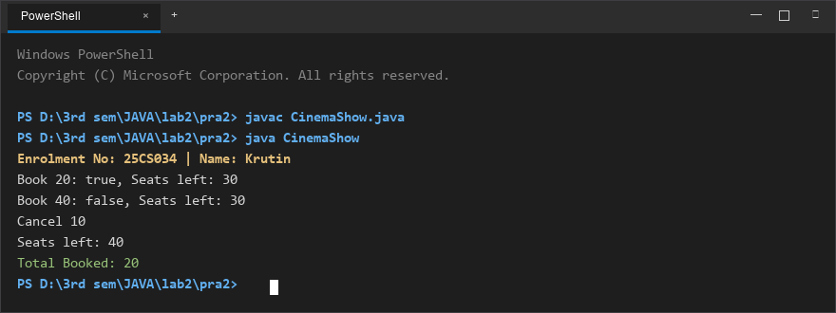
Figure 2: Console execution output for Problem 2 (Student ID: 25CS034)

FACULTY OF ENGINEERING AND TECHNOLOGY
Object Oriented Programming (CEUE203) - Semester 3
Practical 03: Overriding Object-Class Methods (equals, hashCode, toString)
Student Name: Krutin | Enrolment No: 25CS034

Problem 1: Distinct Coordinates Filter
Problem Statement:
(a) Create class Point with private int x, y and a constructor.
(b) Override toString() to return "(x, y)".
(c) Override equals(Object) to be true when both x and y match, and hashCode() to agree (e.g. Objects.hash(x, y)).
(d) In Driver.main: build a Point[] with some repeated coordinates.
(e) Count distinct points: for each point, use equals() to check whether it already appeared earlier; count those that did not.
(f) Print "Distinct: N".
Expected output: 5 points with 2 repeats -> "Distinct: 3".

Java Source Code:
File: Point.java
/**
* Student Name : Krutin
* Enrolment No : 25CS034
* Course : CEUE203 - Object Oriented Programming
*/
import java.util.Objects;
public class Point {
private int x;
private int y;
public Point(int x, int y) {
this.x = x;
this.y = y;
}
@Override
public String toString() {
return "(" + x + ", " + y + ")";
}
@Override
public boolean equals(Object obj) {
if (this == obj) return true;
if (!(obj instanceof Point)) return false;
Point p = (Point) obj;
return this.x == p.x && this.y == p.y;
}
@Override
public int hashCode() {
return Objects.hash(x, y);
}
}

File: Driver.java
/**
* Student Name : Krutin
* Enrolment No : 25CS034
* Course : CEUE203 - Object Oriented Programming
*/
public class Driver {
public static void main(String[] args) {
System.out.println("Enrolment No: 25CS034 | Name: Krutin");
Point[] points = {
new Point(1, 2),
new Point(3, 4),
new Point(1, 2),
new Point(5, 6),
new Point(3, 4)
};
int distinct = 0;
for (int i = 0; i < points.length; i++) {
boolean seenBefore = false;
for (int j = 0; j < i; j++) {
if (points[i].equals(points[j])) {
seenBefore = true;
break;
}
}
if (!seenBefore) {
distinct++;
}
}
System.out.println("Distinct: " + distinct);
}
}

Execution Output Screenshot:

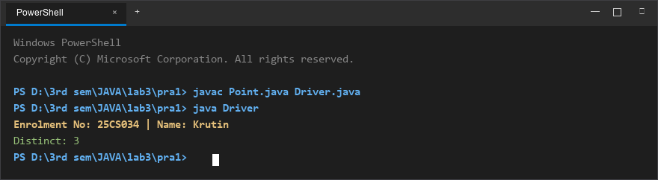
Figure 1: Console execution output for Problem 1 (Student ID: 25CS034)

Problem 2: Duplicate Playing Card Detector
Problem Statement:
(a) Create class Card with private String rank, suit and a constructor.
(b) Override toString() to return rank + " of " + suit (e.g. "Queen of Hearts").
(c) Override equals()/hashCode() by rank + suit.
(d) In Driver.main: add cards to a Card[] one at a time; before adding each, use equals() to check it against the earlier cards.
(e) Print "Duplicate found: <card>" the first time a repeat appears.

Java Source Code:
File: Card.java
/**
* Student Name : Krutin
* Enrolment No : 25CS034
* Course : CEUE203 - Object Oriented Programming
*/
import java.util.Objects;
public class Card {
private String rank;
private String suit;
public Card(String rank, String suit) {
this.rank = rank;
this.suit = suit;
}
@Override
public String toString() {
return rank + " of " + suit;
}
@Override
public boolean equals(Object obj) {
if (this == obj) return true;
if (!(obj instanceof Card)) return false;
Card other = (Card) obj;
return Objects.equals(this.rank, other.rank) && Objects.equals(this.suit, other.suit);
}
@Override
public int hashCode() {
return Objects.hash(rank, suit);
}
}

File: Driver.java
/**
* Student Name : Krutin
* Enrolment No : 25CS034
* Course : CEUE203 - Object Oriented Programming
*/
public class Driver {
public static void main(String[] args) {
System.out.println("Enrolment No: 25CS034 | Name: Krutin");
Card[] stream = {
new Card("Ace", "Spades"),
new Card("King", "Hearts"),
new Card("Queen", "Diamonds"),
new Card("Ace", "Spades"),
new Card("Jack", "Clubs")
};
Card[] cards = new Card[stream.length];
int count = 0;
for (Card c : stream) {
boolean duplicate = false;
for (int i = 0; i < count; i++) {
if (c.equals(cards[i])) {
System.out.println("Duplicate found: " + c);
duplicate = true;
break;
}
}
if (duplicate) {
break;
}
cards[count++] = c;
}
}
}

Execution Output Screenshot:

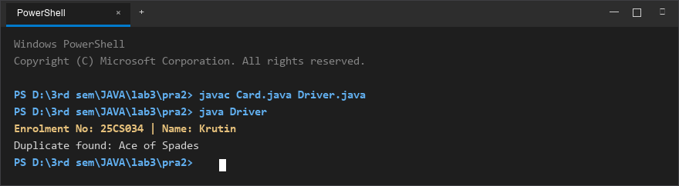
Figure 2: Console execution output for Problem 2 (Student ID: 25CS034)

FACULTY OF ENGINEERING AND TECHNOLOGY
Object Oriented Programming (CEUE203) - Semester 3
Practical 04: String Processing, Regular Expressions, and StringBuilder
Student Name: Krutin | Enrolment No: 25CS034

Problem 1: Password Strength Evaluator
Problem Statement:
(a) In PasswordChecker, check four rules - length >= 8, contains an uppercase letter, contains a digit, contains a special character - using regex or String methods.
(b) Write strength(String pw) that counts how many rules pass and returns "Weak" (0-1), "Medium" (2-3) or "Strong" (4).
(c) In Driver.main: test several passwords; for each, print which rules passed and the final label.

Java Source Code:
File: PasswordChecker.java
/**
* Student Name : Krutin
* Enrolment No : 25CS034
* Course : CEUE203 - Object Oriented Programming
*/
public class PasswordChecker {
public static boolean hasLength(String pw) {
return pw != null && pw.length() >= 8;
}
public static boolean hasUpperCase(String pw) {
for (int i = 0; i < pw.length(); i++) {
if (Character.isUpperCase(pw.charAt(i))) {
return true;
}
}
return false;
}
public static boolean hasDigit(String pw) {
for (int i = 0; i < pw.length(); i++) {
if (Character.isDigit(pw.charAt(i))) {
return true;
}
}
return false;
}
public static boolean hasSpecialCharacter(String pw) {
for (int i = 0; i < pw.length(); i++) {
char ch = pw.charAt(i);
if (!Character.isLetterOrDigit(ch)) {
return true;
}
}
return false;
}
public static String strength(String pw) {
int count = 0;
if (hasLength(pw)) count++;
if (hasUpperCase(pw)) count++;
if (hasDigit(pw)) count++;
if (hasSpecialCharacter(pw)) count++;
if (count <= 1) {
return "Weak";
} else if (count <= 3) {
return "Medium";
} else {
return "Strong";
}
}
}

File: Driver.java
/**
* Student Name : Krutin
* Enrolment No : 25CS034
* Course : CEUE203 - Object Oriented Programming
*/
public class Driver {
public static void main(String[] args) {
System.out.println("Enrolment No: 25CS034 | Name: Krutin");
String[] passwords = {
"abc",
"Password",
"Pass1234",
"Abcd1234!"
};
for (String pw : passwords) {
System.out.println("Password: " + pw);
System.out.println("Length >= 8: " + PasswordChecker.hasLength(pw));
System.out.println("Uppercase: " + PasswordChecker.hasUpperCase(pw));
System.out.println("Digit: " + PasswordChecker.hasDigit(pw));
System.out.println("Special: " + PasswordChecker.hasSpecialCharacter(pw));
System.out.println("Strength: " + PasswordChecker.strength(pw));
System.out.println("-------------------------------");
}
}
}

Execution Output Screenshot:

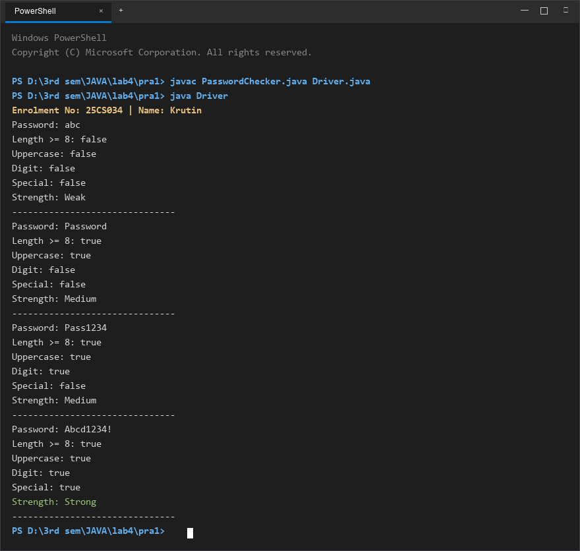
Figure 1: Console execution output for Problem 1 (Student ID: 25CS034)

Problem 2: Chat-Log Stream Filter
Problem Statement:
(a) In Driver.main, define a String[] of log lines like "10:05 alice Hello there" (include one malformed line with fewer than 3 parts).
(b) Read a keyword from the user.
(c) For each line, split into time/user/message with split(" ", 3); skip lines that do not have 3 parts.
(d) If the message contains the keyword (case-insensitive), increment a counter and append "time user: message" to a StringBuilder.
(e) Print "Matches: N" and the built report.

Java Source Code:
File: ChatFilter.java
/**
* Student Name : Krutin
* Enrolment No : 25CS034
* Course : CEUE203 - Object Oriented Programming
*/
public class ChatFilter {
public static String filterLogs(String[] logs, String keyword) {
StringBuilder report = new StringBuilder();
int count = 0;
keyword = keyword.toLowerCase();
for (String line : logs) {
String[] parts = line.split(" ", 3);
if (parts.length < 3) {
continue;
}
String time = parts[0];
String user = parts[1];
String message = parts[2];
if (message.toLowerCase().contains(keyword)) {
count++;
report.append(time)
.append(" ")
.append(user)
.append(": ")
.append(message)
.append("\n");
}
}
return "Matches: " + count + "\n" + report.toString();
}
}

File: Driver.java
/**
* Student Name : Krutin
* Enrolment No : 25CS034
* Course : CEUE203 - Object Oriented Programming
*/
import java.util.Scanner;
public class Driver {
public static void main(String[] args) {
System.out.println("Enrolment No: 25CS034 | Name: Krutin");
String[] logs = {
"10:05 alice Hello there",
"10:10 bob How are you?",
"InvalidLine",
"10:20 charlie Nice to say hello"
};
Scanner sc = new Scanner(System.in);
System.out.print("Enter keyword: ");
String keyword = sc.nextLine();
System.out.println();
System.out.println(ChatFilter.filterLogs(logs, keyword));
sc.close();
}
}

Execution Output Screenshot:

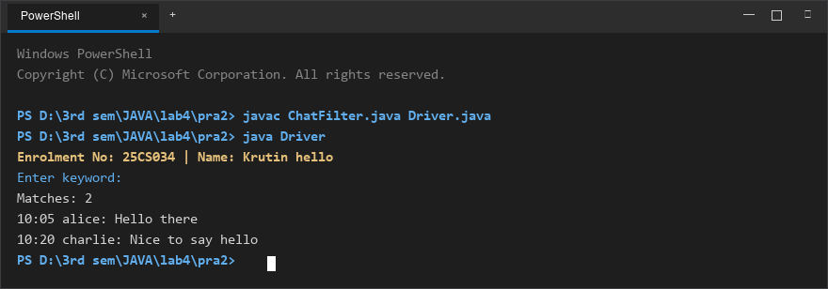
Figure 2: Console execution output for Problem 2 (Student ID: 25CS034)

FACULTY OF ENGINEERING AND TECHNOLOGY
Object Oriented Programming (CEUE203) - Semester 3
Practical 05: Inheritance, Abstract Classes, and Polymorphism
Student Name: Krutin | Enrolment No: 25CS034

Problem 1: Polymorphic Shape Area Calculation
Problem Statement:
Define an abstract Shape with abstract area(); subclasses Circle, Rectangle, Triangle.
Put a mix of shapes in a Shape[] array and loop once to print each area and the running total, tracking the largest shape area - demonstrating one loop handling every shape type through polymorphism.

Java Source Code:
/**
* Student Name : Krutin
* Enrolment No : 25CS034
* Course : CEUE203 - Object Oriented Programming
*/
abstract class Shape {
abstract double area();
}
class Circle extends Shape {
double radius;
Circle(double radius) {
this.radius = radius;
}
@Override
double area() {
return 3.14 * radius * radius;
}
}
class Rectangle extends Shape {
double length, width;
Rectangle(double length, double width) {
this.length = length;
this.width = width;
}
@Override
double area() {
return length * width;
}
}
class Triangle extends Shape {
double base, height;
Triangle(double base, double height) {
this.base = base;
this.height = height;
}
@Override
double area() {
return 0.5 * base * height;
}
}
public class Main {
public static void main(String[] args) {
System.out.println("Enrolment No: 25CS034 | Name: Krutin");
Shape[] shapes = {
new Circle(5),
new Rectangle(4, 6),
new Triangle(10, 5),
new Circle(3)
};
double total = 0;
double largest = 0;
for (Shape s : shapes) {
double currentArea = s.area();
System.out.println(s.getClass().getSimpleName() + " Area = " + currentArea);
total += currentArea;
if (currentArea > largest) {
largest = currentArea;
}
}
System.out.println("\nTotal Area = " + total);
System.out.println("Largest Area = " + largest);
}
}

Execution Output Screenshot:

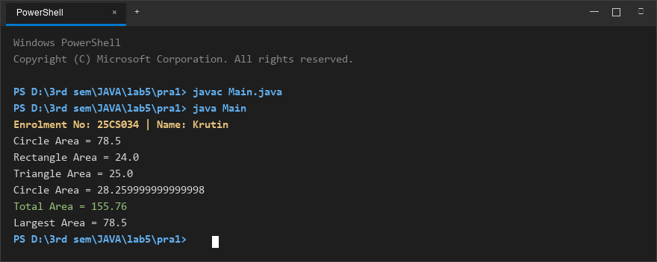
Figure 1: Console execution output for Problem 1 (Student ID: 25CS034)

Problem 2: Employee Payroll & Type Checking
Problem Statement:
Define an abstract Employee with abstract monthlySalary(); subclasses FullTime (fixed salary), PartTime (hours x rate) and Intern (stipend), each calling super constructor for shared name/id fields.
Loop through a mixed array to print each salary and compute total payroll; use the instanceof operator to identify and print a special note only for interns.

Java Source Code:
/**
* Student Name : Krutin
* Enrolment No : 25CS034
* Course : CEUE203 - Object Oriented Programming
*/
abstract class Employee {
String name;
int id;
Employee(String name, int id) {
this.name = name;
this.id = id;
}
abstract double monthlySalary();
}
class FullTime extends Employee {
double salary;
FullTime(String name, int id, double salary) {
super(name, id);
this.salary = salary;
}
@Override
double monthlySalary() {
return salary;
}
}
class PartTime extends Employee {
double hours;
double rate;
PartTime(String name, int id, double hours, double rate) {
super(name, id);
this.hours = hours;
this.rate = rate;
}
@Override
double monthlySalary() {
return hours * rate;
}
}
class Intern extends Employee {
double stipend;
Intern(String name, int id, double stipend) {
super(name, id);
this.stipend = stipend;
}
@Override
double monthlySalary() {
return stipend;
}
}
public class Main {
public static void main(String[] args) {
System.out.println("Enrolment No: 25CS034 | Name: Krutin");
Employee[] employees = {
new FullTime("Rahul", 101, 50000),
new PartTime("Amit", 102, 80, 200),
new Intern("Krutin", 103, 15000)
};
double total = 0;
for (Employee e : employees) {
double salary = e.monthlySalary();
System.out.println(e.name + " (ID: " + e.id + ") = " + salary);
if (e instanceof Intern) {
System.out.println("Note: Intern receives a stipend.");
}
total += salary;
}
System.out.println("--------------------");
System.out.println("Total Payroll = " + total);
}
}

Execution Output Screenshot:

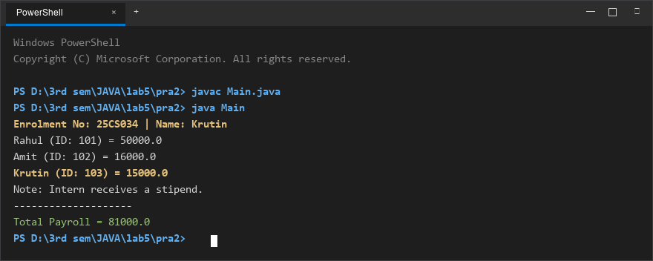
Figure 2: Console execution output for Problem 2 (Student ID: 25CS034)

FACULTY OF ENGINEERING AND TECHNOLOGY
Object Oriented Programming (CEUE203) - Semester 3
Practical 06: Interfaces, Default Methods, Functional Interfaces, and Marker Interfaces
Student Name: Krutin | Enrolment No: 25CS034

Problem 1: Remote Control Switchable Hierarchy
Problem Statement:
Create an interface Switchable with on()/off() and a default toggle() method; classes Fan and Light implement it.
Loop over a Switchable[] toggling each device. Then add a @FunctionalInterface SwitchPolicy that decides, given a device and an hour, whether it may switch on, and supply it once as an anonymous class and once as a lambda expression.

Java Source Code:
/**
* Student Name : Krutin
* Enrolment No : 25CS034
* Course : CEUE203 - Object Oriented Programming
*/
interface Switchable {
void on();
void off();
default void toggle() {
on();
}
}
class Fan implements Switchable {
private boolean isOn = false;
@Override
public void on() {
isOn = true;
System.out.println("Fan is ON");
}
@Override
public void off() {
isOn = false;
System.out.println("Fan is OFF");
}
}
class Light implements Switchable {
private boolean isOn = false;
@Override
public void on() {
isOn = true;
System.out.println("Light is ON");
}
@Override
public void off() {
isOn = false;
System.out.println("Light is OFF");
}
}
@FunctionalInterface
interface SwitchPolicy {
boolean maySwitchOn(Switchable device, int hour);
}
public class RemoteControlDemo {
public static void main(String[] args) {
System.out.println("Enrolment No: 25CS034 | Name: Krutin");
Switchable[] devices = {
new Fan(),
new Light()
};
System.out.println("=== Toggling Devices ===");
for (Switchable device : devices) {
device.toggle();
}
SwitchPolicy dayPolicy = new SwitchPolicy() {
@Override
public boolean maySwitchOn(Switchable device, int hour) {
return hour >= 6 && hour <= 18;
}
};
SwitchPolicy nightPolicy = (device, hour) -> hour >= 18 || hour <= 23;
System.out.println("\n=== Policy Test ===");
int hour = 10;
for (Switchable device : devices) {
System.out.println("Anonymous class policy: " + dayPolicy.maySwitchOn(device, hour));
System.out.println("Lambda policy: " + nightPolicy.maySwitchOn(device, hour));
}
}
}

Execution Output Screenshot:

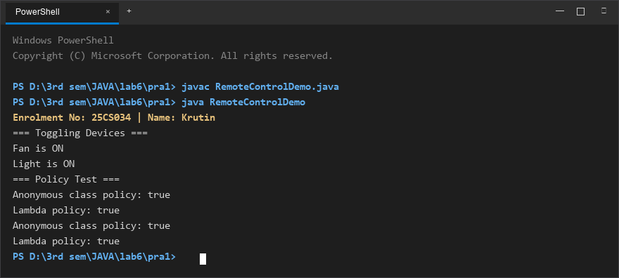
Figure 1: Console execution output for Problem 1 (Student ID: 25CS034)

Problem 2: Broadcast Notification System with Marker Interface
Problem Statement:
Create a functional interface Notifier with send(String); instantiate email and SMS senders using lambda expressions, hold them in an array, and broadcast one message through all.
Add an empty marker interface Urgent and implement it to dispatch messages twice for senders marked urgent.

Java Source Code:
/**
* Student Name : Krutin
* Enrolment No : 25CS034
* Course : CEUE203 - Object Oriented Programming
*/
@FunctionalInterface
interface Notifier {
void send(String message);
}
interface Urgent {}
class UrgentEmail implements Notifier, Urgent {
@Override
public void send(String message) {
System.out.println("Email: " + message);
}
}
public class NotificationDemo {
public static void main(String[] args) {
System.out.println("Enrolment No: 25CS034 | Name: Krutin");
Notifier email = message -> System.out.println("Email: " + message);
Notifier sms = message -> System.out.println("SMS: " + message);
Notifier[] senders = { email, sms };
String message = "Your lab session starts at 2 PM.";
System.out.println("=== Broadcast ===");
for (Notifier sender : senders) {
sender.send(message);
}
System.out.println("\n=== Urgent Notification ===");
Notifier urgentEmail = new UrgentEmail();
Notifier[] urgentSenders = { urgentEmail, sms };
for (Notifier sender : urgentSenders) {
sender.send(message);
if (sender instanceof Urgent) {
sender.send(message);
}
}
}
}

Execution Output Screenshot:

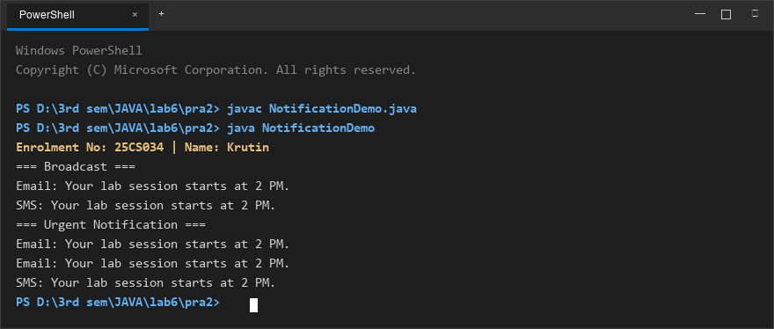
Figure 2: Console execution output for Problem 2 (Student ID: 25CS034)

FACULTY OF ENGINEERING AND TECHNOLOGY
Object Oriented Programming (CEUE203) - Semester 3
Practical 07: Custom Annotations and Runtime Reflection
Student Name: Krutin | Enrolment No: 25CS034

Problem 1: Reflection-Based Form Validator
Problem Statement:
Define custom runtime annotations @NotBlank and @MaxLength(int) for object fields and annotate a SignupForm class.
Write a reflection validator that inspects getDeclaredFields(), reads field annotations at runtime, checks constraints, and returns a list of validation error messages.

Java Source Code:
/**
* Student Name : Krutin
* Enrolment No : 25CS034
* Course : CEUE203 - Object Oriented Programming
*/
import java.lang.annotation.ElementType;
import java.lang.annotation.Retention;
import java.lang.annotation.RetentionPolicy;
import java.lang.annotation.Target;
import java.lang.reflect.Field;
import java.util.ArrayList;
import java.util.List;
@Retention(RetentionPolicy.RUNTIME)
@Target(ElementType.FIELD)
@interface NotBlank {}
@Retention(RetentionPolicy.RUNTIME)
@Target(ElementType.FIELD)
@interface MaxLength {
int value();
}
class SignupForm {
@NotBlank
@MaxLength(20)
String username;
@NotBlank
@MaxLength(30)
String email;
@NotBlank
@MaxLength(15)
String password;
SignupForm(String username, String email, String password) {
this.username = username;
this.email = email;
this.password = password;
}
}
class Validator {
public static List<String> validate(Object obj) {
List<String> errors = new ArrayList<>();
Class<?> clazz = obj.getClass();
for (Field field : clazz.getDeclaredFields()) {
field.setAccessible(true);
try {
Object value = field.get(obj);
String fieldName = field.getName();
if (field.isAnnotationPresent(NotBlank.class)) {
if (value == null || value.toString().trim().isEmpty()) {
errors.add(fieldName + " must not be blank");
}
}
if (field.isAnnotationPresent(MaxLength.class)) {
MaxLength annotation = field.getAnnotation(MaxLength.class);
int max = annotation.value();
if (value != null && value.toString().length() > max) {
errors.add(fieldName + " must not exceed " + max + " characters");
}
}
} catch (IllegalAccessException e) {
errors.add("Cannot access field: " + field.getName());
}
}
return errors;
}
}
public class Main {
public static void main(String[] args) {
System.out.println("Enrolment No: 25CS034 | Name: Krutin");
SignupForm form = new SignupForm(
"",
"verylongemailaddress123456789@example.com",
"12345678901234567890"
);
List<String> errors = Validator.validate(form);
if (errors.isEmpty()) {
System.out.println("Form is valid.");
} else {
System.out.println("Validation Errors:");
for (String error : errors) {
System.out.println("- " + error);
}
}
}
}

Execution Output Screenshot:

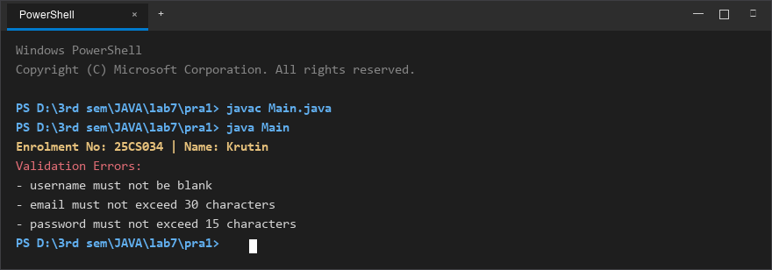
Figure 1: Console execution output for Problem 1 (Student ID: 25CS034)

Problem 2: Custom Unit Test Runner (@Run)
Problem Statement:
Define a @Run annotation with RUNTIME retention and METHOD target. Mark several no-arg test methods of a class with @Run.
Use Java reflection to inspect declared methods, invoke only those annotated with @Run, and print execution results and total tests executed.

Java Source Code:
/**
* Student Name : Krutin
* Enrolment No : 25CS034
* Course : CEUE203 - Object Oriented Programming
*/
import java.lang.annotation.ElementType;
import java.lang.annotation.Retention;
import java.lang.annotation.RetentionPolicy;
import java.lang.annotation.Target;
import java.lang.reflect.Method;
@Retention(RetentionPolicy.RUNTIME)
@Target(ElementType.METHOD)
@interface Run {}
class MyTests {
@Run
public void testAddition() {
System.out.println("Running testAddition");
}
@Run
public void testSubtraction() {
System.out.println("Running testSubtraction");
}
public void normalMethod() {
System.out.println("This method should not run");
}
@Run
public void testMessage() {
System.out.println("Running testMessage");
}
public void anotherMethod() {
System.out.println("This method should not run");
}
}
public class Main {
public static void main(String[] args) {
System.out.println("Enrolment No: 25CS034 | Name: Krutin");
MyTests testObject = new MyTests();
int count = 0;
Method[] methods = MyTests.class.getDeclaredMethods();
for (Method method : methods) {
if (method.isAnnotationPresent(Run.class) && method.getParameterCount() == 0) {
try {
method.invoke(testObject);
count++;
} catch (Exception e) {
System.out.println("Error running: " + method.getName());
}
}
}
System.out.println("\nTotal @Run methods executed: " + count);
}
}

Execution Output Screenshot:

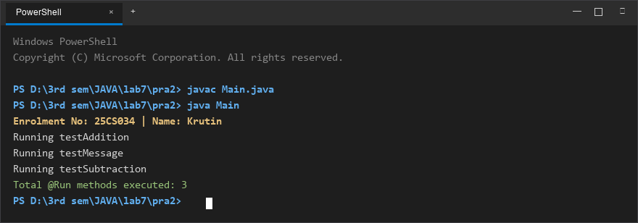
Figure 2: Console execution output for Problem 2 (Student ID: 25CS034)

FACULTY OF ENGINEERING AND TECHNOLOGY
Object Oriented Programming (CEUE203) - Semester 3
Practical 08: Exception Handling and Custom Checked Exceptions
Student Name: Krutin | Enrolment No: 25CS034

Problem 1: Guarded Robust Calculator
Problem Statement:
Create a guarded calculator that reads two numbers and an operator.
Throw a custom DivideByZeroException when denominator is 0, catch InputMismatchException for non-numeric input separately, retry in a loop until valid, and use a finally block to log each calculation attempt.

Java Source Code:
/**
* Student Name : Krutin
* Enrolment No : 25CS034
* Course : CEUE203 - Object Oriented Programming
*/
import java.util.InputMismatchException;
import java.util.Scanner;
class DivideByZeroException extends Exception {
public DivideByZeroException(String message) {
super(message);
}
}
public class GuardedCalculator {
public static void main(String[] args) {
System.out.println("Enrolment No: 25CS034 | Name: Krutin");
Scanner sc = new Scanner(System.in);
boolean success = false;
while (!success) {
try {
System.out.print("Enter first number: ");
double num1 = sc.nextDouble();
System.out.print("Enter operator (+, -, *, /): ");
char operator = sc.next().charAt(0);
System.out.print("Enter second number: ");
double num2 = sc.nextDouble();
double result;
switch (operator) {
case '+':
result = num1 + num2;
break;
case '-':
result = num1 - num2;
break;
case '*':
result = num1 * num2;
break;
case '/':
if (num2 == 0) {
throw new DivideByZeroException("Cannot divide by zero.");
}
result = num1 / num2;
break;
default:
System.out.println("Invalid operator.");
continue;
}
System.out.println("Result = " + result);
success = true;
} catch (InputMismatchException e) {
System.out.println("Invalid number input. Please enter numbers only.");
sc.nextLine();
} catch (DivideByZeroException e) {
System.out.println("Calculation error: " + e.getMessage());
sc.nextLine();
} finally {
System.out.println("Attempt logged.");
}
}
System.out.println("Valid calculation completed.");
sc.close();
}
}

Execution Output Screenshot:

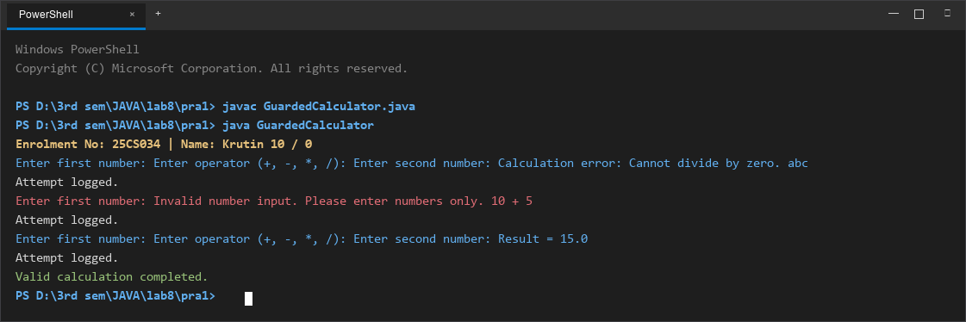
Figure 1: Console execution output for Problem 1 (Student ID: 25CS034)

Problem 2: Warehouse Stock Issue System
Problem Statement:
Model a Warehouse inventory where issue(item, qty) throws a custom checked OutOfStockException carrying the shortfall amount when inventory is insufficient, and InvalidQuantityException for qty <= 0.
Process a list of order requests, catching and reporting each specific failure gracefully without terminating the program.

Java Source Code:
/**
* Student Name : Krutin
* Enrolment No : 25CS034
* Course : CEUE203 - Object Oriented Programming
*/
import java.util.Arrays;
import java.util.HashMap;
import java.util.List;
import java.util.Map;
class OutOfStockException extends Exception {
private int shortfall;
public OutOfStockException(String message, int shortfall) {
super(message);
this.shortfall = shortfall;
}
public int getShortfall() {
return shortfall;
}
}
class InvalidQuantityException extends Exception {
public InvalidQuantityException(String message) {
super(message);
}
}
class Warehouse {
private Map<String, Integer> stock = new HashMap<>();
public Warehouse() {
stock.put("Laptop", 5);
stock.put("Mouse", 10);
stock.put("Keyboard", 3);
}
public void issue(String item, int qty) throws OutOfStockException, InvalidQuantityException {
if (qty <= 0) {
throw new InvalidQuantityException("Quantity must be greater than 0.");
}
if (!stock.containsKey(item)) {
throw new OutOfStockException("Item '" + item + "' is not available.", qty);
}
int available = stock.get(item);
if (qty > available) {
int shortfall = qty - available;
throw new OutOfStockException("Not enough stock for " + item + ". Available: " + available + ", Requested: " + qty, shortfall);
}
stock.put(item, available - qty);
System.out.println("Issued " + qty + " " + item + "(s) successfully.");
}
}
class Request {
String item;
int quantity;
Request(String item, int quantity) {
this.item = item;
this.quantity = quantity;
}
}
public class StockIssue {
public static void main(String[] args) {
System.out.println("Enrolment No: 25CS034 | Name: Krutin");
Warehouse warehouse = new Warehouse();
List<Request> requests = Arrays.asList(
new Request("Laptop", 2),
new Request("Mouse", 20),
new Request("Keyboard", 0),
new Request("Keyboard", 2),
new Request("Monitor", 1),
new Request("Laptop", 1)
);
System.out.println("=== Stock Issue Processing ===");
for (Request request : requests) {
System.out.println("\nRequest: " + request.item + " x " + request.quantity);
try {
warehouse.issue(request.item, request.quantity);
} catch (OutOfStockException e) {
System.out.println("OUT OF STOCK: " + e.getMessage());
System.out.println("Shortfall: " + e.getShortfall());
} catch (InvalidQuantityException e) {
System.out.println("INVALID QUANTITY: " + e.getMessage());
}
}
System.out.println("\nAll requests processed.");
}
}

Execution Output Screenshot:

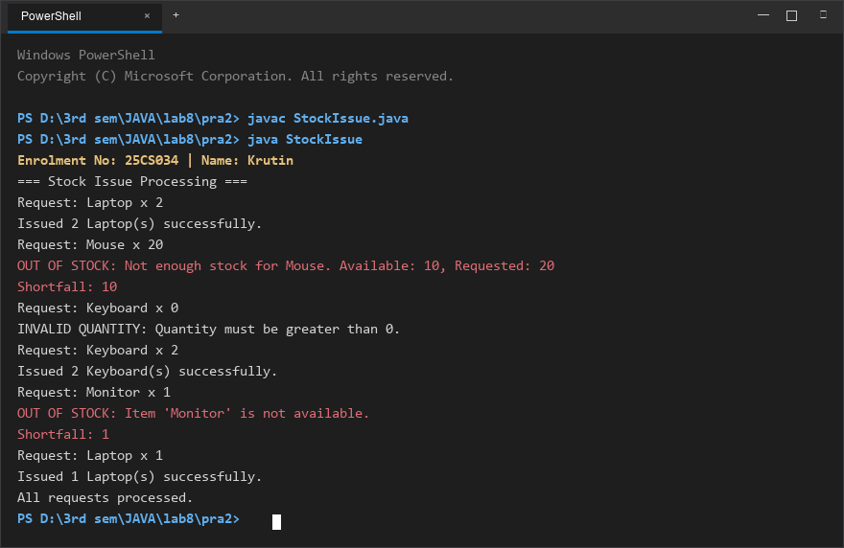
Figure 2: Console execution output for Problem 2 (Student ID: 25CS034)

FACULTY OF ENGINEERING AND TECHNOLOGY
Object Oriented Programming (CEUE203) - Semester 3
Practical 09: Multithreading, Race Conditions, and Synchronization
Student Name: Krutin | Enrolment No: 25CS034

Problem 1: Shared Counter Race Condition & Fix
Problem Statement:
Demonstrate thread race conditions: create 10 concurrent threads each incrementing a shared counter 10,000 times.
Run once without synchronization to observe lost updates (actual < expected), and then demonstrate the fix using a synchronized method, confirming the exact expected count (100,000) every run.

Java Source Code:
/**
* Student Name : Krutin
* Enrolment No : 25CS034
* Course : CEUE203 - Object Oriented Programming
*/
class UnsynchronizedCounter {
private int count = 0;
public void increment() {
count++;
}
public int getCount() {
return count;
}
}
class SynchronizedCounter {
private int count = 0;
public synchronized void increment() {
count++;
}
public int getCount() {
return count;
}
}
public class CounterRace {
public static void main(String[] args) throws InterruptedException {
System.out.println("Enrolment No: 25CS034 | Name: Krutin");
int numberOfThreads = 10;
int incrementsPerThread = 10000;
int expected = numberOfThreads * incrementsPerThread;
UnsynchronizedCounter unsafeCounter = new UnsynchronizedCounter();
Thread[] unsafeThreads = new Thread[numberOfThreads];
for (int i = 0; i < numberOfThreads; i++) {
unsafeThreads[i] = new Thread(() -> {
for (int j = 0; j < incrementsPerThread; j++) {
unsafeCounter.increment();
}
});
unsafeThreads[i].start();
}
for (Thread t : unsafeThreads) {
t.join();
}
System.out.println("Without Synchronization:");
System.out.println("Expected: " + expected);
System.out.println("Actual: " + unsafeCounter.getCount());
SynchronizedCounter safeCounter = new SynchronizedCounter();
Thread[] safeThreads = new Thread[numberOfThreads];
for (int i = 0; i < numberOfThreads; i++) {
safeThreads[i] = new Thread(() -> {
for (int j = 0; j < incrementsPerThread; j++) {
safeCounter.increment();
}
});
safeThreads[i].start();
}
for (Thread t : safeThreads) {
t.join();
}
System.out.println("\nWith Synchronization:");
System.out.println("Expected: " + expected);
System.out.println("Actual: " + safeCounter.getCount());
}
}

Execution Output Screenshot:

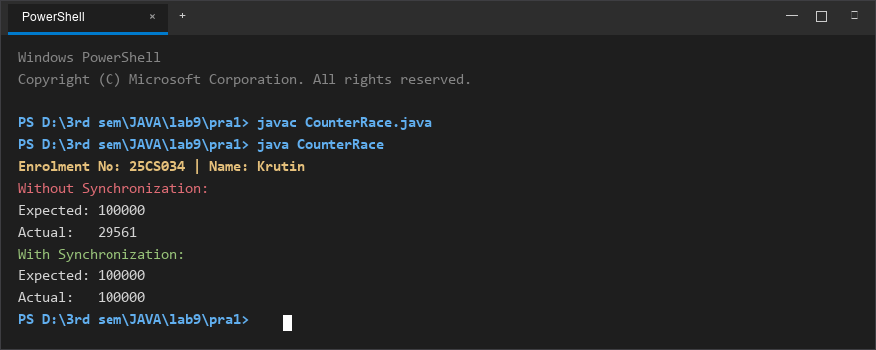
Figure 1: Console execution output for Problem 1 (Student ID: 25CS034)

Problem 2: Seat Booking Race & Thread Safety
Problem Statement:
Model a shared cinema booking system with 5 remaining seats and 10 concurrent customer threads trying to book seats.
Demonstrate that without synchronization overselling occurs (negative remaining seats). Fix the race condition with a synchronized book() method to ensure exactly 5 seats are booked and the rest rejected cleanly.

Java Source Code:
/**
* Student Name : Krutin
* Enrolment No : 25CS034
* Course : CEUE203 - Object Oriented Programming
*/
class UnsafeSeatBooking {
private int seatsLeft = 5;
public boolean book(String name) {
if (seatsLeft > 0) {
try {
Thread.sleep(10);
} catch (InterruptedException e) {
Thread.currentThread().interrupt();
}
seatsLeft--;
System.out.println(name + " booked a seat.");
return true;
}
System.out.println(name + " failed - no seats.");
return false;
}
public int getSeatsLeft() {
return seatsLeft;
}
}
class SafeSeatBooking {
private int seatsLeft = 5;
public synchronized boolean book(String name) {
if (seatsLeft > 0) {
try {
Thread.sleep(10);
} catch (InterruptedException e) {
Thread.currentThread().interrupt();
}
seatsLeft--;
System.out.println(name + " booked a seat.");
return true;
}
System.out.println(name + " failed - no seats.");
return false;
}
public int getSeatsLeft() {
return seatsLeft;
}
}
public class SeatBookingRace {
public static void main(String[] args) throws InterruptedException {
System.out.println("Enrolment No: 25CS034 | Name: Krutin");
System.out.println("=== Without Synchronization ===");
UnsafeSeatBooking unsafeBooking = new UnsafeSeatBooking();
Thread[] unsafeThreads = new Thread[10];
for (int i = 0; i < 10; i++) {
String name = "Customer-" + (i + 1);
unsafeThreads[i] = new Thread(() -> unsafeBooking.book(name));
unsafeThreads[i].start();
}
for (Thread t : unsafeThreads) {
t.join();
}
System.out.println("Seats remaining (Unsafe): " + unsafeBooking.getSeatsLeft());
System.out.println("\n=== With Synchronization ===");
SafeSeatBooking safeBooking = new SafeSeatBooking();
Thread[] safeThreads = new Thread[10];
for (int i = 0; i < 10; i++) {
String name = "Customer-" + (i + 1);
safeThreads[i] = new Thread(() -> safeBooking.book(name));
safeThreads[i].start();
}
for (Thread t : safeThreads) {
t.join();
}
System.out.println("Seats remaining (Safe): " + safeBooking.getSeatsLeft());
}
}

Execution Output Screenshot:

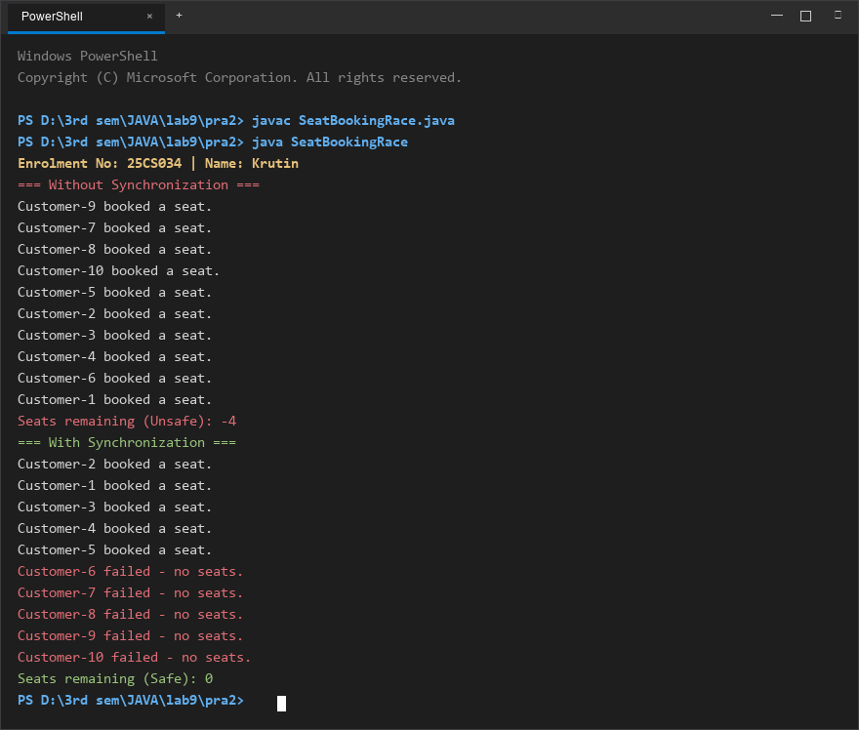
Figure 2: Console execution output for Problem 2 (Student ID: 25CS034)

FACULTY OF ENGINEERING AND TECHNOLOGY
Object Oriented Programming (CEUE203) - Semester 3
Practical 10: ExecutorService Thread Pool & Inter-Thread Coordination
Student Name: Krutin | Enrolment No: 25CS034

Problem 1: Fixed Thread-Pool Task Runner
Problem Statement:
Create a fixed thread pool of 3 worker threads using Executors.newFixedThreadPool(3).
Submit 10 Runnable tasks that print their task ID and executing thread name, sleep briefly to simulate work, shut down gracefully, and await completion using awaitTermination().

Java Source Code:
/**
* Student Name : Krutin
* Enrolment No : 25CS034
* Course : CEUE203 - Object Oriented Programming
*/
import java.util.concurrent.ExecutorService;
import java.util.concurrent.Executors;
import java.util.concurrent.TimeUnit;
public class ThreadPoolRunner {
public static void main(String[] args) throws InterruptedException {
System.out.println("Enrolment No: 25CS034 | Name: Krutin");
ExecutorService executor = Executors.newFixedThreadPool(3);
for (int i = 1; i <= 10; i++) {
int taskId = i;
executor.submit(() -> {
try {
System.out.println("Task " + taskId + " is running on " + Thread.currentThread().getName());
Thread.sleep(200);
System.out.println("Task " + taskId + " completed by " + Thread.currentThread().getName());
} catch (InterruptedException e) {
Thread.currentThread().interrupt();
}
});
}
executor.shutdown();
if (executor.awaitTermination(5, TimeUnit.SECONDS)) {
System.out.println("All tasks completed.");
} else {
System.out.println("Some tasks did not finish.");
}
}
}

Execution Output Screenshot:

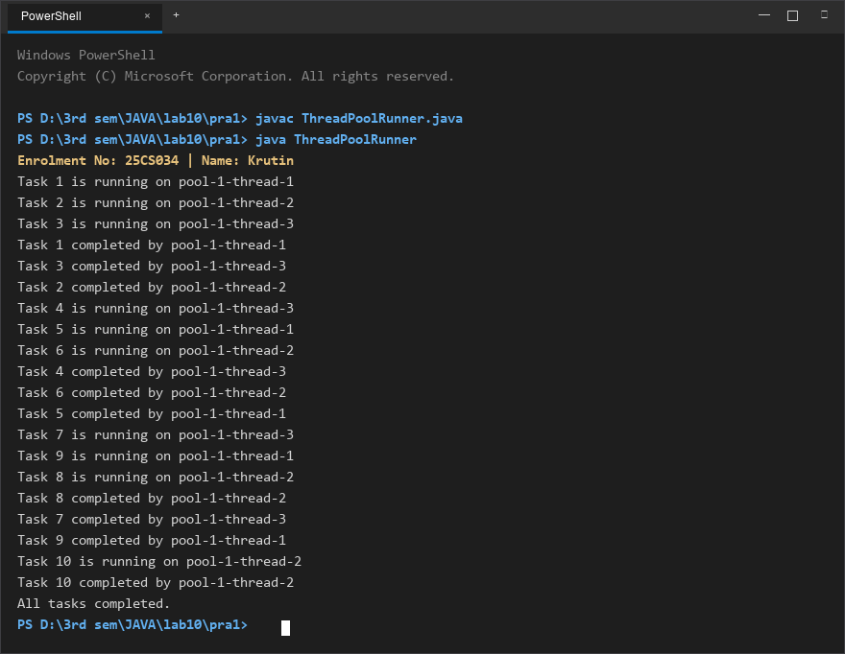
Figure 1: Console execution output for Problem 1 (Student ID: 25CS034)

Problem 2: Producer-Consumer with wait() and notify()
Problem Statement:
Implement the classic Producer-Consumer pattern using a synchronized SharedBuffer.
Coordinate producer and consumer threads using intrinsic locks with wait() and notify() methods, guaranteeing sequential in-order item production and consumption with zero data loss.

Java Source Code:
/**
* Student Name : Krutin
* Enrolment No : 25CS034
* Course : CEUE203 - Object Oriented Programming
*/
class SharedBuffer {
private int item;
private boolean available = false;
public synchronized void produce(int value) throws InterruptedException {
while (available) {
wait();
}
item = value;
available = true;
System.out.println("Produced: " + value);
notify();
}
public synchronized int consume() throws InterruptedException {
while (!available) {
wait();
}
int value = item;
available = false;
System.out.println("Consumed: " + value);
notify();
return value;
}
}
public class ProducerConsumer {
public static void main(String[] args) {
System.out.println("Enrolment No: 25CS034 | Name: Krutin");
SharedBuffer buffer = new SharedBuffer();
Thread producer = new Thread(() -> {
try {
for (int i = 1; i <= 5; i++) {
buffer.produce(i);
}
} catch (InterruptedException e) {
Thread.currentThread().interrupt();
}
});
Thread consumer = new Thread(() -> {
try {
for (int i = 1; i <= 5; i++) {
buffer.consume();
}
} catch (InterruptedException e) {
Thread.currentThread().interrupt();
}
});
producer.start();
consumer.start();
try {
producer.join();
consumer.join();
} catch (InterruptedException e) {
Thread.currentThread().interrupt();
}
System.out.println("All items produced and consumed.");
}
}

Execution Output Screenshot:

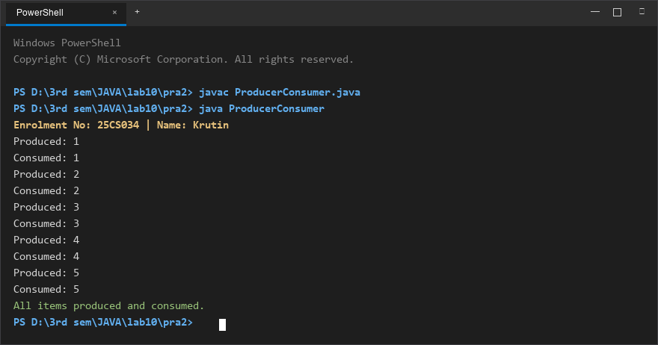
Figure 2: Console execution output for Problem 2 (Student ID: 25CS034)

FACULTY OF ENGINEERING AND TECHNOLOGY
Object Oriented Programming (CEUE203) - Semester 3
Practical 11: Object Serialization and Java NIO File Handling
Student Name: Krutin | Enrolment No: 25CS034

Problem 1: Object Serialization with Transient Fields
Problem Statement:
Define a Serializable Student class with an id, name, and transient password field.
Serialize an array of student objects to a binary file using ObjectOutputStream inside try-with-resources. Deserialize the array back using ObjectInputStream, demonstrating that serialized fields survive while transient fields remain null.

Java Source Code:
/**
* Student Name : Krutin
* Enrolment No : 25CS034
* Course : CEUE203 - Object Oriented Programming
*/
import java.io.FileInputStream;
import java.io.FileOutputStream;
import java.io.IOException;
import java.io.ObjectInputStream;
import java.io.ObjectOutputStream;
import java.io.Serializable;
class Student implements Serializable {
int id;
String name;
transient String password;
Student(int id, String name, String password) {
this.id = id;
this.name = name;
this.password = password;
}
void display() {
System.out.println("ID: " + id + ", Name: " + name + ", Password: " + password);
}
}
public class Saveload {
public static void main(String[] args) {
System.out.println("Enrolment No: 25CS034 | Name: Krutin");
Student[] students = {
new Student(101, "Krutin", "abc123"),
new Student(102, "Rahul", "xyz456")
};
try (ObjectOutputStream out = new ObjectOutputStream(new FileOutputStream("students.dat"))) {
out.writeObject(students);
System.out.println("Objects saved successfully.");
} catch (IOException e) {
e.printStackTrace();
}
try (ObjectInputStream in = new ObjectInputStream(new FileInputStream("students.dat"))) {
Student[] loadedStudents = (Student[]) in.readObject();
System.out.println("\nObjects loaded successfully:");
for (Student s : loadedStudents) {
s.display();
}
} catch (IOException | ClassNotFoundException e) {
e.printStackTrace();
}
}
}

Execution Output Screenshot:

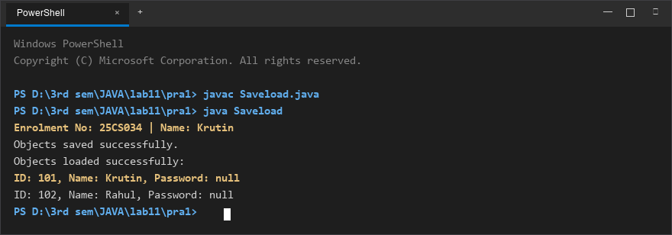
Figure 1: Console execution output for Problem 1 (Student ID: 25CS034)

Problem 2: NIO Directory Stream & Log Analyzer
Problem Statement:
Create multiple log text files using modern Java NIO (Files, Path).
Iterate through the directory using Files.newDirectoryStream(), read line-by-line with BufferedReader, count total lines and keyword matches ("ERROR"), and inspect file sizes using Files.readAttributes().

Java Source Code:
/**
* Student Name : Krutin
* Enrolment No : 25CS034
* Course : CEUE203 - Object Oriented Programming
*/
import java.io.BufferedReader;
import java.io.IOException;
import java.nio.file.DirectoryStream;
import java.nio.file.Files;
import java.nio.file.Path;
import java.nio.file.Paths;
import java.nio.file.attribute.BasicFileAttributes;
import java.util.Arrays;
public class Loganalyzer {
public static void main(String[] args) {
System.out.println("Enrolment No: 25CS034 | Name: Krutin");
Path folder = Paths.get("logs");
String keyword = "ERROR";
int totalLines = 0;
int totalKeywordLines = 0;
try {
Files.createDirectories(folder);
Files.write(folder.resolve("a.txt"), Arrays.asList(
"INFO Server started",
"ERROR Database failed",
"INFO User logged in"
));
Files.write(folder.resolve("b.txt"), Arrays.asList(
"INFO Request received",
"ERROR File not found",
"INFO Request completed",
"ERROR Server stopped"
));
Files.write(folder.resolve("c.txt"), Arrays.asList(
"INFO System running",
"INFO Backup completed"
));
try (DirectoryStream<Path> files = Files.newDirectoryStream(folder, "*.txt")) {
for (Path file : files) {
int lines = 0;
int keywordLines = 0;
try (BufferedReader reader = Files.newBufferedReader(file)) {
String line;
while ((line = reader.readLine()) != null) {
lines++;
if (line.contains(keyword)) {
keywordLines++;
}
}
}
BasicFileAttributes attrs = Files.readAttributes(file, BasicFileAttributes.class);
long size = attrs.size();
System.out.println("File: " + file.getFileName());
System.out.println("Size: " + size + " bytes");
System.out.println("Lines: " + lines);
System.out.println("Contains ERROR: " + keywordLines);
System.out.println();
totalLines += lines;
totalKeywordLines += keywordLines;
}
}
System.out.println("===== Overall Result =====");
System.out.println("Total Lines: " + totalLines);
System.out.println("Total Lines Containing ERROR: " + totalKeywordLines);
} catch (IOException e) {
System.out.println("Error: " + e.getMessage());
}
}
}

Execution Output Screenshot:

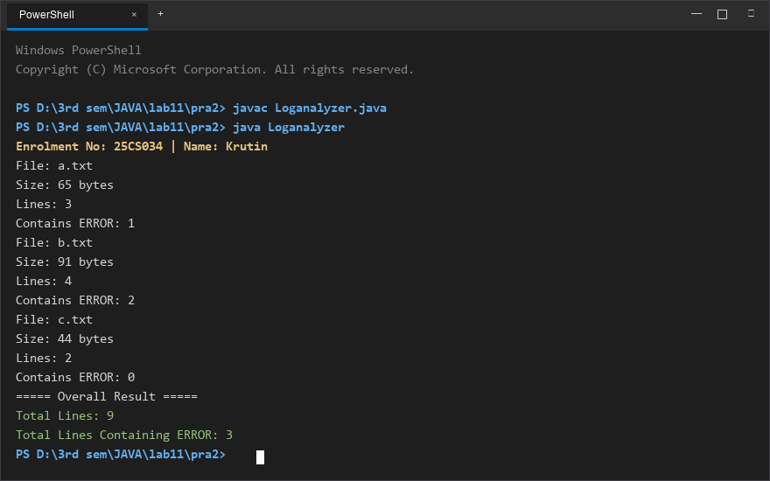
Figure 2: Console execution output for Problem 2 (Student ID: 25CS034)

FACULTY OF ENGINEERING AND TECHNOLOGY
Object Oriented Programming (CEUE203) - Semester 3
Practical 12: Java Collections Framework (HashMap, Set, and Custom Sorting)
Student Name: Krutin | Enrolment No: 25CS034

Problem 1: Word Frequency Analyzer with Comparator
Problem Statement:
Tokenize a paragraph into lowercase words, count the occurrences of each word using a HashMap<String, Integer>, and sort the entry set in descending order of frequency using a custom Comparator / lambda.

Java Source Code:
/**
* Student Name : Krutin
* Enrolment No : 25CS034
* Course : CEUE203 - Object Oriented Programming
*/
import java.util.ArrayList;
import java.util.HashMap;
import java.util.List;
import java.util.Map;
public class WordFrequency {
public static void main(String[] args) {
System.out.println("Enrolment No: 25CS034 | Name: Krutin");
String paragraph = "java is easy and java is powerful java is popular";
String[] words = paragraph.toLowerCase().split("\\s+");
HashMap<String, Integer> frequency = new HashMap<>();
for (String word : words) {
frequency.put(word, frequency.getOrDefault(word, 0) + 1);
}
List<Map.Entry<String, Integer>> list = new ArrayList<>(frequency.entrySet());
list.sort((a, b) -> b.getValue().compareTo(a.getValue()));
System.out.println("Words sorted by frequency:");
for (Map.Entry<String, Integer> entry : list) {
System.out.println(entry.getKey() + " : " + entry.getValue());
}
}
}

Execution Output Screenshot:

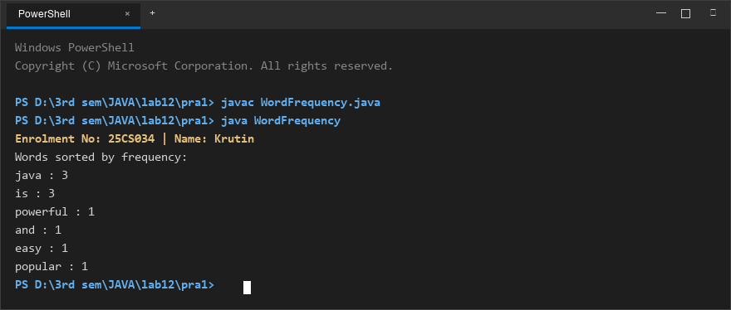
Figure 1: Console execution output for Problem 1 (Student ID: 25CS034)

Problem 2: Unique Visitors Tracker (HashSet & LinkedHashSet)
Problem Statement:
From a stream of user login names containing duplicates, use a HashSet to count unique visitors and a LinkedHashSet to preserve first-seen insertion order.
Print the total distinct visitor count and display the first three distinct visitors in order.

Java Source Code:
/**
* Student Name : Krutin
* Enrolment No : 25CS034
* Course : CEUE203 - Object Oriented Programming
*/
import java.util.Arrays;
import java.util.HashSet;
import java.util.LinkedHashSet;
import java.util.List;
public class UniqueVisitors {
public static void main(String[] args) {
System.out.println("Enrolment No: 25CS034 | Name: Krutin");
List<String> loginNames = Arrays.asList(
"Krutin",
"Rahul",
"Amit",
"Krutin",
"Neha",
"Rahul",
"Priya",
"Jay"
);
HashSet<String> uniqueUsers = new HashSet<>(loginNames);
LinkedHashSet<String> firstSeenUsers = new LinkedHashSet<>(loginNames);
System.out.println("Unique users: " + uniqueUsers.size());
System.out.println("First three distinct names:");
int count = 0;
for (String name : firstSeenUsers) {
System.out.println(name);
count++;
if (count == 3) {
break;
}
}
}
}

Execution Output Screenshot:

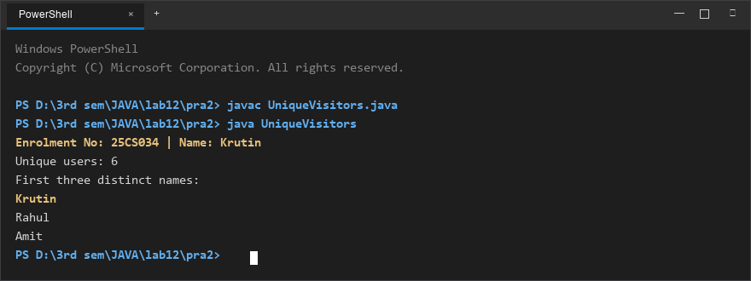
Figure 2: Console execution output for Problem 2 (Student ID: 25CS034)

FACULTY OF ENGINEERING AND TECHNOLOGY
Object Oriented Programming (CEUE203) - Semester 3
Practical 13: Java Generics (Generic Classes, Methods, and Bounded Types)
Student Name: Krutin | Enrolment No: 25CS034

Problem 1: Generic Containers (Box & Pair)
Problem Statement:
Implement generic container classes Box<T> and Pair<A, B> with getter and setter methods.
Demonstrate compile-time type safety with different types (Integer, String) without explicit casting, and write a generic method <T> T firstElement(T[] array) that returns the first element of any array.

Java Source Code:
File: Box.java
/**
* Student Name : Krutin
* Enrolment No : 25CS034
* Course : CEUE203 - Object Oriented Programming
*/
public class Box<T> {
private T value;
public Box(T value) {
this.value = value;
}
public T get() {
return value;
}
public void set(T value) {
this.value = value;
}
}

File: Pair.java
/**
* Student Name : Krutin
* Enrolment No : 25CS034
* Course : CEUE203 - Object Oriented Programming
*/
public class Pair<A, B> {
private A first;
private B second;
public Pair(A first, B second) {
this.first = first;
this.second = second;
}
public A getFirst() {
return first;
}
public B getSecond() {
return second;
}
}

File: GenericDemo.java
/**
* Student Name : Krutin
* Enrolment No : 25CS034
* Course : CEUE203 - Object Oriented Programming
*/
public class GenericDemo {
public static <T> T firstElement(T[] array) {
return array[0];
}
public static void main(String[] args) {
System.out.println("Enrolment No: 25CS034 | Name: Krutin");
Box<Integer> b1 = new Box<>(100);
System.out.println("Box Integer: " + b1.get());
b1.set(200);
System.out.println("Updated Box: " + b1.get());
Box<String> b2 = new Box<>("Hello");
System.out.println("Box String: " + b2.get());
Pair<String, Integer> p1 = new Pair<>("Age", 20);
System.out.println("Pair First: " + p1.getFirst());
System.out.println("Pair Second: " + p1.getSecond());
Integer[] numbers = {10, 20, 30};
System.out.println("First Integer: " + firstElement(numbers));
String[] names = {"Java", "Python", "C++"};
System.out.println("First String: " + firstElement(names));
}
}

Execution Output Screenshot:

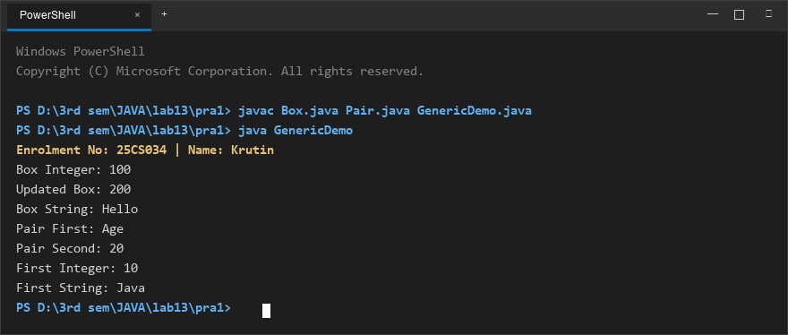
Figure 1: Console execution output for Problem 1 (Student ID: 25CS034)

Problem 2: Bounded Type Generic Method
Problem Statement:
Write a bounded type generic method <N extends Number> double average(N[] values) that computes the arithmetic mean for any numeric array (Integer[], Double[], Long[]).
Demonstrate how the upper bound ensures type safety and allows calling Number methods like doubleValue().

Java Source Code:
/**
* Student Name : Krutin
* Enrolment No : 25CS034
* Course : CEUE203 - Object Oriented Programming
*/
public class BoundedStats {
static <N extends Number> double average(N[] values) {
double sum = 0;
for (N n : values) {
sum += n.doubleValue();
}
return sum / values.length;
}
public static void main(String[] args) {
System.out.println("Enrolment No: 25CS034 | Name: Krutin");
Integer[] intValues = {1, 2, 3, 4, 5};
Double[] doubleValues = {1.0, 2.0, 3.0, 4.0, 5.0};
Long[] longValues = {10L, 20L, 30L, 40L, 50L};
System.out.println("Integer Average: " + average(intValues));
System.out.println("Double Average: " + average(doubleValues));
System.out.println("Long Average: " + average(longValues));
}
}

Execution Output Screenshot:

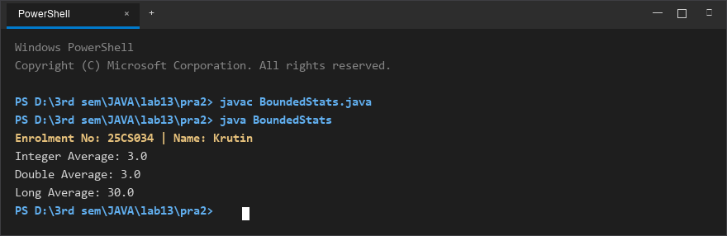
Figure 2: Console execution output for Problem 2 (Student ID: 25CS034)

FACULTY OF ENGINEERING AND TECHNOLOGY
Object Oriented Programming (CEUE203) - Semester 3
Practical 14: Layered Application Architecture, Testing, and State Persistence
Student Name: Krutin | Enrolment No: 25CS034

Problem 1: Modular Layered Student Management Service
Problem Statement:
Build a layered application featuring a model entity (Student), an in-memory service layer (StudentService backed by ArrayList), and an interactive console interface (Main) for managing records, accompanied by JUnit unit tests validating business rules.

Java Source Code:
File: Student.java
/**
* Student Name : Krutin
* Enrolment No : 25CS034
* Course : CEUE203 - Object Oriented Programming
*/
public class Student {
private int id;
private String name;
private String course;
public Student(int id, String name, String course) {
this.id = id;
this.name = name;
this.course = course;
}
public int getId() {
return id;
}
public String getName() {
return name;
}
public String getCourse() {
return course;
}
@Override
public String toString() {
return "ID: " + id + ", Name: " + name + ", Course: " + course;
}
}

File: StudentService.java
/**
* Student Name : Krutin
* Enrolment No : 25CS034
* Course : CEUE203 - Object Oriented Programming
*/
import java.util.ArrayList;
public class StudentService {
private ArrayList<Student> students = new ArrayList<>();
public void addStudent(Student student) {
if (student == null) {
throw new IllegalArgumentException("Student cannot be null");
}
students.add(student);
}
public ArrayList<Student> getStudents() {
return new ArrayList<>(students);
}
public int getCount() {
return students.size();
}
}

File: Main.java
/**
* Student Name : Krutin
* Enrolment No : 25CS034
* Course : CEUE203 - Object Oriented Programming
*/
import java.util.Scanner;
public class Main {
public static void main(String[] args) {
System.out.println("Enrolment No: 25CS034 | Name: Krutin");
StudentService service = new StudentService();
Scanner sc = new Scanner(System.in);
boolean running = true;
while (running) {
System.out.println("\n--- Student Management ---");
System.out.println("1. Add Student");
System.out.println("2. List Students");
System.out.println("3. Exit");
System.out.print("Enter choice: ");
if (!sc.hasNextInt()) {
break;
}
int choice = sc.nextInt();
switch (choice) {
case 1:
System.out.print("Enter ID: ");
int id = sc.nextInt();
sc.nextLine();
System.out.print("Enter Name: ");
String name = sc.nextLine();
System.out.print("Enter Course: ");
String course = sc.nextLine();
service.addStudent(new Student(id, name, course));
System.out.println("Student added. Total: " + service.getCount());
break;
case 2:
System.out.println("\nStudents List:");
for (Student s : service.getStudents()) {
System.out.println(s);
}
break;
case 3:
running = false;
System.out.println("Goodbye!");
break;
default:
System.out.println("Invalid choice.");
}
}
sc.close();
}
}

File: StudentServiceTest.java
/**
* Student Name : Krutin
* Enrolment No : 25CS034
* Course : CEUE203 - Object Oriented Programming
*/
import org.junit.jupiter.api.Test;
import static org.junit.jupiter.api.Assertions.assertEquals;
import static org.junit.jupiter.api.Assertions.assertThrows;
public class StudentServiceTest {
@Test
void addingStudentIncreasesCount() {
StudentService service = new StudentService();
service.addStudent(new Student(1, "Rahul", "CSE"));
assertEquals(1, service.getCount());
}
@Test
void addingTwoStudentsGivesCountTwo() {
StudentService service = new StudentService();
service.addStudent(new Student(1, "Rahul", "CSE"));
service.addStudent(new Student(2, "Priya", "IT"));
assertEquals(2, service.getCount());
}
@Test
void addingNullStudentThrowsException() {
StudentService service = new StudentService();
assertThrows(IllegalArgumentException.class, () -> service.addStudent(null));
}
}

Execution Output Screenshot:

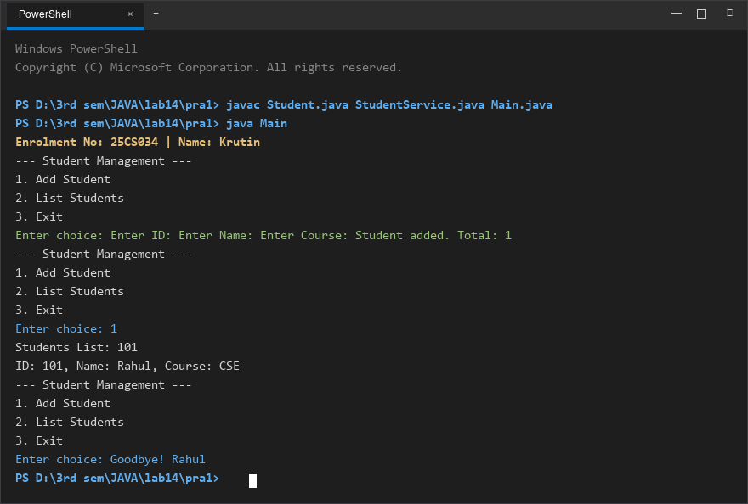
Figure 1: Console execution output for Problem 1 (Student ID: 25CS034)

Problem 2: Application State Serialization Persistence
Problem Statement:
Design a standalone persistent application that encapsulates student records into serializable objects, writes state to disk on exit, and reloads data upon startup verifying state persistence.

Java Source Code:
/**
* Student Name : Krutin
* Enrolment No : 25CS034
* Course : CEUE203 - Object Oriented Programming
*/
import java.io.FileInputStream;
import java.io.FileOutputStream;
import java.io.IOException;
import java.io.ObjectInputStream;
import java.io.ObjectOutputStream;
import java.io.Serializable;
import java.util.ArrayList;
class StudentRecord implements Serializable {
private int id;
private String name;
public StudentRecord(int id, String name) {
this.id = id;
this.name = name;
}
@Override
public String toString() {
return "ID: " + id + ", Name: " + name;
}
}
public class App {
public static void main(String[] args) {
System.out.println("Enrolment No: 25CS034 | Name: Krutin");
ArrayList<StudentRecord> list = new ArrayList<>();
list.add(new StudentRecord(101, "Rahul"));
list.add(new StudentRecord(102, "Priya"));
String filename = "data.dat";
try (ObjectOutputStream out = new ObjectOutputStream(new FileOutputStream(filename))) {
out.writeObject(list);
System.out.println("Data saved successfully.");
} catch (IOException e) {
e.printStackTrace();
}
try (ObjectInputStream in = new ObjectInputStream(new FileInputStream(filename))) {
@SuppressWarnings("unchecked")
ArrayList<StudentRecord> loaded = (ArrayList<StudentRecord>) in.readObject();
System.out.println("Data reloaded successfully:");
for (StudentRecord s : loaded) {
System.out.println(s);
}
} catch (IOException | ClassNotFoundException e) {
e.printStackTrace();
}
}
}

Execution Output Screenshot:

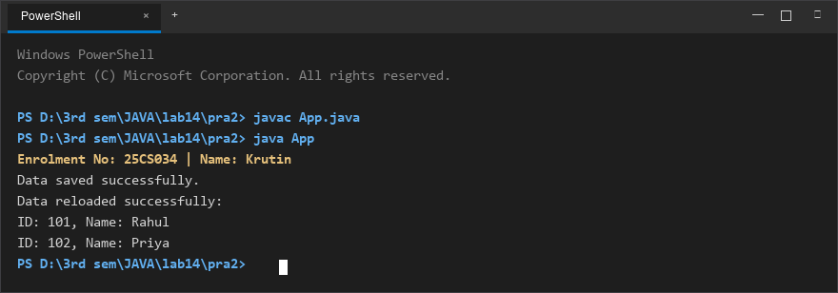
Figure 2: Console execution output for Problem 2 (Student ID: 25CS034)

