FACULTY OF ENGINEERING AND TECHNOLOGY
Object Oriented Programming (CEUE203) - Semester 3
Practical 01: Enums, Records, and Switch Expressions
Student Name: Krutin | Enrolment No: 25CS034

Problem 1: Vending Machine
Problem Statement:
(a) Define an enum Coin with constants ONE, TWO, FIVE, TEN.
(b) In main, set a snack price of 15 and a running total of 0; create a Scanner.
(c) Loop: read a coin name, use a switch expression to convert the Coin to its value (ONE->1, TWO->2, FIVE->5, TEN->10), add it to the total, and print the total so far.
(d) Stop the loop once the total reaches 15 or more.
(e) Print the change to return (total - 15).
Expected output: TEN then FIVE prints "Paid. Change: 0"; TEN then TEN prints "Paid. Change: 5".

Java Source Code:
/**
* Student Name : Krutin
* Enrolment No : 25CS034
* Course : CEUE203 - Object Oriented Programming
*/
import java.util.Scanner;
public class VendingMachine {
enum Coin {
ONE, TWO, FIVE, TEN
}
public static void main(String[] args) {
System.out.println("Enrolment No: 25CS034 | Name: Krutin");
final int PRICE = 15;
int total = 0;
Scanner sc = new Scanner(System.in);
System.out.println("Snack price: " + PRICE);
while (total < PRICE) {
System.out.print("Insert coin (ONE, TWO, FIVE, TEN): ");
String input = sc.next().toUpperCase();
try {
Coin coin = Coin.valueOf(input);
int value = switch (coin) {
case ONE -> 1;
case TWO -> 2;
case FIVE -> 5;
case TEN -> 10;
};
total += value;
System.out.println("Total inserted: " + total);
} catch (IllegalArgumentException e) {
System.out.println("Invalid coin.");
}
}
int change = total - PRICE;
System.out.println("Paid. Change: " + change);
sc.close();
}
}

Execution Output Screenshot:

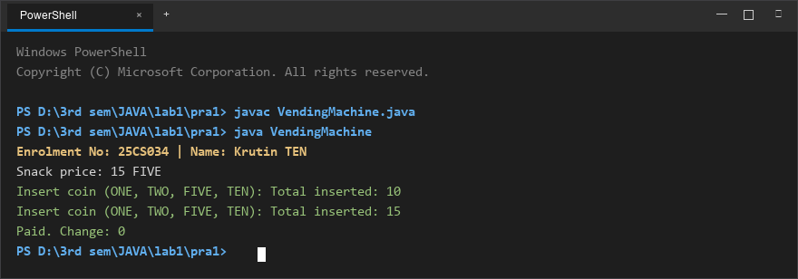
Figure 1: Console execution output for Problem 1 (Student ID: 25CS034)

Problem 2: Toll Booth Management
Problem Statement:
(a) Define a record Vehicle(String number, String type).
(b) In main, keep a running toll total and three counters (bike, car, truck).
(c) Loop until the user types "done" for the number: build a Vehicle, use a switch expression on its type for the toll (bike->20, car->50, truck->150), add to the total, and increment that type's counter.
(d) After the loop, print the total toll and the type with the highest count.
Expected output: two cars + one bike -> "Total toll: 120", "Most frequent: car".

Java Source Code:
/**
* Student Name : Krutin
* Enrolment No : 25CS034
* Course : CEUE203 - Object Oriented Programming
*/
import java.util.Scanner;
record Vehicle(String number, String type) {}
public class TollBooth {
public static void main(String[] args) {
System.out.println("Enrolment No: 25CS034 | Name: Krutin");
Scanner sc = new Scanner(System.in);
int totalToll = 0;
int bikeCount = 0;
int carCount = 0;
int truckCount = 0;
while (true) {
System.out.print("Enter vehicle number (or done to stop): ");
String number = sc.next();
if (number.equalsIgnoreCase("done")) {
break;
}
System.out.print("Enter vehicle type (bike/car/truck): ");
String type = sc.next().toLowerCase();
Vehicle vehicle = new Vehicle(number, type);
int toll = switch (vehicle.type()) {
case "bike" -> 20;
case "car" -> 50;
case "truck" -> 150;
default -> 0;
};
totalToll += toll;
switch (vehicle.type()) {
case "bike" -> bikeCount++;
case "car" -> carCount++;
case "truck" -> truckCount++;
default -> System.out.println("Invalid vehicle type!");
}
}
System.out.println("\nTotal toll: " + totalToll);
if (bikeCount >= carCount && bikeCount >= truckCount) {
System.out.println("Most frequent: bike");
} else if (carCount >= bikeCount && carCount >= truckCount) {
System.out.println("Most frequent: car");
} else {
System.out.println("Most frequent: truck");
}
sc.close();
}
}

Execution Output Screenshot:

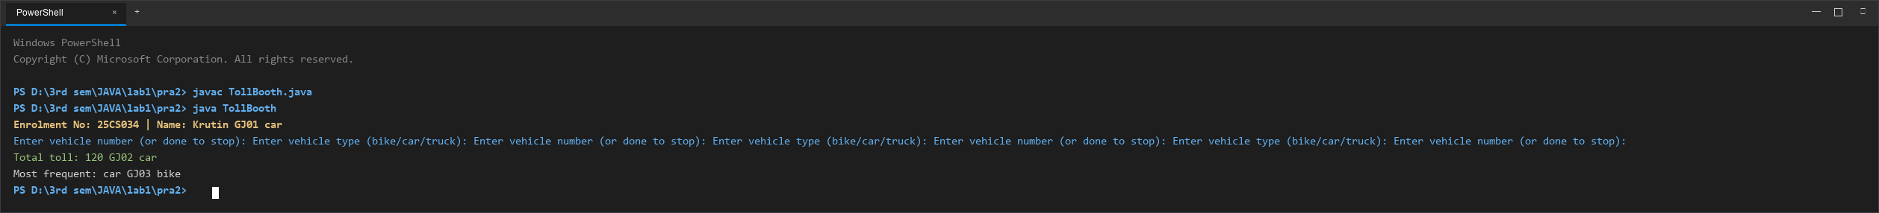
Figure 2: Console execution output for Problem 2 (Student ID: 25CS034)

