FACULTY OF ENGINEERING AND TECHNOLOGY
Object Oriented Programming (CEUE203) - Semester 3
Practical 02: Classes, Constructors, Encapsulation, and Static Members
Student Name: Krutin | Enrolment No: 25CS034

Problem 1: Smart Thermostat
Problem Statement:
(a) Create class Thermostat with private String location, private int temperature, private static final int MIN=16 and MAX=30, and private static int activeCount=0.
(b) Constructor(location, startTemp): store location; set temperature to startTemp if it is within MIN..MAX else 22; increment activeCount.
(c) Constructor(location): chain with this(location, 22).
(d) raise(): if temperature < MAX add 1, else print "Already at maximum (30)".
(e) lower(): if temperature > MIN subtract 1, else print "Already at minimum (16)".
(f) Add getTemperature() (no setter) and static getActiveCount().
(g) In main: create two thermostats, call raise() 10 times then lower() 20 times in loops, then print getActiveCount().

Java Source Code:
/**
* Student Name : Krutin
* Enrolment No : 25CS034
* Course : CEUE203 - Object Oriented Programming
*/
public class Thermostat {
private String location;
private int temperature;
private static final int MIN = 16;
private static final int MAX = 30;
private static int activeCount = 0;
public Thermostat(String location, int startTemp) {
this.location = location;
if (startTemp >= MIN && startTemp <= MAX) {
this.temperature = startTemp;
} else {
this.temperature = 22;
}
activeCount++;
}
public Thermostat(String location) {
this(location, 22);
}
public void raise() {
if (temperature < MAX) {
temperature++;
} else {
System.out.println("Already at maximum (30)");
}
}
public void lower() {
if (temperature > MIN) {
temperature--;
} else {
System.out.println("Already at minimum (16)");
}
}
public int getTemperature() {
return temperature;
}
public static int getActiveCount() {
return activeCount;
}
public static void main(String[] args) {
System.out.println("Enrolment No: 25CS034 | Name: Krutin");
Thermostat t1 = new Thermostat("Living Room", 22);
Thermostat t2 = new Thermostat("Bedroom");
for (int i = 0; i < 10; i++) {
t1.raise();
System.out.println("Temperature: " + t1.getTemperature());
}
for (int i = 0; i < 20; i++) {
t1.lower();
System.out.println("Temperature: " + t1.getTemperature());
}
System.out.println("Active Count: " + Thermostat.getActiveCount());
}
}

Execution Output Screenshot:

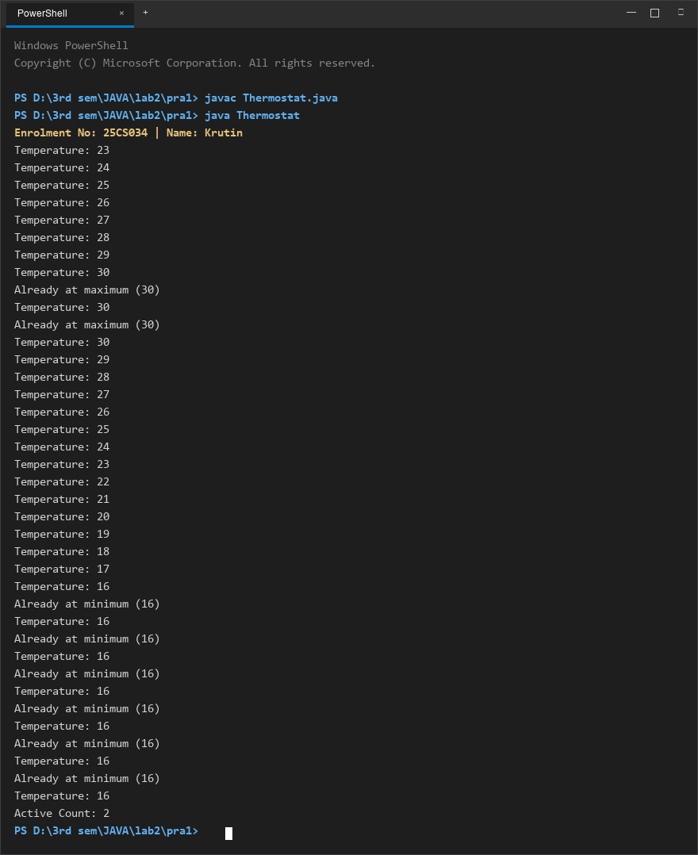
Figure 1: Console execution output for Problem 1 (Student ID: 25CS034)

Problem 2: Cinema Show Booking
Problem Statement:
(a) Create class CinemaShow with private String title, private int seatsAvailable, private final int capacity, and private static int totalBooked=0.
(b) Constructor(title, capacity): set both and seatsAvailable = capacity. Constructor(title): chain with this(title, 100).
(c) book(int n): if n <= seatsAvailable, reduce seatsAvailable by n, add n to totalBooked, return true; else return false unchanged.
(d) cancel(int n): increase seatsAvailable by n but never above capacity.
(e) Add getSeatsAvailable() and static getTotalBooked().
(f) In main: run a sequence of book and cancel calls, printing the result and seats after each, then print getTotalBooked().

Java Source Code:
/**
* Student Name : Krutin
* Enrolment No : 25CS034
* Course : CEUE203 - Object Oriented Programming
*/
public class CinemaShow {
private String title;
private int seatsAvailable;
private final int capacity;
private static int totalBooked = 0;
public CinemaShow(String title, int capacity) {
this.title = title;
this.capacity = capacity;
this.seatsAvailable = capacity;
}
public CinemaShow(String title) {
this(title, 100);
}
public boolean book(int n) {
if (n <= seatsAvailable) {
seatsAvailable -= n;
totalBooked += n;
return true;
}
return false;
}
public void cancel(int n) {
seatsAvailable += n;
if (seatsAvailable > capacity) {
seatsAvailable = capacity;
}
}
public int getSeatsAvailable() {
return seatsAvailable;
}
public static int getTotalBooked() {
return totalBooked;
}
public static void main(String[] args) {
System.out.println("Enrolment No: 25CS034 | Name: Krutin");
CinemaShow show = new CinemaShow("Avengers", 50);
System.out.println("Book 20: " + show.book(20) + ", Seats left: " + show.getSeatsAvailable());
System.out.println("Book 40: " + show.book(40) + ", Seats left: " + show.getSeatsAvailable());
System.out.println("Cancel 10");
show.cancel(10);
System.out.println("Seats left: " + show.getSeatsAvailable());
System.out.println("Total Booked: " + CinemaShow.getTotalBooked());
}
}

Execution Output Screenshot:

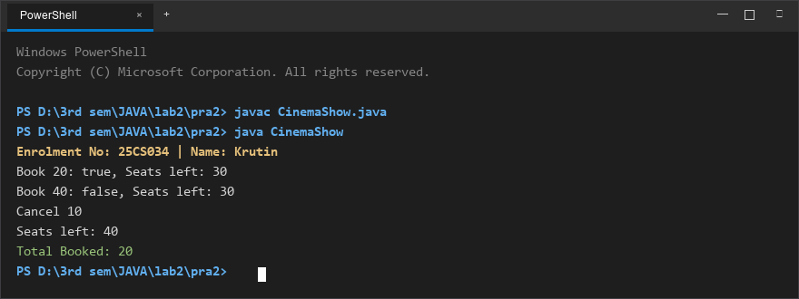
Figure 2: Console execution output for Problem 2 (Student ID: 25CS034)

