FACULTY OF ENGINEERING AND TECHNOLOGY
Object Oriented Programming (CEUE203) - Semester 3
Practical 03: Overriding Object-Class Methods (equals, hashCode, toString)
Student Name: Krutin | Enrolment No: 25CS034

Problem 1: Distinct Coordinates Filter
Problem Statement:
(a) Create class Point with private int x, y and a constructor.
(b) Override toString() to return "(x, y)".
(c) Override equals(Object) to be true when both x and y match, and hashCode() to agree (e.g. Objects.hash(x, y)).
(d) In Driver.main: build a Point[] with some repeated coordinates.
(e) Count distinct points: for each point, use equals() to check whether it already appeared earlier; count those that did not.
(f) Print "Distinct: N".
Expected output: 5 points with 2 repeats -> "Distinct: 3".

Java Source Code:
File: Point.java
/**
* Student Name : Krutin
* Enrolment No : 25CS034
* Course : CEUE203 - Object Oriented Programming
*/
import java.util.Objects;
public class Point {
private int x;
private int y;
public Point(int x, int y) {
this.x = x;
this.y = y;
}
@Override
public String toString() {
return "(" + x + ", " + y + ")";
}
@Override
public boolean equals(Object obj) {
if (this == obj) return true;
if (!(obj instanceof Point)) return false;
Point p = (Point) obj;
return this.x == p.x && this.y == p.y;
}
@Override
public int hashCode() {
return Objects.hash(x, y);
}
}

File: Driver.java
/**
* Student Name : Krutin
* Enrolment No : 25CS034
* Course : CEUE203 - Object Oriented Programming
*/
public class Driver {
public static void main(String[] args) {
System.out.println("Enrolment No: 25CS034 | Name: Krutin");
Point[] points = {
new Point(1, 2),
new Point(3, 4),
new Point(1, 2),
new Point(5, 6),
new Point(3, 4)
};
int distinct = 0;
for (int i = 0; i < points.length; i++) {
boolean seenBefore = false;
for (int j = 0; j < i; j++) {
if (points[i].equals(points[j])) {
seenBefore = true;
break;
}
}
if (!seenBefore) {
distinct++;
}
}
System.out.println("Distinct: " + distinct);
}
}

Execution Output Screenshot:

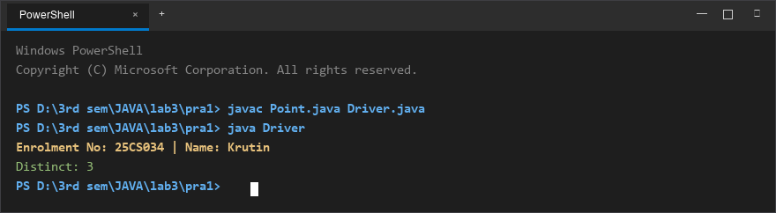
Figure 1: Console execution output for Problem 1 (Student ID: 25CS034)

Problem 2: Duplicate Playing Card Detector
Problem Statement:
(a) Create class Card with private String rank, suit and a constructor.
(b) Override toString() to return rank + " of " + suit (e.g. "Queen of Hearts").
(c) Override equals()/hashCode() by rank + suit.
(d) In Driver.main: add cards to a Card[] one at a time; before adding each, use equals() to check it against the earlier cards.
(e) Print "Duplicate found: <card>" the first time a repeat appears.

Java Source Code:
File: Card.java
/**
* Student Name : Krutin
* Enrolment No : 25CS034
* Course : CEUE203 - Object Oriented Programming
*/
import java.util.Objects;
public class Card {
private String rank;
private String suit;
public Card(String rank, String suit) {
this.rank = rank;
this.suit = suit;
}
@Override
public String toString() {
return rank + " of " + suit;
}
@Override
public boolean equals(Object obj) {
if (this == obj) return true;
if (!(obj instanceof Card)) return false;
Card other = (Card) obj;
return Objects.equals(this.rank, other.rank) && Objects.equals(this.suit, other.suit);
}
@Override
public int hashCode() {
return Objects.hash(rank, suit);
}
}

File: Driver.java
/**
* Student Name : Krutin
* Enrolment No : 25CS034
* Course : CEUE203 - Object Oriented Programming
*/
public class Driver {
public static void main(String[] args) {
System.out.println("Enrolment No: 25CS034 | Name: Krutin");
Card[] stream = {
new Card("Ace", "Spades"),
new Card("King", "Hearts"),
new Card("Queen", "Diamonds"),
new Card("Ace", "Spades"),
new Card("Jack", "Clubs")
};
Card[] cards = new Card[stream.length];
int count = 0;
for (Card c : stream) {
boolean duplicate = false;
for (int i = 0; i < count; i++) {
if (c.equals(cards[i])) {
System.out.println("Duplicate found: " + c);
duplicate = true;
break;
}
}
if (duplicate) {
break;
}
cards[count++] = c;
}
}
}

Execution Output Screenshot:

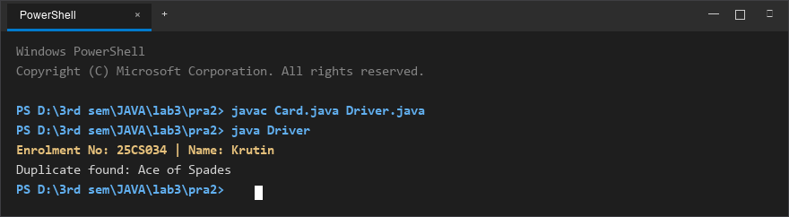
Figure 2: Console execution output for Problem 2 (Student ID: 25CS034)

