FACULTY OF ENGINEERING AND TECHNOLOGY
Object Oriented Programming (CEUE203) - Semester 3
Practical 04: String Processing, Regular Expressions, and StringBuilder
Student Name: Krutin | Enrolment No: 25CS034

Problem 1: Password Strength Evaluator
Problem Statement:
(a) In PasswordChecker, check four rules - length >= 8, contains an uppercase letter, contains a digit, contains a special character - using regex or String methods.
(b) Write strength(String pw) that counts how many rules pass and returns "Weak" (0-1), "Medium" (2-3) or "Strong" (4).
(c) In Driver.main: test several passwords; for each, print which rules passed and the final label.

Java Source Code:
File: PasswordChecker.java
/**
* Student Name : Krutin
* Enrolment No : 25CS034
* Course : CEUE203 - Object Oriented Programming
*/
public class PasswordChecker {
public static boolean hasLength(String pw) {
return pw != null && pw.length() >= 8;
}
public static boolean hasUpperCase(String pw) {
for (int i = 0; i < pw.length(); i++) {
if (Character.isUpperCase(pw.charAt(i))) {
return true;
}
}
return false;
}
public static boolean hasDigit(String pw) {
for (int i = 0; i < pw.length(); i++) {
if (Character.isDigit(pw.charAt(i))) {
return true;
}
}
return false;
}
public static boolean hasSpecialCharacter(String pw) {
for (int i = 0; i < pw.length(); i++) {
char ch = pw.charAt(i);
if (!Character.isLetterOrDigit(ch)) {
return true;
}
}
return false;
}
public static String strength(String pw) {
int count = 0;
if (hasLength(pw)) count++;
if (hasUpperCase(pw)) count++;
if (hasDigit(pw)) count++;
if (hasSpecialCharacter(pw)) count++;
if (count <= 1) {
return "Weak";
} else if (count <= 3) {
return "Medium";
} else {
return "Strong";
}
}
}

File: Driver.java
/**
* Student Name : Krutin
* Enrolment No : 25CS034
* Course : CEUE203 - Object Oriented Programming
*/
public class Driver {
public static void main(String[] args) {
System.out.println("Enrolment No: 25CS034 | Name: Krutin");
String[] passwords = {
"abc",
"Password",
"Pass1234",
"Abcd1234!"
};
for (String pw : passwords) {
System.out.println("Password: " + pw);
System.out.println("Length >= 8: " + PasswordChecker.hasLength(pw));
System.out.println("Uppercase: " + PasswordChecker.hasUpperCase(pw));
System.out.println("Digit: " + PasswordChecker.hasDigit(pw));
System.out.println("Special: " + PasswordChecker.hasSpecialCharacter(pw));
System.out.println("Strength: " + PasswordChecker.strength(pw));
System.out.println("-------------------------------");
}
}
}

Execution Output Screenshot:

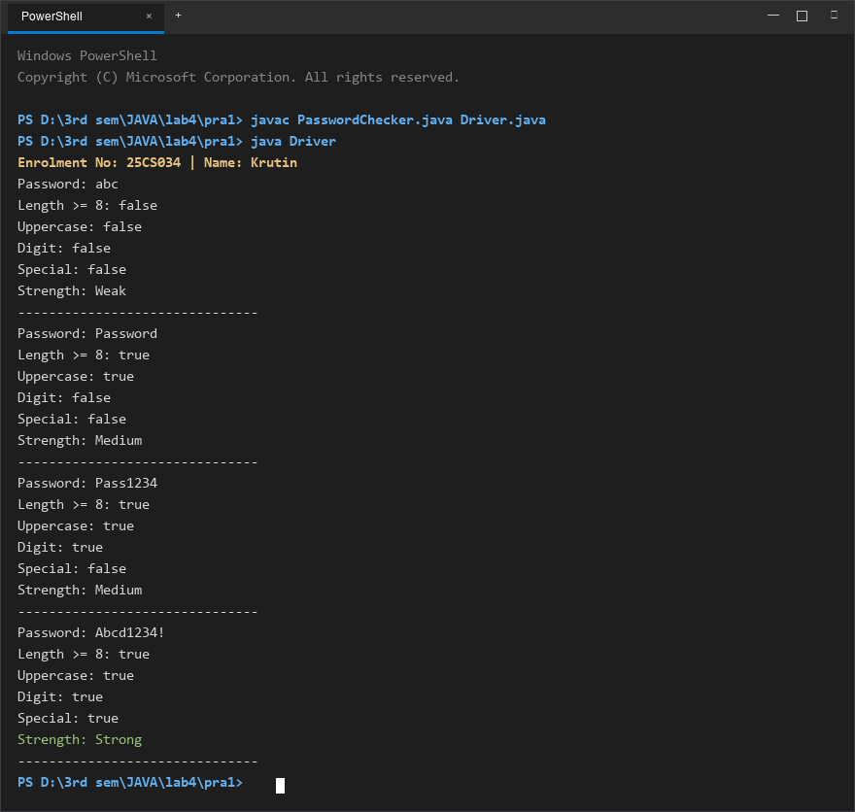
Figure 1: Console execution output for Problem 1 (Student ID: 25CS034)

Problem 2: Chat-Log Stream Filter
Problem Statement:
(a) In Driver.main, define a String[] of log lines like "10:05 alice Hello there" (include one malformed line with fewer than 3 parts).
(b) Read a keyword from the user.
(c) For each line, split into time/user/message with split(" ", 3); skip lines that do not have 3 parts.
(d) If the message contains the keyword (case-insensitive), increment a counter and append "time user: message" to a StringBuilder.
(e) Print "Matches: N" and the built report.

Java Source Code:
File: ChatFilter.java
/**
* Student Name : Krutin
* Enrolment No : 25CS034
* Course : CEUE203 - Object Oriented Programming
*/
public class ChatFilter {
public static String filterLogs(String[] logs, String keyword) {
StringBuilder report = new StringBuilder();
int count = 0;
keyword = keyword.toLowerCase();
for (String line : logs) {
String[] parts = line.split(" ", 3);
if (parts.length < 3) {
continue;
}
String time = parts[0];
String user = parts[1];
String message = parts[2];
if (message.toLowerCase().contains(keyword)) {
count++;
report.append(time)
.append(" ")
.append(user)
.append(": ")
.append(message)
.append("\n");
}
}
return "Matches: " + count + "\n" + report.toString();
}
}

File: Driver.java
/**
* Student Name : Krutin
* Enrolment No : 25CS034
* Course : CEUE203 - Object Oriented Programming
*/
import java.util.Scanner;
public class Driver {
public static void main(String[] args) {
System.out.println("Enrolment No: 25CS034 | Name: Krutin");
String[] logs = {
"10:05 alice Hello there",
"10:10 bob How are you?",
"InvalidLine",
"10:20 charlie Nice to say hello"
};
Scanner sc = new Scanner(System.in);
System.out.print("Enter keyword: ");
String keyword = sc.nextLine();
System.out.println();
System.out.println(ChatFilter.filterLogs(logs, keyword));
sc.close();
}
}

Execution Output Screenshot:

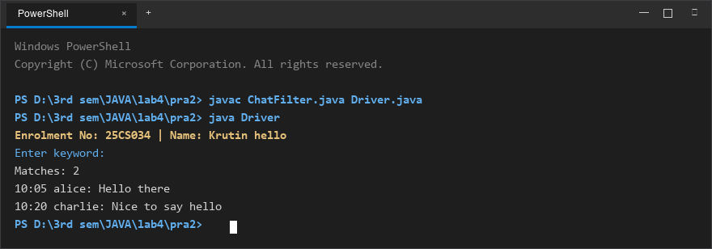
Figure 2: Console execution output for Problem 2 (Student ID: 25CS034)

