FACULTY OF ENGINEERING AND TECHNOLOGY
Object Oriented Programming (CEUE203) - Semester 3
Practical 05: Inheritance, Abstract Classes, and Polymorphism
Student Name: Krutin | Enrolment No: 25CS034

Problem 1: Polymorphic Shape Area Calculation
Problem Statement:
Define an abstract Shape with abstract area(); subclasses Circle, Rectangle, Triangle.
Put a mix of shapes in a Shape[] array and loop once to print each area and the running total, tracking the largest shape area - demonstrating one loop handling every shape type through polymorphism.

Java Source Code:
/**
* Student Name : Krutin
* Enrolment No : 25CS034
* Course : CEUE203 - Object Oriented Programming
*/
abstract class Shape {
abstract double area();
}
class Circle extends Shape {
double radius;
Circle(double radius) {
this.radius = radius;
}
@Override
double area() {
return 3.14 * radius * radius;
}
}
class Rectangle extends Shape {
double length, width;
Rectangle(double length, double width) {
this.length = length;
this.width = width;
}
@Override
double area() {
return length * width;
}
}
class Triangle extends Shape {
double base, height;
Triangle(double base, double height) {
this.base = base;
this.height = height;
}
@Override
double area() {
return 0.5 * base * height;
}
}
public class Main {
public static void main(String[] args) {
System.out.println("Enrolment No: 25CS034 | Name: Krutin");
Shape[] shapes = {
new Circle(5),
new Rectangle(4, 6),
new Triangle(10, 5),
new Circle(3)
};
double total = 0;
double largest = 0;
for (Shape s : shapes) {
double currentArea = s.area();
System.out.println(s.getClass().getSimpleName() + " Area = " + currentArea);
total += currentArea;
if (currentArea > largest) {
largest = currentArea;
}
}
System.out.println("\nTotal Area = " + total);
System.out.println("Largest Area = " + largest);
}
}

Execution Output Screenshot:

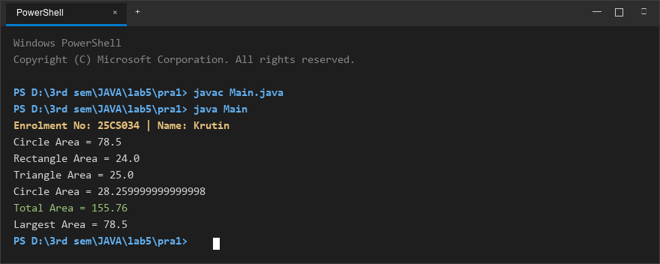
Figure 1: Console execution output for Problem 1 (Student ID: 25CS034)

Problem 2: Employee Payroll & Type Checking
Problem Statement:
Define an abstract Employee with abstract monthlySalary(); subclasses FullTime (fixed salary), PartTime (hours x rate) and Intern (stipend), each calling super constructor for shared name/id fields.
Loop through a mixed array to print each salary and compute total payroll; use the instanceof operator to identify and print a special note only for interns.

Java Source Code:
/**
* Student Name : Krutin
* Enrolment No : 25CS034
* Course : CEUE203 - Object Oriented Programming
*/
abstract class Employee {
String name;
int id;
Employee(String name, int id) {
this.name = name;
this.id = id;
}
abstract double monthlySalary();
}
class FullTime extends Employee {
double salary;
FullTime(String name, int id, double salary) {
super(name, id);
this.salary = salary;
}
@Override
double monthlySalary() {
return salary;
}
}
class PartTime extends Employee {
double hours;
double rate;
PartTime(String name, int id, double hours, double rate) {
super(name, id);
this.hours = hours;
this.rate = rate;
}
@Override
double monthlySalary() {
return hours * rate;
}
}
class Intern extends Employee {
double stipend;
Intern(String name, int id, double stipend) {
super(name, id);
this.stipend = stipend;
}
@Override
double monthlySalary() {
return stipend;
}
}
public class Main {
public static void main(String[] args) {
System.out.println("Enrolment No: 25CS034 | Name: Krutin");
Employee[] employees = {
new FullTime("Rahul", 101, 50000),
new PartTime("Amit", 102, 80, 200),
new Intern("Krutin", 103, 15000)
};
double total = 0;
for (Employee e : employees) {
double salary = e.monthlySalary();
System.out.println(e.name + " (ID: " + e.id + ") = " + salary);
if (e instanceof Intern) {
System.out.println("Note: Intern receives a stipend.");
}
total += salary;
}
System.out.println("--------------------");
System.out.println("Total Payroll = " + total);
}
}

Execution Output Screenshot:

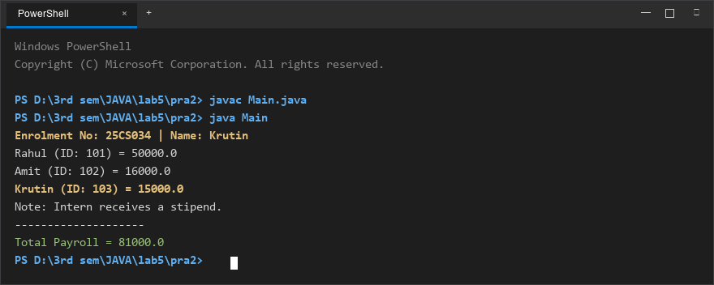
Figure 2: Console execution output for Problem 2 (Student ID: 25CS034)

