FACULTY OF ENGINEERING AND TECHNOLOGY
Object Oriented Programming (CEUE203) - Semester 3
Practical 06: Interfaces, Default Methods, Functional Interfaces, and Marker Interfaces
Student Name: Krutin | Enrolment No: 25CS034

Problem 1: Remote Control Switchable Hierarchy
Problem Statement:
Create an interface Switchable with on()/off() and a default toggle() method; classes Fan and Light implement it.
Loop over a Switchable[] toggling each device. Then add a @FunctionalInterface SwitchPolicy that decides, given a device and an hour, whether it may switch on, and supply it once as an anonymous class and once as a lambda expression.

Java Source Code:
/**
* Student Name : Krutin
* Enrolment No : 25CS034
* Course : CEUE203 - Object Oriented Programming
*/
interface Switchable {
void on();
void off();
default void toggle() {
on();
}
}
class Fan implements Switchable {
private boolean isOn = false;
@Override
public void on() {
isOn = true;
System.out.println("Fan is ON");
}
@Override
public void off() {
isOn = false;
System.out.println("Fan is OFF");
}
}
class Light implements Switchable {
private boolean isOn = false;
@Override
public void on() {
isOn = true;
System.out.println("Light is ON");
}
@Override
public void off() {
isOn = false;
System.out.println("Light is OFF");
}
}
@FunctionalInterface
interface SwitchPolicy {
boolean maySwitchOn(Switchable device, int hour);
}
public class RemoteControlDemo {
public static void main(String[] args) {
System.out.println("Enrolment No: 25CS034 | Name: Krutin");
Switchable[] devices = {
new Fan(),
new Light()
};
System.out.println("=== Toggling Devices ===");
for (Switchable device : devices) {
device.toggle();
}
SwitchPolicy dayPolicy = new SwitchPolicy() {
@Override
public boolean maySwitchOn(Switchable device, int hour) {
return hour >= 6 && hour <= 18;
}
};
SwitchPolicy nightPolicy = (device, hour) -> hour >= 18 || hour <= 23;
System.out.println("\n=== Policy Test ===");
int hour = 10;
for (Switchable device : devices) {
System.out.println("Anonymous class policy: " + dayPolicy.maySwitchOn(device, hour));
System.out.println("Lambda policy: " + nightPolicy.maySwitchOn(device, hour));
}
}
}

Execution Output Screenshot:

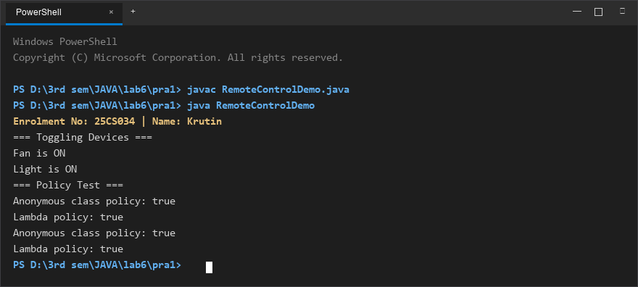
Figure 1: Console execution output for Problem 1 (Student ID: 25CS034)

Problem 2: Broadcast Notification System with Marker Interface
Problem Statement:
Create a functional interface Notifier with send(String); instantiate email and SMS senders using lambda expressions, hold them in an array, and broadcast one message through all.
Add an empty marker interface Urgent and implement it to dispatch messages twice for senders marked urgent.

Java Source Code:
/**
* Student Name : Krutin
* Enrolment No : 25CS034
* Course : CEUE203 - Object Oriented Programming
*/
@FunctionalInterface
interface Notifier {
void send(String message);
}
interface Urgent {}
class UrgentEmail implements Notifier, Urgent {
@Override
public void send(String message) {
System.out.println("Email: " + message);
}
}
public class NotificationDemo {
public static void main(String[] args) {
System.out.println("Enrolment No: 25CS034 | Name: Krutin");
Notifier email = message -> System.out.println("Email: " + message);
Notifier sms = message -> System.out.println("SMS: " + message);
Notifier[] senders = { email, sms };
String message = "Your lab session starts at 2 PM.";
System.out.println("=== Broadcast ===");
for (Notifier sender : senders) {
sender.send(message);
}
System.out.println("\n=== Urgent Notification ===");
Notifier urgentEmail = new UrgentEmail();
Notifier[] urgentSenders = { urgentEmail, sms };
for (Notifier sender : urgentSenders) {
sender.send(message);
if (sender instanceof Urgent) {
sender.send(message);
}
}
}
}

Execution Output Screenshot:

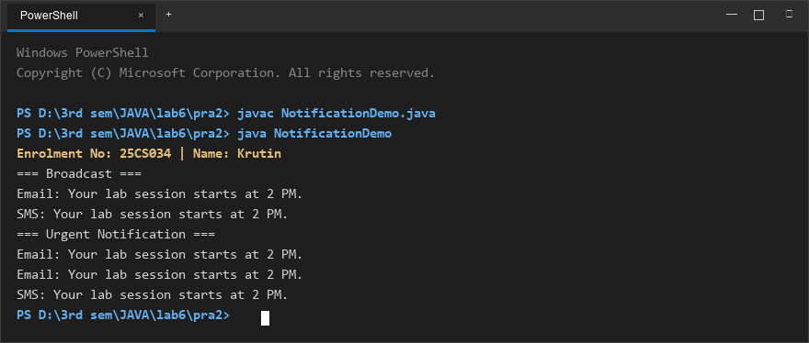
Figure 2: Console execution output for Problem 2 (Student ID: 25CS034)

