FACULTY OF ENGINEERING AND TECHNOLOGY
Object Oriented Programming (CEUE203) - Semester 3
Practical 07: Custom Annotations and Runtime Reflection
Student Name: Krutin | Enrolment No: 25CS034

Problem 1: Reflection-Based Form Validator
Problem Statement:
Define custom runtime annotations @NotBlank and @MaxLength(int) for object fields and annotate a SignupForm class.
Write a reflection validator that inspects getDeclaredFields(), reads field annotations at runtime, checks constraints, and returns a list of validation error messages.

Java Source Code:
/**
* Student Name : Krutin
* Enrolment No : 25CS034
* Course : CEUE203 - Object Oriented Programming
*/
import java.lang.annotation.ElementType;
import java.lang.annotation.Retention;
import java.lang.annotation.RetentionPolicy;
import java.lang.annotation.Target;
import java.lang.reflect.Field;
import java.util.ArrayList;
import java.util.List;
@Retention(RetentionPolicy.RUNTIME)
@Target(ElementType.FIELD)
@interface NotBlank {}
@Retention(RetentionPolicy.RUNTIME)
@Target(ElementType.FIELD)
@interface MaxLength {
int value();
}
class SignupForm {
@NotBlank
@MaxLength(20)
String username;
@NotBlank
@MaxLength(30)
String email;
@NotBlank
@MaxLength(15)
String password;
SignupForm(String username, String email, String password) {
this.username = username;
this.email = email;
this.password = password;
}
}
class Validator {
public static List<String> validate(Object obj) {
List<String> errors = new ArrayList<>();
Class<?> clazz = obj.getClass();
for (Field field : clazz.getDeclaredFields()) {
field.setAccessible(true);
try {
Object value = field.get(obj);
String fieldName = field.getName();
if (field.isAnnotationPresent(NotBlank.class)) {
if (value == null || value.toString().trim().isEmpty()) {
errors.add(fieldName + " must not be blank");
}
}
if (field.isAnnotationPresent(MaxLength.class)) {
MaxLength annotation = field.getAnnotation(MaxLength.class);
int max = annotation.value();
if (value != null && value.toString().length() > max) {
errors.add(fieldName + " must not exceed " + max + " characters");
}
}
} catch (IllegalAccessException e) {
errors.add("Cannot access field: " + field.getName());
}
}
return errors;
}
}
public class Main {
public static void main(String[] args) {
System.out.println("Enrolment No: 25CS034 | Name: Krutin");
SignupForm form = new SignupForm(
"",
"verylongemailaddress123456789@example.com",
"12345678901234567890"
);
List<String> errors = Validator.validate(form);
if (errors.isEmpty()) {
System.out.println("Form is valid.");
} else {
System.out.println("Validation Errors:");
for (String error : errors) {
System.out.println("- " + error);
}
}
}
}

Execution Output Screenshot:

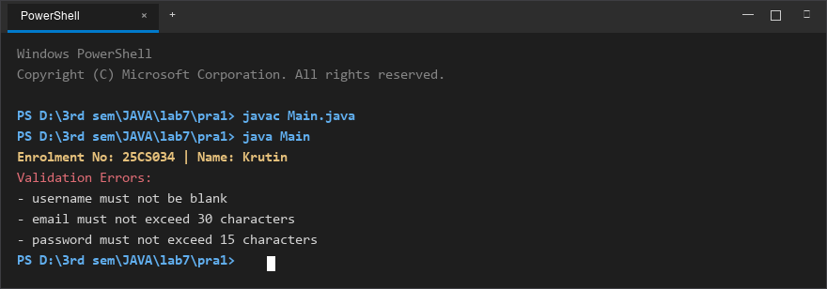
Figure 1: Console execution output for Problem 1 (Student ID: 25CS034)

Problem 2: Custom Unit Test Runner (@Run)
Problem Statement:
Define a @Run annotation with RUNTIME retention and METHOD target. Mark several no-arg test methods of a class with @Run.
Use Java reflection to inspect declared methods, invoke only those annotated with @Run, and print execution results and total tests executed.

Java Source Code:
/**
* Student Name : Krutin
* Enrolment No : 25CS034
* Course : CEUE203 - Object Oriented Programming
*/
import java.lang.annotation.ElementType;
import java.lang.annotation.Retention;
import java.lang.annotation.RetentionPolicy;
import java.lang.annotation.Target;
import java.lang.reflect.Method;
@Retention(RetentionPolicy.RUNTIME)
@Target(ElementType.METHOD)
@interface Run {}
class MyTests {
@Run
public void testAddition() {
System.out.println("Running testAddition");
}
@Run
public void testSubtraction() {
System.out.println("Running testSubtraction");
}
public void normalMethod() {
System.out.println("This method should not run");
}
@Run
public void testMessage() {
System.out.println("Running testMessage");
}
public void anotherMethod() {
System.out.println("This method should not run");
}
}
public class Main {
public static void main(String[] args) {
System.out.println("Enrolment No: 25CS034 | Name: Krutin");
MyTests testObject = new MyTests();
int count = 0;
Method[] methods = MyTests.class.getDeclaredMethods();
for (Method method : methods) {
if (method.isAnnotationPresent(Run.class) && method.getParameterCount() == 0) {
try {
method.invoke(testObject);
count++;
} catch (Exception e) {
System.out.println("Error running: " + method.getName());
}
}
}
System.out.println("\nTotal @Run methods executed: " + count);
}
}

Execution Output Screenshot:

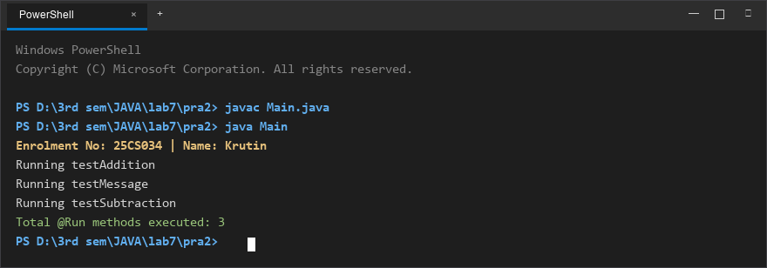
Figure 2: Console execution output for Problem 2 (Student ID: 25CS034)

