FACULTY OF ENGINEERING AND TECHNOLOGY
Object Oriented Programming (CEUE203) - Semester 3
Practical 08: Exception Handling and Custom Checked Exceptions
Student Name: Krutin | Enrolment No: 25CS034

Problem 1: Guarded Robust Calculator
Problem Statement:
Create a guarded calculator that reads two numbers and an operator.
Throw a custom DivideByZeroException when denominator is 0, catch InputMismatchException for non-numeric input separately, retry in a loop until valid, and use a finally block to log each calculation attempt.

Java Source Code:
/**
* Student Name : Krutin
* Enrolment No : 25CS034
* Course : CEUE203 - Object Oriented Programming
*/
import java.util.InputMismatchException;
import java.util.Scanner;
class DivideByZeroException extends Exception {
public DivideByZeroException(String message) {
super(message);
}
}
public class GuardedCalculator {
public static void main(String[] args) {
System.out.println("Enrolment No: 25CS034 | Name: Krutin");
Scanner sc = new Scanner(System.in);
boolean success = false;
while (!success) {
try {
System.out.print("Enter first number: ");
double num1 = sc.nextDouble();
System.out.print("Enter operator (+, -, *, /): ");
char operator = sc.next().charAt(0);
System.out.print("Enter second number: ");
double num2 = sc.nextDouble();
double result;
switch (operator) {
case '+':
result = num1 + num2;
break;
case '-':
result = num1 - num2;
break;
case '*':
result = num1 * num2;
break;
case '/':
if (num2 == 0) {
throw new DivideByZeroException("Cannot divide by zero.");
}
result = num1 / num2;
break;
default:
System.out.println("Invalid operator.");
continue;
}
System.out.println("Result = " + result);
success = true;
} catch (InputMismatchException e) {
System.out.println("Invalid number input. Please enter numbers only.");
sc.nextLine();
} catch (DivideByZeroException e) {
System.out.println("Calculation error: " + e.getMessage());
sc.nextLine();
} finally {
System.out.println("Attempt logged.");
}
}
System.out.println("Valid calculation completed.");
sc.close();
}
}

Execution Output Screenshot:

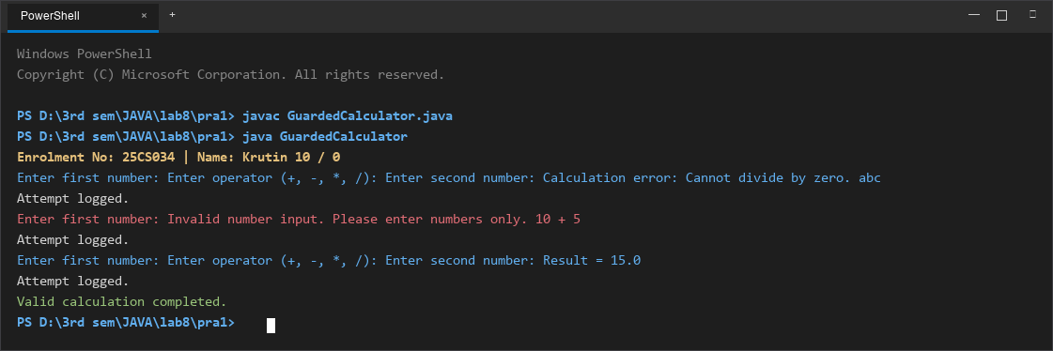
Figure 1: Console execution output for Problem 1 (Student ID: 25CS034)

Problem 2: Warehouse Stock Issue System
Problem Statement:
Model a Warehouse inventory where issue(item, qty) throws a custom checked OutOfStockException carrying the shortfall amount when inventory is insufficient, and InvalidQuantityException for qty <= 0.
Process a list of order requests, catching and reporting each specific failure gracefully without terminating the program.

Java Source Code:
/**
* Student Name : Krutin
* Enrolment No : 25CS034
* Course : CEUE203 - Object Oriented Programming
*/
import java.util.Arrays;
import java.util.HashMap;
import java.util.List;
import java.util.Map;
class OutOfStockException extends Exception {
private int shortfall;
public OutOfStockException(String message, int shortfall) {
super(message);
this.shortfall = shortfall;
}
public int getShortfall() {
return shortfall;
}
}
class InvalidQuantityException extends Exception {
public InvalidQuantityException(String message) {
super(message);
}
}
class Warehouse {
private Map<String, Integer> stock = new HashMap<>();
public Warehouse() {
stock.put("Laptop", 5);
stock.put("Mouse", 10);
stock.put("Keyboard", 3);
}
public void issue(String item, int qty) throws OutOfStockException, InvalidQuantityException {
if (qty <= 0) {
throw new InvalidQuantityException("Quantity must be greater than 0.");
}
if (!stock.containsKey(item)) {
throw new OutOfStockException("Item '" + item + "' is not available.", qty);
}
int available = stock.get(item);
if (qty > available) {
int shortfall = qty - available;
throw new OutOfStockException("Not enough stock for " + item + ". Available: " + available + ", Requested: " + qty, shortfall);
}
stock.put(item, available - qty);
System.out.println("Issued " + qty + " " + item + "(s) successfully.");
}
}
class Request {
String item;
int quantity;
Request(String item, int quantity) {
this.item = item;
this.quantity = quantity;
}
}
public class StockIssue {
public static void main(String[] args) {
System.out.println("Enrolment No: 25CS034 | Name: Krutin");
Warehouse warehouse = new Warehouse();
List<Request> requests = Arrays.asList(
new Request("Laptop", 2),
new Request("Mouse", 20),
new Request("Keyboard", 0),
new Request("Keyboard", 2),
new Request("Monitor", 1),
new Request("Laptop", 1)
);
System.out.println("=== Stock Issue Processing ===");
for (Request request : requests) {
System.out.println("\nRequest: " + request.item + " x " + request.quantity);
try {
warehouse.issue(request.item, request.quantity);
} catch (OutOfStockException e) {
System.out.println("OUT OF STOCK: " + e.getMessage());
System.out.println("Shortfall: " + e.getShortfall());
} catch (InvalidQuantityException e) {
System.out.println("INVALID QUANTITY: " + e.getMessage());
}
}
System.out.println("\nAll requests processed.");
}
}

Execution Output Screenshot:

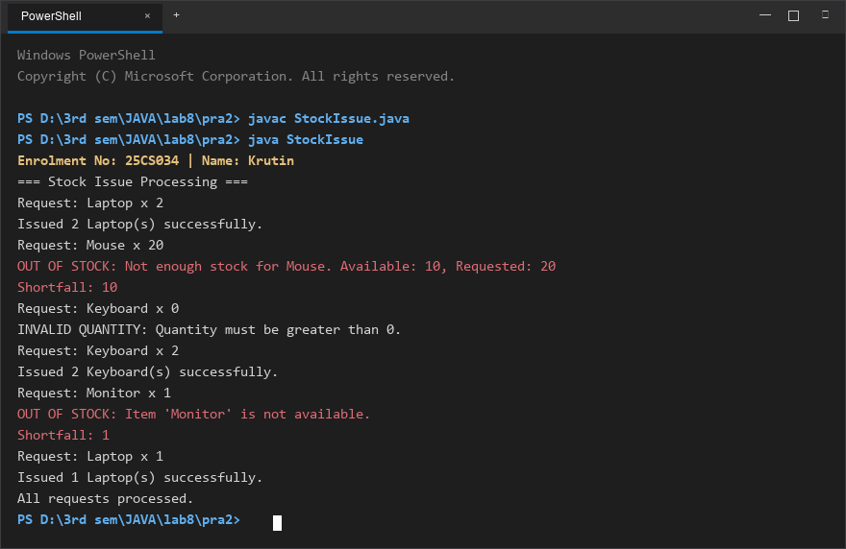
Figure 2: Console execution output for Problem 2 (Student ID: 25CS034)

