FACULTY OF ENGINEERING AND TECHNOLOGY
Object Oriented Programming (CEUE203) - Semester 3
Practical 09: Multithreading, Race Conditions, and Synchronization
Student Name: Krutin | Enrolment No: 25CS034

Problem 1: Shared Counter Race Condition & Fix
Problem Statement:
Demonstrate thread race conditions: create 10 concurrent threads each incrementing a shared counter 10,000 times.
Run once without synchronization to observe lost updates (actual < expected), and then demonstrate the fix using a synchronized method, confirming the exact expected count (100,000) every run.

Java Source Code:
/**
* Student Name : Krutin
* Enrolment No : 25CS034
* Course : CEUE203 - Object Oriented Programming
*/
class UnsynchronizedCounter {
private int count = 0;
public void increment() {
count++;
}
public int getCount() {
return count;
}
}
class SynchronizedCounter {
private int count = 0;
public synchronized void increment() {
count++;
}
public int getCount() {
return count;
}
}
public class CounterRace {
public static void main(String[] args) throws InterruptedException {
System.out.println("Enrolment No: 25CS034 | Name: Krutin");
int numberOfThreads = 10;
int incrementsPerThread = 10000;
int expected = numberOfThreads * incrementsPerThread;
UnsynchronizedCounter unsafeCounter = new UnsynchronizedCounter();
Thread[] unsafeThreads = new Thread[numberOfThreads];
for (int i = 0; i < numberOfThreads; i++) {
unsafeThreads[i] = new Thread(() -> {
for (int j = 0; j < incrementsPerThread; j++) {
unsafeCounter.increment();
}
});
unsafeThreads[i].start();
}
for (Thread t : unsafeThreads) {
t.join();
}
System.out.println("Without Synchronization:");
System.out.println("Expected: " + expected);
System.out.println("Actual: " + unsafeCounter.getCount());
SynchronizedCounter safeCounter = new SynchronizedCounter();
Thread[] safeThreads = new Thread[numberOfThreads];
for (int i = 0; i < numberOfThreads; i++) {
safeThreads[i] = new Thread(() -> {
for (int j = 0; j < incrementsPerThread; j++) {
safeCounter.increment();
}
});
safeThreads[i].start();
}
for (Thread t : safeThreads) {
t.join();
}
System.out.println("\nWith Synchronization:");
System.out.println("Expected: " + expected);
System.out.println("Actual: " + safeCounter.getCount());
}
}

Execution Output Screenshot:

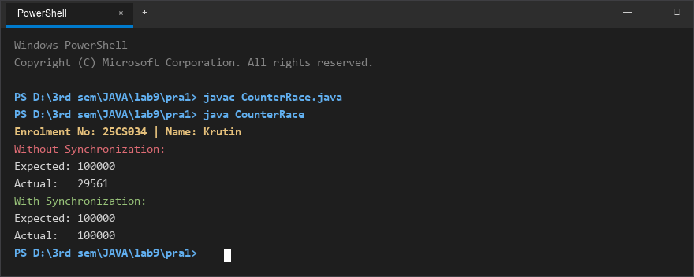
Figure 1: Console execution output for Problem 1 (Student ID: 25CS034)

Problem 2: Seat Booking Race & Thread Safety
Problem Statement:
Model a shared cinema booking system with 5 remaining seats and 10 concurrent customer threads trying to book seats.
Demonstrate that without synchronization overselling occurs (negative remaining seats). Fix the race condition with a synchronized book() method to ensure exactly 5 seats are booked and the rest rejected cleanly.

Java Source Code:
/**
* Student Name : Krutin
* Enrolment No : 25CS034
* Course : CEUE203 - Object Oriented Programming
*/
class UnsafeSeatBooking {
private int seatsLeft = 5;
public boolean book(String name) {
if (seatsLeft > 0) {
try {
Thread.sleep(10);
} catch (InterruptedException e) {
Thread.currentThread().interrupt();
}
seatsLeft--;
System.out.println(name + " booked a seat.");
return true;
}
System.out.println(name + " failed - no seats.");
return false;
}
public int getSeatsLeft() {
return seatsLeft;
}
}
class SafeSeatBooking {
private int seatsLeft = 5;
public synchronized boolean book(String name) {
if (seatsLeft > 0) {
try {
Thread.sleep(10);
} catch (InterruptedException e) {
Thread.currentThread().interrupt();
}
seatsLeft--;
System.out.println(name + " booked a seat.");
return true;
}
System.out.println(name + " failed - no seats.");
return false;
}
public int getSeatsLeft() {
return seatsLeft;
}
}
public class SeatBookingRace {
public static void main(String[] args) throws InterruptedException {
System.out.println("Enrolment No: 25CS034 | Name: Krutin");
System.out.println("=== Without Synchronization ===");
UnsafeSeatBooking unsafeBooking = new UnsafeSeatBooking();
Thread[] unsafeThreads = new Thread[10];
for (int i = 0; i < 10; i++) {
String name = "Customer-" + (i + 1);
unsafeThreads[i] = new Thread(() -> unsafeBooking.book(name));
unsafeThreads[i].start();
}
for (Thread t : unsafeThreads) {
t.join();
}
System.out.println("Seats remaining (Unsafe): " + unsafeBooking.getSeatsLeft());
System.out.println("\n=== With Synchronization ===");
SafeSeatBooking safeBooking = new SafeSeatBooking();
Thread[] safeThreads = new Thread[10];
for (int i = 0; i < 10; i++) {
String name = "Customer-" + (i + 1);
safeThreads[i] = new Thread(() -> safeBooking.book(name));
safeThreads[i].start();
}
for (Thread t : safeThreads) {
t.join();
}
System.out.println("Seats remaining (Safe): " + safeBooking.getSeatsLeft());
}
}

Execution Output Screenshot:

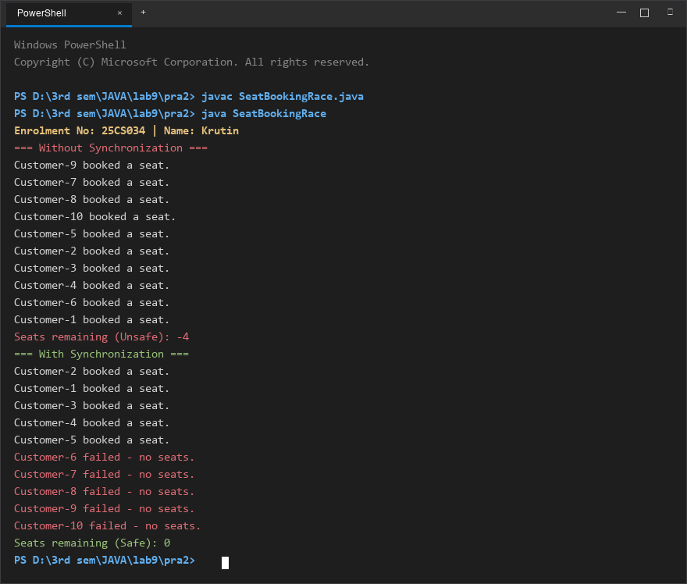
Figure 2: Console execution output for Problem 2 (Student ID: 25CS034)

