FACULTY OF ENGINEERING AND TECHNOLOGY
Object Oriented Programming (CEUE203) - Semester 3
Practical 10: ExecutorService Thread Pool & Inter-Thread Coordination
Student Name: Krutin | Enrolment No: 25CS034

Problem 1: Fixed Thread-Pool Task Runner
Problem Statement:
Create a fixed thread pool of 3 worker threads using Executors.newFixedThreadPool(3).
Submit 10 Runnable tasks that print their task ID and executing thread name, sleep briefly to simulate work, shut down gracefully, and await completion using awaitTermination().

Java Source Code:
/**
* Student Name : Krutin
* Enrolment No : 25CS034
* Course : CEUE203 - Object Oriented Programming
*/
import java.util.concurrent.ExecutorService;
import java.util.concurrent.Executors;
import java.util.concurrent.TimeUnit;
public class ThreadPoolRunner {
public static void main(String[] args) throws InterruptedException {
System.out.println("Enrolment No: 25CS034 | Name: Krutin");
ExecutorService executor = Executors.newFixedThreadPool(3);
for (int i = 1; i <= 10; i++) {
int taskId = i;
executor.submit(() -> {
try {
System.out.println("Task " + taskId + " is running on " + Thread.currentThread().getName());
Thread.sleep(200);
System.out.println("Task " + taskId + " completed by " + Thread.currentThread().getName());
} catch (InterruptedException e) {
Thread.currentThread().interrupt();
}
});
}
executor.shutdown();
if (executor.awaitTermination(5, TimeUnit.SECONDS)) {
System.out.println("All tasks completed.");
} else {
System.out.println("Some tasks did not finish.");
}
}
}

Execution Output Screenshot:

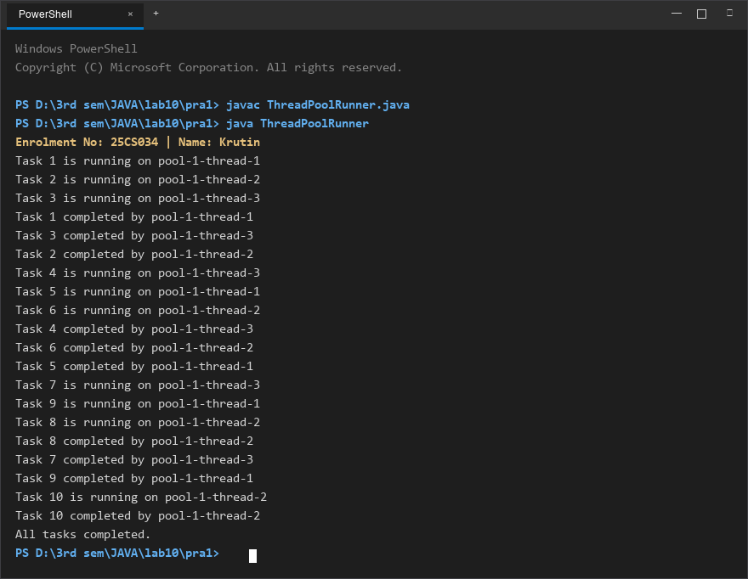
Figure 1: Console execution output for Problem 1 (Student ID: 25CS034)

Problem 2: Producer-Consumer with wait() and notify()
Problem Statement:
Implement the classic Producer-Consumer pattern using a synchronized SharedBuffer.
Coordinate producer and consumer threads using intrinsic locks with wait() and notify() methods, guaranteeing sequential in-order item production and consumption with zero data loss.

Java Source Code:
/**
* Student Name : Krutin
* Enrolment No : 25CS034
* Course : CEUE203 - Object Oriented Programming
*/
class SharedBuffer {
private int item;
private boolean available = false;
public synchronized void produce(int value) throws InterruptedException {
while (available) {
wait();
}
item = value;
available = true;
System.out.println("Produced: " + value);
notify();
}
public synchronized int consume() throws InterruptedException {
while (!available) {
wait();
}
int value = item;
available = false;
System.out.println("Consumed: " + value);
notify();
return value;
}
}
public class ProducerConsumer {
public static void main(String[] args) {
System.out.println("Enrolment No: 25CS034 | Name: Krutin");
SharedBuffer buffer = new SharedBuffer();
Thread producer = new Thread(() -> {
try {
for (int i = 1; i <= 5; i++) {
buffer.produce(i);
}
} catch (InterruptedException e) {
Thread.currentThread().interrupt();
}
});
Thread consumer = new Thread(() -> {
try {
for (int i = 1; i <= 5; i++) {
buffer.consume();
}
} catch (InterruptedException e) {
Thread.currentThread().interrupt();
}
});
producer.start();
consumer.start();
try {
producer.join();
consumer.join();
} catch (InterruptedException e) {
Thread.currentThread().interrupt();
}
System.out.println("All items produced and consumed.");
}
}

Execution Output Screenshot:

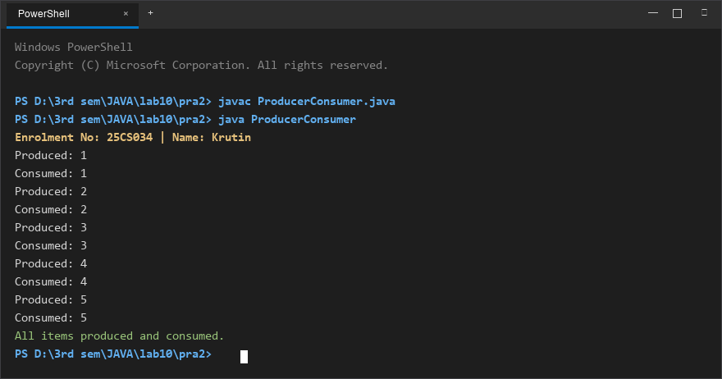
Figure 2: Console execution output for Problem 2 (Student ID: 25CS034)

